World Meteorological Organization  COMMISSION FOR BASIC SYSTEMS  Task Team on evolution of the WIS  2018 Meeting  Beijing, 14-16 November 2018 | TT-eWIS-2018/Final Report
 | 30.Jan.2019

Final Report of the
of the Task Team on EVOLUTION OF THE WIS
14-16 NOVEMBER 2018

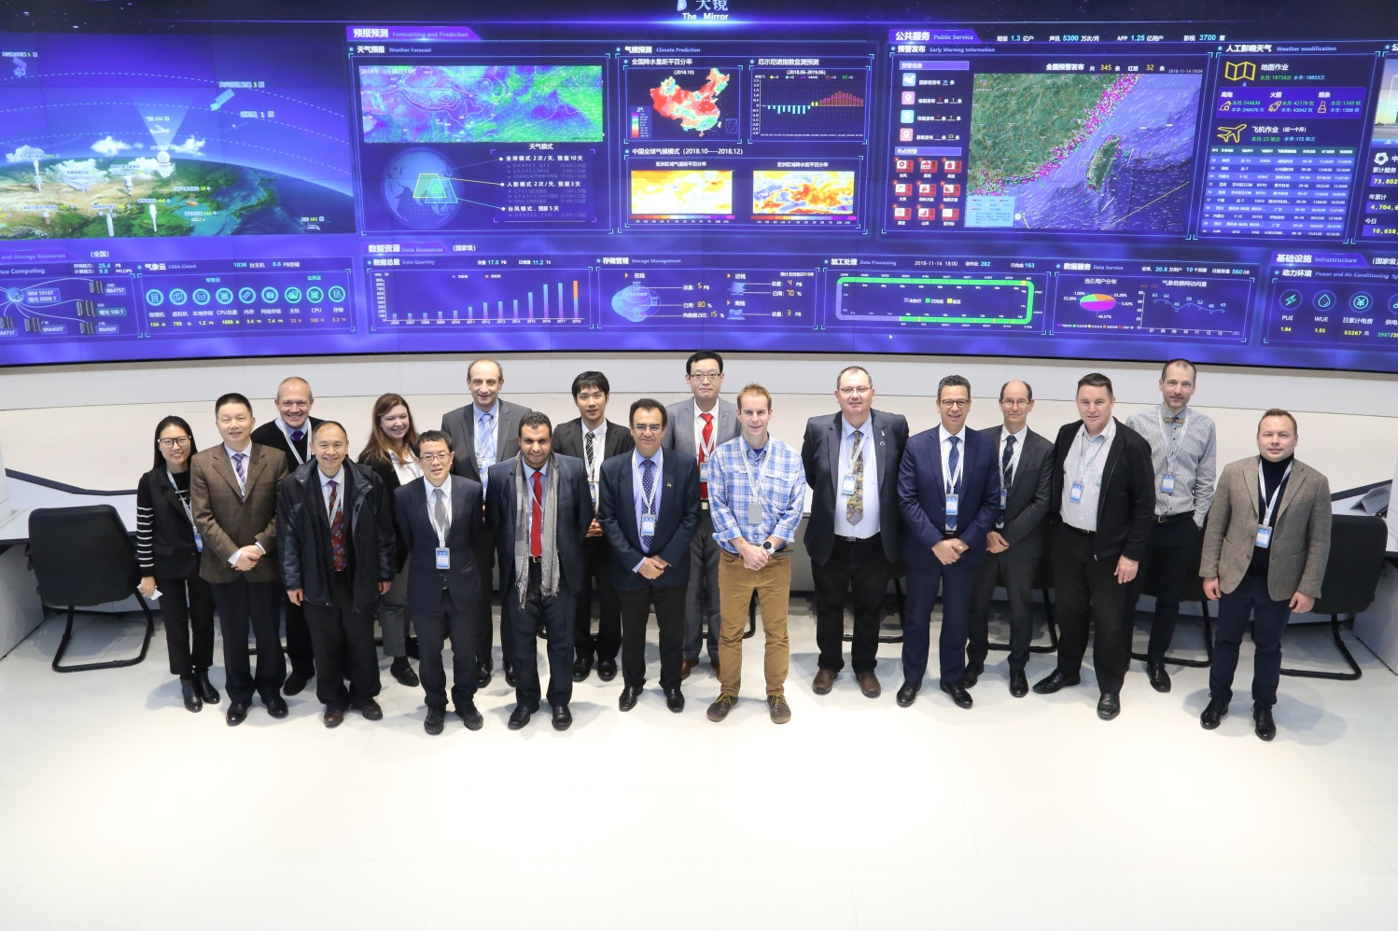

DISCLAIMER
Regulation 43
Recommendations of working groups shall have no status within the Organization until they have been approved by the responsible constituent body. In the case of joint working groups the recommendations must be concurred with by the presidents of the constituent bodies concerned before being submitted to the designated constituent body.
Regulation 44
In the case of a recommendation made by a working group between sessions of the responsible constituent body, either in a session of a working group or by correspondence, the president of the body may, as an exceptional measure, approve the recommendation on behalf of the constituent body when the matter is, in his opinion, urgent, and does not appear to imply new obligations for Members. He may then submit this recommendation for adoption by the Executive Council or to the President of the Organization for action in accordance with Regulation 9(5).
© World Meteorological Organization, 2018
The right of publication in print, electronic and any other form and in any language is reserved by WMO. Short extracts from WMO publications may be reproduced without authorization, provided that the complete source is clearly indicated. Editorial correspondence and requests to publish, reproduce or translate this publication in part or in whole should be addressed to:
Chairperson, Publications Board
World Meteorological Organization (WMO)
7 bis, avenue de la Paix Tel.: +41 (0)22 730 84 03
P.O. Box No. 2300 Fax: +41 (0)22 730 80 40
CH-1211 Geneva 2, Switzerland E-mail: Publications@wmo.int
NOTE:
The designations employed in WMO publications and the presentation of material in this publication do not imply the expression of any opinion whatsoever on the part of WMO concerning the legal status of any country, territory, city or area, or of its authorities, or concerning the delimitation of its frontiers or boundaries.
The mention of specific companies or products does not imply that they are endorsed or recommended by WMO in preference to others of a similar nature which are not mentioned or advertised.
This document (or report) is not an official publication of WMO and has not been subjected to its standard editorial procedures. The views expressed herein do not necessarily reflect those of WMO or its Members.

1 Opening of the meeting
- Dr. Zhao Licheng, Director of CMA National Meteorological Information Centre, welcomed the members of the team and stressed the importance of WIS and its evolution.
- Jeremy Tandy, Chair of TT-eWIS, welcomed members and asked everyone a short personal introduction.
- The Team approved the agenda as reported in ANNEX 1. In ANNEX 2 a list of participants can be found.
- Jeremy Tandy (JT) recalled Decision 18 (EC-70) and Resolution 23 (EC-70), reported in full in ANNEX 3.
- Regarding Decision 18 JT highlighted that
EC-70 requests CBS:
- To consult with Members [...] on WIS 2.0 implementation;
- To provide Congress with the updated Strategy and Implementation Approach and a plan to document specific design requirements;
- To provide more information to Members about the technical infrastructure supporting WIS 2.0 and a comparison of the functional architectures for the original WIS and WIS 2.0;
Decision 18 (EC-70) asks that Congress delegate to EC the final approvals on WIS 2.0 implementation once the detailed design requirements and technical specifications have been provided by CBS.
- Regarding Resolution 23 JT recalled that EC-70 requests CBS, in collaboration with the private sector, to assess how new technology can be applied to the provision of reliable data sharing for all users of WIS 2.0 and report back. This task can be accomplished by organising a workshop on Future Technologies to gather the required input from the private sector.
- The objectives of the meeting are agreed to be
  - Update the draft WIS 2.0 Implementation Approach proposed at CBS-TECO/2018: CBS-TECO-2018-Inf-5(1)
  - Update the WIS Functional Architecture with respect to WIS 2.0, and provide a mapping between the functional architecture of WIS 2.0 and the current WIS implementation
  - Plan the Future Technologies workshop
Outputs of (A) and (B) will be distributed to Members for consultation, with their feedback incorporated into a document to be provided to Cg-18.
A statement from the Future Technologies workshop will also be provided to Cg-18.
- JT presented the following timeline to the team with the aim to clarify objectives and work plan of the meeting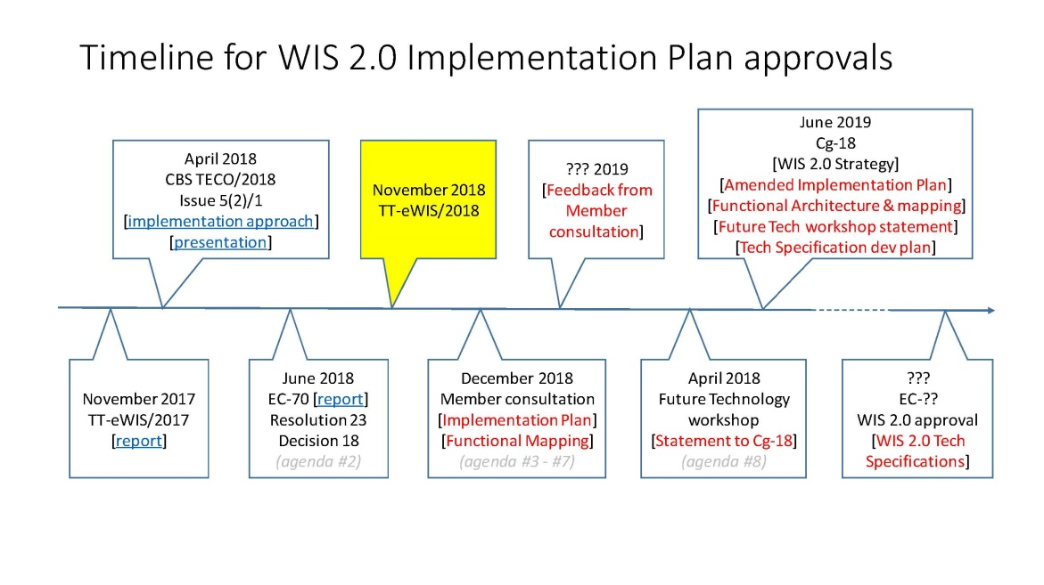

2 Review Decisions and Resolutions of EC-70

- Before discussing the implication of resolutions and decisions of EC-70 in respect of WIS 2.0 implementation plan, Matteo Dell’Acqua (Chair of OPAG-ISS) reminded WIS 2.0 goals:
  - Give to the users the means to access and use unprecedented amount of data and information from all WMO programmes
  - Provide easy and reliable access to services (products, tools, applications, computing, storage …)
  - … while continuing to promote free and open data sharing
  - Allow users to apply own processing to data
  - Rationalise common parts of WIS infrastructure
  - Better serve all types of users, expand the user base, promote interaction between communities: public authorities, research, private, …
- The key goals are summarised in the following table
- Increase the discoverability and accessibility of authoritative weather, water and climate data and information beyond the traditional institutional NMHS user base. | - Ensure that the WMO community is equipped to derive benefit from the explosion in data volumes resulting from continued investment in earth-system modelling and observing systems.
- Cost reduction for WIS Centres from retirement of the legacy systems and infrastructure, and consolidation of how core WIS functions are provided. | - Improve access to data and services in developing countries and, through regional and global cooperation, strengthen the capacity of Members to provide meteorological, hydrological, marine and climate services.
and they are part of the document on implementation of WIS 2.0 submitted at CBS TECO 2018 . The final draft of WIS 2.0 implementation plan was expected to be ready by December 2018, but the discussion during EC-70 made clear that a more detailed technical specification of the implementation approach was required by several Member States to have the plan approved at Congress.
- The finally approved Decision states:
Requests the CBS: […] (3) To provide more information to Members about the technical infrastructure supporting WIS 2.0 and a comparison of the functional architectures for the original WIS and WIS 2.0;
As a result, the submission to Cg-18 would be an update to the WIS 2.0 Strategy and Implementation Approach, plus a PLAN to gather the detailed technical specifications required for Members to assess (and plan and budget for) WIS 2.0 implementation.
Requests the CBS: […] (2) To provide Congress with the updated Strategy and Implementation Approach and a plan to document specific design requirements;
- Furthermore, implementation approval would be delegated to EC at some subsequent date, allowing for more time to develop those technical specifications
Decides to request from Congress to authorize EC to make a decision on implementation once the updated documents, including design requirements, are submitted by CBS
- Secondly, Germany were advocating a decentralised approach to implementation. Reviewing the discussion during the EC-70 side meeting on Cache in the Cloud, and noting our inability to progress the concept of shared services, it seems that we need to fundamentally address the concerns about a decentralised WIS 2.0.
- It is clear that to get consensus on the approval of WIS 2.0 implementation, the technical specifications need to be well understood so to Members can clearly understand what WIS 2.0 will entail, and how much it will cost so that they can budget effectively.
- Matteo dell’Acqua made clear that the requirements for WIS 2.0 have been already gathered and that strategy and requirement are not under discussion. The technical implementation is the argument of discussion and the implementation approach with better specification of the final WIS 2.0 architecture compared to the current one.
- It has been decided by the team not to go back to the requirements.
- Matteo Dell’Acqua to manage WIS 2.0 requirements and to produce a list summarising the requirements gathered in the process leading to the implementation plan.
- Sergei Belov proposed to compare current WIS with WIS 2.0 to point out the benefits and clarify to Member States the advantages of making the migration without going into technical details that can change during the implementation process. The proposal was accepted by the team.
- Comparison between current WIS and WIS 2.0 has to highlighting the benefits of the migration to facilitate the Member States in understanding the advantages of the new architecture without going into specific technical details.
- The Team agreed that reviewed WIS 2.0 Implementation Approach has to be submitted for consultation to WMO Members with the purpose to seek Congress approval. Content of the document to be decided during the meeting.
- Chair to produce a first draft of the document on WIS 2.0 Implementation Approach, including WIS 2.0 functional Architecture compared with current WIS. Team to review the document.
- Secretariat to finalise WIS 2.0 Implementation Approach document and submit to Members for consultation.

3 Review WIS 2.0 Implementation approach

- Implementation approach was submitted as info document at CBS TECO 2018 (Inf 5(1) WIS2-Implementation-Approach). The team will review the implementation approach as expressed in that document and produce an updated implementation plan in agenda item 7.
- Jeremy Tandy recalled the basic elements of WIS 2.0 strategy and implementation approach:
- Jeremy Tandy made a presentation which was already presented at the Global Weather Enterprise Conference in Amsterdam in October He pointed out that
  - Data is the fuel of GWE
  - WIS connects demand for authoritative weather, water and climate information with supply from approved Centres
  - But the design of GTS and current WIS is insufficient in a situation of growing number of applications, increased need of discoverability and accessibility to serve policy making and general public purposes, the growing data volume.
  - Proposal of change for WIS 2.0 is expressed in the following points
    - Internet in place of private networks
    - IP in place of point to point routing
    - Pub/sub messaging in place of bulletins
  - Remembering that WIS 2.0 is a collaborative system of systems using Web-architecture and open standards to provide simple, timely and seamless sharing of trusted weather, water and climate data and information through services
  - Whatsapp for weather? Is it possible to propose something like whatsapp for the delivery of authoritative weather information and warnings?
  - There are already some examples of use of new WEB technologies that can be used in WIS 2.0: Copernicus Climate Data Store (https://cds.climate.copernicus.eu ), SEVIR (http://servir.icimod.org/ ). These are web based applications using cloud technologies to provide web based tools to general users and in support of developing Countries.
  - Challenges for WIS2.0
    - Policy:
How do we ensure that WIS 2.0 evolves into an open ecosystem – welcoming contribution from all sectors of the GWE?
How can we endorse data and services as ‘authoritative’ – currently this is done by the PR, but what criteria should they use?
- Technology
How can WMO work with stakeholders from across the GWE to select the right open standards and technology implementations?
Can industry help operate the basic infrastructure of WIS 2.0 – like real-time messaging? (NMHS aren’t technology businesses!)
- Operational change
What incentives can we provide NMHS to encourage change to their Message Switching – a core element of operations?
Can we work with Message Switch vendors to help insulate Members’ upstream operations from change?
- finance and business
Moving from capital ‘big iron’ to operational ‘service/subscription-based’ expenditure requires a rethink to procurement.
How can we predict future costs in subscription-based pricing?
How can we make service costs (e.g. cloud platforms) affordable for all Members.
Who pays to operate cloud platforms and data processing services? (someone always has to pay)
- basic infrastructure
Developing country Members face the biggest challenges in most things – data being but one…
Is there stable Internet capability with sufficient bandwidth to support Web and cloud-based applications?
Is there consistent energy supply to keep the lights on and the computers running?
Are funding sources available to deploy and sustain basic infrastructure?
- capacity & capability
Are there skills and capability sufficient to build Web applications or exploit cloud-hosted data platforms?
… typical situation in many places is information being shared verbally by telephone
How can GWE support capacity building – training and education?
- cultural
How can we overcome nervousness about loss of control of data if it is shared on the Web?
How can we encourage state actors (NMHS) to look at alternatives to direct participation in the entire end-to-end value chain, e.g. consuming a service rather than buy/operate infrastructure?
- The team discussed the presentation and several comments were made in particular regarding the difference between the market place represented by the commercial component of GWE and the needs for authoritative global data exchange.
- The team agreed that data availability is a challenge that can be addressed using new technologies, but we have to remember that in some regions there are islands with difficult internet connections. Mr. Nishikawa proposed that data exchange topology in WIS 2.0 should be done by relay stations in terms of internet connection difficulties in some regions and impossibilities to provide data to users by some NCs. The team agreed that GISCs should continue to have a role to collect and disseminate information in their area of responsibility.
- The team had a discussion of what does it mean to be WEB centric for WIS 2.0. Baudouin Raoult (co-Chair of TT-eWIS) made clear that in this context web centric means that every item is accessible via URL. He also highlighted that the web is embracing W3C standards and that there are already services like google dataset search ( https://toolbox.google.com/datasetsearch ) providing discovery and access to data and metadata in a similar way as WIS. In this context Jeremy Tandy mentioned the effort behind schema.org that is a collaborative, community activity with a mission to create, maintain, and promote schemas for structured data on the Internet, on web pages, in email messages, and beyond. This is another initiative that could be adopted in the WIS 2.0.
- The team agreed that WIS 2.0 has to be WEB centric by providing URL for all resources and data and by embracing W3C standards.
- The team discussed the role of GTS in WIS and the its possible changes in view of WIS 2.0 strategy. There are several elements to consider in this respect.
  - GTS is seen as closed and serving only NMHSs. There is a need to open to other communities. Actually this the original intent of WIS was already to open up access to environmental data and products, but it was only partially achieved. WIS 2.0 needs to further enable discovery of and access to authoritative weather, water and climate data by humans and machines (i.e. software systems) throughout the global community: NMHS, wider government, non-governmental organizations (NGO), academia, research institutions, private sector, and citizens.
  - With the focus of GISCs on the GTS, WIS has an overriding number of registered metadata records relating to the World Weather Watch programme, lowering the visibility of registered data and products from other WMO programmes and the broader meteorological community.
  - GTS has served the WWW program well since its inception and it is seen as an important resource by WMO Members who have invested and are investing considerable resources in its operations and maintenance. This is making the retirement of GTS or its radical change extremely difficult. However there is also the reality that there are now other systems to exchange data and in some Countries (US is one example) it is maintained mostly for international exchange and its operations are costly and not smooth.
  - However for international exchange purposes a system having the function of GTS is needed. Actually the GTS has significantly changed in the recent years and it is now using many ways of data exchange and many different channels including internet.
  - The characteristic of GTS that the Team agreed that is obsolete and needs to be changed is the routing tables, the bulletin headers and the bulleting themselves. Maintaining the routing tables is a problem and routing tables are restricting the way of exchanging data.
- TT-eWIS agreed to upgrade GTS to decommission abbreviated headers replacing them with suitable mechanisms compatible with new publication/subscription technologies for data exchange.
- The team discussed whether WIS 2.0 should consider implementing access controls to enforce data originator’s access/usage policy.
- The team agreed that WIS 2.0 should promote free exchange of data, but provide access control to data released under commercial or restrictive licenses.
- The team had a discussion on the use of applications like whatsapp, wechat and others. The argument is that these applications are able to reach a huge number of users. However it was pointed out that the discussion is not on the adoption of one of these applications. Indeed there is the problem that these applications are not able to interact each other and that the data exchanged are in their proprietary format. The team agreed that WIS 2.0 should use the same technologies that are used by these applications and has to produce regulations and governance in a way that systems will be able to interoperate.
- The Team agreed that the technology used in messaging application, in particular messaging queue protocols and publication/subscription mechanisms, should be used in WIS 2.0.

4 Develop WIS 2.0 Functional Architecture

- Baudouin Raoult presented a table with a flat view of WIS functions. He proposed to discuss which of the functions are still valid in WIS 2.0, which are changed and if there are new functions that need to be added to the table.
- The team had a discussion function by function and the result is reported in ANNEX 3
- Baudouin Raoult to produce a draft document with WIS 2.0 functional architecture in comparison with current WIS architecture in the form of a table. The document will be submitted for consultation to Members as part of the reviewed Implementation Approach document.
- Secretariat to convert the table of WIS 2.0 functional architecture in a diagram for Cg-18.

5 Technology & architecture

- Session aims as presented by Jeremy Tandy are
  - To agree the big technological changes in WIS 2.0,
  - Decide which of those elements will require changes to Technical Regulation / WIS Tech Specs (e.g. use of Internet, real-time messaging) and those that can evolve as recommended practices for inclusion in the Guide (the implication is that only Tech Regs are required changes- the rest can happen when/if Members are ready to implement and only then because they see benefit in doing so), and
  - Take an in-depth look at those elements that we think will require changes to Tech Regs (because these are the changes that will result in changes to systems with associated financial/resource implications).
- This is a list of possible areas of technological change that the Team has discussed
  - Decentralized / federated architecture
  - Telecommunications networks
  - Real-time messaging
  - Web services
  - Cloud
  - WIS Catalogue
  - Search engine integration
  - Data supply chains (distributed data policy enforcement)
- Considerations on Decentralized / federated architecture for WIS 2.0
  - Draft WIS2.0 implementation approach proposed use of shared services to consolidate WIS Infrastructure – particularly GISCs
  - Cache-in-the-cloud was not approved at EC-70; nor could a finance model be agreed to underpin shared services
  - Feedback from Germany indicates that a decentralised approach is a key requirement for WIS 2.0
  - Historically, decentralised systems are more robust to change as they are extensible
  - A decentralised system may also better support national / regional technology preference/governance…
- Messenger applications (whatsapp, facebook messenger, viber, wechat …) are shared services or federated applications. The various messenger applications cannot interoperate. Interoperability requires decisions regarding the underlying protocols and standardisation.
- The team agreed that one or few protocols must be selected for interoperability reasons. TT-eWIS recommends to have few technical implementations of a small number of protocols in WIS 2.0. Protocols and implementations needs to be included in the technical regulation. It will be the task of another expert team to decide which implementations/protocols to include in WIS 2.0 specifications.
- Decentralisation for current WIS is coming with the problems of synchronising several catalogues between GISCs. However there is the need of a catalogue in the WIS architecture and having several copies of the same catalogue improves resiliency. Synchronisation problems can be solved and we had improvements in the recent years. It is more important to discuss of the content of the catalogue rather than the redundancy of having many copies of the same catalogue to be synchronised.
- The question whether the decentralised model of 15 GISCs needs to be changed in WIS 2.0 was considered. The team came at the conclusion that:
  - Multiple data portals (like GISCs) are not a problem for the users
  - Multiple copies of the catalogue are possible if synchronisation is improved to provide the same data access from the various portals
  - GISCs can continue to be part of WIS 2.0 architecture as they are now.
- TT-eWIS agreed that the distribute model of several GISCs does not have to change in WIS 2.0.
- TT-eWIS had a discussion on the basic elements of WIS 2.0. The list agreed by the team is reported in Annex 4.

6 Definition of prototyping / assessment projects

- Several projects involving new technologies compatible with the architecture of WIS 2.0 have been presented.
- Sergei Belov presented the JCOMM Open Access GTS Pilot Project TT EWIS2018 AI(6) Open GTS Nov 2018
  - Goal is to provide data producers a simpler method of submitting real time data to GTS infrastructure and data consumers a simpler method of access
  - A pilot project to take well understood physical ocean data from known platform types and inject in near real-time onto the GTS for distribution globally.
  - Retrieve these and other data from the GTS and make available through interoperable web services.
  - Conclusions
  - Exercise illustrated importance of GTS data for forecasting activities
- Most GTS data available within 12 hours
- 43% of CMEMS NRT data only available after 24 hours
  - GTS availability is fundamental to increase predicative capabilities
- Thanks to 2x daily observations available within 12 hours of collection
  - Both GTS and CMEMS were missing some data types
- JCOMM Open Access GTS Pilot Project is based on a strategy document available in ANNEX 5. The team noted that most of the functions are already part of WIS and asked Sergei Belov to clarify which components can be considered as WIS 2.0 compatible and propose the project as demonstrator for WIS 2.0.
- Shuichi Ikeda presented Tokyo Pilot project on cloud TT EWIS2018 AI(6) Tokyo Pilot Project
  - Purposes of the project
  - Install cloud service on the internet to exchange information, basically among GISC Tokyo’s AoR and south-east Asia countries who join the radar composite project.
  - Evaluate cloud service provided by private company in terms of operational (satisfy the manual on GTS?) aspects, and develop an understanding of cloud technology.
  - Gather opinions in Tokyo’s AoR, and analyze their needs.
  - Compare costs of dedicated lines and Cloud services, and check reliabilities.
  - Conclusions
  - Plan to Install cloud service on the internet to exchange information basically among GISC Tokyo’s AoR.
  - Evaluate cloud services provided by private company in term of operational aspects through this pilot project experience.
  - Gather opinions of Tokyo’s AoR, and analyze their needs.
  - Compare the cost of dedicated lines and Cloud service. consider whether current dedicated lines are completely replaced to cloud based connections, and check reliabilities.
- Luo Bing presented the CMACast and CMACloud services presentation available here . The team considered the project to be in the direction of WIS 2.0 cloud based approach.
- Remy Giraud presented a project of implementation of AMQP protocol for data exchange developed at Meteo France (presentation available here). The project is an example of implementation of pub/sub technology.
- Jose Mauro Rezende presented the South American Hydrology project (document available here) which is an example of service provision through a web portal which is going to be exposed through a GISC.
- Alexandre Leroux from Canada presented the implementation of Sarracenia at EC. MetPX-Sarracenia is a data duplication or distribution pump that leverages existing standard technologies (web servers and the AMQP brokers) to achieve real-time message delivery and end-to-end transparency in file transfers. Data sources establish a directory structure which is carried through any number of intervening pumps until they arrive at a client. The client can provide explicit acknowledgement that propagates back through the network to the source. Whereas traditional file switching is a point-to-point affair where knowledge is only between each segment, in Sarracenia, information flows from end-to-end in both directions. At its heart, Sarracenia exposes a tree of web accessible folders (WAF), using any standard HTTP server (tested with Apache). Weather applications are soft real-time, where data should be delivered as quickly as possible to the next hop, and minutes, perhaps seconds, count. The standard web push technologies, ATOM, RSS, etc... are actually polling technologies that when used in low latency applications consume a great deal of bandwidth and overhead. For exactly these reasons, those standards stipulate a minimum polling interval of five minutes. Advanced Message Queueing Protocol (AMQP) messaging brings true push to notifications, and makes real-time sending far more efficient. A short paper is available here.
- Rabia Merouchi from Morocco presented the effort of adopting sub/pub technologies in RAI for data exchange.
- Peng Wang from CMA presented some preliminary results on the implementation at CMA of pub/sub technologies based on RabbitMQ for observations exchange.
- The Team noted that many of the new technologies that are planned to be used for international exchange in WIS 2.0 are already in experimental or operational use nationally by some of the Member Countries. This will make it easier to individuate the key technologies and make them work at international level.
- The Team noted that there is a need to select a number of projects to demonstrate the use of those new technologies and study how they can be used in the development of WIS 2.0.
- The Team had a discussion on how to denominate the projects contributing to WIS 2.0 development. Several suggestions were made and “demonstrator project” was the term agreed by the team.
- A demonstrator project will demonstrate the use of new technologies inspired by WIS 2.0 technical and architectural principles. The project should ideally involve several Countries in the attempt to demonstrate that the technology can be used at international level. The project should clarify the advantages of the use of the new technology compared with the existing WIS architecture.
- During the previous agenda item a list of technical and architectural principles of WIS 2.0 has been discussed by the team.
- The list will be further refined during the drafting process of the functional architecture document and a final list of principles will be included in the document.
- The list of WIS 2.0 principles will be used as scorecard for the demonstrator projects. A demonstrator project will have to provide a list of the principles aimed to be demonstrated and a clear description of the project itself.
- Secretariat to collect a list of demonstrator project for review of the Team and submission to Cg-18.

7 Finalize draft of WIS 2.0 Implementation Plan

- Following previous technical discussions, and achievement of consensus on the technical implementation approach for WIS 2.0, the team agreed to update the WIS 2.0 implementation approach document directly following the meeting.

- Jeremy Tandy to lead re-drafting the WIS 2.0 implementation approach document in accordance with consensus position agreed at TTeWIS/2018, ensuring that all team members are afforded opportunity to contribute and comment.

8 Plan CBS Future Technology workshop
- The Secretariat with paper TT EWIS2018 AI(08)r1 FutureTechnology requested TT-eWIS to consider organizing a workshop early in 2019 bringing together experts in future information management and exchange technologies. This would include emerging technologies such as 5G, applications and many of the technologies mentioned in the WIS 2.0 strategy. It is expected that such a workshop would include WMOs partners such as ITU and private organizations, that are heavily involved in developing and the setting of standards and practices for emerging technologies.
- The proposed dates for such a workshop would be the second half of March 2019 in order to allow a statement of findings from the workshop to be prepared for consideration of Congress, and if new elements are identified, included in the papers addressing WIS 2.0 as requested by EC-70.
- TT-eWIS noted the requirements of EC-70 in the development of WIS 2.0 and agreed to including a workshop on future technologies in its work plan for the preparation of material for Congress 18. The workshop should include experts from WMO partner organizations such as ITU and industry that are involved in the development and standards associated with emerging technologies that would be relevant to the evolution of WIS through the decade to 2030, including WIS 2.0. Such information would be included in a short document describing the vision of WIS for 2030 to be prepared by TT-eWIS for consideration by Congress 18.
- The organisation committee for the workshop on future technologies composed by Baudouin Raoult, Jeremy Tandy, Ján OSUSKÝ, Thorsten BÜSSELBERG and Matteo dell’Acqua is going to organise the workshop in collaboration with the Secretariat.

ACTIONS AND DECISION SUMMARY

Actions
A1. Matteo Dell’Acqua to manage WIS 2.0 requirements and to produce a list summarising the requirements gathered in the process leading to the implementation plan.
A2. Chair to produce a first draft of the document on WIS 2.0 Implementation Approach, including WIS 2.0 functional Architecture compared with current WIS. Team to review the document.
A3. Secretariat to finalise WIS 2.0 Implementation Approach document and submit to Members for consultation.
A4. Baudouin Raoult to produce a draft document with WIS 2.0 functional architecture in comparison with current WIS architecture in the form of a table. The document will be submitted for consultation to Members as part of the reviewed Implementation Approach document.
A5. Secretariat to convert the table of WIS 2.0 functional architecture in a diagram for Cg-18.
A6. Secretariat to collect a list of demonstrator project for review of the Team and submission to Cg-18.
‎A7 Jeremy Tandy to lead re-drafting the WIS 2.0 implementation approach document in accordance with consensus position agreed at TTeWIS/2018, ensuring that all team members are afforded opportunity to contribute and comment.

Decisions
D1. Comparison between current WIS and WIS 2.0 has to highlighting the benefits of the migration to facilitate the Member States in understanding the advantages of the new architecture without going into specific technical details.
D2. The Team agreed that reviewed WIS 2.0 Implementation Approach has to be submitted for consultation to WMO Members with the purpose to seek Congress approval. Content of the document to be decided during the meeting.
D3. The team agreed that WIS 2.0 has to be WEB centric by providing URL for all resources and data and by embracing W3C standards.
D4. TT-eWIS agreed to upgrade GTS to decommission abbreviated headers replacing them with suitable mechanisms compatible with new publication/subscription technologies for data exchange.
D5. The Team agreed that the technology used in messaging application, in particular messaging queue protocols and publication/subscription mechanisms, should be used in WIS 2.0.
D6. The team agreed that one or few protocols must be selected for interoperability reasons. TT-eWIS recommends to have few technical implementations of a small number of protocols in WIS 2.0. Protocols and implementations needs to be included in the technical regulation. It will be the task of another expert team to decide which implementations/protocols to include in WIS 2.0 specifications.
D7. TT-eWIS agreed that the distribute model of several GISCs does not have to change in WIS 2.0.
D8. A demonstrator project will demonstrate the use of new technologies inspired by WIS 2.0 technical and architectural principles. The project should ideally involve several Countries in the attempt to demonstrate that the technology can be used at international level. The project should clarify the advantages of the use of the new technology compared with the existing WIS architecture.
D9.The list will be further refined during the drafting process of the functional architecture document and a final list of principles will be included in the document.
D10. The list of WIS 2.0 principles will be used as scorecard for the demonstrator projects. A demonstrator project will have to provide a list of the principles aimed to be demonstrated and a clear description of the project itself.
‎D11 Following previous technical discussions, and achievement of consensus on the technical implementation approach for WIS 2.0, the team agreed to update the WIS 2.0 implementation approach document directly following the meeting.
‎D12 TT-eWIS noted the requirements of EC-70 in the development of WIS 2.0 and agreed to including a workshop on future technologies in its work plan for the preparation of material for Congress 18. The workshop should include experts from WMO partner organizations such as ITU and industry that are involved in the development and standards associated with emerging technologies that would be relevant to the evolution of WIS through the decade to 2030, including WIS 2.0. Such information would be included in a short document describing the vision of WIS for 2030 to be prepared by TT-eWIS for consideration by Congress 18.

ANNEX 1. TT-eWIS-2018 outline agenda

Meeting outcomes:
- Publish mapping between Functional Architectures of WIS 1.0 and WIS 2.0
- Publish draft WIS 2.0 Implementation Plan for consultation with Members
- Plan CBS Future Technology workshop

Agenda:
DAY-1
 | 1. Opening
02:00 | 2. Review Decisions and Resolutions of EC-70
 | - Resolution 23
 | - Decision 18
02:00 | 3. Review WIS 2.0 Implementation Approach
 | - (new draft to be circulated)
 | - Aim to achieve consensus
02:00 | 4. Develop WIS 2.0 Functional Architecture
 | - Extend WIS 1.0 Function Architecture
 | - Complete mapping between WIS 1.0 and WIS 2.0 Functional Architectures
DAY-2
05:00 | 5.Technology & architecture
01:00 | - Decentralized / federated architecture
00:30 | - Telecommunications networks
00:30 | - Real-time messaging
00:30 | - Web services
01:00 | - Cloud
00:30 | - WIS Catalogue
00:30 | - Search engine integration
00:30 | - Data supply chains (distributed data policy enforcement)
 | - Key question to consider:
 | (1) Where is controlled change required and where can change emerge?
 | (2) What level of detail can we include in the WIS 2.0 Implementation Plan?
03:00 | 6. Definition of prototyping / assessment projects
 | - e.g. to evaluate proposed technology choices and develop technical specifications / recommended practices
DAY-3
02:00 | 7. Finalize draft of WIS 2.0 Implementation Plan
 | - (Initial draft to be prepared – based on implementation approach)
 | - Document will be shared with Members for consultation ahead of Cg-18
02:00 | 8. Plan CBS Future Technology workshop
 | - Tentatively scheduled for March 2019
 | - With public sector, industry and academia, “analyze the data exchange needs for WIS in order to provide reliable data access to all users considering the availability of new technologies, architectures and communication techniques” - see Resolution 23 (EC-70)
01:00 | 9. Any other business
01:00 | 10. Review of meeting decisions, action items and work plan, including next meetings

ANNEX 2. TT-eWIS-2018 Participants

- Jeremy Tandy (Chair TT-eWIS), UK
- Baudouin RAOULT (Co-chair TT-eWIS), ECMWF
- Matteo DELL'ACQUA (Chair OPAG-ISS), France
- Kevin ALDER (on behalf of Darren HALLET), NZ
- Sergei BELOV, Russian Fed.
- Thorsten BÜSSELBERG, Germany
- Shuichi IKEDA, Japan
- Shigeharu NISHIKAWA, Japan
- Rémy GIRAUD, France
- Kari SHEETS, USA
- Alexandre LEROUX, Canada (remote participant)
- LUO Bing, China
- Rabia MEROUCHI, Morocco
- Ján OSUSKÝ, HMEI/IBLSoft
- José Mauro REZENDE, Brazil
- Kate ROBERTS, Australia (remote participant)
- Weiqing QU, Australia (remote participant)
- Peng WANG, CMA

- Peiliang Shi (Secretariat, D/WIS)
- Enrico Fucile (Secretariat, C/DRMM)

ANNEX 3. EC-70 Resolutions and Decisions

Resolution 23 (EC-70)
WMO Information System 2.0
THE EXECUTIVE COUNCIL,
Recalling that:
(1) The future WMO Information System (WIS) was first envisaged by the Commission for Basic Systems (CBS) in 1992, the concept adopted by the Fourteenth World Meteorological Congress (2003) and approved by Resolution 2 (Cg-XV) – World Weather Watch Programme for 2008–2011,
(2) The first operational Global Information System Centres (GISCs) began in 2012,
Noting that WIS development, in addition to creating the new functionalities of discovery and access, was conceived to be an evolution of the Global Telecommunication System (GTS),
Noting also that:
(1) The current architecture of WIS was developed almost 12 years ago, and that there are many new technologies, architecture designs and industry solutions that were not available at the time it was developed initially,
(2) Members have made considerable progress in moving from a telecommunications architecture to data-centric infrastructure built on GISCs,
(3) Some Members are keen to ensure that WIS 2.0 is developed without such restrictions, making full use of the new information technology and the public–private partnerships environment and practices that are available to achieve the requirements of Members for the full cycle of information management, building on the investments of Members in the initial development and roll-out of WIS,
Requests CBS, in collaboration with the private sector and involving those Members that currently operate GISCs, to analyze the data-exchange needs for WIS to provide reliable data access to all users considering the availability of new technologies, architectures and communication techniques, including cloud-based solutions, web services, application programming interfaces, modern messaging protocols, and the like, and to study how they would support or contribute to the evolution to WIS 2.0, and report back;
Requests the Secretary-General to provide the resources to support this work;
Urges Members to provide resources for development of potential solutions and feasibility studies.

Decision 18 (EC-70)
WMO Information System 2.0 implementation approach
The Executive Council noting the WMO Information System 2.0 Strategy, endorsed by Resolution 8 (EC-69) and the Draft WMO Information System 2.0 implementation approach as described in the document presented to the Commission for Basic Systems (CBS) Technical Conference (TECO) 2018 (CBS-TECO-2018-Inf-5(1)-WIS2-Implentation-approach_draft1),
Noting further that CBS Management Group recommended EC-70 consideration for referral to Congress,
Requests the CBS:
(1) To consult with Members on amendments needed to further develop the Strategy and Implementation Approach and specific design requirements;
(2) To provide Congress with the updated Strategy and Implementation Approach and a plan to document specific design requirements;
(3) To provide more information to Members about the technical infrastructure supporting WIS 2.0 and a comparison of the functional architectures for the original WIS and WIS 2.0;
Encourages Members to provide feedback to CBS on amendments needed to further develop the Strategy and Implementation Approach;
Agrees to consider the status of WIS 2.0 at Cg-18 with a view toward implementation and;
Decides to request from Congress to authorize EC to make a decision on implementation once the updated documents, including design requirements, are submitted by CBS.
Decision justification: CBS Management Group, following discussion at the CBS TECO 2018, recommended that WIS 2.0 be discussed by Cg-18.

ANNEX 3. Functional architecture WIS 2.0

Function | WIS2.0
A1 Collect Observations, Generate Products, Create Metadata and Archive Information | Yes
A11 Collect, Generate and Archive National Information & Create Metadata | Yes
A111 Collect National Observations | Yes
A112 Check Meteorological Content of Products and Observations | Not in scope of WIS1.0 (maybe in WIS2.0)
A113 Archive | Not in scope of WIS1.0 (maybe in WIS2.0)
A114 Generate National Products | Not in scope of WIS1.0 (maybe in WIS2.0)
A115 Generate Metadata | Yes (also covers service metadata, and collection metadata, platform metadata, etc.)
A116 Unpack Information | N/A
A117 Verify Correct Telecommunication Attributes of Information | N/A
A12 Collect, Generate and Archive Regional, Programme-related and Specialised Information & Create Metadata | Yes
A121 Collect Regional, Specialised and Programme-related Observations | Yes
A122 Check Meteorological Content of Observations | Not in scope of WIS1.0 (maybe in WIS2.0)
A123 Archive | Not in scope of WIS1.0 (maybe in WIS2.0)
A124 Generate Regional, Specialised and Programme-related Products | Not in scope of WIS1.0 (maybe in WIS2.0)
A125 Generate Metadata | Yes (also covers service metadata, and collection metadata, platform metadata, etc.)
A126 Unpack Information | N/A
A127 Verify Correct Telecommunication Attributes of Information | N/A
A13 Collect and Cache Global Information | (Cache is a verb) Not sure. Rename to “Provision of global information”. Not limited to “global” information
A131 Unpack Information | N/A (because we do not use bulletins)
A132 Verify Correct Communication Attributes of Information | N/A (because we do not do routeing)
A134 Associate Information with DAR Metadata | Yes – not limited to DAR. (needed to implement subscription) – Not limited to “global” information
A135 Maintain and make available Cache of Global Information for 24 Hours | Yes. Extend to xx hours (at least 24).
A2 Assign User Role | Yes
A3 Maintain and Expose Catalogue of Services and Information | Yes + But the service catalogue is new
A31 Search DAR Metadata Catalogue | Retire the term “DAR”
A32 Maintain and Expose Consolidated DAR Metadata Catalogue | Yes
A33 Maintain Dissemination Metadata Catalogue in Accordance with Authorised Subscriptions | Yes, but for a different purpose (inform users of subscriptions). (Sharing of subscriptions for H/A was proven to not work)
A4 Authorise Access to Information by Users | Yes
A5 Deliver Information to Users (Internal and External) | Yes
A51 Schedule and Control Activities | Yes
A511 Derive Time-driven (synchronous) activity schedule and list of event-driven (asynchronous) activities | Partial. Delivery is event-driven, but not time-driven. Information should be delivered when available.
A512 Monitor for Events | Yes, to implement A513
A513 Resolve any activity scheduling conflicts, reflecting relative service priorities | Yes. (Because some piece of information have more priority than other).
A52 Package Information for Delivery | Yes – not important
A53 Deliver Information | Yes
A6 Manage System Performance | Yes
A61 Non Real-time Performance Monitoring | Yes
A611 Analyse Traffic Trends | Yes
A612 Analyse Performance Against Requirements and SLAs | Yes
A62 Real-time Performance Monitoring | Yes
A621 Real-time Monitoring of the Telecommunications Network | Yes – Related to decision on what the WIS2.0 network is.
A622 Real-time Monitoring of the Application Content | Yes(?)

What is missing?
- A56 - Provide access to services
  - Data access is a service
  - Processing next to the data
- A57 – Notifications
- A4 – Needs to mention data policies (including redistribution)
- A9 – Information management (out of scope of WIS1.0)
  - Including metadata.
- A10 – Interoperability with other information systems
- Points 3, 4, 5 of out-of-scope in WIS1.0 are now in scope

ANNEX 4. Technical and ARchitectural Features OF WIS2.0

- Use publication and submission protocols with message queues for real time exchange of data.
- Upgrade GTS to decommission abbreviated headers replacing them with suitable mechanisms compatible with new publication/subscription technologies for data exchange.
- Provide open internet access to private networks used for data exchange.
- Promote easy access (without registration or with simple self-registration) to discovery portals whilst providing data policy management.
- Focus on provision of data through web services by providing a catalogue of web services rather than a data catalogue. In this context the simple provision of data can be seen as a special web service.
- Use web and open standards for data sharing. In particular use URL based approach and web APIs.
- Provide services which are registered in the WIS2.0 catalogue with the view to build a system of systems.
- Maximization of data discovery by integration with commercial search engines.
- Offer data processing services (SaaS) with the aim to bring the processing closer to the data rather than providing only direct access to the data. To respond to the explosion in data volume Centres are encouraged to provide data reduction processes through services that work close to the data.

ANNEX 5. JCOMM Open Access to GTS strategy document

TASK: Develop an OpenGTS strategy document reflecting OCG-9 discussions, concerns and interests. Including possible national sensitivities regarding data distributions, “junk” data, clarity of mission, how does openGTS compare to “best copy” data sets, nodes for data insertion and capacity development.

- Introduction

During 2017, prior to JCOMM V, the JCOMM Observations Coordination Group (OCG) initiated a pilot project whose goal was to improve the way data is getting onto and off of the GTS. The goal was to make this process easier for users who were neither operational forecast nor national weather service users.

As described in more detail below, the pilot project was a success in a few key ways: 1) An improved workflow, based upon common data standards (NetCDF) and leveraging existing tools (ERDDAP data platform) was developed that provides an easier mechanisms for data providers to put their data onto the GTS; 2) Similarly, leveraging the ERDDAP data platform, the pilot project was also able to provide interoperable access to the near real-time observations that were pulled from the GTS; 3) the project was presented at several meeting venues, each time to enthusiastic response and requests for participation from data provides and users alike.

However, because the GTS is a well-structured and feeds operational processes, concerns were raised about the project. These concerns are discussed below in the “issues” section. The combination of user enthusiasm and operational concern brought forth the recommendation, at the 9th JCOMM Observations Coordination Group meeting, that a more defined strategy be developed to ensure that any further expansion of the Open Access to GTS workflow meet with the strict requirements of the GTS and operational community.

- Background

PIlot Project Description
A pilot project to take well understood data (ie, physical ocean data) from known platform types and inject the data in near real-time onto the GTS for distribution globally. Retrieve this data and other “essential” data from the GTS and make them available through interoperable web services for public access.

The goal of the pilot project is to prototype a workflow providing ocean data producers a simpler method of distributing real time data through the GTS infrastructure and ocean data consumers a simpler method of accessing that data.

Pilot project requirements for data ingestion onto GTS
- Data must be well understood physical ocean data (ie, temperature, salinity, meteo-marine data)
- Platform must be a well understood type and associated with known BUFR templates with which to encode the data for distribution onto the GTS
- Each platform must have a WMO ID assigned by authorized entity (i.e., JCOMMOPS)
- Platform observation data must be in recognized file format and be associated with complete metadata

Pilot project process for ingestion of data onto GTS
- Platform observations and metadata to be available in known format (netcdf, csv, xml)
  - Metadata requires WMO ID to be assigned to platform
- Data and metadata will then be ingested into ERDDAP server/framework
- Participating GTS institution (NDBC) will use the defined ERDDAP API to access the platform observation data and metadata
- Participating institution will encode the data and metadata using the appropriate BUFR template
- Participating institution will inject encoded BUFR message onto GTS
- This process will be automated for daily or more frequent data ingestion, as required

Pilot project process for access data from GTS
- The OSMC project already pulls data hourly from the GTS at the National Data Buoy Center and makes this data available through an ERDDAP framework
  - The OSMC project will retrieve the newly inserted platform data from the GTS, decode the BUFR data with the appropriate decoder and then add the data and metadata to the OSMC database
  - OSMC project will develop web-accessible tools and visualizations to illustrate the platform data in context with the other real time observations available from the GTS

- Issues

Data ingestion
- Data duplication
    - Potential Recommendation: Ensure only one National Center is harvesting data for insertion onto GTS
- Data provenance
    - Potential Recommendation: Connection to JCOMMOPS metadata services to provide as much metadata as possible
    - Question: What additional metadata should be recommended to be inserted into BUFR messages, if any?
- Data quality
    - Potential Recommendation: Utilize verified QC procedures (QARTOD, Coriolis, ??) prior to providing data for insertion onto GTS.
    - Potential Recommendation: Add QC status/info/process to BUFR metadata template
- Participating institutions
    - Potential Recommendation: Data center should be doing the transition/encoding to BUFR because BUFR tables change frequently
    - Potential Recommendation: With WMO, identify data centers will to participate using the defined Workflow
      - IMOS, Marine Institute of Ireland, BODC, US NDBC
- National ownership of data
    - Question: Can participating data centers user headers that properly describe nation collecting observations, if it is from a nation that is not the same as national center?
- For “new” data platforms
    - Potential Recommendation: Ensure proper data template used
    - Question: What to recommend if BUFR template doesn’t exist (ie, USV)?
- GTS routing headers used
    - GTS routing headers are important to:
      - Establish responsibility of data that is put onto GTS
      - Provide some information about what is collecting the data
        - I would prefer this is in BUFR metadata rather than contextually contatind in a header such as “IOB”
      - Credit the nation providing the data
    - Question: Who is the authority on what the headers should be? WMO? Each National Center?
    - Question: Should this process have it’s own GTS routing header????

Data Access
- Data Provenance
    - Again, the more medata provided the better.
    - JCOMMOPS and their global metadata would have to be a strong partner in this effort.
- RT vs Delayed mode data
    - How to inform user that high-quality, delayed mode data now exists and these real-time observations should no longer be used

- Next Steps
  - Develop, in partnership with JCOMM, a Unmanned Surface Vehicle BUFR template to encode Saildrone data
  - Continue to place high-value Saildrone data onto GTS
    - Implement automated QC for Saildrone meteorological data
  - Identify National Data Centers willing to participate
  - GO-SHIP as possible partner for Open Access to GTS
  - Tide Gauge platforms as possible partner for Open Access to GTS

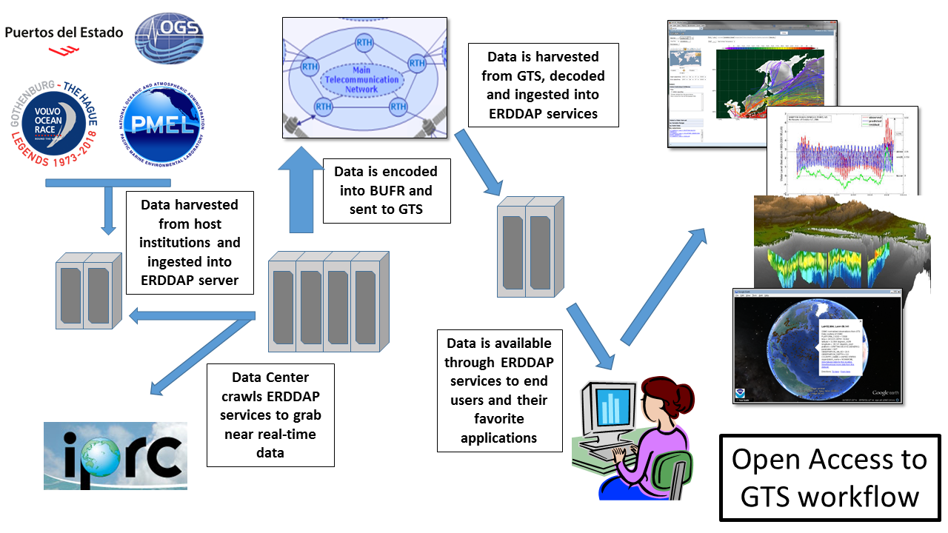

All available in situ observations from the marine environment as well as upper air observations are regarded as “essential” by the resolution 40 and thus they can be exchanged without charge and with no conditions on use

