WORLD WEATHER WATCH
COMMISSION FOR BASIC SYSTEMS
Ad hoc ICT-ISS  Paris, 19-21 May 2015 |  | ICT-ISS-2015-1/Final Report  DRAFT
 |  | 15 July 2015

Final report of the ad hoc meeting of ICT-ISS on WIS strategy
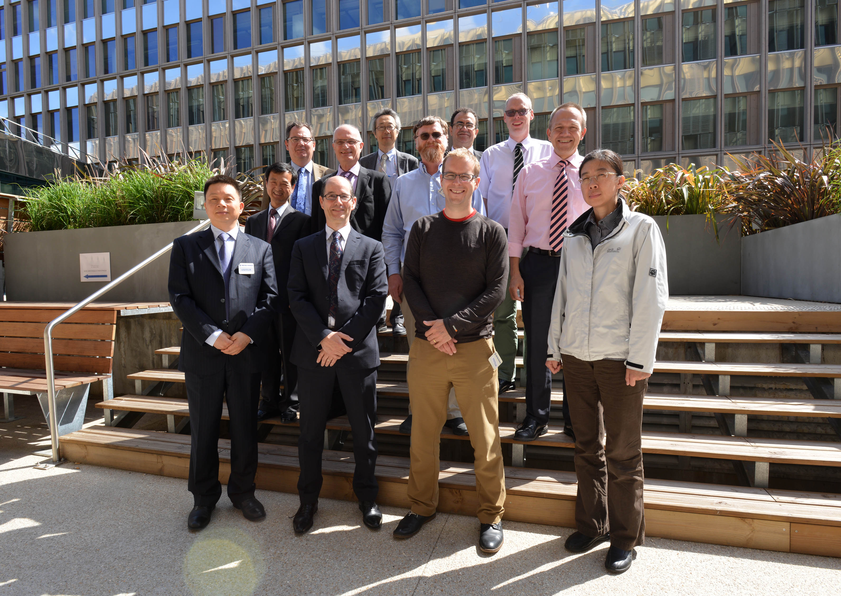

DISCLAIMER
Regulation 43
Recommendations of working groups shall have no status within the Organization until they have been approved by the responsible constituent body. In the case of joint working groups the recommendations must be concurred with by the presidents of the constituent bodies concerned before being submitted to the designated constituent body.
Regulation 44
In the case of a recommendation made by a working group between sessions of the responsible constituent body, either in a session of a working group or by correspondence, the president of the body may, as an exceptional measure, approve the recommendation on behalf of the constituent body when the matter is, in his opinion, urgent, and does not appear to imply new obligations for Members. He may then submit this recommendation for adoption by the Executive Council or to the President of the Organization for action in accordance with Regulation 9(5).
© World Meteorological Organization, 2015
The right of publication in print, electronic and any other form and in any language is reserved by WMO. Short extracts from WMO publications may be reproduced without authorization provided that the complete source is clearly indicated. Editorial correspondence and requests to publish, reproduce or translate this publication (articles) in part or in whole should be addressed to:
Chairperson, Publications Board
World Meteorological Organization (WMO)
7 bis, avenue de la Paix Tel.: +41 (0)22 730 84 03
P.O. Box No. 2300 Fax: +41 (0)22 730 80 40
CH-1211 Geneva 2, Switzerland E-mail: Publications@wmo.int

NOTE:
The designations employed in WMO publications and the presentation of material in this publication do not imply the expression of any opinion whatsoever on the part of the Secretariat of WMO concerning the legal status of any country, territory, city or area or of its authorities, or concerning the delimitation of its frontiers or boundaries.
Opinions expressed in WMO publications are those of the authors and do not necessarily reflect those of WMO. The mention of specific companies or products does not imply that they are endorsed or recommended by WMO in preference to others of a similar nature which are not mentioned or advertised.
This document (or report) is not an official publication of WMO and has not been subjected to its standard editorial procedures. The views expressed herein do not necessarily have the endorsement of the Organization

FINAL REPORT OF THE AD HOC MEETING OF ICT-ISS ON WIS STRATEGY

Executive Summary

1. Organization of the meeting

1.1. Welcome
- Mr dell’Acqua opened the meeting at 0915 and welcomed participants to Paris and Météo France. He stated that the purpose of the meeting was to propose the future direction to WIS to ensure that it meets the needs of the whole WMO community. He noted that all the GISCs have been endorsed by CBS. However, not all meteorological services were taking advantage of the WIS, often because they did not see the benefits of the WIS to them. ICT-ISS needed not only to provide the services, but also to provide the information needed for people to understand why the WIS was important to them. Further, not all Programmes were contributing information through the WIS. A new WIS strategy was needed to make sure that there was clarity on what WIS had to deliver for members.
- Mr Shi, Director WIS Branch, OBS Department, welcomed participants on behalf of the Secretary-General of WMO, and thanked Météo France for hosting the meeting. He noted that CBS Ext.(2014) had asked ICT-ISS to consider the strategic planning for WIS for the coming ten years. Since Cg-XVI, WIS had been given additional requirements from programmes other than the World Weather Watch. WIGOS (WMO Integrated Global Observing System) and GFCS (Global Framework for Climate Services) were creating new demands for sharing information in standard ways. Aviation and marine meteorology, hydrology and other WMO programmes were proposing new features for WIS so that WIS can better serve their needs. The meeting would not have time to create a full strategy, but it did need to identify the key issues to be addressed and how the strategy should be structured. He reminded participants that this was an ad hoc meeting to prepare for Inter-Commission meetings later in the year; one on traffic management and related matters, and the other on data management matters.

1.2. Adoption of the agenda
- The participants in the meeting are listed in Annex 1.
- Participants agreed the working agenda in Annex 2. Item 2.1 would be tackled on Thursday.
- Mr dell’Acqua commented that lifecycle data management was a critical issue for the future of the WIS. Although the NWP community was clear on its requirements and solutions to these, other communities had unresolved issues in information management throughout the lifecycle of information, from initial exchange to long term retention. The current meeting would need to provide strong guidance on the workshop to prepare for WIS Part C.

1.3. Working arrangements
- Working hours would be 0900 to 1730, with breaks in the morning and afternoon. Lunch break would an hour and a half starting at 1230.

2. Urgent issues for consideration by ICT-ISS

2.1. Escalation procedure for data representation errors
- ICT-ISS considered the proposed escalation procedure for resolving problems with messages represented using the Table Driven Code Forms (Doc 2). It clarified the time line for the procedures, and asked the Secretariat to publish the procedures.

2.2 TEMP messages recoded in BUFR
- NWP centres were unable to process upper air ascents that are translated from the individual parts of TEMP into separate BUFR messages. If centres producing this type of BUFR stop sending the TAC, then NWP centres say they would not be able to process the data, and thus the quality of forecasts would decrease.
- ICT-ISS agreed that it was highly desirable that high resolution upper air data are exchanged, but considered that it was more important to ensure that NWP centres were able to process the upper air information.
- Mr Qu noted that for many countries, even if the country had equipment that could be upgraded to create native high resolution BUFR, the country would need assistance to perform the upgrade. He recommended that centres that were unable to produce a single BUFR message should continue to issue upper air reports in TAC until that centre was able to create the single BUFR message.
- ICT-ISS noted that any Member producing BUFR by converting from TAC must already be producing TAC. Therefore, continuing dual transmission would not impose any significant cost on the Members concerned.
- ICT-ISS recommended that, instead of interventions by Members at Congress on the issue of upper air BUFR converted from TEMP, ICT-ISS would ask CBS Management Group to formally request Members that are unable to produce a single BUFR report containing the whole ascent to continue to transmit the TAC TEMP reports.
- Chair OPAG ISS will ask CBS Management Group to request that Members who could not produce a single BUFR message containing a whole upper air ascent to continue transmitting the TAC TEMP reports.
- ICT-ISS requested that IPET-DRMM provide guidance for the permanent resolution of the upper air BUFR issue.

3. Review of status of WIS

3.1. Implementation of required functionality
3. ICT-ISS considered the specifications of the functional architecture of the WIS as they were originally specified.

3.2. Assessment of effectiveness of WIS in meeting requirements
- ICT-ISS noted the requirements identified for the WIS in 2007, including those for data volumes and timeliness.
- Mr Tsunoda presented the results of monitoring the differing timeliness of delivery of tsunami warning messages to national tsunami focal points. Email had 80-90% success in reaching the end user; the GTS had improved from 35% to 85% over the period March 2011 to December 2013. Fax had about 45% success and SMS about 55% in reaching the user. Not all countries have connected their national focal point to the GTS; if such a connection were implemented the percent received would rise to closer to 100%. As a result of its greater prevalence, email delivery was more effective than the GTS. The main reason for lack of success of SMS and fax was failure to record and act on changes in the telephone numbers of the intended recipients. The delay of SMS messages was less than a minute; email and GTS had a similar delay of about 15 minutes. Mr Elliott showed GTS delays for satellite information (ATOVS). Although the delays in the GTS were adequate for standard data, the system was not fast enough for the warnings data to reach the end users on time.
- Mr Tsunoda also presented the data volumes handled by RTH Tokyo. In 2008, RTH Tokyo received 1.7 GBytes of data each day, and transmitted 1.2Gbytes. By 2015 this had increased to 9.1Gbytes received and 6.4 transmitted. He estimated that by 2020 the data volumes would have increased to 200-250%. 96% of the traffic was NWP and satellite data; these sources accounted for most of the increase in volume between 2014 and 2015. The same RTH provides GISC functionality, and registered users downloaded about 150 GBytes a day from the cache.
- It was clear from the difficulty in estimating the data volumes that the monitoring of the WIS was not yet adequate to allow capacity planning of the WIS. It was important to understand the data bandwidths required, and whether the structure of the WIS was driving unnecessary duplication of data transmission.
- There was a requirement for all GISCs to hold all data marked for global exchange. In practice, GISCs were using the GTS RTH transmission structure to achieve this and not using alternative techniques.
- Mr Giraud outlined the ET-CTS investigation of using cloud storage as a means of direct exchange of data between GISCs to avoid the n(n-1) distribution problem.
- The team created a working document on perceptions of the effectiveness of the WIS in order to inform further development of the strategy on the WIS.
- Developments in provision of weather services in countries were going in different directions. Some were involving the private sector in key infrastructure provision, while at the same time others were restricting meteorological services to the NMHS. This disparity meant that governance issues, particularly for access to data through the WIS and publication of data through the WIS, needed to be articulated more clearly in the future, and with this potentially came a need of greater granularity in the control over access.
- Increasingly map, feature and coverage services would be needed by users, even NMHS and users in the developing and least developed countries. Standardizing in how these are delivered would be of benefit, but it was likely to be premature to require such services to be provided as an integral part of WIS; rather, if these services were provided, they should be delivered according to the recommended practices. An example of where web services might be an integral (but optional) practice for WIS would be provision of services by DCPCs or NMHS to others (such as in the SWFDP). ICT-ISS noted that although providing such services through the WIS would deliver benefits, care would be needed to avoid placing requirements on Members that raised the perception of technical barriers to participation in WIS.
- WIS should support all NMHS and all WMO Programmes. The strategy had to include communicating the benefits of participating in WIS. It also had to address the scope of the intended user base for WIS.
- Ms Li would arrange for TT-GISC to exchange information on the contents of the global cache based on the example shown by Mr Qu during the meeting.

3.3. Functionality required but not yet scheduled for implementation
- ICT-ISS considered the functionality of the WIS that was not scheduled for implementation as part of the 2007 WIS implementation plan.

3.4 Priorities for implementing functionality
- ICT-ISS took account of missing functionality in the indicative architecture for WIS in the future that was produced during the meeting.

4. Future requirements for WIS

4.1. Known user requirements for WIS Part A and Part B
- ICT-ISS took note of the requirements for WIS that had been identified in Doc 7 as information that should guide the development of the strategy.

4.2. Known user requirements for WIS Part C
- ICT-ISS took note of the requirements for WIS that had been identified in Doc 8 as information that should guide the development of the strategy.

4.3. Gathering new and updated user requirements for WIS (Parts A, B and C)
- A workshop to be held in 2015 would include representatives of many WMO Programmes and would be used to update user requirements.
- The participants considered the requirements and status of WIS, and split into two groups to consider possible future designs of WIS.

5. Developing the strategy for WIS

5.1. Key issues to address in WIS strategy
- Mr Elliott demonstrated the EUMETSAT Product Navigator that has been used successfully to guide users to appropriate products.
- WMO Programmes needed to decide whether WIS should serve the general public as well as WIS centres.
- Mr Tsunoda presented the survey of WIS usage in Region II.
- Following the decision (D1) of the ICT-ISS teleconference on 11 February 2015, Mr Tsunoda introduced the concept of using a questionnaire to seek requirements from Programmes that could then be analysed to produce a unified set of requirements for WIS. Participants recognized that the outcomes of the Workshop on Information Access Enablers, held in Geneva, Switzerland, 17-18 May 2010, included user requirements.
- Participants noted that WIS metadata and associated discovery service were not efficient enough to find data. ICT-ISS concluded that this issue should be addressed in priority.
- Participants considered that an area of activity that had received less attention than needed was communicating the benefits of WIS and how to participate in the WIS. Participants concluded that the WIS National Focal Points should have greater involvement in this activity.
- The role definition of the WIS National Focal point should be updated to add “acting as a champion for WIS”.

5.2. Draft structure of WIS strategy
- Participants prepared an outline of the future WIS architecture to assist identification of what would be required in the WIS strategy. Participants also produced a working document with an outline of the structure of the WIS strategy document and allocated responsibilities for drafting sections of the document.
- Participants agreed on key improvements that were needed for WIS to provide a better service to its community and concluded that the 10 year strategy would have to be implemented step by step.

5.3. Finalization of the WIS strategy

Id | Outcome | By | Responsible
 | Brief President CBS on the progress with the Strategy | End Cg-17 | Dell’Acqua
 | Recommendations from workshop with all Programmes on Strategy; requirements, governance (IP-TT WIS) | November 2015 | dell’Acqua
 | “GISC monitoring day” to create reference statistics. | Before December 2015 | Li
 | Recommendations from workshop on WIS Part C (information management); requirements, what is in scope of WIS and what provided by Programmes through WIS, how Part C can be included in strategy | December 2015 | dell’Acqua
 | Technical assessments on how metadata might be indexed by search engines, how service metadata should work, how AMQP or event notification might be advertised in metadata. | December 2015 | Tandy
 | Drafting of “input” sections of strategy document (status, SWOT) to have provisional draft by a member of ICT-ISS | March 2016 | Sections to be allocated by dell’Acqua

- The strategy documents should only be available to members of ICT-ISS teams. Readers should be encouraged to pass any comments to Mr dell’Aqua. [Note: members of ICT-ISS can find the documents at http://wis.wmo.int/folder=175]
- During Cg-17, Mr dell’Acqua would brief President CBS on progress with the WIS strategy.

6. Work Plan for members of ICT-ISS
- The work plan for members of ICT-ISS had been identified during the discussions on earlier agenda items.

7. Any Other Business
- There was no other business.

8. Closure of meeting
- The meeting closed at 1600 on 21 May 2015. Mr dell’Aqua thanked participants for the work they contributed during the meeting. He noted the consensus on what is needed for WIS to better serve the WMO community. There was now a draft strategy that would be a good basis for the further development of the WIS strategy.

Action and Decision Summary

Actions
A1 Chair OPAG ISS will ask CBS Management Group to request that Members who could not produce a single BUFR message containing a whole upper air ascent to continue transmitting the TAC TEMP reports.
A2 ICT-ISS requested that IPET-DRMM provide guidance for the permanent resolution of the upper air BUFR issue.
A3 Ms Li would arrange for TT-GISC to exchange information on the contents of the global cache based on the example shown by Mr Qu during the meeting.
A4 During Cg-17, Mr dell’Acqua would brief President CBS on progress with the WIS strategy.

Decisions

D1 ICT-ISS recommended that, instead of interventions by Members at Congress on the issue of upper air BUFR converted from TEMP, ICT-ISS would ask CBS Management Group to formally request Members that are unable to produce a single BUFR report containing the whole ascent to continue to transmit the TAC TEMP reports.
D2 WMO Programmes needed to decide whether WIS should serve the general public as well as WIS centres.
D3 The role definition of the WIS National Focal point should be updated to add “acting as a champion for WIS”.

Annex 1: Participants in the meeting
Matteo DELL'ACQUA  (Chair)  Proposed by: France  Chair OPAG-ISS | Météo-France  42, avenue Gaspard Coriolis  31057 TOULOUSE CEDEX  France  Fax: (+33) 5 6107 8109  Tel: (+33) 5 6107 8124  Email: matteo.dellacqua@meteo.fr
Kenji TSUNODA  (Co-chair)  Proposed by: Japan  Co-chair-OPAG-ISS | Japan Meteorological Agency (JMA)  1-3-4 Otemachi, Chiyoda-ku  100-8122 TOKYO  Japan  Fax: +81-3 3211 8404  Tel: +81-3 3212 8341 ext. 3177  Email: tsunoda@met.kishou.go.jp
Xiang LI  (Core member)  Proposed by: China  Chair ET-WISC | China Meteorological Administration  46 Zhongguancun Nandajie  100081 BEIJING  China  Fax: +86 10 6218 6241  Tel: +86 10 6840 6275  Email: lixiang@cma.gov.cn
Simon ELLIOTT  (Core member)  Proposed by: EUMETSAT  Chair IPET-DRMM | EUMETSAT  EUMETSAT-Allee 1  D-64295 DARMSTADT  Germany  Fax: +49 6151 8073040  Tel: +49 6151 8073850  Email: simon.elliott@eumetsat.int
Remy GIRAUD  (Core member)  Proposed by: France  Chair ET-CTS | Météo-France  42, avenue Gaspard Coriolis  31057 TOULOUSE CEDEX  France  Tel: +33561078173  Mobile: +33779827985  Email: remy.giraud@meteo.fr
Jeremy TANDY  (Core member)  Proposed by: United Kingdom  Chair IPET-MDRD | Met Office  FitzRoy Road  EX1 3PB EXETER  Devon  United Kingdom of Great Britain and Northern Ireland  Fax: +44 870 900 5050  Tel: +44 1392 88 6584  Email: jeremy.tandy@metoffice.gov.uk
Weiqing QU  (Invited member)  Proposed by: Australia  Focal Point GISC Melbourne | Bureau of Meteorology  G.P.O. Box 1289  3001 MELBOURNE  VIC  Australia  Fax: +61 3 9669 4128  Tel: +61 3 9669 4236  Email: w.qu@bom.gov.au
Jose Mauro REZENDE  (Invited member)  Proposed by: Brazil  Focal Point GISC Brasilia | Instituto Nacional de Meteorología (INMET)  Eixo Monumental - Via S1  70680-900 BRASILIA  D.F.  Brazil  Fax: +55 61 2102 4621  Tel: +55 61 2102 4650  Email: jmauro.rezende@inmet.gov.br
Baudouin RAOULT  (Invited member)  Proposed by: ECMWF  Lead TT-CAC | ECMWF  Shinfield Park  RG2 9AX READING,  United Kingdom of Great Britain and Northern Ireland  Fax: +44 118 986 9450  Tel: +44 118 949 9404  Email: baudouin.raoult@ecmwf.int
Robert BUNGE  (Invited member)  Proposed by: United States  Focal Point GISC Washington | NOAA - National Weather Service  1325 East-West Highway  SILVER SPRING  MD 20910  United States of America  Fax: +1 (301) 608-1409  Tel: +1 (301) 713-0882 Ext 114  Email: robert.bunge@noaa.gov
Steve FOREMAN  (Secretariat)  Proposed by: WMO Secretariat | World Meteorological Organization  7 bis, avenue de la Paix  Case postale No. 2300  CH-1211 2 GENEVA  Switzerland  Fax: +41 22 730 8021  Tel: +41 22 730 8171  Email: sforeman@wmo.int
Peiliang SHI  (Secretariat)  Proposed by: WMO Secretariat | World Meteorological Organization  7 bis, avenue de la Paix  Case postale No. 2300  CH-1211 2 GENEVA  Switzerland  Fax: (+41 –22) 730-8021  Tel: (+41 –22) 730-8219  Email: pshi@wmo.int

Annex 2: Agenda for the meeting

Agenda item
1. Organization of the meeting
1.1 Welcome
1.2 Adoption of the agenda
1.3. Working arrangements
2. Urgent issues for consideration by ICT-ISS
2.1 Escalation procedure for data representation errors
3. Review of status of WIS
3.1 Implementation of required functionality
3.2 Assessment of effectiveness of WIS in meeting requirements
3.3 Functionality required but not yet scheduled for implementation
3.4 Priorities for implementing functionality
4. Future requirements for WIS
4.1 Known user requirements for WIS Part A and Part B
4.2 Known user requirements for WIS Part C
4.3 Gathering new and updated user requirements for WIS (Parts A, B and C)
5. Developing the strategy for WIS
5.1. Key issues to address in WIS strategy
5.2. Draft structure of WIS strategy
5.3. Finalization of the WIS strategy
6. Work Plan for members of ICT-ISS
7. Any Other Business
8. Closure of meeting

