|  |
| --- |
| WORLD METEOROLOGICAL ORGANIZATIONREGIONAL ASSOCIATION IV(North America, Central America and the Caribbean) |
|  |
|  |
| RA IVWIS IMPLEMENTATION PLAN |
| *2016-2017* |
|  |
|  |
|  |
|  |
| wmo_pp |
| DECEMBER 2015 |

## Version control

|  |  |  |  |
| --- | --- | --- | --- |
| ***Version*** | ***By*** | ***Date*** | ***Changes*** |
| 0.0 | WMO Secretariat | 04/12/2015 | Initial draft based on RA I WIS Implementation Plan. |
| 0.1 | Co-Chair Task Team | 08/12/2015 | Update initial draft to include RA IV matters |
| … |  |  |  |
| 1.0 |  |  |  |
| 1.1 |  |  |  |
| 1.2 |  |  |  |
|  |  |  |  |
|  |  |  |  |

\_\_\_\_\_\_\_\_\_\_

## Content

1. Executive Summary
2. Introduction
3. Scope and purpose of the RA IV WIS Implementation Plan
4. Description of WIS
   1. WIS Services
   2. The structure of WIS
   3. WIS Centres
   4. WIS data networks
   5. Benefits of WIS
   6. WMO information sources and regulations on WIS
5. WIS in Region IV (North America, Central America and the Caribbean)
   1. Current status of RA IV telecommunication
   2. WIS centres in RA IV
6. WIS planning and implementation by RA IV Members
   1. Pre-requisites for participation WIS operation by an NMHS as an NC
   2. Pre-requisites for participation of WIS operation by other centres
7. Challenges associated with WIS implementation in RA IV
   1. General WIS acceptance
   2. Lack of staff resources for operational WIS centre
   3. Discovery Metadata knowledge
   4. Adoption of new technologies at national level
8. RA IV WIS Implementation Plan – Execution and Timeline
   1. Approval
   2. Regional coordination and monitoring
   3. National Implementation Plans
   4. Capacity building – training and support
   5. Goals and timeline
   6. Progress and Performance Monitoring

**Appendices:**

Appendix I: Action Plan for implementing a NC in RA-IV under WIS

Appendix II: Action Plan for implementing a DCPC in RA-IV under WIS

Appendix III: Sample letters

Appendix IV: NC Demonstration Test Cases

Appendix V: List of acronyms

Appendix VI: Contact points for this plan

Appendix VII: WIS implementation monitoring

Appendix VIII: Terms of Reference of Focal Points

Appendix IX: Checklist of ICT related actions that might be considered in national plans to improve national ability to exchange and process information

## 1- Executive Summary

### Authority

The authority of this Plan is Resolution 3 (RA IV-16) which described the RA IV decision to give high priority to the implementation of WIS in the Region so that all Members may achieve at least basic WIS functionality by the Seventeenth Congress and full WIS implementation by the seventeenth session of RA IV. The plan was developed and being maintained by the RA IV Task Team on WIS/WIGOS which was tasked by Res 3 (RA VI-16) to establish as soon as possible a Regional WIS Implementation Plan to ensure that the initial functionality of WIS is achieved by all RA IV Members by 2016, with full implementation by the seventeenth session of the Regional Association.

### Purpose

This plan outlines how RA IV management group and Members will address the request of RA IV-16 to regularly review and update the Implementation Plan; to guide, oversee and monitor progress in implementation of the Plan to; submit amendments/updates to the Plan to the president of the Association for approval; coordinate with Members the implementation of the Regional Plan and to consult with the appropriate technical commissions on technical aspects of the implementation.

### Benefits of WIS

Benefits for the Member countries of WMO Regional Association IV (North America, Central America and the Caribbean) arising from the full implementation of WIS (the WMO Information system) will include:

* Continued and enhanced operation of the GTS (WMO's Global Telecommunication System) providing a reliable and timely collection and dissemination service for time-critical and operation-critical data and products;
* The GTS will continue to make better use of public communications such as the Internet where appropriate and supported by advanced satellite distribution systems;
* The GTS data management framework will continue to pursue fast and efficient coding practices and data representations;
* A new system of catalogues available through a Global Information System Centre (GISC) Washington portal, enabling online search, discovery and access of available data and products. This facilitates access to a much greater range of current and archived data and products;
* Easy access to GTS data and products published in the past 24 hours using browsers and other standard applications;
* Simplified processes for Member countries to update GTS routeing and to provide information about available data and products.

### RA IV WIS-IP

The RA IV WIS Implementation Plan (WIS-IP) is aimed at guiding RA IV Members to implement WIS functionality in their identified centres and to become effective WIS users in a timely and harmonized manner. Therefore, it concentrates on enablement of new WIS functionality by NMHSs as National Centres (NC), i.e. it focuses on helping the members of RA IV to set up WIS functionality in their National Centres (NC) connected to their principal GISC in the Region. Although the establishment of Data Collection or Production Centres (DCPC) has been mentioned briefly, the implementation detail is not covered by this document, because implementation procedures for DCPCs and WIS Demonstration Process are documented in the Manual on WIS[[1]](#footnote-2) and in “WIS Demonstration Procedures and Guidelines”[[2]](#footnote-3).

The WIS-IP outlines: the features of WIS; the benefits for Members to be connected to WIS; the current status of WIS in RA IV; the telecommunication network used for meteorological data and products; then goes on to describe steps for implementation in RA IV. The list of countries in RA IV together with their proposed principal GISC provides an overview of the structure of WIS after its regional implementation. The steps an NMHS has to take to function as a WIS NC are described in detail. The initial steps to establish a DCPC are also mentioned. Sample step-by-step implementation approach for these two cases is provided in the Appendices.

The goal is for most of the RA IV Members to be WIS enabled by the end of 2016.

Performance indicators for the initial implementation of WIS at an NMHS

1. A centre’s ability to edit and manage their GTS discovery metadata using GISC infrastructure
   1. Registered access to GISC for an NMHS
   2. At least basic training to allow maintenance of valid metadata for GTS records
   3. Can create valid discovery metadata for national products
2. NMHS has a working WIS Implementation Plan
   1. National WIS focal point
   2. Managerial sign off and commitment
   3. Have co-signed commitment between NMHS and principal GISC
   4. Include a working structure for managing the implementation plan
   5. Include a training programme or objectives/strategy
   6. Have an internal communication plan for WIS
3. NMHS should have a reliable internet access with sufficient capacity to work on GISC interface
   1. Bandwidth should be sufficient to allow smooth and quick response

Challenges associated with the WIS implementation in RA IV are identified, together with possible remedies. The plan recommends that RA IV forms a WIS implementation working group (WG-WIS) that includes representatives of the GISC Washington and National WIS Focal points lead by the co-chair of TT-WIS/WIGOS. Each Permanent Representative in RA IV has to nominate a national WIS Focal Point and an alternate who have the responsibility for coordinating the actions needed to deliver the WIS in their own country. Permanent Representatives must also confirm the GISC they wish to use as their principal GISC. The responsibilities of the WG-WIS in the WIS implementation monitoring are described with their importance for the successful implementation of the plan. The participation and cooperation of the national WIS Focal Points is stressed. The future activities to implement the plan are also listed.

Member countries and specifically their national WIS Focal Points are urged to maintain active collaboration with their principal GISC. For most RA IV countries the principal GISC is GISC Washington, some are with GISC Toulouse and one is with GISC Exeter. GISC contact details are provided in Appendix VI.

## 2. Introduction

In 2003, the World Meteorological Congress (Cg-14) stated that an overarching approach for solving the data management problems for all WMO and related international programmes, a single coordinated global infrastructure was required. This solution was named the WMO Information System (WIS) with the following features:

* WIS would be used for the collection and sharing of information for all WMO and related international programmes;
* WIS would provide a flexible and extensible structure allowing the participating centres to enhance their capabilities as their national and international responsibilities grow;
* Implementation of WIS should build upon the most successful components of existing WMO information systems in an evolutionary process;
* WIS development should pay special attention to a smooth and coordinated transition;
* The basis for the core communication network should be the communication links used within the World Weather Watch (WWW) for the high priority real-time data;
* WIS should utilize international industry standards for protocols, hardware and software.

Between Cg-14 (2003) and Cg-15 (2007), good progress was made in demonstrating the technological solutions for WIS through pilots and prototypes projects.

Cg-15 agreed that the WMO Information System should provide three fundamental types of services to meet the different requirements, as follows:

1. Routine collection and dissemination service for time-critical and operation-critical data and products;
2. Data discovery, access and retrieval service;
3. Timely delivery service for data and products.

Cg-15 also emphasized that the WIS implementation should build upon existing WMO information systems in a smooth and evolutionary process. It agreed that the WIS implementation plan should have two parts that would be developed in parallel:

* **Part A:** the continued consolidation and further improvements of the GTS for time-critical and operation-critical data, including its extension to meet operational requirements of WMO Programmes in addition to the World Weather Watch (including improved management of services);
* **Part B**: an extension of the information services through flexible data discovery, access and retrieval services to authorized users, as well as flexible timely delivery services.

Cg-15 further emphasized that the support and involvement of all NMHSs, including regional associations and technical commissions in the WIS development was a crucial factor for ensuring a successful implementation and a shared ownership of the system.

During the period 2007–2011, between Cg-15 and Cg-16, under the leadership of the CBS, the development of WIS progressed both in terms of technological solutions and preparation of regulatory and guidance material for its implementation. Thus, Cg-16 (2011) noted the significant progress achieved by Members in implementing WIS with 18 Members/organizations that had entered into the first round of the demonstration process for a total of 13 GISCs and 56 DCPCs (some of these centres had been in pre-operational mode since May 2010). Congress accepted the recommendation by CBS on the designation of the initial set of WIS centres. Congress requested that after the initial designation of WIS centres, further designations will be performed by EC in accordance with the Manual on WIS.

Cg-16 stated that WIS had moved from a development stage into an operational stage and advised Members and relevant international organizations that WIS activities in 2012-2015 should focus on:

1. Complete WIS implementation across all WMO Centres;
2. Capacity building to ensure support of all WMO Members;
3. Leveraging WIS advantages for all WMO Programmes; and
4. Taking advantage of WIS in all WMO Data Management.

Cg-16 became a turning point for intensive global, regional and national planning for the implementation of WIS and emphasized that although the implementation of the new functionality of WIS had been advanced in a few core centres, many Members were yet to begin their implementation. Cg-16 expected that the full implementation of WIS by all Members will take at least the whole of the 2012-2015 financial period.

Congress set-up the following major activities and implementation target dates, urging all Members and the Secretary-General to identify the necessary resources for reaching the objectives:

1. Improving the knowledge and capabilities of Members to benefit from WIS functionality, in particular least developed countries, developing countries and small island states through regional workshops and information sessions: 2012-2013;
2. Implementation of WIS at all NMHS national centres (NCs): 2012-2015;
3. Implementation of remaining candidate GISCs: 2012-2013;
4. Implementation of more DCPCs, i.e. WIS interfaces at WMO Programmes’ centres: 2012-2015;
5. Amendments to the Manual on WIS for enhanced operational arrangements of WIS centres, especially GISCs: 2014.

The introduction on WIS presented above showed that the implementation of WIS in the WMO community opened a new chapter for the global data exchange. The benefits for the Member countries of WMO Regional Association IV (North America, Central America and the Caribbean) arising from the full implementation of WIS will include:

* Continued and enhanced operation of the GTS (WMO's Global Telecommunication System) providing a reliable and timely collection and dissemination service for time-critical and operation-critical data and products;
* The GTS will make better use of public communications including the Internet where appropriate, and supported by advanced satellite distribution systems;
* The GTS data management framework will continue to pursue fast and efficient coding practices and data representations;
* A new system of catalogues available through a GISC portal, enabling online search, discovery and access of available data and products. This facilitates access to a much greater range of current and archived data and products;
* Download or re-runs of GTS data and products published in the past 24 hours;
* Simplified processes for Member countries to update GTS routing and provide information about available data and products.

The sixteenth session of Regional Association IV (RA IV-16) in April 2013 established the structure of RA IV as described in the following diagram (Figure 01).



Figure 1 RA IV Working Structure

As seen Figure 1, the Management Group included the following four task areas noting that WIS and WIGOS were key components to the other three areas. The task teams were:

* Task Team on WIS/WIGOS;
* Task Team on GFCS;
* Task Team on Aviation
* Task Team on Disaster Risk Reduction

TT-WIS/WIGOS comprised of nine regional experts, co-chaired by the British Caribbean Territories (BCT) and the USA. The Co-Chairs of the RA IV Task Team on WIS/WIGOS would report on progress to the Management Group at least on an annual basis. Membership of the TT is as follows:

* Co-Chairs:
  + Mr Glendell De Souza (BCT)
  + Mr Fred Branski (USA)
* Regional experts:
  + Mr Donald Simon (Antigua and Barbuda)
  + Mr Hugo Saavedra (Colombia)
  + Ms María Esther Suárez (Costa Rica)
  + Mr Dionicio Cordero (Dominican Republic)
  + Mr Bryan Thomas (Trinidad and Tobago)

The authority of this Plan came from Resolution 3 (RA IV-16) which described the RA IV decision to give high priority to the implementation of WIS in the Region, so that all Members may achieve at least basic WIS functionality by the Seventeenth Congress and full WIS implementation by the seventeenth session of RA IV. The plan was developed and being maintained by the RA IV Task Team on WIS/WIGOS which was tasked by Res 3 (RA VI-16) to establish as soon as possible a Regional WIS Implementation Plan to ensure that the initial functionality of WIS is achieved by all RA IV Members by 2016, with full implementation by the seventeenth session of the Regional Association.

This plan outlines how RA IV management group and Members will address the request of RA IV-16 to regularly review and update the Implementation Plan; to guide, oversee and monitor progress in implementation of the Plan; and to submit amendments/updates to the Plan to the president of the Association for approval; and to coordinate with Members the implementation of the Regional Plan and to consult with the appropriate technical commissions on technical aspects of the implementation.

RA IV-16 requested the GISCs supporting RA IV Members to take a leading role in ensuring all centres in their Area Meteorological Data Communication Network (AMDCN) are trained in the use of WIS functionality and able to create and manage discovery metadata. It also requested RA IV Members to review the list of centres that are part of WIS in other Regions and, where appropriate, in consultation with relevant technical commissions, to identify and register centres in their State or Territory as NCs and DCPCs in the WMO manual on WIS.

In conclusion, this RA IV WIS Implementation Plan is an all-inclusive guiding document for RA IV Members to follow in building an effective and efficient WIS infrastructure, in line with the guidance given by Cg-16 and RA IV-16 for a fast transition from development to implementation phase of the WIS.

## 3. Scope and purpose of RA I WIS Implementation Plan

The RA IV WIS Implementation Plan is aimed at guiding RA IV Members to implement WIS functionality in their identified centres and to become effective WIS users in a timely and harmonized manner. Therefore, it concentrates on enablement of new WIS functionality by NMHSs as National Centres (NC). Included in the scope of this plan is assisting Members to understand the benefits of WIS and convey these benefits to stakeholders.

Resolution 3 (RA IV-16) requested GISCs to take a lead in WIS implementation in the region. As such, GISCs supporting RA IV Members should establish close contacts with the NCs in their areas of responsibility. GISCs registered as principal GISCs in the Manual on WIS for RA IV are GISC Washington (32 NCs), GISC Toulouse (3 NCs) and GISC Exeter (1 NC). In particular, GISCs should act as “help desks” and provide assistance to build the capacity of the NCs to handle the required discovery metadata. Also, the plan states the standards for WIS compliance of NCs for the guidance of Members and their principal GISCs.

The regional dimension of the implementation process is addressed in this WIS-IP. This dimension is important because it facilitates a synchronized and coordinated implementation by all Members and partner organizations of the Region. The existing capacity gaps, both technical and human resource related, could be addressed through the cooperation and assistance mechanisms of the Regional Association, which would accelerate the implementation and bring the expected benefits to all Members.

The Plan also provides practical guidance and a step-by-step approach towards the WIS implementation by Members in their National Centres. A primary task for the NMHSs is ensuring compliance with the WIS requirements established by the WMO regulatory material *WMO Technical Regulations, Volume I (*WMO*-*No. 49*)* and its *Annex VII, Manual on the WMO Information System* (WMO-No. 1060).

## 4. Description of WIS

WIS is the global infrastructure for managing and making available weather, water and climate information. WIS meets the requirements for routine collection and automated dissemination of observed data and products, as well as data discovery, access and retrieval services for all weather, climate, water and related data and products provided by centres and Member countries in the framework of all WMO Programmes.

### 4.1 WIS Services

While WIS builds on and extends the GTS, it is also a new approach to data discovery and data provision in the meteorological community. WIS goes far beyond providing telecommunication services, and offers new and modern data management services to its users. These are essentially the possibility to discover all data and products of the wider WMO community, as well as the means and information on how to obtain the data. For this purpose, all information within WIS is described by discovery metadata in accordance to the WMO Metadata Core Profile. It is assumed that WIS by including the GTS and the Internet will have sufficient bandwidth/link capacity available to fulfil future user needs. To this end, WIS provides three types of services:

* + 1. **Routine collection and dissemination service for time-critical and operation-critical data and products:** This service is an extension of the current GTS. It is based on subscription to real-time “push and forward” distribution systems, including multicast and broadcast, and implemented mostly through dedicated telecommunication means providing a guaranteed quality of service. An important component of this service will be the “all hazards warning network” facilitating warnings to be distributed from one point in WIS to all other points within 2 minutes.
    2. **Service for the timely delivery of non time-critical, operationally critical or voluminous data and products:** This is a new service which allows users to subscribe to data that would not otherwise have been available through the GTS because it is too voluminous or because the delivery is not so critically time- or operationally- dependent. Thus, the delivery method for these data does not need to use the capacity of the GTS. It is also suitable for those users not connected to the GTS. The service is focused on a “push” mechanism and implemented mostly via public data-communication networks, such as the Internet. As with the time and operationally critical service (1), users may use the discovery service (3) to search for the information they would like to access or subscribe to.
    3. **Data Discovery, Access and Retrieval (DAR) service:** This is a new service where the user can use a variety of discovery services to search for data, products or other information registered within the WIS. Depending on the access policy for the data, the user may also access and download the data. The service is based on a request/reply “pull” mechanism and is to be implemented mainly through the Internet, but the user may also subscribe to receive data or products via the GTS or any other delivery mechanism available between the information provider and the user (for example via e-mail, SMS, facsimile, courier or postal services). In this way, WIS users can potentially discover and access all WMO data and products without having an extensive knowledge of the information practices and procedures of the WMO Programme responsible for the data or product. Note that if a user has an account at a GISC, then, depending on the data policy, it may be able to access information directly from the GISC, all of which hold information that is available for global exchange for at least 24 hours.

### 4.2 The structure of WIS

The WIS services described above are realized by WMO Members and associated centres through three types of WIS centres as well as the WIS data communication network. WIS centres need to be endorsed by WMO in accordance with the regulations described in the *WMO Technical Regulations* (WMO-No. 49) and the *Manual on WIS* (WMO-No. 1060).

The concept of interoperability guarantees that the overall functionality of WIS is realized by each WIS centre through implementing the specifications required for this type of centre. The four core components are:

* Global Information System Centres (GISC);
* Data Collection or Production Centres (DCPC);
* National Centres (NC);
* Data networks.

### 4.3 WIS Centres

**GISC**s collect and distribute information for routine global dissemination, such as GTS data. They serve as collection and distribution centres in their areas of responsibility and they provide access points for any request for data held within the WIS. A WIS user accessing the web portal of any GISC will be able to browse any data catalogue of information available in WIS.  
  
**DCPC**s are connected to the GISCs and are responsible for the collection or generation of specialized sets of data, forecast products, processed or value-added information beyond the scope of NCs, and/or for providing archiving services.

**NC**s collect, produce and distribute data and products on a national basis and coordinate or authorize the use of the WIS by national users, normally under a policy established by the respective Permanent Representative with WMO.

The terms NC, DCPC and GISC are used for describing the necessary functions, not actual organizational entities. There may be organizations, such as NMHSs, which combine all three functions within their structure. There may be several GISCs in a Regional Association. NCs and DCPCs can be associated with several GISCs but have to choose one of the GISCs as their principal GISC for the purposes of uploading and managing discovery metadata. The following diagram provides an overview of the various components:

*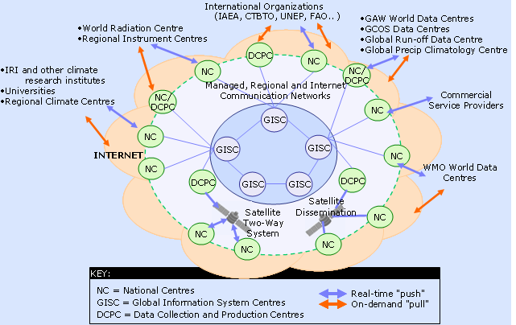*

*Figure 2: WIS core components and Information Exchange*

### 4.4WIS data networks

The WIS network structure consists of a WIS Core Network connecting all GISCs to each other. Each GISC has an Area Meteorological Data Communication Networks (AMDCN) connecting them to NCs and DCPCs in their area of responsibility. This is illustrated in Figure 3. An NC or DCPC may be in multiple AMDCNs. The AMDCNs incorporate GTS infrastructure and may involve single, partial or multiple regional meteorological telecommunication networks.

The data communication networks that can be used in WIS include:

* + The Main Telecommunication Network (MTN) of the GTS[[3]](#footnote-4) forms the WIS Core Network;
  + GISCs are also connected by the Internet, which presently is being used for discovery metadata synchronization;
  + The GTS (MTN and RMTN) provides the dedicated network component of the AMDCNs, especially for meeting real-time exchange requirements and the all hazards network. Note that the GTS includes extensive use of Internet through Virtual Private Networks (VPN) in many areas;
  + Satellite distribution systems such as those described by the Integrated Global Data Dissemination Service (IGDDS) form an essential part of the GTS and therefore the WIS, especially for the support of remote areas where terrestrial communication systems do not effectively meet the need. This includes data collection systems for remote platforms as well as for distribution of data and products related to the WMO Space Programme;
  + Terrestrial links or managed data network services;
  + The Internet, either open or utilizing VPN, which will be used in the AMDCNs to increase bandwidth capacity to many centres as well as providing connectivity for non-GTS centres and for individual users accessing WIS.

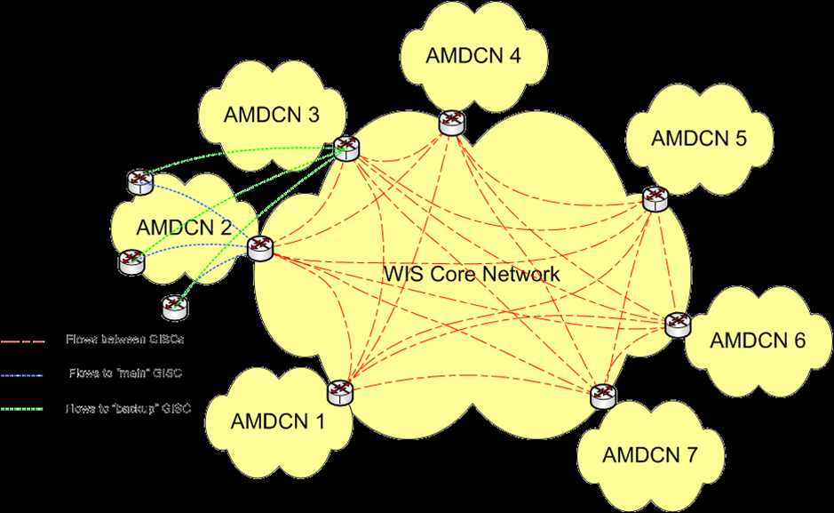

*Figure 3: WIS network topology*

### 4.5 Benefits of WIS

As an integral part of WIS under the World Weather Watch Programme (WWW), the aim of the GTS is to ensure delivery of time-critical and operation-critical data, products and services for all WMO Programmes, including warnings to and from NMHSs. GTS realizes this through the "Routine collection and dissemination service for time-critical and operation-critical data and products", mentioned above.

The GTS will continue to develop and incorporate new technology, linking all WMO Members with a dedicated, secure network. This network will continue to be supported by advanced satellite distribution systems. In addition, the GTS will also be able to supplement the private networks and make better use of public communications such as the Internet, where appropriate.

The GTS data management framework will include the development of data representations, including fast and efficient coding practices that allow increasingly voluminous data streams to reach countries with less advanced or low capacity communication systems. New functionality of WIS for GTS users will include:

* Online discovery of which data and products are available on the GTS by interactively accessing a GISC portal;
* Download or re-runs of GTS data and products published during the past 24 hours. This is of interest for users that have missed data because of a failure of IT systems, equipment or networks;
* Updating of GTS routeing based on online subscription services rather than service messages requesting the GTS Point of Contacts to change the routeing. An NMHS may configure its own routeing information. Thus, a centre needs only deal with its associated GISC for changing subscription and publishing schedules;
* Configure upload of data to the GTS. Rather than requesting the GTS Point of Contact and WMO to change information about the data that is uploaded to the GTS, the NMHS may do the configuration;
* Ensure that the ownership and availability of the data provided is advertised by using the DAR metadata.

Existing centres within WMO Member States that comply with the required WIS functions and technical specifications will be designated as one of the three types of WIS centre. While Members can choose to apply for a type of centre matching their level of responsibilities and commitment, the expected mapping of WWW centres into WIS centres remains to be:

|  |  |
| --- | --- |
| **WWW Centre** | **WIS Centre** |
| NMC | NC |
| RSMC | DCPC |
| WMC | DCPC and/or GISC |
| RTH | DCPC |
| RTH on MTN | DCPC and/or GISC |
| Others | NC and/or DCPC |

### 4.6 WMO information sources and regulations on WIS

Information on all aspects of WIS is available on the WMO website at: <http://www.wmo.int/wis>

The implementation of the WIS is coordinated through a Global Project and Implementation Plan available at: <http://www.wmo.int/pages/prog/www/WIS/documents/WIS-ProjectPlan-v1-2-1.doc>.

The technical regulations related to WIS are published in the *WMO Technical Regulations* (WMO‑No. 49), Volume 1, General Meteorological Standards and Recommended Practices, Part I, Section 3, and in Annex VII, *Manual on the WMO Information System* (WMO-No. 1060). Practical guidance on the implementation of the technical regulations is provided in the *Guide to the WMO Information System* (WMO-No. 1061).

## 5. WIS in Region IV (North America, Central America and the Caribbean)

### 5.1 Current status of RA IV regional meteorological telecommunication network (RMTN)

The current RMTN in RA IV is provided by the US National Weather Service "International Services and Communication Systems" (ISCS). See <http://www.nws.noaa.gov/iscs/>. This is a collective group of message dissemination systems used to provide weather, water and climate information to segments of the WMO international community as described in the Manual on the GTS (WMO No. 386). The ISCS systems provide service to RA-IV and are managed by the US National Weather Service (NWS) Dissemination Systems Branch (W/OPS17); they include:

* GTS Internet File Service (GIFS)
* GeoNetCast - Americas (GNC-A)
* Emergency Managers Weather Information Network (EMWIN)

ISCS systems are an integral part of the RA-IV Regional Meteorological Telecommunications Network (RMTN), which focuses on the timely collection and delivery of both time-critical and routine watches, warnings, observations and forecasts.

Additional telecommunication systems are identified as part of the RA-IV RMTN which supplement the capabilities of the ISCS systems for the exchange of messages. These other systems include:

* Secure Socket Layer Virtual Private Network (SSL VPN) / NWSTG FTP Ingest Server [RTH Washington System]
* Email Data Input Service (EDIS) [RTH Washington System]
* WAFS Internet File Service (WIFS) receive service [WAFC Washington System (FAA/ICAO)].

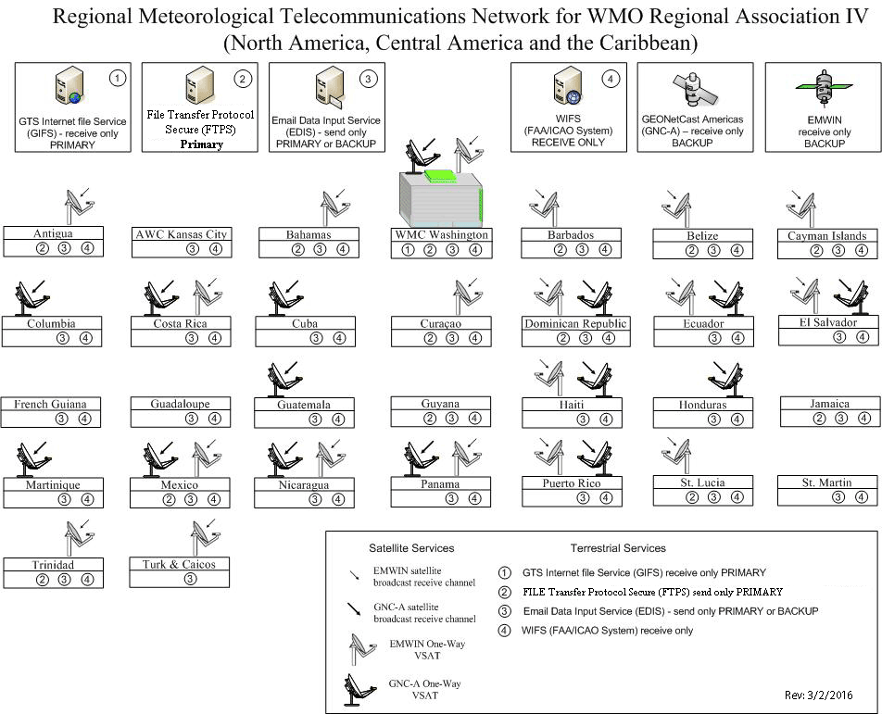

*Figure 4: RMTN in RA IV*

Connecting RA IV to the rest of the world is through the WIS Core Network from WMC Washington as shown in Figure 5. The MTN connectivity is primarily via Toyko, Melbourne and Exeter, although the WIS Core Network connects GISC Washington to all other GISCs

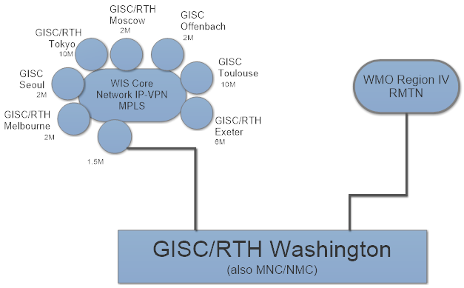

Figure 5 Connectivity Diagram WIS Core Network to RA IV

Table 1 shows GTS access speeds for Members’ centres. WIS links are still to be added as a part of the WIS implementation plan process. GISC Washington will provide the primary gateway from RA IV to the WIS Core Network.

| **Country** | **Centre location** | **Link Bandwidth** | **Link Type & Protocol** | **Internet Bandwidth** | **GISC** |
| --- | --- | --- | --- | --- | --- |
| **Caribbean** |  |  |  |  |  |
| 1. Antigua and Barbuda | St. John's | 1Gbps | FTPS | 7 Mbps | Washington |
| 2. Aruba | |  | | --- | | Oranjestad | | 1Gbps | FTPS | 150 Mbps | Washington | |
| 3. Bahamas | Nassau | 1Gbps | FTPS | 11 Mbps | Washington |
| 4. Barbados (Met Service) | Christ Church | 1Gbps | FTPS | 40 Mbps | Washington |
| 5. Barbados (CIMH) | St. James | 1Gbps | FTPS | 20 Mbps | Washington |
| 6. Cayman Islands | George Town | 1Gbps | FTPS | 4.6 Mbps | Washington |
| 7. Cuba (Met Service) | Havana | 1Gbps | EDIS (HTTP) | 1 Mbps | Washington |
| 8. Curacao | Seru Mahuma | 1Gbps | FTPS | 20 Mbps | Washington |
| 9. Dominica | Melville Hall | 1Gbps | EDIS (HTTP) | 2 Mbps | Washington |
| 10. Dominican Republic | Santo Domingo | 1Gbps | EDIS (HTTP) | 2 Mbps | Washington |
| 11. Grenada | True Blue | 1Gbps | FTPS | 30 Mbps | Washington |
| 12. Guadeloupe | Point-à-Pitre | 1Gbps | FTPS | 2 Mbps | Toulouse |
| 13. Haiti | Port-au-Prince | 1Gbps | EDIS (HTTP) | 2 Mbps | Washington |
| 14. Jamaica | Kingston | 1Gbps | FTPS | 12 Mbps | Washington |
| 15. Martinique | Le Lamentin | 1Gbps | FTPS | 2 Mbps | Toulouse |
| 16. Saint Lucia | Vieux Fort | 1Gbps | FTPS | 4 Mbps | Washington |
| 17. Sint Maarten | Simpson Bay | 1Gbps | FTPS | 10 Mbps | Washington |
| 18. Trinidad & Tobago | Piarco | 1Gbps | FTPS | 10 Mbps | Washington |
|  |  |  |  |  |  |
|  |  |  |  |  |  |
| **Central America** |  |  |  |  |  |
| 19. Belize | Ladyville | 1Gbps | FTPS | 21 Mbps | Washington |
| 20. Costa Rica | San José | 1Gbps | FTPS | 30 Mbps | Washington |
| 21. El Salvador | San Salvador | 1Gbps | FTPS | 2 Mbps | Washington |
| 22. Guatemala | Guatemala City | 1Gbps | EDIS (HTTP) |  | Washington |
| 23. Honduras | Tegucigalpa | 1Gbps | FTPS | 10 Mbps | Washington |
| 24. Mexico (Met Service) | Mexico City | 1Gbps | FTPS | 39.5 Mbps | Washington |
| 25. Nicaragua | Managua | 1Gbps | EDIS (HTTP) |  | Washington |
| 26. Panama | Panama City | 1Gbps | FTPS | 20 Mbps | Washington |
|  |  |  |  |  |  |
| **South America** |  |  |  |  |  |
| 27. Columbia | Bogota | 1Gbps | EDIS(HTTP) | 128Mbps | Washington |
| 28. French Guiana | Rochambeau | 1Gbps | FTPS | 2Mbps | Toulouse |
| 29. Guyana | Timehri | 1Gbps | FTPS | 5Mbps | Washington |
|  |  |  |  |  |  |
|  |  |  |  |  |  |
| **North America** |  |  |  |  |  |
| 31. Canada | Dorval |  | **Metadata** services: HTTP / OAI / PMH harvesting **Operational** data traffic: SFTP, with some AMQP | I Gbps | Washington |
| 32. United Kingdom (Bermuda) | St David | 1Gbps | FTPS | 20 Mbps | Washington |
| 33. United States of America | Silver Springs Washington DC | 1Gbps | FTPS | 1 Gbps | Washington |

Table 1 Network connection and bandwidth for RA IV centres

### 5.2 Status of WIS Centres in Region IV (North America, Central America and the Caribbean)

The procedures for the designation of the three types of WIS centres are provided in the *Manual on WIS* (WMO-No. 1060), Part II. After successful completion of the designation procedure, the centre is included in Appendix B to the Manual, Approved WMO Information System Centres.

*Note: Information on the current status of the designation of centres by Members is available on:* [*http://wis.wmo.int/WIScentresDb*](http://wis.wmo.int/WIScentresDb)*.*

1. **GISCs used by centres in RA IV**

GISC Washington is the only GISC located within Region IV and is the principal GISCs for most centres in the Region. GISCs Toulouse and Exeter are also Principal GISCs for some centres in RA IV. All are operational.

1. **DCPCs in RA IV**

Table 2 below provides information on the DCPCs in RA-IV with their planned functions and designation status (as of July 2014). For DCPCs to complete their registration in the Manual on the WIS, it is necessary for them to work with their GISC and the CBS Task Team on Centre Audits and Certification in order to demonstrate their compliance with the WIS Manual as described in the Manual on WIS and in the Demonstration Guidelines.

| [**Member/ Org**](http://www.wmo.int/pages/prog/www/WIS/centres/index_en.php?sortBy=countryName&sortAsc=true) | **DCPC** [**Function**](http://www.wmo.int/pages/prog/www/WIS/centres/index_en.php?sortBy=centreName&sortAsc=true) | [**Principal GISC**](http://www.wmo.int/pages/prog/www/WIS/centres/index_en.php?sortBy=centreGisc&sortAsc=true) | [**Const. Body**](http://www.wmo.int/pages/prog/www/WIS/centres/index_en.php?sortBy=TCorBODYnew&sortAsc=true) | [**Endorsement CBS**](http://www.wmo.int/pages/prog/www/WIS/centres/index_en.php?sortBy=CBS&sortAsc=true) | [**Congress/ EC**](http://www.wmo.int/pages/prog/www/WIS/centres/index_en.php?sortBy=CGEC&sortAsc=cgec) |
| --- | --- | --- | --- | --- | --- |
| Canada | [RSMC-Activity-ATM](http://weather.gc.ca/) | Washington | CBS | Approved by Cg/EC | 01/06/2011 |
| USA | [WMC (Washington)](http://www.nws.noaa.gov/tg/) | Washington | CBS | Approved by Cg/EC | 01/06/2011 |
| USA | [WAFC (Washington)](http://www.nws.noaa.gov/tg/metarwfs.php) | Washington | CAeM | Not submitted to TT-CAC | 01/06/2011 |
| USA | [RSMC-Activity-TC (Miami)](http://www.nhc.noaa.gov/?) | Washington | CBS | Not submitted to TT-CAC |  |
| USA | [RSMC-Activity-TC (Honolulu)](http://www.prh.noaa.gov/hnl/cphc/) | Washington | CBS | Not submitted to TT-CAC |  |
| USA | [WAFC (Washington)](http://www.nws.noaa.gov/tg/metarwfs.php) | Washington | CAeM | Not submitted to TT-CAC | 01/06/2011 |
| USA | RSMC-Activity-ATM | Washington | CBS | Not submitted to TT-CAC | 01/06/2011 |
| USA | [RMSC-Geographical / NESDIS](http://www.nesdis.noaa.gov/) | Washington | CBS | Not submitted to TT-CAC | 01/06/2011 |
| USA | [NODC](http://www.nodc.noaa.gov/) | Washington | JCOMM | Not submitted to TT-CAC | 01/06/2011 |
| USA | [NGDC](http://www.ngdc.noaa.gov/ngdc.html) | Washington | CBS | Not submitted to TT-CAC | 01/06/2011 |
| USA | [NCEP](http://www.ncep.noaa.gov/) | Washington | CBS | Under review by TT-CAC |  |
| USA | [NCAR](http://ncar.ucar.edu/) | Washington | CBS | Under review by TT-CAC | 01/06/2011 |
| USA | GPC/LC-LRFMME | Washington | CBS | Not submitted to TT-CAC | 01/06/2011 |
| USA | [GOSIC](http://gosic.org/) | Washington | CCl | Not submitted to TT-CAC | 01/06/2011 |
| USA | [COMET](http://www.comet.ucar.edu/) | Washington | EC-Pan-ET | Under review by TT-CAC |  |
| USA | [Air Resources Laboratory (ARL)](http://www.arl.noaa.gov/) | Washington | CBS | Under review by TT-CAC |  |

Table 2 DCPCs in RA I

**NCs in RA IV**

In accordance with the *Manual on WIS* (WMO-No. 1060), each WMO Member shall notify the WMO Secretariat of the name and location of its centre(s) that are to be designated as NC(s). It is therefore expected that each Member will have at least one NC in WIS.

In February 2012, WMO circulated a letter to all Members inquiring information from the Permanent Representatives regarding: (1) nomination of a principle GISC which will be associated with the WIS centre(s) of the Member; and (2) nomination of a focal point for WIS/GTS related matters).

Table 3 below presents the current status[[4]](#footnote-5) of the designation of NCs in RA-IV with their Principal GISC and Focal Points.

Table 3 RA IV NCs

| **Member/Org** | **Function** | **Principal GISC** | **PR letter** | **Focal Point (FP)** | **FP confirmed to WMO** |
| --- | --- | --- | --- | --- | --- |
| [Antigua and Barbuda](http://www.antiguamet.com/) | [NMC](http://www.antiguamet.com/) | Washington | Yes | Donald Simon | Yes |
| [Aruba](http://www.meteo.aw) | [NMC](http://www.meteo.aw) | Washington | Yes | Marck Oduber | Yes |
| [Bahamas](http://www.bahamasweather.org.bs/) | [NMC](http://www.bahamasweather.org.bs) | Washington |  | Jeffery Simmons |  |
| [Barbados](http://www.barbadosweather.org/) | [NMC](http://www.barbadosweather.org/) | Washington | Yes | Clairmonte Williams | Yes |
| [Belize](http://www.hydromet.gov.bz/) | [NMC](http://www.hydromet.gov.bz/) | Washington | Yes | Roy Thompson | Yes |
| [British Caribbean Territories](http://www.cmo.org.tt/) | WSO (Turks and Caicos Islands) | Washington | Yes | Kerry Powery | Yes |
| [British Caribbean Territories](http://www.cmo.org.tt/) | WSO (Montserrat) | Washington | Yes | Kerry Powery | Yes |
| [British Caribbean Territories](http://www.cmo.org.tt/) | WSO (British Virgin Islands) | Washington | Yes | Kerry Powery | Yes |
| [British Caribbean Territories](http://www.cmo.org.tt/) | WSO (Anguilla) | Washington | Yes | Kerry Powery | Yes |
| [British Caribbean Territories](http://www.cmo.org.tt/) | NMC ([Cayman Islands](http://www.weather.gov.ky/portal/page/portal/nwshome)) | Washington | Yes | Kerry Powery | Yes |
| [Canada](http://www.ec.gc.ca/meteo-weather) | [NMC](http://weather.gc.ca/) | Washington | Yes | Alexandre Leroux | Yes |
| [Costa Rica](http://www.imn.ac.cr/) | [NMC](http://www.imn.ac.cr/) | Washington | Yes | Maria Esther Suarez Baltodano | Yes |
| [Cuba](http://www.insmet.cu/asp/genesis.asp?TB0=PLANTILLAS&TB1=INICIAL) | [NMC](http://www.insmet.cu/asp/genesis.asp?TB0=PLANTILLAS&TB1=INICIAL) | Washington | Ye | Luciano Amaro | Yes |
| [Curacao](http://www.meteo.cw/) and [Sint. Maarten](http://www.meteosxm.com/) | NMC | Washington | Yes | Haime Pieter (Curacao)  Carshena Gordon (S.M.) | Yes |
| [Dominica](http://www.weather.gov.dm/) | [NMC](http://www.weather.gov.dm/) | Washington | Yes | Fitzroy Pascal | Yes |
| [Dominican Republic](http://www.onamet.gov.do/) | [NMC](http://www.onamet.gov.do/) | Washington | Yes | Orlando Severino | Yes |
| [Dominican Republic](http://www.onamet.gov.do/) | NHS | Washington |  |  |  |
| [El Salvador](http://www.snet.gob.sv/) | [NMC](http://www.snet.gob.sv/) | Washington | Yes | Edwin Santiago Escobar Rivas | Yes |
| [France](http://www.meteo.fr/) | WSO (St. Pierre And Miquelon) | Toulouse | Yes | Jacques Anquetil | Yes |
| [France](http://www.meteo.fr/) | [WSO (Martinique)](http://www.meteofrance.gp/) | Toulouse | Yes | Jacques Anquetil | Yes |
| [France](http://www.meteo.fr/) | [WSO (Guadeloupe, St. Martin, St. Barthelemy](http://www.meteofrance.gp/)) | Toulouse | Yes | Jacques Anquetil | Yes |
| [Guatemala](http://www.insivumeh.gob.gt/) | [NMC](http://www.insivumeh.gob.gt/) | Washington | Ye | Paris Rivera | Yes |
| [Haiti](http://www.meteo-haiti.gouv.ht/) | [NMC](http://www.meteo-haiti.gouv.ht/) | Washington | No | Esterlin Marcelin | No |
| [Honduras](http://www.smn.gob.hn/) | [NMC](http://www.smn.gob.hn/) | Washington | Yes | Emerson Gomez | Yes |
| [Jamaica](http://www.metservice.gov.jm/) | [NMC](http://www.metservice.gov.jm/) | Washington | Yes | Lawrence Brown | Yes |
| [Mexico](http://smn.cna.gob.mx/) | [NMC](http://smn.cna.gob.mx/) | Washington | No | Jorge Bustamante  Romero; **Alternate**  Gloria Herrera Vazquez | Yes |
| [Netherlands](http://www.knmi.nl/) | [WSO Bonaire, Saba & Sint Eustatius](http://www.knmidc.org/) | Exeter | Yes | [Mr NOTEBOOM Jan Willem](mailto:janwillem.noteboom@knmi.nl) | Yes |
| [Nicaragua](http://www.ineter.gob.ni/Direcciones/meteorologia/meteorologia.htm) | [NMC](http://www.ineter.gob.ni/) | Washington | Yes | Marcio Baca | Yes |
| [Panama](http://www.hidromet.com.pa/) | [NMC](http://www.hidromet.com.pa/) | Washington | Yes | Alberto Cumbrera | Yes |
| [Saint Lucia](http://www.slumet.gov.lc/) | NMC | Washington |  | Venantius Descartes | Yes |
| [Trinidad and Tobago](http://www.metoffice.gov.tt/met/d7/) | [NMC](http://www.metoffice.gov.tt/) | Washington | Yes | Bryan Thomas | Yes |
| [UK](http://www.metoffice.gov.uk/) | [WSO (Bermuda)](http://www.weather.bm) | Exeter | Yes | Ian Curie | Yes |
| [United States of America](http://www.weather.gov/) | [NMC](http://www.weather.gov/) | Washington | Yes | Robert Bunge | Yes |

***Note:*** *In view of the important role the national WIS focal points plays in the coordination of the WIS implementation, the Members who have not yet responded to the WMO circular letter are strongly encouraged to do soon as soon as possible. Members should also keep the WMO Secretariat Regional Office for the Americas and the WIS Branch (Geneva) informed of any changes of the status and operation of their centres and/or changes of their focal points information.*

## 6. WIS planning and implementation by RA IV Members

In planning the WIS implementation at national level, Members should strive to comply with the relevant WMO technical regulations, that include procedures, specifications and functional requirements, provided in the *WMO Technical Regulations* (WMO-No. 49),Volume I, Part 1,Section 3, and the *Manual on WIS* (WMO-No. 1060). The *Guide to WIS* (WMO-No. 1061) complements the technical regulations with additional description and explanation of the WIS, which would assist Members in their implementation actions.

### 6.1 Pre-requisites for participate WIS operation by an NMHS as NC

For an NMHS, there are several requirements to be met by a current GTS centre and thus become a compliant NC. They are mostly concerned with administrative issues and less with technical matters.

When a centre implements compliance with WIS, the PR of the country should nominate a “WIS Focal Point” and a “Principal GISC”.

1. **WIS Focal point**

The National WIS Focal[[5]](#footnote-6) point should be a member of staff who is familiar with the telecommunications and information provision in the country and other topics in the Terms of Reference for the WIS Focal Point (see [Appendix VIII](#_Appendix_VIII._Terms)), and in particular the current GTS support. Within Region IV it is considered good practice to nominate an alternate WIS Focal Point as well to help maintain organizational memory. The person will receive all WIS related information with regard to the country on one hand, but is expected on the other hand to inform WMO and its relevant bodies about any progress or problems encountered when using WIS. He/she will attend training courses organized by WMO or WIS centres and serve as the national distributor of WIS knowledge, in particular the concept of metadata. It is envisaged that the national WIS Focal point will provide the necessary monitoring information.

Since the structure of WIS assumes that an NC is connected to a GISC for its WIS functions and thus participates in the AMDCN organized by that GISC, it is necessary to set up the required administrative links with the GISC. In principle, an NC may belong to the users of any GISC, unless the network connectivity only allows one choice. In any case, an agreement should be reached between the NC and the GISC about their relationship, including identifying their “Principal GISC” for the purposes of managing discovery metadata, of which the WMO should be notified together with the nomination of the WIS Focal point (see [Appendix III](#_APPENDIX_III_)).

For users who want to access GISC system for services and request an account on the GISC system, the GISC is required to seek permission from the national WIS Focal Point of the country where the users are from.

1. **Principal GISC**

The principal GISC will ensure within its AMDCN that all connected centres will receive all the data meant for them, be it globally distributed, additional or addressed data. The principal GISC will also collect the data sent by NCs and distribute them in accordance with GTS/WIS regulations. It will maintain the global metadata catalogue and provide means for its AMDCN centres to create/update those parts of the discovery metadata catalogue describing their own data and products, possibly via Internet access.

The principal GISC is to be contacted first by any of its connected centres about any issue related to WIS. It will organize regular meetings with the WIS Focal Points of the centres belonging to its AMDCN and provide training material and courses as required. It will support the metadata activities in its area of responsibility in a suitable manner and provide data for the regional WIS monitoring.

Member countries and specifically their national WIS Focal Points are urged to maintain active collaboration with their principal GISC. For many RA IV countries the principal GISC is GISC Washington. Contact details for GISC Washington, Toulouse and Exeter are provided in [Appendix VI](#_Appendix_VI._Contact).

Each GISC is required to have a back-up GISC for operational continuity in case the partial or total failure of the principal GISC. To guarantee at least the dissemination and collection of the globally distributed GTS data, the principal GISC need to consider a communication connection being established between NCs and the backup GISC, in collaboration with the NC and the backup GISC. Agreement needs to be reached on the network specific details, the conditions when it should be used and the actual services provided by it. The primary role of the backup GISC is to ensure data and products continue to be collected and distributed within RA IV and shared with other Regions. Regular tests should be carried out to ensure the availability of the back-up when suddenly required. Details of further back-up arrangements to be provided still need further work by the relevant CBS WIS expert teams. The backup GISCs for Washington, Toulouse and Exeter will be formalized in regards to RA IV centres, and the GISCs will inform NCs that have designated them as Principal GISC of the decision so that the NCs can make the appropriate arrangements with the backup GISCs.

**Connectivity**

RA IV Members are connected to RTH Washington using a variety of methods. These are shown in Figure 4. National telecommunications networks vary between Members of RA IV, using fixed line, GSM and some DCP services. Other services such as EMWIN also have an important role in the region.

1. **Bandwidth**

The GTS in RA IV has been steadily improving through various updates of technology made possible through NOAA. However, the capacity in the form of access speed and bandwidth, as well as access to the Internet is varied. Current access speeds are recorded in Table 1 maintained by the TT-WIS/WIGOS.

1. **Discovery Metadata**

Whereas the GTS data is defined by its header which is recorded in the relevant volumes of WMO No. 9, the data in WIS is described by a discovery metadata record in accordance to the WMO Metadata Core Profile and is stored in a metadata catalogue of the data owner’s principal GISC and shared amongst all GISCs at regular intervals. It is the responsibility of the data owner to generate the corresponding discovery metadata record and to maintain it. However, in order to facilitate the initial deployment of WIS, Météo-France generated metadata records for all data currently exchanged via the GTS. In the longer term though, these initial records have to be taken over by the relevant data owners and updated if required. In addition, if any new data is being considered for exchange, a corresponding discovery metadata record has to be generated and sent to the principal GISC in advance of the data.

Each NC, therefore, requires personnel with metadata knowledge and responsibility. To train the staff of NCs in discovery metadata handling, their principal GISC will offer regular training courses in addition to WMO sponsored training events likethe WMO WIS Centre Jump-Start Offer[[6]](#footnote-7). Each NC should make sure that staff are knowledgeable about the WMO Metadata Core Profile and are able to update its metadata records.

1. **Access to metadata editor**

The editor for metadata records consists of a software tool which can be used locally by an NC or remotely at a GISC which makes this service available to NCs. New or modified records have to be made available to the principal GISC for feeding them into the WIS.

1. **Demonstration of WIS Compliance**

A National Centre will need to demonstrate its compliance with WIS standards as laid out in the Manual on WIS. This is achieved by the centre working with the principal GISC to successfully complete the three test cases in [Appendix IV](#App4) and advising the WMO secretariat that the GISC has endorsed the centre as having demonstrated its compliance with relevant WIS standards.

### 6.1 Pre-requisites for participation of WIS operation by other centres

There may be other WIS centres besides the NC of an NMHS within a country. For example, the NMHS might also operate one or more DCPCs for specialized data or there may be multiple DCPCs run by different organizations like hydrology and oceanographic centres. It is also possible, with the permission of the PR, for a centre other than the NMHS to operate an NC.

1. **DCPC**

As stated earlier, a DCPC is the WIS categorization of a programme centre that provides programme-specific data, e.g. An RTH is a centre supporting the GTS, or a RSMC providing specialize products under the GDPFS. Therefore, it has to be sponsored by a WMO Programme . As for all WIS centres, it has to be associated with a principal GISC. In addition, special software to support the WIS functions of the centre has to be implemented, and have sufficient bandwidth to deliver its products to the users. Once this has been achieved, the relevant PR and centre director may submit a proposal to WMO for the DCPC to be accepted, nominating a staff member responsible and stating the commitment to operate the DCPC after its validation.

In accordance with the Manual on WIS, a number of certifications and tests by WMO and, in particular, the CBS expert team (TT-CAC) designated for this role, will subsequently be carried out. When all operational and administrative requirements have been met successfully, including the handling of metadata in accordance with WMO Metadata Core Profile, CBS will propose to the EC that the DCPC becomes part of WIS.

1. **NC**

Any NC additional to that of the NMHS will have to adhere to the same procedures as stated in 6.1. Its WIS centre Focal Point should work closely with the national WIS Focal point of the NMHS who will be the main WIS interface of the country.

## 7. Challenges associated with WIS implementation in RA-IV

### 7.1 General WIS acceptance

The benefits of WIS rely to a large extent on the global acceptance of WIS as the standard communication, discovery and access platform for WMO and associated institutions. Although WIS was declared operational in January 2012, many NMHS centres in RA IV are still in the process of learning and understanding WIS. It is, therefore, necessary to raise the awareness of WIS in the region. GISCs should help centres to gain in-depth knowledge of how WIS works and what the benefits are. Other WMO initiatives such as WIGOS and GFCS are encouraged to use WIS as their information system, which will ensure the full benefits of WIS to all WMO Programmes and activities to be delivered.

Issues that have to be addressed include:

* Ensuring that senior decision-makers are aware of the benefits offered by WIS and that there are initial and on-going tasks that their centres will need to undertake that that will require an appropriate level of resources to achieve;
* Technical staff understand what they are expected to deliver;
* Potential users are aware of the benefits that the WIS can offer them and how they can use WIS to deliver those benefits.

### 7.2 Lack of staff resources for operational WIS centre

Depending on the type of WIS centre being considered, there may be a concern of staff resources. For example, operating a DCPC requires staff who understand the software/system such as DAR to support the metadata. For an NC, the competence requirements can usually be met by the available resources for the on-going GTS support with additional training in maintaining WIS discovery metadata. Generally, staff need to be trained to run WIS system and handle WIS related requests. CBS-Ext.(2014) has developed a set of WIS Competencies and an associated Training and Learning Guide available in the WIS manual and guide. RA IV Members are encouraged to use the WIS Competencies in identifying their own NMHSs human resource needs.

Not only is there a need to bring the WIS competences of staff up to the required levels initially, it is essential that mechanisms are put in place to allow new staff to gain the competences and for organizations to retain a corporate memory of what has to be done to operate their WIS centre.

### 7.3 Discovery Metadata knowledge

Initially, there may be a lack of relevant metadata knowledge amongst the staff of the prospective WIS centre. It is therefore important to train staff on the WMO Metadata Core Profile and metadata in general. In addition, the WMO would try to arrange for training courses and support the attendance of relevant staff from developing countries. The necessary training material should be widely circulated. Furthermore, centres may take the WIS Jump-Start offered by the WMO secretariat or GISCs.

### 7.4 Adoption of new technologies at national level

In many countries, NMHSs are lagging behind technological advances, especially in the transmission of observations to the national centre and internationally. In addition, the human and financial implications of adopting and operating new technology (such as software and hardware) are prohibitive. This negatively affects the quality, timeliness of exchange and processing of information. WIS will only be able to deliver full benefits to countries if solutions to these national problems are found, implemented and maintained.

## 8. RA IV WIS Implementation Plan – Execution and Timeline

### 8.1 Approval

This Implementation Plan prepared by WG-WIS will be presented to TT-WIS/WIGOS and submitted to the President of RA IV for approval.

### 8.2 Regional coordination and monitoring

It is proposed that the TT-WIS/WIGOS establish a working group on WIS Implementation (WG-WIS) to coordinate the implementation of WIS consisting of WIS experts and report to the RA IV Management Group, chaired by a member of the RA IV Management Group, and consisting of representatives of GISC Washington and a selection of WIS Focal Points from RA IV sub-regions. An important aspect of the regional approach is the monitoring of the implementation actions that would allow quick identification and response to the problems and deficiencies. Without monitoring, there is a high risk that the implementation of WIS in some parts of RA-IV would be delayed. The monitoring procedures will be defined to include regular information flow between RA-IV WIS Focal Points, and TT-WIS/WIGOS. GISCs and DCPCs will play an important role in the monitoring as described in 8.6 below.

WIS will be considered implemented in an NMHS once it has met the criteria listed under section 8.6.

The target for WIS implementation for the Region is all NMHS meet the above criteria by the end of 2016, to be reported to RA IV-17

### 8.3 National implementation plans

Members are expected to develop their national WIS Implementation Plans by mid 2016. The national WIS Focal point should communicate the national plans to the RA IV WG-WIS the target dates for the planned operation of WIS centres (NC, DCPC). The national plans should be coordinated with the principal GISCs and should be in agreement with the RA IV WIS Implementation Timeline.

### 8.4 Capacity building – training and support

Noting the WIS competencies identified by CBS and the requirement to enable WIS functionality by all Members by the end of 2016, an essential activity in RA IV is to provide “train the trainer” metadata management training as soon as possible. It is suggested that at least one expert be trained in each NMHS. Members are encouraged to utilise the WIS competencies and training guide in undertaking their capacity development and staffing.

Regional capacity development should utilize GISC Washington or Toulouse or Exeter and the skills of the RTCs for capacity-building through regional cooperation, including sharing of training resources to support the WIS Training and Learning Guide, and reusing those prepared outside RA IV. This would benefit from WMO ETR coordination of the development of training materials.

### 8.5 Goals and timeline

The main goal of the WIS implementation in RA IV is that the majority of RA IV Members should be WIS users by December 2016, which means that most NMHSs are:

1. Certified as a NC or DCPC, according to the WMO WIS centre certification procedure outlined in the Manual on WIS. The principal GISC of those NMHSs shall help in this process by providing technical support and conducting test for all WIS related operations together with the NCs or DCPCs;
2. Able to participate in major WIS operations, i.e. a NC or DCPC should be able to obtain data and products from WIS system of its principal GISC, and to provide its own observation data and other products, along with the associated metadata, to its principal GISC.

The WIS implementation efforts so far and future timeline is as follows:

1. August 2015: RA IV workshop on WIS Discovery Metadata
2. November 2015: RA IV TT-WIS/WIGOS meeting on WIGOS implementation – set the direction for WIS implementation;
3. Nov 2016: WG-WIS review and updated draft Regional WIS Implementation Plan;
4. Dec 2016: President RA IV approve draft Regional WIS Implementation Plan;
5. 1st Quarter 2017: Updated draft Regional WIS Implementation Plan available in English, French and Spanish;
6. Mid-17: Workshop of WIS Focal points to establish National WIS implementation plans;
7. June–December 2017: Act on the National WIS Implementation plan by each Member, with the help and support from its Principal GISC, to archive the goal outline at the beginning of this paragraph.
8. September 2017: WG-WIS identify centres that will not make WIS functional by timeline and put in arrangements to accelerate WIS implementation.

### 8.6 Progress and Performance Monitoring and support

RA IV WG-WIS in conjunction with GISC Washington, GISC Toulouse and GISC Exeter will play an active role in monitoring the progress of the WIS implementation in the Region. A half-yearly report will be issued to the RA IV Management Group by the TT-WIS/WIGOS which will include updates from the RA IV online WIS Survey to report the overall progress of the implementation. The members of the WG-WIS should also report experience with metadata and problems encountered in the areas they are representing, as well as other implementation related issues, so that this information can be shared among the members through the half-yearly report.

The following Performance indicators will be used to determine whether a Member has succeeded in the initial implementation of WIS.

#### Performance indicators for the initial implementation of WIS at an NMHS

1. A centre’s ability to edit and manage their GTS discovery metadata using GISC infrastructure
   1. Registered access to GISC for a NMHS
   2. At least basic training to allow maintenance of valid metadata for GTS records
   3. Can create valid discovery metadata for national products
2. NMHS has a working WIS Implementation Plan
   1. National WIS focal point
   2. Managerial sign off and commitment
   3. Have co-signed commitment between NMHS and principal GISC
   4. Include a working structure for managing the implementation plan
   5. Include a training programme or objectives/strategy
   6. Have an internal communication plan for WIS
3. NMHS should have a reliable internet access with sufficient capacity to work on GISC interface
   1. Bandwidth should be sufficient to allow smooth and quick response

RA IV WG-WIS should communicate to those countries not present at the WIS implementation planning workshops or other training sessions the need to take prepare their national plans, and to send a representative to one of the remaining WIS Implementation Planning Workshops.

RA IV WG-WIS (or its successor) should consult with the WMO Regional Office for Americas on the results of its monitoring of the RA IV WIS Implementation Plan and how Members might be supported in their implementation activities. In particular, should monitoring show that some Members were not expected to meet successfully the criteria for initial implementation of WIS by September 2016, RA IV WG-WIS, with the WMO Regional Office for Americas, should initiate corrective action.

Further improvement of the communications connectivity in RA IV is an on-going task, which is crucial for the success of WIS implementation in the Region. It is important to coordinate with NOAA NWS plans and to keep the WIS IP current.

## APPENDIX I – NC Action Plan

Implementing an NMHS NC in RA IV under WIS

1. Confirm (national) decision to commit to WIS as an NC.
2. Confirm the Principal GISC (Appendix B, Manual on WIS (WMO No 1060)).
3. Confirm/nominate the national WIS focal point and focal point for the NC. The national focal point should preferably be a part of the NMHS knowledgeable on current GTS operation and the concept of WIS. A centre focal point should be familiar with the functions of the centre.
4. Review the status of the information technology and communication network, in particular the bandwidth to the current RTH and the bandwidth of the Internet connection.
5. Review the current GTS operation in terms of data exchange and ensure that the communication network is sufficient to send and receive data in a reliable and timely fashion under WIS. If this is not the case, the improvement of the communication network would be a priority. Solutions, such as increasing the bandwidth existing network or adopting additional communication means (e.g. satellite communication etc.) need to be implemented.
6. Communicate with the chosen Principal GISC for support in the process of NC certification. Test cases listed in Appendix IV need to be carried out in cooperation with the GISC and approved by GISC.
7. Set up a communication link to the principal GISC and create user accounts at the GISC for using the GISC systems.
8. Decide whether the metadata generation/update should be supported locally or remotely by the GISC. In view of this decision, set up the necessary software environment: either by installing the metadata editor on a local server or by setting-up a connection to the GISC to use the metadata editing facility on GISC system.
9. Ensure that a WMO has been informed by letter from the PR on: (a) the commitment to being an NC and the endorsement from the Principal GISC after the success in performing the test cases; (b) the choice of the principal GISC and the nomination of the WIS Focal point.
10. Train a staff member and, if possible, a back-up in the WMO metadata Core Profile by sending them to training courses organized by WMO or the GISC. It is also possible to ask for on-site support/training through the WMO WIS Jumpstart Offer.
11. Take over responsibility for the metadata records describing the data submitted by the NMHS and modify/update them, if necessary.
12. Start using the WIS functionality for sending and receiving data with their associated metadata. Consider registering partner national entities data and products in WIS.
13. Join the user group of the GISC by attending meetings and other organized events.
14. Support the monitoring of the regional WIS operation by responding to queries and/or questionnaires from the Principal GISC, which collects information, including availability of service, network traffic status, errors and other comments etc.
15. Ensure WIS Focal Point Completes RA IV WIS survey when prompted by WMO Secretariat.

## APPENDIX II – DCPC Action Plan

Implementing a DCPC in RA IV under WIS

1. Make (national) decision to join WIS as a DCPC. Inform WMO by letter from the Director of the Organization about the wish to become a DCPC.
2. Confirm the Principal GISC.
3. Nominate the WIS Centre Focal Point for the DCPC. The person should preferably be knowledgeable on the concept of WIS and, if applicable, knowledgeable on current GTS operations.
4. Review the status of the communication network, in particular the bandwidth of the Internet connection and if applicable, the bandwidth to the current RTH.
5. Review the current data exchange, including if applicable the GTS operation, ensuring that the communication network is sufficient to send and receive data a reliable and timely fashion under WIS. Ensure internet connectivity is sufficient for using GISC interface. If either is not the case, ensure that an upgrade of the communication network is planned and implemented prior to the operation as a DCPC.
6. Select and install system(s) that can provide required services by a DCPC, as described in the Manual on WIS, in particular the metadata management, which is new under WIS.
7. Communicate with the chosen Principal GISC for support in the process of DCPC certification. Contact WIS Secretariat to organize demonstration of DCPC capability, in order to be endorsed by CBS and designated by the WMO Congress as a DCPC.
8. In accordance with the Manual on WIS and Guide to the WIS, collaborate with the relevant CBS ET’s to pass all the necessary tests for a DCPC, which are outlined in the Manual on WIS and in the WIS Demonstration Process “Procedures and Guidelines” (<http://www-db.wmo.int/WIS/centres/guidance.doc>).
9. Once the tests have been passed successfully and the centre has been endorsed by WMO Congress / EC, make operational the WIS functionality of the DCPC.
10. Train a staff member and, if possible, a back-up in the WMO metadata Core Profile by sending them to training courses organized by WMO or the GISC. It is also possible to ask for on-site support/training through the WMO WIS Jumpstart Offer.
11. Join the user group of the GISC by attending meetings and other organized events.
12. Support the monitoring of the regional WIS operation by responding to queries and/or questionnaires from the Principal GISC, which collects information, including availability of service, network traffic status, errors and other comments etc.

## APPENDIX III - Sample letter by PR of country to WMO for Establishment of NC, nomination of the WIS Focal point and the Principal GISC

To: the Secretary-General

WMO

Subject: Proposal for designation of WIS National Centre.

Dear Secretary-General,

In accordance with the *Manual on the WMO Information System* (WMO-No. 1060), paragraph 2.4.2, and as part of the national plan for the implementation of the WIS, I would like to request that the centre [*name, location*], which is part of the [*name of the Organization*], be designated as a National Centre (NC) of the WMO Information System (WIS), in accordance with the established procedure. I would like to inform you that the principal Global Information System Centre (GISC) associated to NC [name] should be [GISC name].

For coordination of WIS-related issues, I hereby nominate Mr/Ms [*name, position, e-mail address, phone*] as the [centre/national] WIS Focal Point.

Please update the records accordingly.

I look forward to receiving your advice on the action taken on the above request.

Yours sincerely

Permanent Representative of [*WMO Member*]

## APPENDIX IV – NC Demonstration Test Cases

(See Guide to WIS, WMO No 1061)

|  |  |  |  |  |  |
| --- | --- | --- | --- | --- | --- |
| **Test Case Name: NC Demonstration Test Case 1** | | | | | |
| Uploading of Discovery Metadata for Data and Products into DAR catalogue | | | | | |
| **Test Case ID** | NC-TC1 | | | | |
| **Component** | Metadata Management | | | | |
| **Purpose of test** | | | | | |
| Validate the function of adding, updating and deleting metadata records from NC to the Principal GISC.  All metadata records must be checked against the relevant schemas. (e.g. The record should be rejected if not fitting the schema)  Note 1: The term “upload” refers to the movement of metadata records between the National Centre that provides the metadata and the WIS centre that manages the DAR catalogue hosted by the Principal GISC. It can actually be implemented as a “pull” initiated from the DAR catalogue site, or as a “push” initiated by the metadata provider.  Note 2: this functionalities can be implemented as:   * A web interface allowing registered users to manage their metadata interactively * A machine-to-machine interface allowing automated batch processing of metadata.   All GISCs support both methods. The NC may choose one or both methods | | | | | |
| **Relevant technical specifications** | | | | | |
| * Tech specs 1 (Uploading of metadata) * Tech specs 8 (DAR Catalogue Search and Retrieval) | | | | | |
| **Precondition** | | | | | |
| 1. Network connection (dedicated and/or public connection) exists between the NC and GISC 2. GISC has a file upload facility for collecting metadata from other WIS centre(s) 3. GISC has a fully functional DAR catalogue 4. GISC has a registered user/process that is authorized to manage metadata of a given WIS centre 5. GISC has a web interface to the DAR catalogue that allow searches (see WIS-TC6[[7]](#footnote-8)) | | | | | |
| **Test Steps** | | | | | |
| |  |  |  |  | | --- | --- | --- | --- | |  | **Description** | **Expected Results** | **Actual Results** | | **1** | A user/process adds a valid metadata record to the DAR catalogue | The metadata record must be found when browsing/searching the DAR catalogue |  | | **2** | A user/process modifies a record from the DAR catalogue, | The modification should be immediately visible when browsing/searching the DAR catalogue |  | | **3** | A user/process deletes a record from the DAR catalogue, | The deleted record should not be found when browsing/searching the DAR catalogue |  | | **…** | A authorized user/process attempts to upload an invalid metadata record | The user/process must be notified of the fact that the metadata record is invalid. The addition/update operation is aborted. The DAR catalogue is unchanged. |  | | **…** | A authorized user/process attempts to upload a record with a unique identifier that is already in the DAR catalogue | The DAR catalogue should not contain record with duplicate identifiers. Either:  1. The new metadata record replaces the old metadata record. The old metadata record should not be present in the catalogue. The new metadata record must be found when browsing/searching the catalogue  2. The user/process must be notified of the fact that the record is a duplicate. The addition/update operation is aborted. The DAR catalogue is unchanged.  Note: it is essential to ensure an update is an edit and not an accidental duplication |  | | **…** | Access control No unauthorized addition 1 | A non-authorized user/process should not be able to add a metadata record to the DAR catalogue |  | | **…** | Access control – No unauthorized addition 2 | A user/process should not be able to add a metadata record to the DAR catalogue representing data from another WIS centre |  | | **…** | Access control No unauthorized modification 1 | A non-authorized user/process should not be able to modify a metadata record from the DAR catalogue |  | | **…** | Access control No unauthorized modification 2 | A user/process should not be able to modify a metadata record from the DAR catalogue that belongs to another WIS centre |  | | **…** | Access control No unauthorized deletion 1 | A non-authorized user/process should not be able to delete a metadata record to the DAR catalogue |  | | **…** | Access control No unauthorized deletion 2 | A user/process should not be able to delete a metadata record from the DAR catalogue that belongs to another WIS centre |  | | | | | | |
| **Centre** |  | **Organization** |  | **Country** |  |
| **Test Date** |  | | | | |

|  |  |  |  |  |  |
| --- | --- | --- | --- | --- | --- |
| **Test Case Name: NC Demonstration Test Case 2** | | | | | |
| Uploading and downloading of data between WIS centres | | | | | |
| **Test Case ID** | NC-TC2 | | | | |
| **Component** |  | | | | |
| **Purpose of test** | | | | | |
| Validate the upload and download of data and products and association with metadata | | | | | |
| **Requirements Covered** | | | | | |
| * Tech specs 2 (Uploading of data and products) * Tech specs 10 (Downloading file via dedicated network) * Tech specs 11 (Downloading file via non-dedicated network) * Tech specs 12 (Downloading file via other methods) | | | | | |
| **Precondition** | | | | | |
| 1. Network connection (dedicated and/or public connection) between the NC and GISC (includes via RTH where relevant 2. Have file upload and download facilities (FTP, mail, HTTP, …) 3. Have data available for upload or download 4. Have DAR facilities available at GISC. | | | | | |
| **Test Steps** | | | | | |
| |  |  |  |  | | --- | --- | --- | --- | |  | **Description** | **Expected Results** | **Actual Results** | | **1** | a. upload a file which is associated with a metadata record in the DAR catalogue of the GISC to a GISC centre  b. use DAR facilities to search the metadata then retrieve the file | a. The uploaded file has been delivered to the GISC and match with the corresponding metadata  b. The file can be downloaded |  | | | | | | |
| **Centre** |  | **Organization** |  | **Country** |  |
| **Test Date** |  | | | | |

|  |  |  |  |  |  |
| --- | --- | --- | --- | --- | --- |
| **Test Case Name: NC Demonstration Test Case 3** | | | | | |
| Maintenance of users, roles, authorization and authentication | | | | | |
| **Test Case ID** | NC-TC3 | | | | |
|  |  | | | | |
| **Component** | Management of users and access | | | | |
| **Purpose of test** | | | | | |
| Create and exercise a variety of user types.  Note: A centre may utilize GISC user control interface | | | | | |
| **Relevant Technical Specifications** | | | | | |
| * Tech specs 4 (Maintenance of User Identification and Role Information) * Tech specs 6 (Authentication of a User) * Tech specs 7 (Authorization of a User Role) * Tech specs 13 (Maintenance of Dissemination Metadata) | | | | | |
| **Precondition** | | | | | |
| 1. The Centre has authority to provide access to users (i.e. PR approval) 2. A process is in place between the NC and GISC for the Centre to authorize its users to use the GISC with appropriate access levels. 3. The user interface is via the internet (i.e. web page) | | | | | |
| **Test Steps** | | | | | |
| |  |  |  |  | | --- | --- | --- | --- | |  | **Description** | **Expected Results** | **Actual Results** | | **1** | Provide access for an external user to search metadata | Temporary user can search metadata, but not access data from the GISC or cache, or subscribe to data. |  | |  | 1. User goes to search web page 2. User makes metadata search 3. Tries to access data | 1. User has access to search page 2. User finds metadata 3. User tries to access data and is referred to authorisation page at data source. Cannot access data without validating in an authorized user role |  | | **2** | Create accounts with access to WIS metadata and data for a WMO centre authorized user | Two users are created. One with access to metadata only, the other with the ability to access the Centre subscription service or ad hoc request from the cache |  | |  | 1. User goes to registered user web page 2. User is required to login or create account 3. User registers account and selects role of valid WMO member with authority to access WIS data (e.g. is from WMO NC) 4. User enters login details 5. User makes metadata search 6. Tries to access WMO globally available data from the centre 7. User tries to access additional data at centre that he is not authorized to access 8. Tries to access data or product at another site 9. User subscribes to data for future delivery from centre 10. User returns on another session and reuses login to search or subscribe 11. User edits subscription details 12. User cancels a subscription 13. User logs out or leaves centre’s site and tries to return to a bookmarked page at a later date and access data | 1. User has access to login page 2. New user, so has to create an account 3. User account is validated as a WMO NC member and account is created. The user receives a user login (e.g. code via e-mail or encrypted symbol) 4. User is logged in. As user us validated as WMO NC member, he is allocated access to search and access to download data from cache and to subscription services 5. User finds metadata 6. User successfully accesses data from centre 7. User receives advice that he is not authorized to access this data and referred to access page where he can request change in user role or re-login as another user 8. User is referred to authorisation page at other site. 9. User receives scheduled data via agreed method at agreed time 10. User maintains successful access with same access rights 11. Users subscription details are updated and reflected in subsequent deliveries 12. Users subscription details are updated and receives no further deliveries 13. Attempting to use a bookmarked page from earlier session to access data, directs the user to the registered user login page. |  | | **4** | User checks status of account and subscriptions | User can view his account and subscription details, including historic and future transactions, and the status of current transactions |  | | **…** |  |  |  | | | | | | |
| **Centre** |  | **Organization** |  | **Country** |  |
| **Test Date** |  | | | | |

## APPENDIX V - List of acronyms AND SELECTED DEFINITIONS

|  |  |
| --- | --- |
| AMDCN | Area Meteorological Data Communication Network |
| Associated GISC | A GISC with which a WIS centre has a bilateral agreement for the purposes of uploading or downloading data. A centre can have multiple associated GISCs but shall identify a principal GISC for uploading and managing metadata. |
| CBS | Commission for Basic Systems |
| Cg | Congress |
| DAR | Data Access and Recovery |
| DCPC | Data Collection or Production Centre |
| ECMWF | European Centre for Medium-range Weather Forecasts |
| ET-WISC | CBS Expert Team on WIS Centres (responsible for GISC/DCPC demonstration process) |
| GFCS | Global Framework for Climate Services |
| GISC | Global Information System Centre |
| GTS | World Weather Watch Global Telecommunication System |
| IGDDS | Integrated Global Data Dissemination Service |
| IMTN | Improved Main Telecommunication Network |
| MPLS | Multi-protocol Label Switching |
| MTN | Main Telecommunication Network |
| NC | National Centre |
| NMHS | National Meteorological and Hydrological Service |
| PR | Permanent Representative |
| Principal GISC | The GISC that is used by a WIS centre for updating and managing the centre’s WIS Discovery Metadata. |
| RA | Regional Association |
| RMDCN | Regional Meteorological Data Communication Network |
| RMTN | Regional Meteorological Telecommunications Network |
| RTH | Regional Telecommunication Hub |
| WG-OI | RA I Working Group on Observations and Infrastructure |
| TT-WIGOS | Task Team on WIGOS |
| TT-WIS | Task Team on WIS |
| VPN | Virtual Private Network |
| WIGOS | WMO Integrated Global Observing System |
| WIS | WMO Information System |
| WMO | World Meteorological Organization |
| WWW | World Weather Watch |

## 

## Appendix VI - Contact points for this plan

The following contact details are referred to within the text of the plan. These are recorded in this Appendix so that they can be updated without changing the text of the plan itself.

|  |  |
| --- | --- |
| **GISC Washington** |  |
| **Main contact**  Mr Robert BUNGE,  NOAA - National Weather Service  1325 East-West Highway SILVER SPRING  MD 20910  United States of America Tel: +1 (301) 713-0882 Ext 114 Fax: +1 (301) 608-1409 Email: [robert.bunge@noaa.gov](mailto:robert.bunge@noaa.gov) | **Operational issues** Mr Robert BUNGE,  NOAA - National Weather Service  1325 East-West Highway SILVER SPRING  MD 20910  United States of America Tel: +1 (301) 713-0882 Ext 114 Fax: +1 (301) 608-1409 Email: [robert.bunge@noaa.gov](mailto:robert.bunge@noaa.gov) |
| **GISC Toulouse** |  |
| **Main** contact  Mr Jacques ANQUETIL,  Météo-France  42, avenue Gaspard Coriolis 31057 TOULOUSE CEDEX  France Tel: +33 5 6107 8572 Fax: +33 5 6107 8109 Email: [jacques.anquetil@meteo.fr](mailto:jacques.anquetil@meteo.fr) | **Operational issues**  Mr Jacques ANQUETIL,  Météo-France  42, avenue Gaspard Coriolis 31057 TOULOUSE CEDEX  France Tel: +33 5 6107 8572 Fax: +33 5 6107 8109 Email: [jacques.anquetil@meteo.fr](mailto:jacques.anquetil@meteo.fr) |
| **GISC Exeter** |  |
| **Main Contact**  Mr Colin MATHISON  Met Office  FitzRoy Road EXETER EX1 3PB  Devon  United Kingdom of Great Britain and Northern Ireland Tel: +44 139 288 69 50 Fax: +44 139 288 56 81 Email: [colin.mathison@metoffice.gov.uk](mailto:colin.mathison@metoffice.gov.uk) | **Operational Issues**  Mr Colin MATHISON  Met Office  FitzRoy Road EXETER EX1 3PB  Devon  United Kingdom of Great Britain and Northern Ireland Tel: +44 139 288 69 50 Fax: +44 139 288 56 81 Email: [colin.mathison@metoffice.gov.uk](mailto:colin.mathison@metoffice.gov.uk) |
| **GISC Brasilia** (Proposed back up GISC to Washington) |  |
| Mr Jose Mauro REZENDE  Instituto Nacional de Meteorología (INMET)  Eixo Monumental - Via S1 70680-900 BRASILIA  D.F.  Brazil Tel: +55 61 2102 4650 Fax: +55 61 2102 4621 Email: [jmauro.rezende@inmet.gov.br](mailto:jmauro.rezende@inmet.gov.br) |  |

## Appendix VII – WIS implementation Monitoring (Survey Results[[8]](#footnote-9))

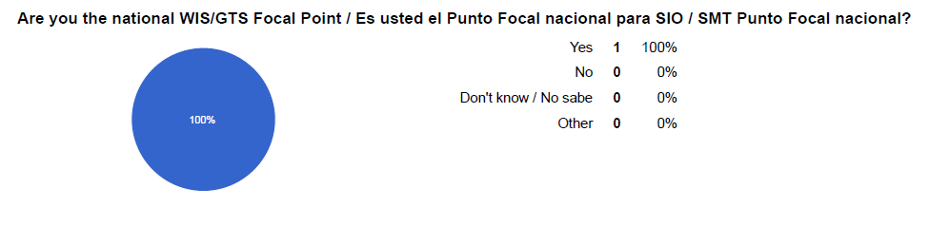

WIS Focal Point

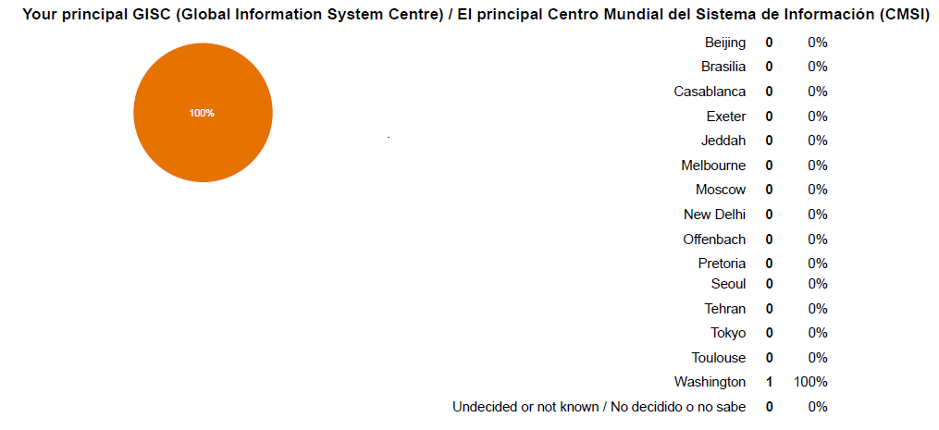

Principal GISC

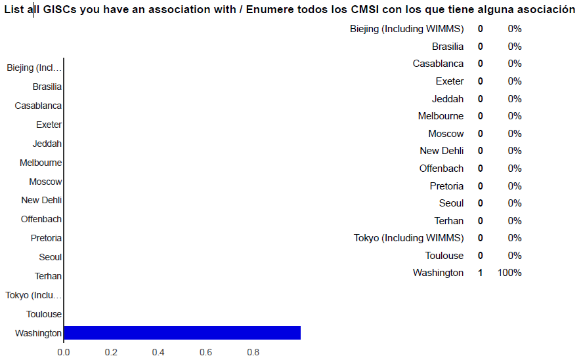

Associated GISCs

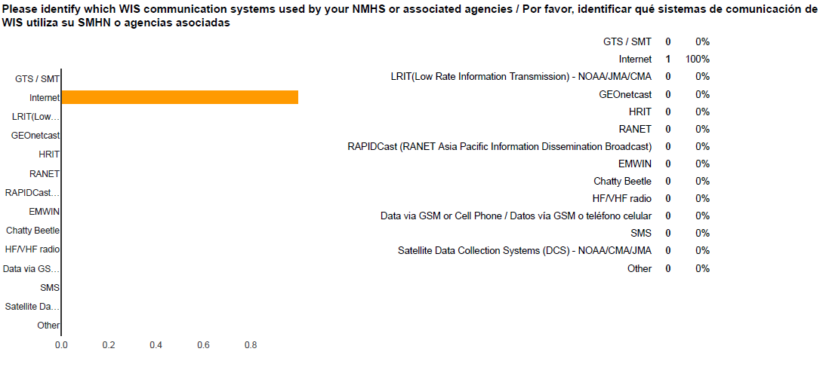

Communication technologies

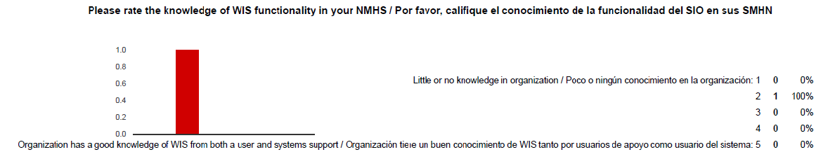

Level of organizational knowledge of WIS

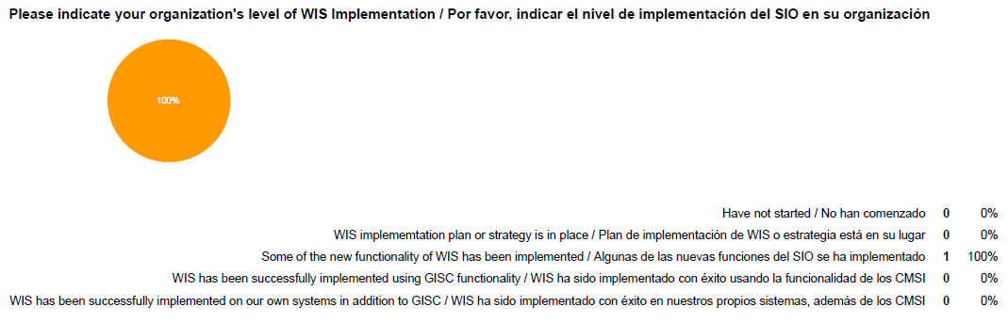

WIS implementation progress

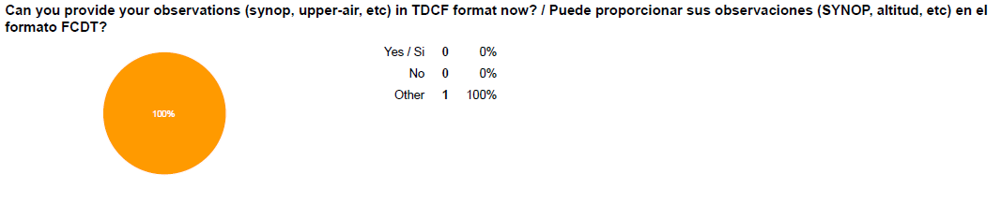

Progress in TDCF Migration

\_\_\_\_\_\_\_\_

## Appendix VIII - Terms of Reference for Focal Points

### National Focal Point for WIS

National Focal Points for WIS are nominated by the Permanent Representatives of Members of WMO. These Focal Points provide the operational channel of communication with the WMO Secretariat, and Centre and National Focal Points for WIS.

The responsibilities of the Focal Points are:

(a) Act as a focal point on all WIS activities within the Member State or territory;

(b) Monitor and report on the national status of WIS implementation;

(c) Participate in regional or sub-regional WIS coordination and implementation activities;

(d) Arrange for the authorization of national entities or people for access to WIS;

(e) Ensure issues relating to WIS, including the GTS, and World Weather Watch monitoring are directed to the relevant person and followed-up on;

(f) Monitor and participate in the overall maintenance of WIS including CBS expert teams addressing data management and data representation as well as network issues;

(g) Oversee the creation and management of WIS Discovery Metadata for data and products from participation centres;

(h) Assist centre focal points in matters relating to WIS, including compliance and functional issues;

(i) Identify and follow-up on training and capacity development needs;

(j) Represent the NMHS in WIS contributions and liaison with other initiatives such as WIGOS and GFCS.

(k) To receive notifications of amendments to the Manual on WIS (WMO-No. 1060), the Guide to WIS (WMO‑No. 1061), the Manual on the GTS (WMO‑No. 386) and associated Guides, and propagate the information within their state or territory;

(l) To comment on amendments to the Manual on WIS (WMO-No. 1060), the Guide to WIS (WMO‑No. 1061), the Manual on the GTS (WMO‑No. 386) and associated Guides by the simple procedure, on behalf of the Permanent Representative;

(m) To request amendments to the Manual on WIS (WMO-No. 1060), the Guide to WIS (WMO‑No. 1061), the Manual on the GTS (WMO‑No. 386) and associated Guides on behalf of the Permanent Representative.

### Centre Focal Point for WIS matters

Centre Focal Points for WIS matters are nominated by the centre or the Permanent Representative responsible for the centre. These Focal Points provide the operational channel of communication with the WMO Secretariat, and Centre and National WIS Focal Points.

The responsibilities of the Focal Points are:

(a) Monitor and report on the status of WIS implementation within the centre;

(b) Participate in national and international WIS coordination and implementation activities;

(c) Arrange for the authorization of access to data, products and/or services available through the centre;

(d) Ensure issues relating to WIS are directed to the relevant person and followed-up on;

(e) Monitor and participate in the overall maintenance of WIS including contributions to CBS expert teams addressing data management and data representation as well as network issues;

(f) Oversee the creation and management of WIS Discovery Metadata for data and products from the centre;

(g) Assist staff and users of the centre in matters relating to WIS, including WIS Discovery Metadata, WIS applications, WIS networks and systems;

(h) Identify and follow up on training and capacity development needs.

### GTS Focal Point

GTS Focal Points are nominated by the Permanent Representatives of Member countries of WMO that are connected to the GTS. These Focal Points provide the operational channel of communication with the WMO Secretariat, RTH and GTS Focal Points.

The Terms of Reference of the Focal Points are:

(a) Act as a focal point on all GTS matters within the centre and with its national users;

(b) Manage authorization of reception or transmission of information using the GTS;

(c) Manage subscriptions and access to GTS traffic;

(d) Oversee the creation and management of GTS headers for data and products from the centre;

(e) Ensure data and products published to the GTS from your centre have appropriate WIS discovery metadata already uploaded to the principal GISC;

(f) Coordinate GTS traffic with the RTH(s) to which the centre is attached exchange of information through the GTS for national centres

(g) Arrange for exchange of information between the GTS and national users, including WIS centres;

(h) Ensure issues relating to the GTS and World Weather Watch monitoring are directed to the relevant person and followed-up on;

(i) Monitor, report on, and participate in the overall maintenance of the GTS including contributions to CBS expert teams addressing data management and data representation as well as network issues;

(j) Assist staff and users of the centre in matters relating to GTS, including compliance and functional issues;

(k) Identify and follow up on training and capacity development needs.

### RTH Focal Point

Regional Telecommunications Hub Focal Points are nominated by the Permanent Representatives of Member countries of WMO that are responsible for a Regional Telecommunications Hub. These Focal Points provide the operational channel of communication with the WMO Secretariat, other RTHs and GTS centres.

The responsibilities of the Focal Points are:

(a) Undertake the role of national GTS Focal Point;

(b) Arrange for the attached GTS centres to initiate, modify and terminate data flows on the GTS, including negotiation of relevant GTS headers, provision of required notices and maintaining operational information held by WMO on the information within the area of responsibility of the RTH;

(c) Monitor and report on the status of RTH operations;

(d) Coordinate the flow of GTS traffic flowing through the RTH, including supporting GISC subscriptions;

(e) Working with the WIS Centre Focal Points, to ensure that GTS traffic from the attached centres has appropriate WIS Discovery Metadata records.

**APPENDIX IX - CHECKLIST OF ICT RELATED ACTIONS THAT MIGHT BE CONSIDERED IN NATIONAL PLANS TO IMPROVE NATIONAL ABILITY TO EXCHANGE AND PROCESS INFORMATION**

| **Action No.** | **Action** | **Urgency** |
| --- | --- | --- |
| 1 | Creation of digital reports at manual station for transmission |  |
| 2 | Automatic digital transmission of AWS information to national/sub-national collection point |  |
| 3 | Telecommunications connection from observing site (or production office) to national/sub-national centre |  |
| 4 | National/sub-national collection centre |  |
| 5\* | National/sub-national data store |  |
| 6\* | Display/production system (integration of information from multiple sources) |  |
| 7 | Create reports in TDCF |  |
| 8 | Transmit information to national users |  |
| 9 | Transmit information to international users – management of data flow (including GTS) |  |
| 10 | International telecommunications connections |  |
| 11 | Reception of information from international centres (including GTS) |  |
| 12\* | Data store for international information (ideally the same as the national/sub-national data store to allow seamless use of information) |  |
| 13\* | Long term storage and protection of information |  |
| 14 | Creation and maintenance of WIS Discovery metadata records |  |
| 15 | Delivery of non real-time national products through the WIS |  |
| 16 | Implementation of centres other than the NMHS as WIS National Centres (or DCPCs) |  |
| 17 | National Centre/DCPC compliance with WIS requirements |  |
| 18 | Exploit GISC and other WIS facilities to provide more information to national users |  |
| 19 | National training in WIS – users |  |
| 20 | National training in WIS – operators of WIS infrastructure |  |

\* Not a component of WIS, but a task that may need to be done to deliver the benefits of WIS/WIGOS nationally

1. Manual on the WMO Information System (WMO No 1060) - <http://wis.wmo.int/wis-manual> [↑](#footnote-ref-2)
2. WIS Demonstration Process Guidelines - <http://www-db.wmo.int/WIS/centres/guidance.doc> [↑](#footnote-ref-3)
3. A full description of the existing GTS structure and networks can be found in the *Manual on the GTS* (WMO-No. 386). <http://wis.wmo.int/gts-manual> [↑](#footnote-ref-4)
4. The current status is based WMO [WIS Centres Database](http://www.wmo.int/pages/prog/www/WIS/centres/index_en.php?sortBy=region&sortAsc=true) in December 2015. Focal Point is based responses following the letter of 10 February 2012 (<http://www.wmo.int/pages/prog/www/WIS/circular_letters_questionnaires.html>) and subsequent processes requesting PRs to nominate WIS focal points and Principal GISCs. [↑](#footnote-ref-5)
5. Terms of Reference for WIS Focal Points <http://www.wmo.int/pages/prog/www/CBS/Lists_WorkGroups/CBS/cross-cutting/fp%20wis/tors> [↑](#footnote-ref-6)
6. WIS Jump Start - <http://www.wmo.int/pages/prog/www/WIS/documents/JumpStartFlyer.doc> [↑](#footnote-ref-7)
7. WIS Demonstration Process - http://www-db.wmo.int/WIS/centres/guidance.doc [↑](#footnote-ref-8)
8. See survey questions and results at: <http://wis.wmo.int/page=RA4-WIS> [↑](#footnote-ref-9)