Aim: To establish a standard practice among GISCs to establish a training Land GISC set, and users that can be used in training of people to use WIS.
Elements should be that trainees should be able to create, edit and delete metadata and search for that metadata without the metadata being synchronized to other GISCs. Users need to be temporary and not affect operational systems. Should include normal user registration process. The experience should be as close to possible as a user would feel when working on their operational system.
Needs to be accessible outside of GISC
All GISCs need to establish the same procedures to support training on their system

Decision: Establish a small team to document practices and report back at end of meeting for refinement by group. Such practices should then be adopted and implemented by all GISCs.

Team: Leon Mika, Jose Mauro, Dave Thomas, Mark Francis
…/page 2

Use of Training Land during RA-V Training Sessions

BoM prepared two training activities for RA V NCs to learn how to use the GISC software to create and manage metadata records. The following describes how the BoM allowed for users to have some hands-on time with the GISC software whilst isolating any training metadata from the operational side of the GISC:
- The first session was hosted in Melbourne, which meant that participants had some access to services within the fire-wall, including the development GISC server. The approach taken to allow users to create test metadata involved:
  - Creating temporary accounts for all participants, with a common password, on the development GISC server that they can use to login.
  - Creating a new set, WIS_UNPUBLISHED, which was used to isolate the metadata created during the workshop. Metadata within the set was searchable but was not synchronized to other systems (n.b. there is no synchronization of the development catalogue, but the same set is used on the operational server). The participants were instructed to make use of this catalogue for all unpublished metadata, including test metadata.
  - Participants were also instructed to use "au.gov.bom.test" in the metadata URNs.
  - After the workshop was complete, the test accounts and the associated metadata were removed.
- The second session involved visits to each of the NCs. Since these sessions sat outside the firewall, and since there was currently no way of running the GISC software on a single laptop, the operational server was used to host the "training land" metadata:
  - Four demo accounts – demo1, demo2, etc. – were created.
  - The WIS_UNPUBLISHED set was also created. Although the set is also used to host metadata not yet ready for synchronization, the trainees were instructed to use this set during the training session.
  - Participants were also instructed to use "au.gov.bom.test" in the metadata URNs (the training script actually dictated the URNs of the metadata to create during the training session).
  - After the workshop, the GISC operational staff logged into each of the dummy accounts and removed the metadata created by them. Any metadata records which contained "au.gov.bom.test" was also treated as test metadata and was removed from the catalogue. The accounts were then recycled for the next session.
  - This approached proved to be more useful as the GISC software was more true to actual usage, in terms of performance and things like the software's URL. However, significant oversight is required to ensure that the correct set was chosen and no other metadata records were tampered.

Recommendation

The team would like to make the following recommendation pertaining to the content and process of training users within the GISCs area of responsibility using the operational GISC environment.

TT-GISC agreed to the recommendation of the sub team on Training Land and further agreed that all GISCs should implement a training environment along these lines.

Functional Architecture

The training material should cover the following components of the functional architecture (Figure 1) of the GISC software:
- User Registration: the trainee should be instructed on the registration process of a new user, and the authentication process of a registered user. Specifically, the trainee should be instructed on:
  - The process of validating a registration request from a new user.
  - The process of obtaining permission from the WIS Focal Point of the National Centre the user is a member of.
  - The process of how the new user is authorized and registered in the GISC software by the GISC controller.
  - The authentication process a registered user must go through in order to make use of the registered user features.
- Registered User Interface: the trainee should be instructed on how to use the core functionalities the GISC software makes available to registered users. Specifically, the trainee should be instructed on:
  - The process of searching the metadata catalogue.
  - The process of managing the user's profile (e.g changing their email address or password).
  - The process of obtaining products in an adhoc manner. At a minimum, the trainee should be able to extract data and download or have it delivered to them as an email. Other forms of adhoc delivery can be shown to the trainee if they are supported.
  - The process of creating a subscription. This should include the process of creating a new subscription, including how to specify the mode of delivery (e.g. email, ftp, other), how to manage the subscriptions once created, and how to disable or delete their subscription. It should include email subscription at a minimum.
- Metadata Authoring: the trainee should be instructed on how to create, modify, publish and delete metadata using the authoring facilities available from the GISC software. Specifically, the trainee should be instructed on:
  - The process of creating a new metadata record, including how to specify a suitable URN.
  - The process of editing metadata created by or permitted to be edited by the user.
  - The process of pushing a metadata created by or permitted to be published by the user.
  - The process of removing metadata created by or permitted to be removed by the user.

Constraints and Pre-Conditions

The team recommends that the use of a non-operational environment for training if such an environment is available and closely resembles of the operational environment, including the contents or the metadata catalogue and cache. In cases where no suitable non-operational environment is available, the team recommends that any training conducted on the operational GISC must satisfy the following constraints and pre-conditions (See Figure 2):
- Any metadata created as part of the training should be placed in a metadata set dedicated for testing purposes which is separate from the set holding the GISCs operational metadata. The metadata within this set should be searchable using the GISCs search facilities, but should not be synchronized across to other GISCs via the OAI-PMH endpoint.
- Any metadata created as part of the training should be associable to non-operational test products in order to demonstrate the association between metadata and data. This association can be as simple as referencing flat files hosted on a HTTP or FTP server that is referenced using the resource location field within the metadata. The test products should be retrievable by the trainee using adhoc product requests.
- Any user account created for trainees for the purpose of editing metadata should be created within a temporary test organization or domain. This organization must restrict the trainee's right to create, modify, publish or remove metadata to only that metadata that has been created as part of the training and that belongs to the test organization.
- At the conclusion of the training session or at an agreed time afterwards, any new metadata, products or user accounts created as part of the training should be zeroed or removed using the administration features available to the GISC controller.

Guidelines

The team makes the following recommendations on training guidelines in order to satisfy the constraints and pre-conditions listed in the previous section:
- Use of test metadata URNs: In order to identify temporary metadata created during the training session, it is suggested that such metadata should be clearly identified as test metadata. One approach for doing so would be to set the authority of the metadata URN to the reverse DNS of the GISC with the suffix "test". For example, test metadata belonging to the Bureau of Meteorology will have the authority "au.gov.bom.test". This permits the use of any local identifier within this authority as required during the training session (e.g. "urn:x-wmo:md:au.gov.bom.test::TEST01")
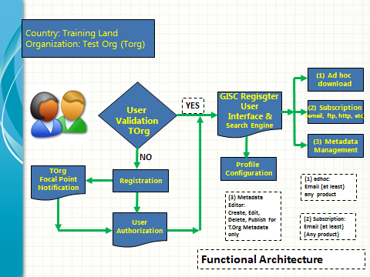
Figure 1 Functional Architecture
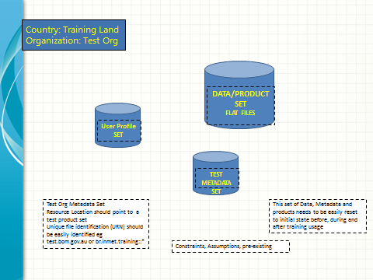
Figure 2 Initial state databases

