WMO Common Dashboard for WIS Monitoring Project

Overview
The discussions in this document are based on the Final Report of WIS Monitoring Workshop (Final Report hereafter). The goal of this document is to put forward a concrete proposition to build a demonstrablepilotforthe WMO Common Dashboard (WCD),in accordance to the Pilot Project described in the Final Report (Appendix F).
The WCD concerns only about the real-time operations monitoring, which is the information required to be exchanged globallyaccording to the Final Report (Appendix C.1). The quarterly and incident reports (Appendix C.2 & C.3) are hence out of the scope of this document. Due to the relatively constrained time frame (demonstration to Congress in May), the pilot WCD is envisioned to be simple and focus only on a limited set of overall real-time monitoring metrics.

Scope
This document covers the high level architecture and operation of the WCD and defines the set of metrics that will be implemented in the initial version of the dashboard. This document also includes an example of the JSON messages that will be exchanged between the GISCs and the WCD, and includes conceptual diagrams of the final UI. Out of scope of this document is a full specification of the JSON message structure, and a description of the actual UI that will be built. This will be provided in subsequent documents if and when this proposal is accepted.

Architecture
The overall WIS Monitoring system includes co-operations among all three types of centres (GISC, DCPC and NC) plus the WCD. The WCD provides an integrated report produced by aggregating exchanged monitoring messages from all GISCs. There is no direct communication between WCD and DCPC/NC. Figure 1 shows the interactions among different components of the WIS monitoring system.
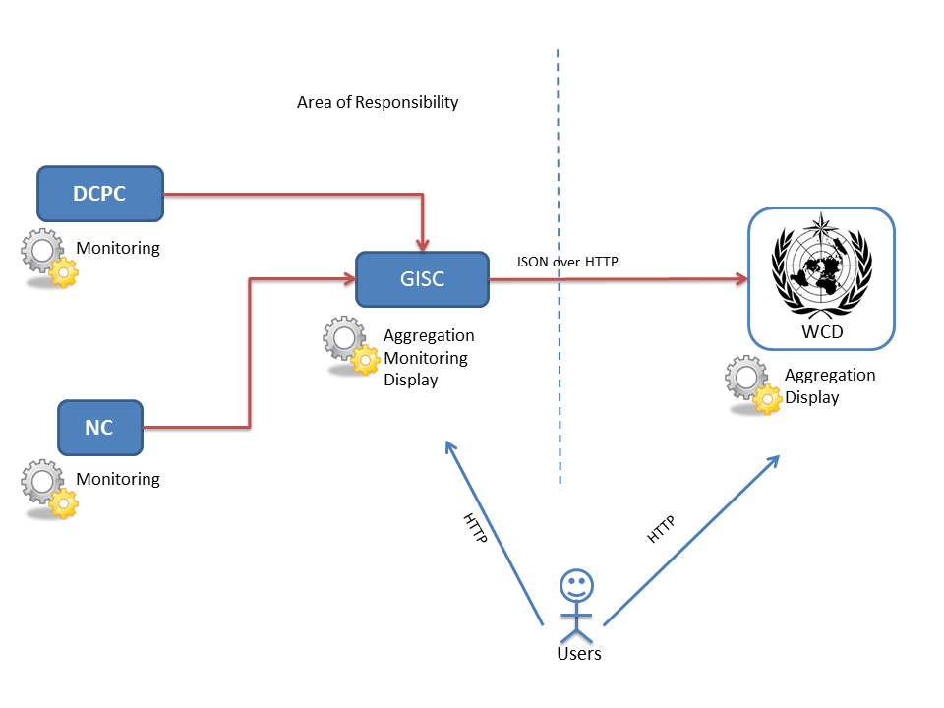
Figure 1. Schematic of the architecture of the overall WIS monitoring system
The monitoring messages flow from DCPC/NC to their designated GISCs. The messages are then aggregated in each GISCs, which also perform their own monitoring tasks. Each GISC is responsible for building its own monitoring website as well as provides required monitoring information to WCD. The WCD pulls the monitoring messages from all GISCs once every 24 hours (Appendix G, Final Report). The messages are then aggregated and displayed as a consolidated view of WIS.
Note that the Final Report seems to suggest that each GISC shall host its own common dashboard by stating “All of the other GISC will download this file (e.g. with wget) regularly, in order to create a consolidated view of the WIS” (Appendix G). However, we propose that a single common dashboard to be hosted by WMO and all other GISCs can simply provide a link pointing to the common dashboard. This reduces the redundancy and keeps a single point of truth.
The WCD provides an overview of the entire WIS system. While it does also providea fewdetailed metrics about a specific GISC, itcertainly does not cover all the details. Full monitoring details about a GISC shall bemade available at the GISC’s own monitoring website, whose linkis provided by the WCD to redirect end-users.Note that the build of a GISC’s own monitoring website is out of scope of this document.
For simplicity, the pilot WCD is stateless. This means that content displayed by the WCD depends only on the last messages pulled from each GISC. It does not provide historical views. Previous messages are discarded once new messages become available. This eliminates the need of a backend database so that the implementation is simplified.

Exchanged Monitoring Message
Based on the Final Report (Appendix C.1), following metrics are selected for the pilot WCD.
Item | Description | Example | Remarks
Overall Centre Availability | A “roll-up” indicator derived from the availability of several system components, e.g. network, storage, services | 99.9% | This metric is shown as the traffic light symbol on WCD’s overview page.  Green: > 99% ?  Yellow: 90-99% ?  Red: < 90% ?  The indicator of the backup centre is not required for the pilot.
Network usage | The loading of the network as an average of last 24 hours | 50% | This metric is shown as a traffic light symbol on WCD’s GISC page.  Green: < 50% ?  Yellow: 50-80% ?  Red: > 80% ?
Number of metadata | Total number of metadata records in the catalogue | 150,000 | At 00:00 UTC
Metadata changes | Total number of metadata records that are created, updated and deleted | 100 | Between 00:00 - 23:59 UTC
Data received with no metadata | Number of data received in the last 24 hours with no associated metadata (draft in OpenWIS) | 8 | Between 00:00 - 23:59 UTC
Number of products | Total number of files in the 24-Hour cache | 310,000 | At 00:00 UTC
Cache size |  | 1300000.0 KB | At 00:00 UTC
Ingested products | Number of files ingested in last 24 hours | 5,678 | Between 00:00 - 23:59 UTC
Ingested size | The size of files ingested in last 24 hours | 512000.0 KB | Between 00:00 - 23:59 UTC
Application Availability | Availability of various network applications, e.g. OAI-PMH, FTP | up / down | At 00:00 UTC  Shown as traffic light symbols on WCD

The metrics are encoded as JSON message and will be made available via HTTP at a URL chosen by the GISCs. The JSON message will be fetched from the WCD using the HTTP GET command. A sample JSON message is shown as follows:

{
"wmo_wis_monitoring": "1.0",
"centre": "GISC Melbourne",
"timestamp": "2014-11-10T00:00:00Z",
"monitor_url": "http://wis.bom.gov.au/monitor",
"metrics": {
"overall_availability": 99.9,
"network_usage": 50.0,
"metadata_catalogue": {
"number_of_records": 150000,
"number_of_changes_in_the_last_24h": 100,
"data_without_metadata_in_the_last_24h": 8
},
"cache_24h": {
"number_of_products": 310000,
"kbytes_of_cache": 1300000.0,
"number_of_products_recieved_in_the_last_24h": 5678,
"kbytes_recieved_in_the_last_24h": 512000.0
},
"services": {
"oai_pmh": { "status": "up" },
"ftp": { "status": "down"}
}
},
"remarks": "Any additional text message"
}
Although the monitoring is categorized as “real-time”, the WCD only pulls the JSON messages from all the GISCs once every 24 hours (Appendix G, Final Report). It is possible that each GISC’s own monitor website would update the metrics in a much higher frequency (e.g. every 5 min for CPU/disk loadings).

Dashboard Layout
The webpages of WCD are essentially just a user-friendly rendering of the received JSON message from GISCs. For the pilot project, the WCD does not perform any significant calculations against the incoming messages.
The WCD has two templates for its webpages. The first one is an overview of all GISCs. The second one is a dedicated page for a single GISC. The schematic of the overview page is shown as Figure 2.
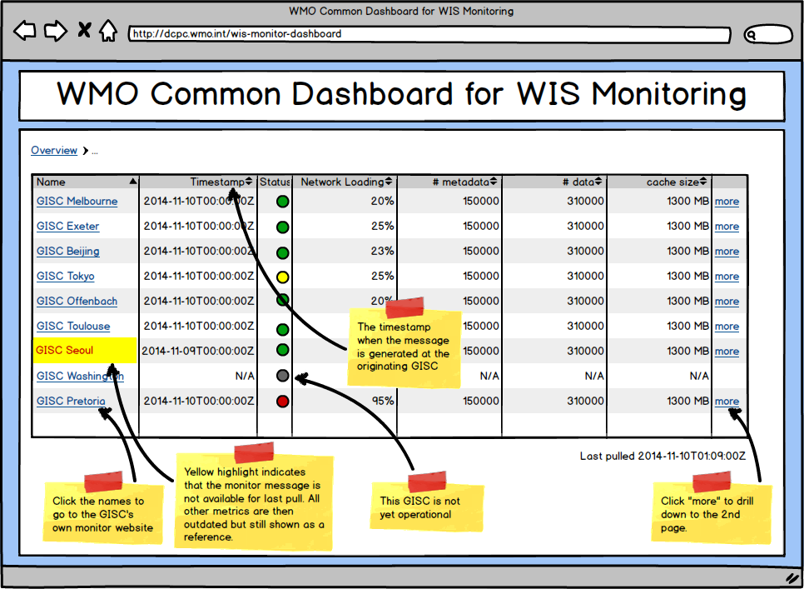
Figure 2. Schematic layout of the WCD’s overview page
The second template is reached when any of the “more” links is clicked. It shows a few more metrics about a specific GISC.
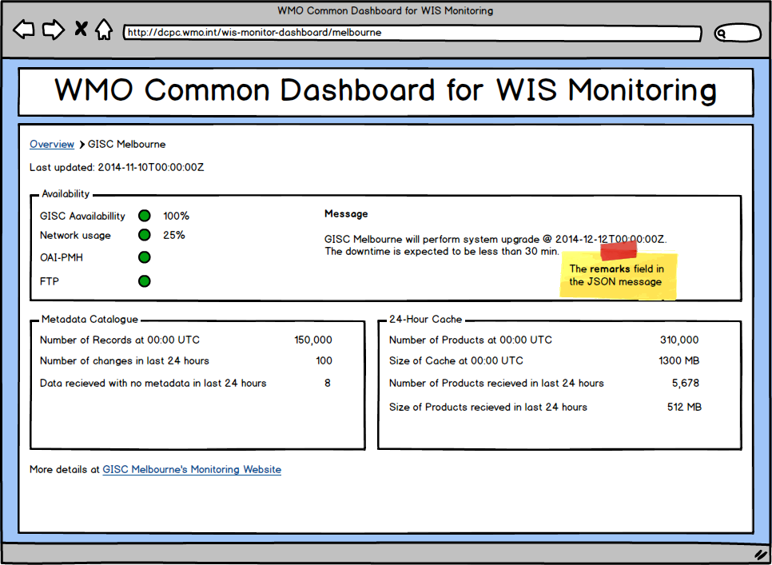
This page also contains a link to the GISC’s own monitor website, where more details can be found.

Possible Future Works
In order to meet the deadline of the pilot project, the scope for the initial version of the WCD will be strictly limited. At the conclusion of the pilot, further work can be made to improve the quality and usefulness of the WCD for the WIS community. Possible future work on the portal can include the following:
- Support for more metrics:The set of metrics that are to be displayed can be increase to cover most, if not all, the metrics defined within the Final Report.
- Metric value persistence: The initial version of the WCD will be stateless and, as such, will not maintain historical records of metric values as provided by the GISCs. However, this can be added in a subsequent version of the WCD and can be used to view changes of metrics over time in the form of time-series graphs, etc.
- Internationalisation: Although the initial version of the WCD will not support end-user choice of language or locality, work can be put in place to eventually provide full support of this. A possible and desirable extension of the WCD would be to allow the end-user to choose their preferred language and localisation settings from the UI. At a minimum, the 6 official languages of the WMO should be supported.
- Internationalisation in JSON messages: Select fields of the JSON message, such as the centre name or remarks, can be extended to support internationalised strings. These fields can either have a string value, which will be displayed as is, or a JSON object mapping language codes to localised strings. If the user were to select a specific language in the portal, the appropriate localised string will be displayed. This will require the resolution specification if the user’s chosen language is not present in the JSON object (a possible requirement is that an English string must be present and will be displayed in such a case).

Final Report of WIS Monitoring Workshop, 21-24 Jan. 2014, Geneva (http://wis.wmo.int/file=695)

