## Draft Recommendation 2.4(2)/2 (CBS-Ext.(2014))

## Guide FOR NATIONAL METEOROLOGICAL AND HYDROLOGICAL SERVICES Participation in Radio Frequency Coordination

THE COMMISSION FOR BASIC SYSTEMS,

**Noting:**

(1) Resolution 4 (Cg-XV),

(2) Resolution 11 (EC-64),

(3) Resolution 9 (EC-65),

**Noting further:**

(1) The importance of increased involvement of NMHS in national frequency policy development to take into consideration the dependence of NMHS services on observation and communications systems in order to meet national priorities, including the provision of forecasts and warning services and for climate monitoring,

(2) The need for guidance on how NMHS could be more effectively involved in the national, regional and global development and maintenance of the International Telecommunications Union Radiocommunication Sector’s Radio Regulations that govern the use of radio frequency,

**Recommends** the Guide to National Meteorological and Hydrological Services participation in radio frequency coordination be adopted, as given in the Annex to this recommendation, in all the WMO official languages.

__________

### Annex to draft Recommendation 2.4(2)/2 (CBS-Ext.(2014))

### GUIDE FOR NATIONAL METEOROLOGICAL AND HYDROLOGICAL SERVICES PARTICIPATION IN RADIO FREQUENCY COORDINATION

## Executive Summary

### Purpose of this Guide

1. The Guide for National Meteorological and Hydrological Services (NMHSs), hereafter referred to as this “Guide”, has been prepared to assist Members in addressing the requirements of Resolution 4 (Cg-XV). The International Telecommunications Union (ITU), in particular its Radiocommunications sector (ITU-R), has the global responsibility for facilitating the global management of the radio frequency spectrum and satellite orbits.
2. The Guide provides the general description of ITU’s main processes related to radio frequency coordination, regional structure and regulatory framework that governs the use of radio frequency spectrum globally[1] and guides the national management of radio frequency spectrum as well as management of satellite orbits. More detailed information on which frequencies are important to meteorology and related activity is available in the WMO/ITU joint publication[2] on the “Use of Radio Spectrum for Meteorology: Weather, Water and Climate Monitoring and Prediction.”
3. **Resolution 4 of World Meteorological Congress XV**[3] and **Resolution 11 (EC-64)[4]** highlight the importance of radio frequencies for meteorological and related environmental activities. They urge all WMO Members to do their utmost to ensure the availability and protection of suitable radio frequency bands required for meteorological and related environmental operations and research, and in particular:

(1) To ensure that their national radiocommunication administrations are fully aware of the importance of and requirements for radio frequencies for meteorological and related activities, and to seek their support in the ITU World Radiocommunication Conferences and Radiocommunication Sector activities;

(2) To participate actively in the national, regional and international activities on relevant radiocommunication regulatory issues and, in particular, to involve experts from their Services in the work of relevant regional radiocommunication organizations and of ITUR, especially ITUR Study Group 7 on Science Services;

(3) To register adequately with their national radiocommunication administrations all radiocommunication stations and radio frequencies used for meteorological and related environmental operations and research.

### Regulatory Structure of ITU

1. ITU-R maintains its regulation framework that consists of agreed regulations, procedures, rules, international standards (ITU-R Recommendations in the ITU terminology) and other documents relating to the radio frequency spectrum and satellite orbits management. The main part of this framework is the ITU Radio Regulations (RR). The RR, like WMO Technical Regulations, is an international treaty. The regulated frequency range (8.3 KHz to 3 000 GHz) is segmented into smaller bands that are allocated to over 40 defined Radio Services. The most relevant Radio Services to WMO include the: meteorological aids service (MetAids); meteorological‑satellite service (MetSat); Earth exploration-satellite service (EESS) and radiolocation service (RLS) – see sub-section 2.2. For a radio system or application to seek protection from interference from other systems or applications, it must be attributed to a known Radio Service.
2. RR Article 5 contains the international Table of Frequency Allocations for all frequencies between 8.3 KHz and 3000 GHz based on one row for each band divided into one to three columns. There is one column for each of the three ITU Regions (see Figure 3). ITU Region 1 incorporates WMO Regions I and VI plus the northern parts of Region II. ITU Region 2 incorporates WMO Regions III and IV plus Greenland. ITU Region 3 covers the southern half of WMO Region II and most of Region V.
3. Allocations to the radio services are made at World Radiocommunication Conferences (WRCs) which meet every three to four years. Allocations are made either on PRIMARY or secondary basis where services operating on secondary allocations shall cause no harmful interference to, nor claim protection from, services operating in the PRIMARY allocations. Where multiple services are operating in the same PRIMARY allocation, the stations of this services must coordinate with each other to ensure that they do not cause harmful interference to each other. When documenting allocations in the RR Tables, PRIMARY allocations are always entered in UPPER CASE, while secondary allocations are written in normal sentence (lower) case.
4. ITU-R also carries out studies and approves international standards on radiocommunication matters (ITU-R Recommendations in the ITU terminology). It works through world and regional Radiocommunication conferences, the Radio Regulation Board (RRB), Radiocommunication Assemblies (RA), Radiocommunication Study Groups and the Radiocommunication Bureau (BR). BR in cooperation with administrations implements coordination and recording procedures for space and terrestrial wireless systems, networks and stations.
5. Member-States of ITU have established six regional telecommunication organizations that formally are not part of the regulatory development process, but play a significant role in world and regional preparation for world radiocommunication conferences. These regional telecommunication organizations coordinate and prepare common proposals related to different aspects of spectrum management including proposals on worldwide and regional allocations for consideration at WRC. The organizations are the:

* African Telecommunication Union (ATU);
* Arab Spectrum Management Group (ASMG);
* Asia-Pacific Telecommunity (APT);
* European Conference of Postal and Telecommunication Administrations (CEPT);
* Inter-American Telecommunication Commission (CITEL); and
* Regional Commonwealth in the Field of Communications (RCC).

1. ITU Member-States have voting rights in the WRCs, but these regional organizations have no such rights. Nevertheless they carry a lot of weight in the decision making process. It is essential that national and regional bodies are fully aware of the impact of decisions on earth observations and other WMO activities.
2. Coordination of frequency assignments of radiocommunication systems, stations and applications belonging to terrestrial and space radio services is one of the most important methods providing the way for the effective operations all radio systems and optimal use of radio frequency spectrum and satellite orbits. Coordination of a system/station/application in many cases is not only mandatory in accordance with national and international regulations and rules but also necessary for obtaining national/international recognition and as the result protection from harmful interference from frequency assignments of the existing and future stations/systems that will support successful operation of this system/station/application in particular and the WMO Integrated Global Observing System in general.

### WMO involvement in ITU-R

1. WMO is an observer in ITU-R and through the work of CBS Steering Group on Radio‑frequency Coordination (SG-RFC) members is a regular contributor to ITU-R Study Groups in WRC processes. WMO’s input is well respected within the ITU-R technical activities. Unfortunately, WMO does not get a vote on WRC decisions. SG-RFC members also represent WMO requirements when registered as a WMO representative or as a part of their national delegation at many of the ITU meetings and some of the six regional groups. This is important for ensuring that the meteorological related requirements are taken into consideration in the establishment of new or modification of existing provisions of the RR. Similarly, some SG-RFC members have an input through their own administrations and organizations to national radio frequency coordination and management processes.
2. Although ITU has Sector-Members such as telecommunication companies, operators, equipment manufacturers, etc., WRC decisions on changes to the RR are made by ITU Member‑States. However, many Member-States include industry representatives in their delegations as well as representatives from their regulatory bodies. In this way, unlike within the WMO infrastructure, industry has a very direct and effective influence on WRC decisions.
3. NMHSs are encouraged to use this Guide to help them understand the organization and processes that make up the radio frequency coordination and management. The aim is for NMHSs to take advantage of CBS and Regional frequency coordination expertise to become more effective in ensuring the radio frequency services that their present and future basic observations and systems depend on are able to be protected from interference that negatively impacts on their functioning. This Guide should be used in conjunction with the WMO/ITU Handbook on the “Use of Radio Spectrum for Meteorology: Weather, Water and Climate Monitoring and Prediction” 1.

## Introduction

1. Radio frequency spectrum and satellite orbits are a valuable and limited natural resource employed by different radio-based systems providing the tremendous opportunities for social development of the modern society. Technological progress has continually opened doors to a variety of new radio applications that have spurred interest in, and demand for spectrum. Dependence on radio communications in one form or another has grown dramatically in recent years, and the growth in the number and variety of applications - many of them bandwidth hungry - and the huge expansion in user expectations place ever increasing demands on the radio spectrum.
2. Many services, systems and applications make extensive use of the radio spectrum. These include fixed and mobile radiocommunication systems, broadcasting, aviation, railway and maritime transport, defence, medical electronics, emergency services, remote control and monitoring, radio astronomy, earth-exploration and space research systems, as well as many other applications.
3. The access to the spectrum is extremely important for earth observations, weather forecasting, climate monitoring and climate change prediction. Certain frequencies are unique to particular environmental elements and can be monitored passively provided the signals are not overwhelmed by emissions of other radio frequency users operating in or around that band. Similarly, active sensors based on the use of a certain radio frequency are also subject to interference from other radio systems making them unusable in some circumstances.
4. However, there is almost no absolutely free radio frequency spectrum in populated areas. Different types of radio stations use the same frequencies and in order to operate efficiently technical parameters of these stations should be selected and tuned in such way that their emissions would not create interference above the specified level. Otherwise it may lead to the situation where not one of them is operating in accordance with technical requirements and none of them would be able to implement the required function.
5. That is why there is a need to properly regulate usage of radio frequency spectrum by different systems/applications (including meteorological) in order to avoid harmful interference and to implement relevant procedures for the effective use of the spectrum. International and regional agreements, national laws, other documents, procedures and activities related to effective use of radio frequency spectrum and satellite orbits form the spectrum management system (SMS). Radio frequency coordination activities are part of the processes carried out in the framework of SMS.
6. The meteorological community also makes extensive use of radio frequency spectrum by meteorological radio-based systems and applications that obtain environmental information employed for weather forecasting, environment monitoring, natural disaster prediction, detection, early warning and for planning and management of disaster relief operations. Technical details on the use of spectrum for environmental monitoring are available in the WMO/ITU joint publication, the Handbook on the “Use of Radio Spectrum for Meteorology: Weather, Water and Climate Monitoring and Prediction”. 1
7. This Guide describes the basic concepts of radio frequency coordination process on international, regional and national level that is necessary for effective non-interference operation of different kind of radio equipment including meteorological systems and applications. It includes some a suggested approach for NMHSs to improve their own effectiveness in influencing spectrum management ant national and international levels, but could be used as guidelines by any of the meteorological community.
8. This Guide has been developed by Steering Group on Radio-Frequency Coordination[5] (SG-RFC) working in the framework of the WMO Commission for Basic Systems (CBS).

## What is frequency assignment coordination and why is IT necessary?

### Frequency Coordination

1. There is no definition of the term “coordination” in the main international agreement regulating the use of radio frequency spectrum and satellite orbits - the Radio Regulations[6] (RR) developed and maintained by the International Telecommunication Union[7] (ITU). However, coordination should be understood as a process followed by users of radio frequency spectrum in order to avoid potential harmful interference between new and existing wireless systems/stations/applications.
2. When is coordination necessary? The main purposes of coordination are:

* To allow effective operation of already existing radio stations/system as well as the new one;
* To provide recognition of this new station/system in the future. That practically means to provide protection from harmful interference[8] of stations/systems, which could be brought into the use in the future.

1. The coordination process involves:

* The exchange of technical and operational data of existing and earlier submitted (usually data of the existing and earlier assignments are obtained from the relevant national and/or international data base) and new frequency assignment(s) of radio stations/systems;
* Studies of potential interference effects between existing and new frequency assignment(s);
* Correspondence between spectrum management authorities (national and/or international, depending on the case) and spectrum users and between users themselves regarding new proposals and, as necessary;
* Adjustment of technical parameters and/or re-design of proposed systems/applications in order to allow effective operation of new and existing radio systems/applications.

1. It is essential before starting the coordination process to select proper technical/operational characteristics/parameters and avoid serious mistakes that may prevent a successful coordination from the beginning. The working technical/operational characteristics/parameters of a future station/system should be consistent with international and/or national spectrum management regulations/rules. For example:

* Selected working frequencies of new station/system shall be allocated (on international and/or national level) to the radiocommunication service in which this new station/system should operate;
* Technical characteristics of the future station/system shall respect international and/or national regulatory limitations specified in the relevant regulations/rules (e.g. output power, antenna characteristics, out-of-band emission level), etc.

1. If technical/operational characteristics/parameters of a station/system are not accordance with international and/or national regulations/rules it is not possible to coordinate such a station/system.
2. A simplified general description of coordination process is provided in Figure 1.

Figure 1: Simplified description of radio-frequency assignment(s) coordination process



1. If the coordination process completed successfully then according to the Radio Regulations the frequency assignment(s) belonging to the new stations/systems obtain(s) rights to international recognition (RR No. **8.3**) and should be recorded into the Master International Frequency Register (MIFR):

* Any frequency assignment recorded in the Master Register with a favourable finding *(means successfully coordinated)* with respect to the Table of Frequency Allocations and other provisions of the RR shall have the right to international recognition;
* This right means that other administrations shall take it into account when making their own assignments, in order to avoid harmful interference.

1. Similar or exactly the same rights are in general also applied according to national regulations, not only for internationally recognized assignments but also for assignments recorded in the national frequency register (or data base of the national spectrum management system).
2. Formally the coordination is completed after reaching agreement with all involved parties. However, it is extremely important to notify the coordinated frequency assignment(s) and their parameters to the relevant spectrum management authority (national and/or international) for recording them into the relevant data base to be taken into account in the future.
3. The general description of the international coordination, notification and recording of frequency assignments through the Radiocommunication Bureau of the ITU is shown in Figure 2.

Figure 2: The general description of international coordination, notification and recording of frequency assignments



1. The time limit for satellite network coordination as specified in the Radio Regulation is seven years. It is a clear indication of complexity of the coordination process.
2. Descriptions of different elements of radio frequency coordination process are provided in the following sub-sections of this section.

### Radio services

1. Article **1** of the Radio Regulations contains definitions of over 40 different radio services most, but not all, of them are radiocommunication services. For example, the radio astronomy service is a radio service not a radiocommunication service.
2. Radio Regulations define a radiocommunication service as *“*A service as defined in this Section involving the transmission, emission and/or reception of radio waves for specific telecommunication purposes” (RR No. **1.19** in Section II-Specific terms related to frequency management of Article 1).
3. Among these radio services there are four radiocommunication services of prime interest/concern for meteorology. The definition of those services and samples of applications operating are shown in the Table 1 below.

Table 1: List of the radio services that are of interest for meteorology and environmental observations

| **Provision numbers and definitions of radio services in the Radio Regulations (Edition of 2012)** | **Acronym** | **Sample(s) of applications[9]** |
| --- | --- | --- |
| RR No. 1.51  *Earth exploration-satellite service:*  A *radiocommunication service* between *earth stations* and one or more *space stations*, which may include links between *space stations*, in which:   * information relating to the characteristics of the Earth and its natural phenomena, including data relating to the state of the environment, is obtained from *active sensors* or *passive sensors* on Earth *satellites;* * similar information is collected from airborne or Earth-based platforms; * such information may be distributed to *earth stations* within the system concerned; * platform interrogation may be included.   This service may also include *feeder links* necessary for its operation. | **EESS** | space-borne sensors (active and passive) for environmental monitoring the Earth’s surface and atmosphere such as soil moisture, sea surface temperature, ice extend, snow cover, water vapour content and concentration in atmosphere, different gases content, altitude of the Earth’s ocean, wind direction, wind speed and precipitation rate over the ocean surface, etc. |
| RR No. 1.50  *meteorological aids service:*A *radiocommunication service* used for meteorological, including hydrological, observations and exploration. | **MetAids** | radiosondes, dropsondes, rocketsonds for atmospheric *in situ* measurements with high vertical resolution (relative humidity, temperature and wind speed); lightning detection systems |
| RR No. 1.52  *meteorological-satellite service:*  An *earth exploration-satellite service* for meteorological purposes. | **MetSat** | meteorological satellite systems (geostationary and non-geostationary) for collection of data with visible and infrared images, passive and active sensors and disseminating these data |
| RR No. 1.48  *radiolocation service:*  A *radiodetermination service* for the purpose of *radiolocation*.  *Related definitions:*  RR No. 1.40  *radiodetermination service:*  A *radiocommunication service* for the purpose of *radiodetermination*.  RR No. 1.9  *radiodetermination:*The determination of the position, velocity and/or other characteristics of an object, or the obtaining of information relating to these parameters, by means of the propagation properties of *radio waves*. | **RLS** | meteorological radars: weather radars, wind-profiler radars for surface-based observations such as precipitation and wind measurements that also play crucial role in the immediate alert processes and disaster warning (flash flood or severe storm events, etc.) |
| RR No. 1.55  *space research service:*A *radiocommunication service* in which *spacecraft* or other objects in space are used for scientific or technological research purposes. | **SRS** | space weather observation system for monitoring the physical processes occurring in the space environment, driven by the Sun and Earth’s upper atmosphere (the solar wind, flow of solar wind plasma which carries the Sun's embedded magnetic field and releases energy, such as flares of electromagnetic radiation (radio waves, IR, visible, UV, X-rays), energetic particles (electron, protons and heavy ions), and high speed plasma through coronal mass ejections, etc.) |

1. It is also worth to mention that the fixed-satellite service systems, through commercial payloads in the C-band (3 400-4 200 MHz) and the Ku Band (10 700-11 700 MHz), are used globally to disseminate weather, water and climate related information, including disaster warnings to meteorological agencies and user communities.
2. National spectrum management systems, in most cases, use the same classification of radio services as the ITU. However, it is necessary to check whether a national spectrum management system applies the same classification or if there is a difference at least for some services.

**Frequency allocations and the Table of Frequency Allocations**

1. *Allocation* (of a frequency band)*:*Entry in the Table of Frequency Allocations of a given frequency band for the purpose of its use by one or more terrestrial or space *radiocommunication services* or the *radio astronomy service* under specified conditions. This term shall also be applied to the frequency band concerned (RR No. **1.16**).
2. An allocation of portion of radio-frequency spectrum could be made to one or several radiocommunication services.
3. It could have different rights and obligations:

* *Primary allocations* grant to specific services priority in using the allocated spectrum. When there are multiple primary services within a frequency band, they all have equal rights. A station, however, has the right to be protected from any others that start operation at a later date;
* *Secondary allocations* are made for services that must protect all primary allocations in the same band. Services operating in secondary allocations must not cause harmful interference to, and must accept interference from, primary service stations. All secondary service stations have equal rights among themselves in the same frequency band.

1. An allocation usually does not combine together services that use high and lower power systems (such as terrestrial broadcasting stations and meteorological aids stations, for example, radiosondes).
2. Tables of frequency allocations to different radio services and technical/operational limitations rights, obligations and responsibilities of users/operators and regulators, etc. are normally incorporated in the national and international regulations and/or rules.
3. The Radio Regulations contain the international Table of Frequency Allocations (included in RR Article **5**), which is based on a block allocation method with footnotes. The regulated frequency band (8.3 kHz – 3 000 GHz) is segmented into smaller bands and allocated to over 40 defined radio services. Allocations to the radio services made either on PRIMARY or secondary basis (the latter shall cause no harmful interference to, nor claim protection from, the former). Footnotes are used to further specify how the frequency ranges are to be assigned or used.

### ITU Regions

1. For the allocation of frequencies the world has been divided into three Regions as shown on the Figure 3 below. Descriptions of ITU Regions are provided in RR Nos. **5.3**, **5.4** and **5.5**.

5.3 *Region 1:*Region 1 includes the area limited on the east by line A (lines A, B and C are defined in Figure 3 below) and on the west by line B, excluding any of the territory of the Islamic Republic of Iran which lies between these limits. It also includes the whole of the territory of Armenia, Azerbaijan, the Russian Federation, Georgia, Kazakhstan, Mongolia, Uzbekistan, Kyrgyzstan, Tajikistan, Turkmenistan, Turkey and Ukraine and the area to the north of Russian Federation which lies between lines A and C.

5.4 *Region 2:*Region 2 includes the area limited on the east by line B and on the west by line C.

5.5 *Region 3:*Region 3 includes the area limited on the east by line C and on the west by line A, except any of the territory of Armenia, Azerbaijan, the Russian Federation, Georgia, Kazakhstan, Mongolia, Uzbekistan, Kyrgyzstan, Tajikistan, Turkmenistan, Turkey and Ukraine and the area to the north of Russian Federation. It also includes that part of the territory of the Islamic Republic of Iran lying outside of those limits.

Figure 3: ITU Radiocommunication Regions

5-01e

1. An extract from the RR Article **5** Table of Frequency Allocation is shown in Table 2. Capital letters indicate PRIMARY allocations, lower case is used to indicate secondary allocations. Numbers are used for provisions employed for specifying conditions, additional and alternative allocations and descriptions of special uses. For example RR No. **5.341**:

5.341 In the bands 1 400-1 727 MHz, 101-120 GHz and 197-220 GHz, passive research is being conducted by some countries in a programme for the search for intentional emissions of extra-terrestrial origin.

1. Each column of the Table of Frequency Allocations corresponds to one of the Regions. Where an allocation occupies the whole width of the Table of one or two of tree columns, this is a worldwide allocation or a Regional allocation, respectively – see the Table 2 below.

Table : An Extract from the RR Article 5 Table of Frequency Allocations

|  |  |  |
| --- | --- | --- |
| Allocation to services | | |
| Region 1 | Region 2 | Region 3 |
| 1 670-1 675 METEOROLOGICAL AIDS  FIXED  METEOROLOGICAL-SATELLITE (space-to-Earth)  MOBILE  MOBILE-SATELLITE (Earth-to-space) 5.351A 5.379B  5.341 5.379D 5.379E 5.380A | | |
| 1 675-1 690 METEOROLOGICAL AIDS  FIXED  METEOROLOGICAL-SATELLITE (space-to-Earth)  MOBILE except aeronautical mobile  5.341 | | |
| 1 690-1 700  METEOROLOGICAL AIDS  METEOROLOGICAL-SATELLITE (space-to-Earth)  Fixed  Mobile except aeronautical mobile | 1 690-1 700  METEOROLOGICAL AIDS  METEOROLOGICAL-SATELLITE (space-to-Earth) | |
| 5.289 5.341 5.382 | 5.289 5.341 5.381 | |
| 1 700-1 710  FIXED  METEOROLOGICAL-SATELLITE (space-to-Earth)  MOBILE except aeronautical mobile | | 1 700-1 710  FIXED  METEOROLOGICAL-SATELLITE (space-to-Earth)  MOBILE except aeronautical mobile |
| 5.289 5.341 | | 5.289 5.341 5.384 |

1. As ITU Regions may have different allocations, sometimes done by footnote to the Table, it is also necessary to, apart from checking the table itself to check provisions included in each row, because sometimes they contain additional allocations. For example, the 15.4-18.4 GHz part of the Table of Frequency allocations (see Table 3) does not contain allocations to the meteorological satellite service, but RR No. 5.519 at the bottom 17.7-18.1 GHz row in the Region 2 column and 18.1-18.4 GHz row in the global column provides additional allocation to the MetSat for geostationary satellites as follows:

5.519 *Additional allocation:*the bands 18-18.3 GHz in Region 2 and 18.1-18.4 GHz in Regions 1 and 3 are also allocated to the meteorological-satellite service (space-to-Earth) on a primary basis. Their use is limited to geostationary satellites.     (WRC-07)

Table 3: A fragment of the 15.4-18.4 GHz portion of the Table of Frequency Allocations in Article 5 of the Radio Regulations 15.4-18.4 GHz

|  |  |  |
| --- | --- | --- |
| Allocation to services | | |
| Region 1 | Region 2 | Region 3 |
| … | | |
| 17.3-17.7  FIXED-SATELLITE (Earth-to-space) 5.516 (space-to-Earth) 5.516A 5.516B  Radiolocation | 17.3-17.7  FIXED-SATELLITE (Earth-to-space) 5.516  BROADCASTING-SATELLITE  Radiolocation | 17.3-17.7  FIXED-SATELLITE (Earth-to-space) 5.516  Radiolocation |
| 5.514 | 5.514 5.515 | 5.514 |
| 17.7-18.1  FIXED  FIXED-SATELLITE (space-to-Earth) 5.484A (Earth-to-space) 5.516  MOBILE | 17.7-17.8  FIXED  FIXED-SATELLITE (space-to-Earth) 5.517 (Earth-to-space) 5.516  BROADCASTING-SATELLITE  Mobile  5.515 | 17.7-18.1  FIXED  FIXED-SATELLITE (space-to-Earth) 5.484A (Earth-to-space) 5.516  MOBILE |
|  | 17.8-18.1  FIXED  FIXED-SATELLITE (space-to-Earth) 5.484A (Earth-to-space) 5.516  MOBILE  5.519 |  |
| 18.1-18.4 FIXED  FIXED-SATELLITE (space-to-Earth) 5.484A 5.516B    (Earth-to-space) 5.520  MOBILE  5.519 5.521 | | |

### Regional telecommunication organizations

1. ITU Member-States have established six regional telecommunication organizations that formally are not part of the regulatory development process, but play a significant role in world and regional preparation for world radiocommunication conferences. These regional telecommunication organizations coordinate and develop common proposals related to different aspects of spectrum management including proposals on worldwide and regional allocations for consideration at WRC. The organizations are the:

* African Telecommunication Union (ATU);
* Arab Spectrum Management Group (ASMG);
* Asia-Pacific Telecommunity (APT);
* European Conference of Postal and Telecommunication Administrations (CEPT);
* Inter-American Telecommunication Commission (CITEL); and
* Regional Commonwealth in the Field of Communications (RCC).

1. ITU Member-States have voting rights in the WRCs, but these regional organizations have no such rights. Nevertheless they carry a lot of weight in the decision making process. It is essential that national and regional bodies are fully aware of the impact of decisions on earth observations and other WMO activities.

### National frequency allocations

1. Although most countries follow in the great degree the ITU allocations, it is still possible for a country to deviate from the international allocations, to a limited degree, to satisfy specific national requirements. That is why many regulators develop national frequency allocation tables.
2. National frequency allocation tables (sometimes called plans or otherwise) are usually published on web-pages of national regulators – see sub-section 2.10 [international and national regulators]. Some of them provide national frequency allocation tables in more transparent and clear way using a graphical format[10]. A fragment of such graphical presentation is shown in Figure 4 below as an example.

Figure 4: An extract from a frequency allocation table for the frequency range 2 200-2 500 MHz

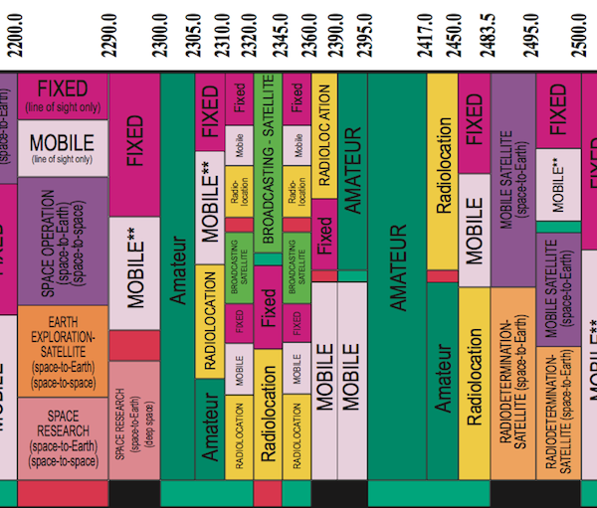

### Technical/operational limitations

1. Frequencies are assigned and used with due account of any restrictions on their use, stipulated by the international and national regulations. Some countries may place local limitations on the use of specified frequency bands for individual radio services. These can be restrictions on the utilization of some frequencies by particular users, on the radiated power in specific radio services operating in a specified frequency band, or in certain geographical areas.

### Technical and/or operational conditions and limitations contained in the international and national agreements, law, regulations and rules

1. The following documents of the International Telecommunication Union are to be used when an assignment needs international recognition:

* The ITU Radio Regulations (mainly Article **5**, Article **21** - for assignments belonging to the terrestrial services, Article **22** - for assignments belonging to the space services). RR contain the complete texts as adopted by the World Radiocommunication Conference (Geneva, 1995) (WRC-95) and subsequently revised and adopted by World Radiocommunication Conferences, including all Appendices, Resolutions, Recommendations and ITU-R Recommendations incorporated by reference;

available free of charge at: <http://www.itu.int/en/publications/ITU-R/pages/publications.aspx?parent=R-REG-RR-2012&media=electronic>;

* The Rules of Procedure, approved by the Radio Regulations Board, for the application by the Radiocommunication Bureau of the provisions of the Radio Regulations, Regional Agreements and Resolutions and Recommendations of World and Regional Radiocommunication Conferences; available free of charge at: <https://www.itu.int/en/publications/ITU-R/pages/publications.aspx?parent=R-REG-ROP-2012&media=electronic>;
* Recommendations of the ITU Radiocommunication Sector;

available free of charge at: <http://www.itu.int/pub/R-REC>.

1. RR Article **5** contains some provisions specifying conditions of the use for some stations/systems. Two samples (RR Nos. **5.54A** and **5.549A**) are shown below.

5.54A Use of the 8.3-11.3 kHz frequency band by stations in the meteorological aids service is limited to passive use only. In the band 9-11.3 kHz, meteorological aids stations shall not claim protection from stations of the radionavigation service submitted for notification to the Bureau prior to 1 January 2013. For sharing between stations of the meteorological aids service and stations in the radionavigation service submitted for notification after this date, the most recent version of Recommendation ITU‑R RS.1881 should be applied.    (WRC‑12)

5.549A In the band 35.5-36.0 GHz, the mean power flux-density at the Earth’s surface, generated by any spaceborne sensor in the Earth exploration-satellite service (active) or space research service (active), for any angle greater than 0.8° from the beam centre shall not exceed −73.3 dB(W/m2) in this band.     (WRC‑03)

1. Similarly RR Articles 21 and 22 contain technical limitations applied to stations of different space services including those of the interest for the meteorological community. Two samples are provided below.

22.4§ 3 In the frequency band 29.95-30 GHz space stations in the Earth exploration-satellite service on board geostationary satellites and operating with space stations in the same service on board non-geostationary satellites shall have the following restriction:

Whenever the emissions from the geostationary satellites are directed towards the geostationary-satellite orbit and cause unacceptable interference to any geostationary-satellite space system in the fixed-satellite service, these emissions shall be reduced to a level at or less than accepted interference.

22.5§ 4 In the frequency band 8 025-8 400 MHz, which the Earth exploration-satellite service using non-geostationary satellites shares with the fixed-satellite service (Earth-to-space) or the meteorological-satellite service (Earth-to-space), the maximum power flux-density produced at the geostationary-satellite orbit by any Earth exploration-satellite service space station shall not exceed −174 dB(W/m2) in any 4 kHz band.

1. National operational and technical conditions/limitations on the use certain frequency bands by stations/systems/applications belonging to the specific services in different frequency bands are described in national regulations/rules that are usually published on web-pages of national regulators – see sub-section 2.10 [International and national regulators].

### Analysis of electromagnetic compatibility between existing and newly submitted stations/systems

1. The analysis of electromagnetic compatibility of stations/systems using the same frequency band and the analysis of interfering effects of out-of-band emissions spilling in the adjacent bands is a very complicated engineering task. Such analysis requires sophisticated software and significant computing resources. Fortunately, ITU-R processes identify and agree on standard methods so different projects can arrive at consistent solutions. As such, methods, criteria and algorithms to be employed for electromagnetic compatibility analysis between station/systems belonging to different radio services on international level are specified in Appendix 5 of the RR titled “Identification of administrations with which coordination is to be effected or agreement sought under the provisions of Article 9”.
2. The national approaches, methods and algorithms to electromagnetic compatibility analysis applicable on the national level are usually provided in the relevant national regulations/rules published on the “regulator web-page” – see sub-section 2.10 [International and national regulators].
3. The complexity of the problem is reflected in Figure 5 for a new geostationary satellite.

Figure 5: An illustration of types of interfering sources to be considered during electromagnetic compatibility analysis of a new geostationary satellite system

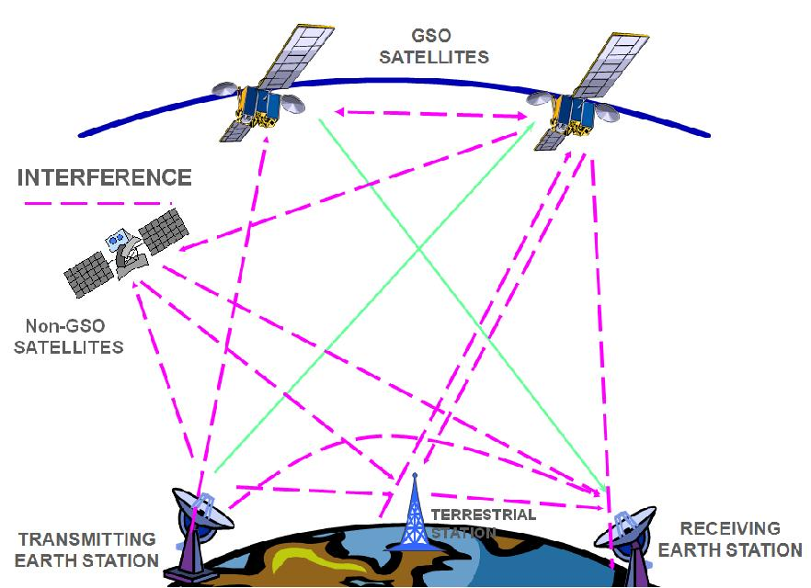

1. Another important factor is the amount frequency assignments to be considered in compatibility analysis. The ITU Master International Frequency Register, the database of radio stations operating around the world, is constantly updated by the ITU Radiocommunication Bureau. It contains more than 2 million frequency assignments for terrestrial services and more than 1.1 million assignments to space services. The Radiocommunication Bureau treats every year 120 plus thousands of notices for stations of terrestrial services and about 1300 filings of satellite networks, covering some 0.5 million frequency assignments and 300 earth stations and radio‑astronomy stations.

### International and national regulators

1. The global management of the radio-frequency spectrum and satellite orbits is provided by the International Telecommunication Union (ITU) established in 1865. The ITU is a **specialized agency of the United Nations for telecommunications and information and communication technologies (ICTs).**
2. According to Article 12 of the ITU Constitution (see at: <http://www.itu.int/net/about/basic-texts/constitution/chapterii.aspx>)[11] "the ITU shall in particular:

|  |  |
| --- | --- |
| **11   PP-98** | *a)*effect allocation of bands of the radio-frequency spectrum, the allotment of radio-frequencies and the registration of radio-frequency assignments and, for space services, of any associated orbital position in the geostationary-satellite orbit or of any asso­ciated characteristics of satellites in other orbits, in order to avoid harmful interference between radio stations of different countries; |
| **12   PP-98** | *b)*coordinate efforts to eliminate harmful interference between radio stations of different countries and to improve the use made of the radio-frequency spectrum for radiocommunication services and of the geostationary-satellite and other satellite orbits;” |

1. The ITU Radiocommunication Sector (ITU-R) is the international steward of the radio-frequency spectrum and satellite orbits. ITU-R through the World Radiocommunication Conferences (WRCs) allocates the necessary radio-frequency spectrum to allow the effective operation of different radio-based systems and applications (terrestrial and space) used for different purposes including climate monitoring and prediction, weather forecasting and disaster early warning and detection. ITU-R also carries out studies and approves international standards on radiocommunication matters (ITU-R Recommendations in the ITU terminology).

Figure 6: Radio Regulations - 4 volumes ~2000 pages.

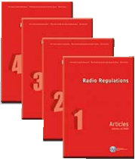

1. It works through world and regional Radiocommunication conferences, the Radio Regulation Board (RRB), Radiocommunication Assemblies (RA), Radiocommunication Study Groups and the Radiocommunication Bureau (BR). BR implements coordination and recording procedures for space and terrestrial wireless systems, networks and stations.
2. The WRCs revise usually every 3-4 years the texts of the Radio Regulations (see Figure 2.8), international treaty, covering and regulating the use of the radio-frequency spectrum and satellite orbits by systems and stations of radio services. The main goal of the RR is to ensure that reliable radio services are available everywhere and at every moment, enabling people to live and travel safely and enjoy high performance radiocommunications. For further relations between the ITU and the WMO activities see “WMO Strategy on Radio-Frequency Protection for Meteorology” at: <http://wis.wmo.int/file=1029>.
3. The ability of each country to take full advantage of the spectrum resource depends heavily on spectrum management activities that facilitate the implementation of radio systems and ensure minimum interference. National spectrum management consists of the structures, procedures, and regulations whereby an administration controls the use of the radio spectrum within its geographical boundaries. Effective management of the spectrum resource encompasses major directives that establish the responsibility of the national authority. This authority regulates the spectrum use as well as all related processes. Although no two administrations would manage the spectrum in exactly the same manner, the basic processes are essential to all national approaches.
4. Usually the national radiocommunication law delegates the authority and responsibility to manage spectrum use to one or more government bodies. Many countries establish their national frequency coordination procedures. Frequency coordination is the process of obtaining agreement between existing spectrum users and a prospective spectrum user when there is some potential spectrum conflict. Coordination on the national level may involve technical, administrative, legal, or other considerations. Frequency coordination at the national level is essential because the same frequency band is, typically, shared by radio systems that belong to different users. For example, some microwave links may be operated by different governmental agencies, others by national or local carriers, and some by one or more private companies – all using the same frequency allocations. The process of coordination is regulated by appropriate national rules. All users potentially affected by a new radio system under consideration are obliged to examine the possibility of interference with that assignment.
5. How to find what ministry/organization/commission is in charge of the spectrum regulations? It is possible to do so through the ITU Global Directory published and maintained at: <http://www.itu.int/en/membership/Pages/default.aspx>. The Global Directory contains the basic information on ITU membership, including information concerning national regulators. Clicking on the [**ITU Member States**](http://www.itu.int/online/mm/scripts/mm.list?_search=ITUstates&_languageid=1&_foto=y) entry under **Lists of the Global Directory** results in the list of the ITU Member States as shown on the Figure 7 below.

Figure 7: An extract from the list of the ITU Member States

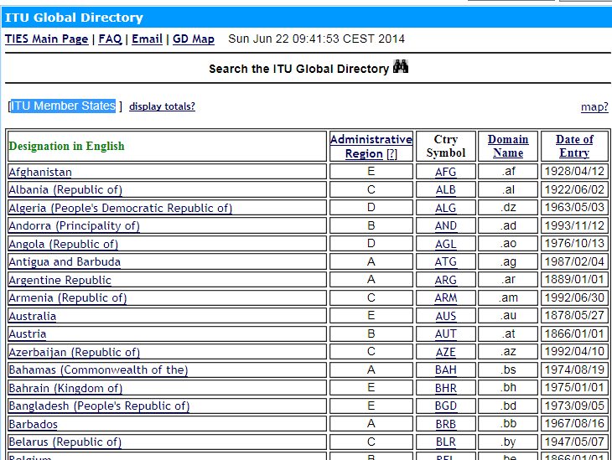

1. Then it is necessary to click on the country of interest. Let’s click on Bangladesh (People's Republic of). The next screen will present the detailed administrative information related to this member state, including information about the regulation authorities, as shown in Figure 8 below.

Figure 8: A part of administrative information concerning an ITU Member State – the People’s Republic of Bangladesh

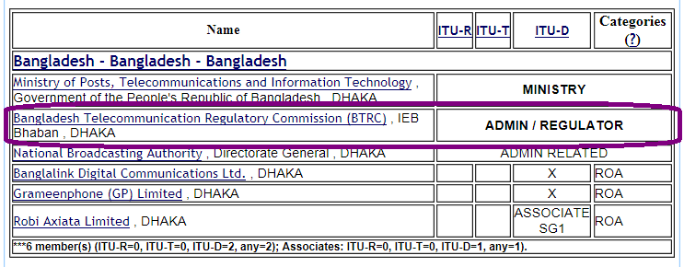

1. Going further and clicking on the name of in the row containing the REGULATOR indicator (see above) it is possible to get necessary information concerning the relevant national regulator (address, phones and URL) as presented in Figure 9.

Figure 9: Information concerning the regulation authority of the People’s Republic of Bangladesh

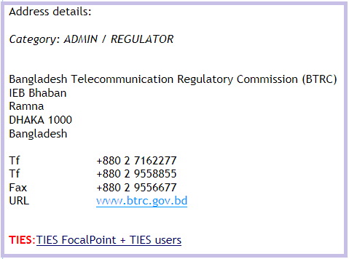

## Step by step coordination guideline

1. The step-by-step guideline of coordination of radio-frequencies within ITU is shown in Figure 10. How an NMHS should get engaged in this process is described in Section 4 below. Formally speaking, steps 7 to 9 of Figure 10 are not part of the coordination process, however, they are essential for protection of the coordinated assignment(s) (system/station/application) from harmful interference of future systems/stations/applications.

Figure 10: A fragment of the 15.4-18.4 GHz portion of the Table of Frequency Allocations



## How to engage an NMHS in ITU’s frequency management and coordination

1. The purpose of this Guide is primarily to assist the heads of NMHSs to understand the ITU process that supports radio frequency coordination, and what they should do to engage in their national, regional and global coordination. The following summarizes some common elements of approaches that Members have found to be successful.
2. In order to engage in radio frequency coordination, there are two high-level objectives. The main objective is to be effective in influencing frequency management decision makers. The second high-level objective is to use the wider WMO expertise to ensure frequency regulators decisions relative to the meteorological requirements are scientifically and technically strong. The nature of radio frequency coordination activities means that input needs to be provided at national, regional and global forums.
3. An effective approach used by some NMHSs in achieving the first objective has been to identify which agencies or departments are the frequency regulators and to convince the regulatory body and its parent ministry of the importance of meteorology to national priorities. This opens the way to emphasize meteorology’s dependence on frequencies. Having ministers, or at least departmental head, buy in is an important element that will ensure a sustainable relationship. Once achieved, the aim is then to get involved in the national, regional and global processes, including NMHS representation on relevant delegations.
4. Annex 1 describes the above in more detail and identifies some tools to assist in achieving these objectives. It is noted that the CBS Steering Group on Radio-frequency Coordination (SG‑RFC), Regional Association relevant infrastructure working groups and the Secretariat are important sources of support for your activities. As such, NMHSs are encouraged to participate through registering their national focal point or experts in SG-RFC or regional groups, and to encourage them to actively participate.

## Conclusion

1. The purpose of this Guide is primarily to assist the heads of NMHSs to understand the ITU process that supports radio frequency coordination, and what they should do to engage in their national, regional and global coordination.
2. Coordination of frequency assignments of terrestrial and space radiocommunication systems, stations and applications belonging to terrestrial and space radio services is one of the most important methods providing the way for the effective operations all radio systems and optimal use of radio-frequency spectrum and satellite orbits.
3. Coordination of a system / station / application in many cases is not only mandatory in accordance national and international regulations and rules but also necessary for obtaining national / international recognition and as the result protection from harmful interference from frequency assignments of the existing and future stations/systems that will support successful operation of this system/station/application in particular and the WMO Integrated Global Observing System (see Figure 11) in general.

Figure 11:: WMO Integrated Global Observing System

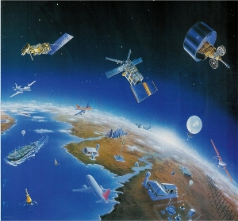

1. It becomes especially essential taking into account the limited financial resources available for the National Meteorological and Hydrological Services, regional and national organizations involved in meteorological activities as well as for the World Meteorological Organization that cannot afford improper implementation of national regulations, regional and international agreements concerning the use of radio-frequency spectrum and satellite orbits.

_________________

## Annex 1 – Possible action plan

| **High Level Objectives** | **Approach** | **Tools** |
| --- | --- | --- |
| **(1) Influence Decision Making** | | |
| (a) Get Ministerial / Departmental Head support from:   * (i) NMHS parent body * (ii) Regulatory Department and its parent body.   (b) To get involved in regulatory processes  (i) National  (ii) Regional  (iii) ITU-R / WRC bodies | * Use available guidance to brief relevant minister and department on the importance of RF to meteorological and related services * Identify national priorities (e.g. Emergency response and disaster risk reduction) and define their dependence on NMHS services * Identify frequency regulator and arrange meetings between departmental heads. * Get NMHS representative on regulatory agency’s frequency management steering committee or its equivalent (ie Board Level participation). * Aim to get NMHS technical expert on national delegations to relevant ITU-R regional and global meetings. | * Guide to NMHS on spectrum management * Handbook on the “Use of Radio Spectrum for Meteorology: Weather, Water and Climate Monitoring and Prediction” * Government policy documents defining national priorities * ITU-R list of regulatory agencies[12] * SG-RFC/ WMO Secretariat for identifying   + relevant regional groups   + relevant ITU working groups and committees. * SG-RFC membership and TORs. |
| **(2) Ensure sound scientific and technical input to frequency management.** | | |
| (a) Get involved in WMO RFC activity  (i) National  (ii) Regional  (iii) Global | (i) National  Identify a national focal point on radiofrequency matters. Most likely for your observations or engineering staff.  (ii) Regional  1. At a minimum, register Focal Point and relevant experts with Regional WIGOS / Infrastructure working group  2. Support focal point / expert’s participation in regional WIGOS radio-frequency coordination activities.  (iii) Global  1. Register your focal point and experts as associated members of SG-RFC  2. Support participation of NMHS representative in national delegations to SG-RFC and relevant ITU-R /WRC related meetings. | * Report on Regional Association Sessions and subsequent TORs of working groups and bodies. * SG-RFC/ WMO Secretariat for identifying relevant:   + regional groups   + ITU working groups and committees * SG-RFC membership and TORs * ITU-R list of meetings and registration pages |

.

1. The further details on the development and modification of the radio-frequency management framework on the world-wide basis are provided in the publication “WMO Strategy on Radio-Frequency Protection for Meteorology” (<http://wis.wmo.int/file=1029>).
2. “Use of Radio Spectrum for Meteorology: Weather, Water and Climate Monitoring and Prediction.” <http://www.itu.int/en/publications/ITU-R/pages/publications.aspx?parent=R-HDB-45-2008&media=electronic>
3. Resolution 4 (Cg-XV) - <http://www.wmo.int/pages/prog/www/TEM/WMO_RFC/Res4_en.html>
4. Resolution 11 (EC-64) - <ftp://ftp.wmo.int/Documents/PublicWeb/mainweb/meetings/cbodies/governance/executive_council_reports/english/pdf/64_session_1092_part1_en.pdf>
5. See at: <http://www.wmo.int/pages/prog/www/TEM/WMO_RFC/meetings-en.html>.
6. See at: <http://www.itu.int/pub/R-REG-RR/en> (*Hereafter all references made to the Radio Regulations, Edition of 2012*).
7. See at: <http://www.itu.int>
8. RR No. **169** defines the harmful interference as follows:

   “*harmful interference:* Interference which endangers the functioning of a radionavigation service or of other safety services or seriously degrades, obstructs, or repeatedly interrupts a radiocommunication service operating in accordance with Radio Regulations.”

   *(RR No.****169*** *means provision No.****169*** *of the Radio Regulations. This format will be used for further references to the relevant provisions of RR).*
9. See also Handbook “Use of radio spectrum for meteorology: weather, water and climate monitoring and prediction” at: [www.itu.int/ITU-R/go/R-HDB-45-2008](http://www.itu.int/ITU-R/go/R-HDB-45-2008)
10. See an example at: [www.acma.gov.au/webwr/radcomm/frequency_planning/spectrum_plan/arsp-wc.pdf](http://www.acma.gov.au/webwr/radcomm/frequency_planning/spectrum_plan/arsp-wc.pdf), [www.ic.gc.ca/eic/site/smt-gst.nsf/vwapj/2014_Canadian_Radio_Spectrum_Chart.pdf/$file/2014_Canadian_Radio_Spectrum_Chart.pdf](http://www.ic.gc.ca/eic/site/smt-gst.nsf/vwapj/2014_Canadian_Radio_Spectrum_Chart.pdf/$file/2014_Canadian_Radio_Spectrum_Chart.pdf), [www.fab.gov.pk/images/spectrumchart.jpg](http://www.fab.gov.pk/images/spectrumchart.jpg), [www.icta.mu//images/spectrum.jpg](http://www.icta.mu//images/spectrum.jpg).
11. Collection of the basic texts of the International Telecommunication Union, including the ITU Constitution, Convention ant other texts, is available free of charge at: <http://www.itu.int/pub/R-REG-RR/en>.
12. ITU Global Directory published and maintained at: <http://www.itu.int/en/membership/Pages/default.aspx>