WORLD WEATHER WATCH
COMMISSION FOR BASIC SYSTEMS
RA-I ad hoc Task Team on WIS Implementation  Pretoria, South Africa, 21-26 September 2014 |  | RA-I-TT-WIS-1/Final Report
 |  | 14 October 2014

FInal Report of the Meeting of the
RA-I ad hoc Task Team on WIS Implementation
21-22 September 2014

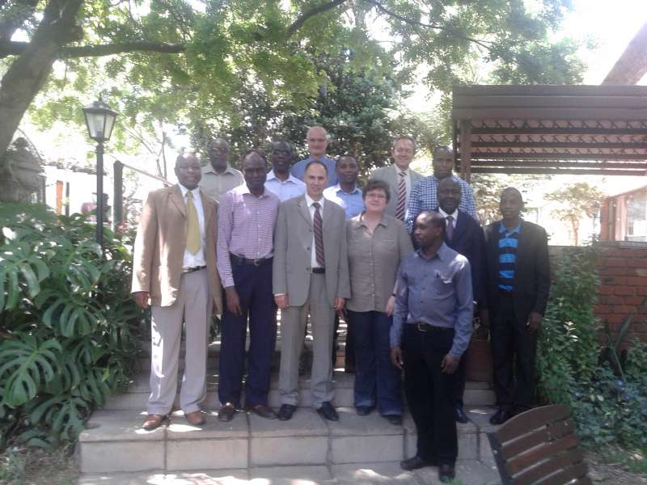
DISCLAIMER

Regulation 43
Recommendations of working groups shall have no status within the Organization until they have been approved by the responsible constituent body. In the case of joint working groups the recommendations must be concurred with by the presidents of the constituent bodies concerned before being submitted to the designated constituent body.

Regulation 44
In the case of a recommendation made by a working group between sessions of the responsible constituent body, either in a session of a working group or by correspondence, the president of the body may, as an exceptional measure, approve the recommendation on behalf of the constituent body when the matter is, in his opinion, urgent, and does not appear to imply new obligations for Members. He may then submit this recommendation for adoption by the Executive Council or to the President of the Organization for action in accordance with Regulation 9(5).
© World Meteorological Organization, 2104
The right of publication in print, electronic and any other form and in any language is reserved by WMO. Short extracts from WMO publications may be reproduced without authorization provided that the complete source is clearly indicated. Editorial correspondence and requests to publish, reproduce or translate this publication (articles) in part or in whole should be addressed to:
Chairperson, Publications Board
World Meteorological Organization (WMO)
7 bis, avenue de la Paix Tel.: +41 (0)22 730 84 03
P.O. Box No. 2300 Fax: +41 (0)22 730 80 40
CH-1211 Geneva 2, Switzerland E-mail: Publications@wmo.int

NOTE:
The designations employed in WMO publications and the presentation of material in this publication do not imply the expression of any opinion whatsoever on the part of the Secretariat of WMO concerning the legal status of any country, territory, city or area or of its authorities, or concerning the delimitation of its frontiers or boundaries.
Opinions expressed in WMO publications are those of the authors and do not necessarily reflect those of WMO. The mention of specific companies or products does not imply that they are endorsed or recommended by WMO in preference to others of a similar nature which are not mentioned or advertised.
This document (or report) is not an official publication of WMO and has not been subjected to its standard editorial procedures. The views expressed herein do not necessarily have the endorsement of the Organization.

____________

FINAL REPORT OF THE MEETING OF THE

RA-I AD HOC TASK TEAM ON WIS IMPLEMENTATION

21-22 SEPTEMBER 2014
- The meeting of the RA-I ad hoc Task Team on WIS Implementation was opened at 0900 on Monday 21 September in the Schoongezich Guesthouse, Pretoria, South Africa.
- Mnikeli Ndamambi, SAWS General Manager of Operations, welcomed participants to the meeting to the meeting. He noted the difficulty of maintaining skilled staff to support the WIS, and emphasized the intention of South Africa to fully support WIS and to provide a high level of service through GISC Pretoria. He commented that it had been necessary to postpone the planned WIS training because of the low level of responses, and committed to providing a training session at a later date. He conveyed the welcome and best wishes of the Permanent Representative for the success of the meeting.
- Steve Foreman, C/DRMM at WMO, welcomed the participants and explained that the objective of the meeting was to develop the WIS Implementation Plan for Region I.
- The agenda for the meeting is in Appendix A, and the list of participants is in Appendix B. Participants benefited from a visit to the headquarters of the South African Weather Service.
- The objective of the meeting was achieved, and the draft Region I WIS Implementation Plan is available from http://wis.wmo.int/file=1157. The team identified the need to update the information about international telecommunications connections and set itself the goal of updating the tables in the report for publication in November 2014, so that the update information is available for the RA-I session.
- The short term actions, to be completed by 24 October 2014, and by the members of the team representing sub-regions, were:
- check if DCPCs in the sub-region are still willing to be DCPCs
- for each country in the sub-region, ask the Permanent Representative to confirm or to nominate
  - the Principal GISC for each of its National Centres
  - the name of the national WIS focal point together with that of an alternate
- update the information on the GTS links for the sub-region so that the table in the report reflects the current situation
- ask each country in the sub-region to submit results of the survey every 6 months
- Remy Giraud offered the services of ET-CTS to redraw the network diagram of the GTS in Region I (the “spaghetti diagram”)
- Amos Makarau will write to all Permanent Representatives in Region I reminding them that they are required to nominate WIS Focal Points (and alternates), a Principal GISC, and requesting them to complete the WIS survey again.
- The team recommended that RTH Dakar and RTH Nairobi should seek to connect to the RMDCN so that they can cooperate more effectively with GISC Casablanca and GISC Pretoria in managing WIS data flows in Region .
- The team recommended to RA-I that RA-I creates a RA-I Task Team on WIS Implementation that reports to RA-I Management Group that will have responsibility for overseeing WIS implementation in RA-I. The team will use the following information that will be placed on a WMO web page to help the task team manage the WIS implementation:
- WIS Survey every six months
- Focal point nominations
  - Who is nominated
  - Are they responding
- Which countries are changing their metadata
- WIS related workshops that are held. Those expected are the GISC training workshops (Pretoria for English speaking countries, Casablanca for French speaking) and a proposed workshop to train Metadata trainers.
- Six-monthly reports from sub-regional focal points to the President of RA-I.
- The meeting closed at 1230 on 26 September 2014.

Appendix A: Agenda

1 ORGANIZATION OF THE SESSION
1.1 Opening of the meeting
1.2 Adoption of the agenda
1.3 Working arrangements
2 BACKGROUND ON WIS
2.1 WIS Overview
2.2 WIS Competences
2.3 WIS Discovery Metadata
3 PLANNING FOR WIS
3.1 WIS Regulations and guidance
3.2 Summary of WIS implementation plans in other regions
3.3 Reports from sub-regional WIS/WIGOS workshops
4 STATUS OF WIS IN RA I
4.1 GISC Pretoria
4.2 GISC Casablanca
4.3 Other GISCs supporting RA I - Exeter, Offenbach, Toulouse
4.4 Reports from sub-regions
4.4.1 Northern
4.4.2 Central
4.4.3 Eastern
4.4.4 Southern
5 PRIORITY ACTIVITIES FOR IMPLEMENTING WIS IN RA I
6 CREATE RA I WIS IMPLEMENTATION PLAN
7 MONITORING THE RA I WIS IMPLEMENTATION PLAN
8 ANY OTHER BUSINESS
9 CLOSURE OF MEETING

Appendix B: Participants
Amos MAKARAU  (Vice-president)  Proposed by: Zimbabwe  Chair | Meteorological Services Department  P.O. Box BE 150  Belvedere  HARARE  Zimbabwe  Fax: +263 477 8161  Tel: +263 477 8209  Email: makaraua1957@gmail.com
Remy GIRAUD  (Representative)  Proposed by: France  GISC Toulouse | Météo-France  42, avenue Gaspard Coriolis  31057 TOULOUSE CEDEX  France  Tel: +33561078173  Mobile: +33779827985  Email: remy.giraud@meteo.fr
Bernd RICHTER  (Representative)  Proposed by: Germany  GISC Offenbach (remote participant) | Deutscher Wetterdienst  Frankfurter Strasse 135  D-63067 OFFENBACH AM MAIN  Germany  Fax: +49 69 8062 3559  Tel: +49 69 8062 2559  Email: bernd.richter@dwd.de
Donatien KAMUNGA  (Focal point)  Proposed by: Congo, DRC  Central | Agence nationale de météorologie et de Télédétection par satellite METTELSAT)  B.P. 4715  II KINSHASA  République démocratique du Congo  Tel: (+243)998416566  Email: dbmkamunga@gmail.com
Peter. K. MUTAI  (Focal point)  Proposed by: Kenya  Eastern | Kenya Meteorological Services (KMS)  Dagoretti Corner  Ngong Road  P.O. Box 30259-00100  NAIROBI  Kenya  Fax: +254 20 3867955  Tel: +254 20 3867880  Mob: +254 722 670 907  Email: pmutai@meteo.go.ke, pmutai@gmail.com
Hassan HADDOUCH  (Focal point)  Proposed by: Morocco  North | Direction de la météorologie nationale, DMN  B.P. 8106 en face de la prefecture Hay Hassani  CASABLANCA  Morocco  Fax: +212 5 22 91 3797  Tel: +212 61 47 23 68  Email: haddouchh@yahoo.com
SaÏdou DIEME  (Focal point)  Proposed by: Senegal  Western | Agence nationale de la météorologie du Sénégal  Aéoroport Léopold Sédar Senghor  BP 8257 DAKAR-YOFF  Senegal  Fax: +221 338200272  Tel: +221 33 869 2203 / 2321  Mobile: 776525387  Email: saidoudieme@yahoo.fr
Dennis KAPASO  (Focal point)  Proposed by: Zimbabwe  Southern | Department of Meteorological Services  P.O. Box BE 150  Belvedere  HARARE  Zimbabwe  Tel: +263778398782  Email: denniskapaso@gmail.com
Mnikeli NDABAMBI  (Representative)  Proposed by: South Africa  GISC Pretoria | South African Weather Service  Private Bag X097  Pretoria  South Africa  Fax: +27 12 367 6042, +27 12 367 6043  Tel: +27 12 367 6033  Email: mnikeli.ndabambi@weathersa.co.za
Bubele VAKALISA  (Representative)  Proposed by: South Africa  GISC Pretoria | South African Weather Service  Private Bag X097  Pretoria  South Africa  Fax: +27 123676118  Tel: +27 123676118  Email: bubele.vakalisa@weathersa.co.za
Christa FERREIRA  (Representative)  Proposed by: South Africa  GISC Pretoria | South African Weather Service  Private Bag X097  Pretoria  South Africa  Fax: +27 123676435  Tel: +27 123676135  Email:
Freedom MUKANGA  (Representative)  Proposed by: Zimbabwe  Zimbabwe | Department of Meteorological Services  P.O. Box BE 150  Belvedere  HARARE  Zimbabwe  Fax: +263 4 778161  Tel: +263 773 421 881  Email: freedommukango@gmail.com

