WORLD WEATHER WATCH

COMMISSION FOR BASIC SYSTEMS
Document SG-RFC/2015-Doc23
16 September 2015
English only

“OBSERVING SYSTEMS CAPABILITY ANALYSIS AND REVIEW TOOL” (OSCAR)

Introduction
The WMO Integrated Global Observing System (WIGOS) is a framework for all WMO observing systems and the contributions of co-sponsored observing systems in support of all WMO Programmes and activities. It aims to facilitate the use by WMO Members of observations from systems that are owned, managed and operated by a diverse array of organizations and programmes. It includes surface-based and space-based systems.
The Observing System Capability Analysis and Review Tool (OSCAR) was developed to allow a critical review of observing system capabilities (both surface-based and space-based), taking into account all contributing observing systems, against the observational requirements of WMO Members and contributing partners in a way that is independent of the technology and observing platform. OSCAR is evolving from an initial tool developed by the WMO Space Programme office for the space-based observing systems. A new tool is being developed for surface-based observing systems in a new software environment (https://oscar.meteoswiss.ch/OSCAR/index.html#/). Eventually, the two tools should be integrated in the new environment.
As shown below OSCAR/Space already contains frequency related metadata divided into two categories “Communications” and “Instrument”. OSCAR/Surface at this time only has basic data about station locations, observation types, etc but much work is being done by the WIGOS expert team on metadata to be recorded and reported on in OSCAR/Surface.
OSCAR/Space was presented to the SFCG-35 meeting this year and was well received. Feedback from SFCG is included below.
The work in developing OSCAR should also be complementary to the work being done on developing other databases such as the Radar Database (See http://wrd.mgm.gov.tr/default.aspx?l=en).
SG-RFC is requested to review OSCAR/Space and /Surface and to provide advice to the OSCAR developers and metadata expert teams on what frequency elements should be recorded in instrument and station metadata and what information needs to be searchable and reportable.

OSCAR Overview
Overall OSCAR aims to provide:
- Information on quantitative observational user requirements for all WMO Application Areas and observed variables (OSCAR/Requirements);
- A one stop shop access to space-based observing systems capabilities (OSCAR/Space), and surface-based capabilities (OSCAR/Surface), including information on instruments, and network metadata, providing an overall description of past, existing, and planned observing systems contributing to WIGOS;
- Access to specific information systems developed by Members and partner organizations to record detailed observational platform metadata (OSCAR/Distributed);
- A tool for performing critical reviews and identify gaps by comparing surface-based observing system capabilities and space-based capabilities with the observational user requirements;
- A mechanism to assist decision makers for matching needs with resources;
- A tool allowing to identify potential synergies at the national, sub-regional, regional, and global scales, and between disciplines in order to assist decision makers in making the component observing systems contributing to WIGOS more cost-effective;
- Monitoring information on the evolution of observing systems capabilities, and possibility to compare them with the plans, and assess progress.
The space-based capabilities part of the OSCAR database (OSCAR/Space) has been operational since 2012. The site receives around 875 page views per day. The database is updated on a regular, near-daily basis by the Secretariat. It has been presented in various international forums and conferences over the past years and is regularly used by a number of agencies and individual users around the world.
OSCAR/Space contains different kinds of information:
- Programmatic and technical details on satellite programmes, missions and instruments, as reported by the agencies within CGMS, and additional information provided by agency authorized sources;
- A tentative evaluation of the relevance of the various categories of instruments for the measurement of physical variables, based on instrument design features, taking into account the input available from specific application expert groups; this assessment is also used to generate preliminary “gap analyses” for these variables;
- An assessment of how well the actual and planned missions can respond to the WMO Vision of global observing systems (this is accessible in OSCAR/space under the “Capability review” tab).
For meteorological and related missions, each “Programme” entry includes information on the data circulation scheme, and each “satellite” entry includes a field for “data access information” as well as a link to a data access service, when this information is available.
In the latest release of OSCAR/Space, each model of a series of instruments is characterized individually, which allows associating specific information such as its commissioning date, its actual status, and a link to latest calibration information or to an “events log” of the instrument as defined by GSICS.

Benefits for SG-RFC
The availability of information about the dependency of observing elements on various instruments could be very useful to SG-RFC activities, and in aiding demonstration of the importance of certain instruments’ characteristics to environmental monitoring. Included in the OSCAR/Space data base are the frequencies used for communications (See Figure 1) and those of the active and passive sensors (See Figure 2), although the frequency bands are often given in wavelength rather than frequency.
A brief guide on how to access frequency (or wavelength) information in the OSCAR/Space database is provided in Annex 1 and for OSCAR/surface in Annex 2. The WMO Secretariat is available to assist any SG-RFC member wishing to make use of this system by contacting wis-help@wmo.int.
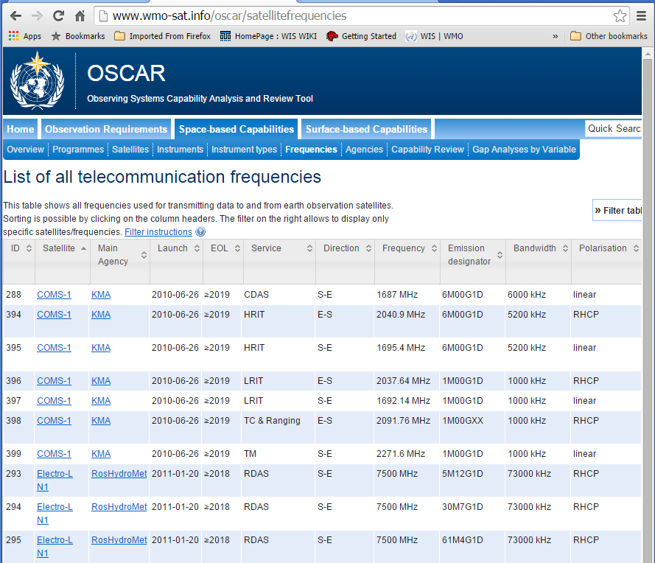
Figure 1 OSCAR Communication Frequencies

Future developments
A major development at this time is the implementation of OSCAR/Surface. This will be the central repository for the components of WIGOS metadata about observing stations and platforms other than satellites that are of most interest to the international community (See Figure 3). OSCAR/Surface presently contains information from WMO No 9 Volume A, the WMO station index, and includes what observations are being made at each registered site. It also contains station data from partner programmes such as Global Atmosphere Watch (GAW) and the Joint Commission for Marine Meteorology (JCOMM). Metadata about satellite observing systems are held in OSCAR/Space.
The need has also been identified for allowing users to make queries based on frequencies both for communications usage and for instrument operating characteristics. At present, the only frequencies directly searchable are those used for telecommunications that are recorded in OSCAR/Space. Within OSCAR/Space the remote-sensing frequency information is recorded in a text form only, but this might be reconsidered in a future version in order to facilitate the use of OSCAR/Space by SG‑RFC members if required. It is also considered that OSCAR/Surface will work towards making available frequency related characteristics, although at this time, the demand for this capability is seen as small.
An important step in developing frequency requirements of OSCAR/Surface is in ensuring that the metadata standard and architecture are able to capture the right elements. The WIGOS metadata group and climate database metadata group are working with little guidance, but have already noted the need to consider communications and passive/active remote sensing elements. The secretariat has also provided them with the elements described in the work being done in identifying the frequency needs of Space Weather (See SG-RFC 2015 Doc 19). The metadata experts’ initial goal is to ensure that the basic elements are captured and that further elements can be added without breaking the metadata standard. This work is being done in parallel to the development of OSCAR/Surface so it is also important for the OSCAR database developers to know as early as possible the likely structure and relationships between the frequency related elements of the metadata.

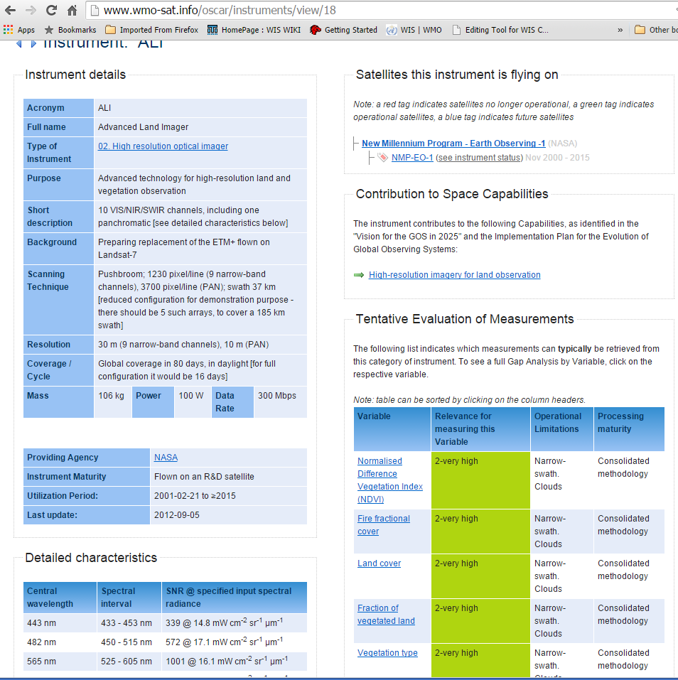
Figure 2 Instrument Frequencies

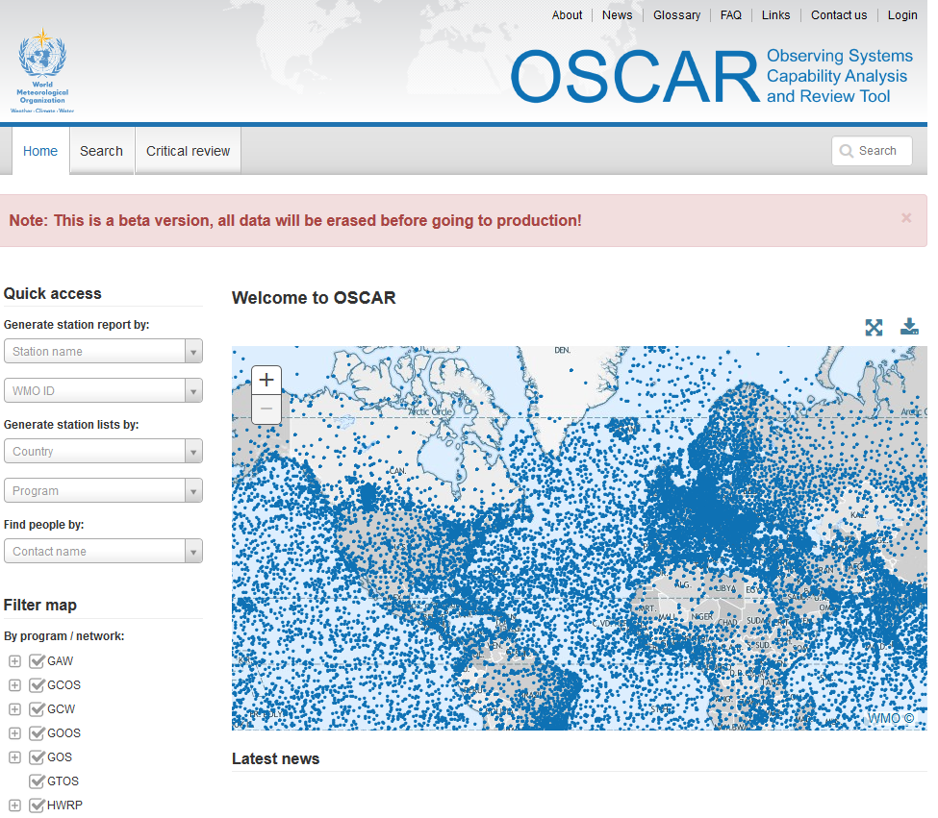
Figure 3 OSCAR Surface

Feedback from SFCG

A similar document to this one was provided to SFCG-35 this year along with demonstrations on how to use OSCAR/Space for exploring frequency usage. SFCG responded well to the demonstration with some members indicating that they were already using OSCAR/Space. The meeting compared the data in OSCAR with CEOSS and other databases that SFCG use noting that it would be a valuable asset complementary. They highlighted that making such information available was likely to be very useful in demonstrating WMOs use of frequency, but that it could also be used against WMO’s needs if the data was wrong or out of date. That is, if the representation of usage in the database was lower than reality or contained misleading out-dated data. SFCG participants committed to reviewing the OSCAR/Space further and providing feedback through the WMO Secretariat.

Summary
OSCAR is an important tool for WMO’s Integrated Global Observing System framework as a reference for studies, and in particular to facilitate gap analyses between users’ observational needs and observing systems current and future capabilities. It contains some information that may be useful to the work of SG-RFC in the form of frequency and or wavelength details for space-based observing and related communication systems. In a new development of OSCAR/Space, as requested by CGMS-43, it is envisaged to make the information on all (active, passive and comms) frequency use available and searchable, such that pre-defined reports are easily accessible via external hyperlinks. This would further improve the usefulness of OSCAR/Space for frequency coordination purposes. There is no equivalent information in OSCAR/Surface at the moment but with support of expert users such as SG-RFC members, developers and observing system providers can be encouraged to record suitable information for surface based observing systems and instruments in OSCAR/Surface.
SG-RFC is requested to explore the use of OSCAR, taking note of current capabilities in OSCAR/Space and the beta version of OSCAR/Surface with an aim to improving OSCAR/Space and OSCAR/Surface to meet the very specialist needs of radio frequency coordination. Perhaps a focal point can be nominated to work with the metadata and OSCAR development teams.

Annex 1 Simple examples of finding frequency related data in OSCAR/Space
Observing Systems Capability Analysis and Review Tool (OSCAR)
OSCAR exists in two major components. 1) Surface based observations, and 2) Space Based. The focus here is on OSCAR Space which contains useful information on radio frequency usage of Earth observations from a WMO Space Programme perspective.
Option 1: For Telecommunication and ranging frequencies only
These frequencies are associated to the satellites (not to the instruments)
Step 1:
Go to the OSCAR page http://www.wmo-sat.info/oscar/spacecapabilities
Step 2 :
Click on the Frequencies Tab to display all frequencies used for transmitting data to and from earth observation satellites. Sorting is possible by clicking on the column headers.
The filter on the right allows displaying only specific satellites/frequencies. See http://www.wmo-sat.info/oscar/satellitefrequencies
Alternative to step 2:
You can also access directly to the information related to a satellite in starting to type the satellite name in the “Quick Search” window on the top right of the screen, and selecting the required satellite in the drop-down menu. When available the telecommunication frequencies are listed in a table at the bottom of the page.
Option 2: For remote-sensing frequencies
These frequencies are associated to the instruments (not to the satellites).
Step 1:
Go to the OSCAR page http://www.wmo-sat.info/oscar/spacecapabilities
Step 2:
For instrument related frequencies, click on “Instrument Types” tab. See http://www.wmo-sat.info/oscar/instrumenttypes
Here you will get a list of instruments by type (eg MW sounding radiometer, cross-track scanning)
Types 6, 7, 8 and 9 include passive MW sensors. Types 16, 17 and 19 include active MW sensors.
Step 3:
Click on Instrument Acronym (eg ATMS). See http://www.wmo-sat.info/oscar/instruments/view/53
The instrument details are summarised in the table on the top left, while more detailed characteristics are listed in the table on the bottom left and when available or relevant include the central frequency and the bandwidth, polarizations etc. Note that some of these are represented as wavelengths rather than frequencies.
Alternative to steps 2 and 3:
You can access directly to the information related to an instrument in starting to type the instrument name in the “Quick Search” window on the top right of the screen, and selecting the required instrument in the drop-down menu.
Note that for some instruments, the frequencies or wavelengths may only be available in the Short Description Field, but there are many with detail characteristics.

Annex 2 Simple examples of finding frequency related data in OSCAR/Surface

Step 1 (Method 1)
Go to OSCAR/surface at https://oscar.meteoswiss.ch/OSCAR/index.html#/ (See Figure 3 Above)

Step 2
Deselect all programs except GAW from table on bottom left corner

Step 3
Click on any station on the map
This will bring you to details on the station with a fixed URL.
Eg https://oscar.meteoswiss.ch/OSCAR/index.html#/search/station/stationReportsDetails/407 for Santa Maria Island (Azores) (Portugal)

Step 4
Click on the “>” in “> Observations / Measurements” to open drop down menu

Here you will see a list of observation made with a summary description of “Method”

Step 4
Click on the “>” in “> {type of observation (eg Total column ozone)}”
This will show the details in a drop down menu as follows in our ozone example

Total column ozone - [Method: Dobson]  Variable:  Variable unit:  Analytical method:  Programs / network affiliation:  Source of observation:  Geometry:  Latency:  Near Real Time:  Data centre:  Data policy / use constraints:  Last updated: | Total column ozone  (unknown)  Dobson  GAW ( from 1958-07-31 )  (unspecified)  (unspecified)  (unknown)  No  World Ozone and UV Data Centre  (unspecified)  On 2004-10-31

Alternative approach using advanced search
Step 1 (Method 2)
Go to OSCAR/surface at https://oscar.meteoswiss.ch/OSCAR/index.html#/ (See Figure 3 Above)

Step 2
Select “Search” from the top tab

Step 3
Select “>” from “>Search using advanced criteria”

Step 4
a) search by “search term” – enter Dobson
this will provide a map of stations using Dobson Spectrometers
Click on any station for details.

Step 4 alternative
b) search using one of the more detailed elements, eg “Variable”
Click on “.-“ option and Select Atmosphere, then Ozone then click on “Add” at the bottom
Then hit search
This will give a map of ozone detection equipment
Click on any station for details.

(Baseline 1 August 2014 – 6 March 2015)
Global Space-based Inter-calibration System (http://www.wmo.int/pages/prog/sat/GSICS/ )

