|  |  |  |  |  |
| --- | --- | --- | --- | --- |
| **WORLD WEATHER WATCH**  **COMMISSION FOR BASIC SYSTEMS** |  | | | |
|  | |  | | |
| **Steering Group on Radio Frequency  Coordination (SG-RFC)**  **Geneva. Switzerland. 17-19 Nov 2014.** | | **Document SG-RFC/2014-2-05** | | |
|  | | **11 Nov 2014** | | |
|  | | **English only** | | |
|  | |  | | |
|  | | **Restricted access required? (Y/N)[1]\*** | **N** |  |
| STEERING GROUP ON RADIO FREQUENCY COORDINATION (SG-RFC) | | | | |
| David Franc (USA) | | | | |
| ITU-R New Report on Assessment of interference to radars operating within the 2 700-2 900 MHz band from broadband wireless systems operating in adjacent frequency bands | | | | |

**Introduction**

Within the last few years in several countries there have been some cases of interference into meteorological and air traffic control radars operating in the frequency band 2700-2900 MHz from broadband wireless systems operating in the lower adjacent frequency band. These cases of interference have been successfully mitigated through the use of several mitigation techniques applied to both radars and the broadband wireless systems, depending on the particular interference case and mechanism. The attached ITU-R Report provides guidance for characterizing the interference, isolating interference mechanisms, and application of mitigation techniques. This information may be of value to all operators of meteorological radars operating in the 2700-2900 MHz frequency band, and possibly other frequency bands as well.

**X. Action (by SG-RFC) Proposed**

The ITU-R Report, approved by ITU-R Study Group 5 on November 11, 2014, is attached. This report was developed to be used as a reference for administrations that may experience similar interference in the frequency band 2700-2900 MHz. It is recommended that the SG-RFC take steps to make this Report known to Members.

**Y. Draft Text for Inclusion in the SG-RFC Meeting Reports or Other Documents**

The Meeting Report should refer Members to this new Report as a valuable tool for resolving adjacent band interference to meteorological radars.

|  |  |
| --- | --- |
| **Radiocommunication Study Groups** |  |
|  |  |
|  |  |
| Source: Document 5B/TEMP/364(Rev.1) | **Document 5/181-E** |
| **6 November 2014** |
| **English only** |
| **Working Party 5B** | |
| DRAFT NEW REPORT ITU-R M.[OOB S-Band] | |
| **Assessment of interference to radars operating within the 2 700-2 900 MHz band from broadband wireless systems operating in adjacent frequency bands** | |

This Report addresses issues experienced by radar systems from broadband mobile systems operating in adjacent frequency bands.

It provides information on interference cases that some administrations had encountered during deployment of broadband transmissions (i.e., WIMAX/LTE/OFDM) in an allocated band below 2 690 MHz, which caused interference to existing meteorological and aeronautical radionavigation radars operating in the frequency band 2 700-2 900 MHz. Although these are individual instances, it highlights a potential issue related to the continued safe operation of radar services.

Based on information available to date, this document provides knowledge of potential interference mechanisms, mixing vulnerabilities of radars in the vicinity of broadband transmitters and their characteristics. It identifies potential root causes of interference such as shortfall in selectivity performance of certain types of radars, unwanted emissions from broadband base stations into the radar receiver passband causing desensitization of radar receivers or interference strobes, radar front-end overload (also called receiver blocking) by strong signals of broadband communications, and out of band interference due to insufficient distance and frequency separation between broadband transmitters and radar receivers.

The interference problems that are documented in this report occur even though both broadband communication transmitters and radar receivers meet all currently applicable technical regulatory performance criteria.

This report also considers several mitigation techniques based on a combination of frequency separation, and/or spatial separation, with or without modification of Base Station’s antenna pattern, retuning radar frequencies and modification the radar receivers.

Choosing or defining an appropriate mitigation technique to address an interference case is complex, because it requires multi-criteria trade-offs, and considered limitations or non-effectiveness of different techniques noting that adjacent bands interference requires a case-by-case consideration, to point out a solution.

It has also to be noted that, in some cases, interference in radar receivers cannot always be identified by an operator, as visible strobes on the radar data display, and corruption of key radar products can take place long before any visible strobes appear, hence no interference mitigation techniques could be applied to effectively protect radar products from being corrupted by this interference.

This Report, based on operational experience of some administrations regarding interference between broadband wireless systems and radar systems provides information which could help administrations to outline methodologies for understanding the nature of interference which could impact radars. Furthermore, this information could be helpful regarding the future IMT network deployment plan in the band 2 500-2 690 MHz, noting that all mitigation options require some level of coordination between broadband service providers and operators of adjacent-band radars with some trade-offs between costs, effectiveness, and coordination efforts in order to reduce the likelihood of interference.

STUDY 1

**1 Introduction**

This study describes an investigation of radio frequency interference into meteorological radars operating above 2 700 MHz .The Report contains a methodology for determining the interference source, its mechanism, and interference mitigation techniques. In addition, it shows that interference from broadband systems emitting orthogonal frequency division multiplexed (OFDM) broadband transmissions in the upper band segment of the frequency band 2 614-2 690 MHz can result in interference to meteorological radars operating in adjacent bands.[2]

The study documents that unwanted emissions into the adjacent frequency band from broadband base station transmitters can cause interference to meteorological radars. It quantifies the power levels that result in interference to the radar receivers and the amount of de-coupling that is required to mitigate the interference. It also describes several mitigation techniques which are based on a combination of frequency separation and/or spatial separation with and without antenna down-tilt.

**2 Executive summary**

The study outlines a methodology for identifying the nature of interference which was impacting several meteorological radars sites and identifies several techniques which can be used to mitigate unwanted emissions interference from broadband systems into meteorological radar systems which are operating in adjacent bands. The solutions include: careful frequency planning to maximize the frequency differences between broadband transmitters and meteorological radar receivers, using down-tilt of the broadband antennae along with careful placement and height adjustment, and installing filters on the outputs of broadband transmitters to reduce their unwanted emission levels into the adjacent frequency band.

The Report shows that, because the noise like emissions from the broadband transmitters are on the radars’ assigned frequencies that adding filtering to radar receivers will not mitigate the interference.

The Report describes the trade-offs between costs, effectiveness, and coordination efforts for each solution and concludes that careful network planning and effective communication between radar operators and broadband service providers can significantly reduce the likelihood of the occurrence of interference.

**3 Background**

Several administrations have examined the issue of electromagnetic compatibility between radar transmissions (2 700-2 900 MHz) and broadband wireless systems using frequencies just below 2 700 MHz[3]. These studies indicated that interference between broadband systems operating just below 2 700 MHz and radars that operate above that frequency were likely. The Electronic Communications Committee (ECC) of the European Conference of Postal and Telecommunications Administrations (CEPT) recently released its own report on compatibility in Europe between broadband systems operating within the frequency band 2 500-2 690 MHz and the Radiodetermination (radar) service in the frequency band 2 700-2 900 MHz[4]. These studies have also shown that there is a potential for broadband systems operating adjacent to the frequency band 2 700-2 900 MHz to interfere with radar operations within the frequency band 2 700-2 900 MHz. Additional reports by other administrations and various agencies have also shown that unwanted emissions from OFDM broadband systems can interfere with adjacent band services.[5]

In May 2010, a brief preliminary investigation of operational meteorological weather radar products indicated that interference from broadband OFDM based systems had been occurring to meteorological radars operating in the frequency band 2 700-3 000 MHz. This investigation employed a methodology that used combined data observations of weather- reporting and earth-satellite observation web sites. NEXRAD[6] radar weather products at several locations across the United States showed strobes[7] that aligned on azimuths of local broadband service base stations within line-of-sight of the radar stations. Although this circumstance could have been coincidental, further investigation was needed to characterize the radio frequency (RF) environments so that the interference could be identified. Figure 5 shows a meteorological radar display when no interference was present; the multi‑colour zone near the radar is a normal, clear-air, interference-free baseline condition.

Figure 5

**Normal, clear-air, interference-free baseline condition**

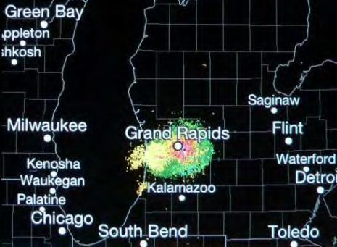

In contrast, Figures 6-8 show examples of radar displays when interference was present. As seen in Figures 6-8, the strobes contaminated all three of the radar’s base moments: reflectivity, velocity, and spectrum width data. (The meteorological radar that was impacted by this interference is described more fully in Annex 2 of this Report.)

Figure 6

**Strobes (three radial blue-and-green lines compared to Figure 1)  
caused by interference to the reflectivity data**

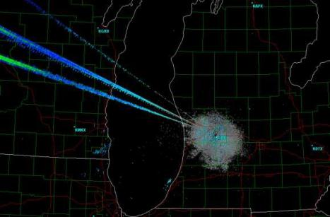

Figure 7

**Strobes (two radial purple lines) caused by interference to the velocity data**

Figure 7

**Strobes (two radial purple lines) caused by interference to the radial velocity data**

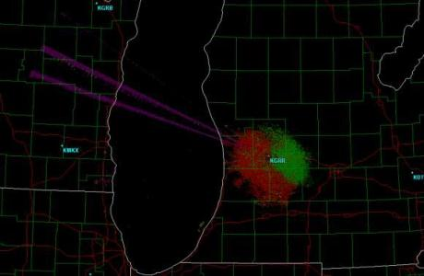

figure 8

**Strobes (two radial purple lines) caused by interference to the spectrum width data**

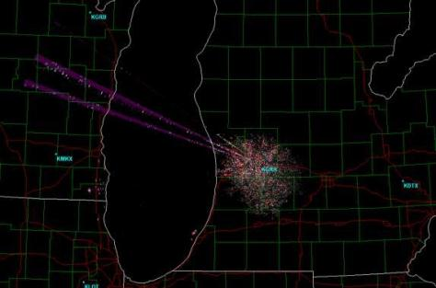

Similar interference was later reported at an additional site. A detailed investigation of both sites was undertaken. Annex 1 presents the results of that analysis and the mitigation techniques which were employed to alleviate the interference.

Preliminary analysis indicated that the source of this interference could be a broadband service base station transmitter located within a few kilometres of the radar’s location. The initial evidence consisted of correlations between broadband service transmission tower azimuths and the azimuths of the strobes. Emission spectra of the interference sources that were collected within the meteorological radars receiver were consistent with known emission spectra of WiMAX transmitters.

The interference to the meteorological radar had begun shortly after broadband services were inaugurated in that area. A measurement and analysis program to positively identify the source of the interference and to develop interference mitigation techniques was undertaken.

**4 Measurement and analysis overview**

The overall goals of the measurement program and analysis effort were to identify and document the source of the interference, identify the interference mechanism (i.e., to distinguish between the mechanism of RF front-end overload in the meteorological radar receivers versus interference directly on the radar operational frequencies), and determine the power level of the interference relative to the internal receiver noise floor of the radar receiver. With these data in hand, EMC analyses could lead to technical solutions for the interference problem. Specific tasks to accomplish were:

1) Measure and record the RF and intermediate frequency (IF) response (frequency selectivity) of the NEXRAD receiver’s RF front-end filter.

2) Measure and record the NEXRAD front-end low noise amplifier (LNA) gain-response curve as a function of frequency and determine its power-output compression behaviour.

3) Measure and record the RF frequency-domain response of the entire NEXRAD RF front end, comprising its RF bandpass filter, passive diode limiter (PDL), and LNA.

4) Measure and record the frequency response of the entire NEXRAD receiver from the input of the RF front-end filter to the output of the IF stage.

5) Formally document the RF configuration of the NEXRAD receiver front end and IF down conversion hardware stages.

6) Formally document the interference by measuring and recording the interference in both the frequency domain and the time domain at the following points in the NEXRAD receiver: a) the antenna output (which is the same as the front end RF bandpass filter input); b) the LNA output; and c) the IF stage output.

7) Observe and record the overall interference environment by scanning 360 degrees of horizon around the NEXRADs at a low elevation angle while the radar was operated in a receive only mode and the IF stage output was monitored and recorded in the time domain for the duration of the scan. Any interfering signals that were being received at or above -6 dB below the radar receiver’s internal noise floor would appear as bumps that would be 1 dB or more higher than the receiver’s noise floor. The interference signal at each bump was observed in the time domain to ascertain its modulation and hence its likely source. This observation would identify interference signals that could cause possible degradation of the NEXRADs’ performance but which were too   
low-powered to produce overtly visible strobes on the radar’s plan position indicator (PPI) output display.

With these objectives in mind, measurements were taken at two meteorological radar sites. The details of the work associated with these measurement and analysis objectives are included in Annex 1, the technical characteristics of the meteorological radar that were involved in the measurement program are included in Annex 2, the technical characteristics of the broadband systems that were the suspected source of the interference are included in Annex 3 and potential interference mitigation methodologies are include in Annex 4.

**5 Summary**

In this study, interference from WiMAX base stations operating below 2 690 MHz to nearby meteorological radar receivers operating above 2 700 MHz has been examined and confirmed.[8] The interference occurs at meteorological radars stations that are relatively close to broadband service base stations in both frequency and spatial separation.

Although a particular interference source has been identified (WiMAX emissions), the interference is not caused by any unique aspect of WiMAX waveforms or emissions. Any RF base station transmitters operating in the so-called WiMAX frequency band between 2 600-2 690 MHz (e.g., possible future LTE stations) could potentially cause such interference. The interference occurs even though the WiMAX and adjacent-band radar stations meet all applicable statutory technical regulatory criteria.

In this case, interference from WiMAX base stations operating below 2 690 MHz to adjacent‑band meteorological radars operating above 2 700 MHz in Grand Rapids and Jacksonville have been examined. The problem has only been observed in those locations as occurring in NEXRAD radar receivers.6 The problem occurs at NEXRAD stations when they are relatively close to WiMAX base stations in both frequency and spatial separation. The specific conclusions that have been developed in this study are provided below.

**6 Conclusions**

Interference from broadband OFDM systems at two sites in the United States has been shown. Although these are individual instances of a potentially more widespread problem, additional situations and circumstances may need to be evaluated on case-by-case basis. Measurement data indicated that unwanted emissions into the adjacent frequency band from broadband service WiMAX base stations are the cause of interference to meteorological radars. Front-end receiver amplifier overload have been ruled out as the measured characteristics of the meteorological radar that was being interfered with show that front-end overload should not occur in its receiver. Using measurement data and known characteristics of WiMAX base stations, frequency-separation distance separation curves have been developed for WiMAX base stations located in the vicinity of 2 700-3 000 MHz radars. A set of mitigation options that will resolve all known or likely incidences of interference from WiMAX base stations to NEXRAD radar receivers has been developed and is presented in Annex 4 of this Report. Output RF filtering of WiMAX base station emissions can provide an effective solution to interference problems without the need to sacrifice any use of spectrum. This option is less costly to install on new base stations than on existing base stations.

Most WiMAX base stations should not need such filtering. But in cases in which interference to meteorological radars in other frequency bands occurs and no other mitigation options are effective or feasible, this option ultimately provides an assured method of mitigation. In summary:

1) The interference problem that is documented in this study occurs even though both the private-sector broadband transmitters (WiMAX) and the adjacent-band meteorological radar receivers meet all currently applicable technical regulatory performance criteria.

2) Measurement data show that NEXRAD receivers that are tuned close to 2 700 MHz are experiencing interference from WiMAX base stations at several locations. These are individual instances of a potentially more widespread problem. Any additional instances will need to be evaluated on case-by-case basis across the country.

3) Interference to ASRs from WiMAX base stations has not yet been observed in the United States.

4) Measurement data indicate that unwanted emissions from WiMAX base stations within the radar receiver passband are the cause of interference to NEXRADs.

5) The measured characteristics of NEXRAD show that front-end overload should not occur in these receivers; unwanted emissions from WiMAX base stations should be the only interference mechanism of concern for these systems.

6) Using measurement data and known characteristics of WiMAX base stations, frequency-separation distance separation curves have been developed for WiMAX base stations located in the vicinity of 2 700-3 000 MHz meteorological radars.

7) A set of mitigation options that will resolve all known or likely incidences of adjacent-band interference from WiMAX base stations to 2 700–3 000 MHz meteorological radar receivers has been developed and is presented in Annex 4 of this Report.

8) Most mitigation options can be implemented with relative ease and at relatively low cost. All mitigation options require some level of coordination between WiMAX service providers and operators of adjacent-band radars.

9) Output RF filtering of WiMAX base station emissions can provide an effective solution to meteorological radar interference problems without the need to sacrifice any use of spectrum. This option is less costly to install on new base stations than on existing base stations. Most WiMAX base stations should not need such filtering. But in cases in which interference to adjacent-band meteorological radars occurs and in which no other mitigation options are effective or feasible, this option ultimately provides an assured method of mitigation.

10) Interference in NEXRAD receivers is not always manifested as visible strobes on the radar data display; strobes only occur when interference is present at relatively high interference-to-noise (*I/N*) levels. Corruption of key weather forecasting products can take place long before any visible strobes appear. Additional measurements should be taken to confirm that the applied interference mitigation technique effectively protects these sensitive weather forecasting products from being corrupted by the interference.

11) Filtering has been implemented at several WiMAX base station sites that has been shown to be effective in mitigating the interference to meteorological radars.

12) Since the interference is due to WiMAX RF energy falling within the passband of the radar receiver, filtering applied to that radar will not mitigate the interference without also rendering the radar inoperable. Filtering applied to the radar receive path will also suppress the radar return signals.

STUDY 2

**European Radar adjacent band selectivity**

**1 Summary**

Some European countries have identified a potential vulnerability of meteorological and aeronautical radars that operate in the frequency band 2 700-3 100 MHz with respect to transmissions in the frequency bands 2 500-2 690 MHz. The issue has initially been attributed to inadequate radar receiver selectivity to adjacent band transmissions although other mechanisms have not yet been ruled out. This document provides an initial quantification of radar selectivity from some European countries’perspective, based on information available to date. This information identifies suitable mitigation techniques that may have to be refined and completed. The objectives in doing so are to highlight a potential issue related to the continued safe operation of radar services and to enable full use of the adjacent bands for non-radar services as soon as possible.

**2 Introduction**

This document provides information on the receiver performance of some meteorological and aeronautical radars operating within the frequency band 2 700-3 100 MHz and the potential susceptibility to transmissions in adjacent bands, which can include those of wireless base-stations operating within the frequency bands 2 500-2 690 MHz. This document highlights the key interim findings, to date, from some European administrations on a potential shortfall in selectivity performance of certain types of radars.

The document provides a first set of results from on-going investigative studies undertaken in some European countries on the potential for interference to aeronautical air traffic control (ATC) navigation radar systems from reception in the frequency band 2 500-2 690 MHz. Results include system modelling of radar performance and measurements of radar performance undertaken on a limited number of test radars.

**3 Background**

Agenda item 1.6 of the 2000 World Radiocommunication Conference sought to identify additional global frequency bands for the terrestrial component of IMT-2000. As a result of this agenda item RR footnote **5.384A**[9] was added to identify that the mobile allocations in the frequency range

2 500-2 690 MHz could be used by IMT-2000 by those administrations wishing to implement such applications. This footnote was later amended to include the frequency band 2 300-2 400 MHz and remove the 2000 designation after IMT.

At WRC-07, agenda item 1.4 sought to identify additional spectrum bands for services described as IMT. This led to regulatory changes that identified the frequency band 3 400-3 600 GHz for IMT.

The use of the frequency band 2 700-3 100 MHz by radars is adjacent to the frequency bands 2 500‑2 690 MHz assigned for use by fixed and mobile services (among other services). A number of countries, including all 27 European Member States, have identified the frequency band 2 500‑2 690 MHz for use by IMT systems. Additionally, a number of countries already make use of the frequency bands 2 500‑2 690 MHz for wide-area terrestrial systems; a number of countries are also planning to make these bands available for use by such systems in the near future.

In Europe the Commission has harmonised the use of 2 500-2 690 MHz frequency band for terrestrial systems capable of providing electronic communications services (Commission Decision 2008/477/EC). The use shall be on a technology and service neutral basis. Member States are required to designate and subsequently make available, on a non-exclusive basis, the frequency band 2 500-2 690 MHz for terrestrial systems capable of providing electronic communications services in compliance with certain RF parameters including maximum in-band e.i.r.p. level. Some European countries have already completed this process while other countries are at various stages within the process.

**4 Scope**

This document addresses the Radar adjacent band selectivity issues identified in the initial studies detailed in sections 5.1 to 5.6 below. This work is in progress and may generate further relevant information.

**5 Work undertaken to date**

**5.1 Initial study**

As a part of the on-going preparations to make the frequency band 2 500-2 690 MHz available for new applications, a study to conduct a study to assess the potential susceptibility of radars operating above 2 700 MHz to transmissions in the frequency band 2 500-2 690 MHz. The objective of the study was to provide an indication of the maximum levels of transmissions that a radar could tolerate at its receiver in terms of: the out-of-band interference into the Radar IF pass band potentially due to insufficient transmitter mask and intermodulation phenomena of broadband signals; blocking performance due to the effects of amplifier saturation within the Radar receiver pass-band; and adjacent channel selectivity from receiving adjacent channel power due to imperfect Radar receiver filtering characteristics.

For this study, trials using a test Radar into which they injected four types of adjacent band signal (CW, AWGN, and test WiMAX /UMTS signals) and measured the impact on the radar performance for both co-frequency as well as at various frequency offsets from the radar centre frequency. A Report was produced by those conducting the studies in October 2008 the main findings of which are given below.

**5.1.1 Co-channel interference**

The results for continuous interference (i.e. interference continuously present on all azimuths) show that there is good correlation between the modelled radar performance and the measured results for the injected tests. The theoretical noise floor of the radar was calculated at –110 dBm and the values below show the measured interference level required to reduce the probability of detection (Pd) from an initial level that is varied relative to a reference signal level (RSL) to 50% allowing for measurement tolerances. The wanted return signal level was then adjusted in order to simulate various probabilities of detection in the absence of interference, noting that the RSL +0.2 dB case equates to a radar suffering interference at an I/N level of –10 dB. Comparing theory, which would predict for the case of RSL + 0.2 dB an interference level of –120 dBm per 3MHz bandwidth, with the results given below in Table 1 shows good correlation.

Table 1

**Summary of co-frequency results for continuous interference in   
IF filter (~3 MHz) – Initial study for test radar**

|  |  |  |  |  |
| --- | --- | --- | --- | --- |
| **Interference type** | **Interference level (dBm/3 MHz)** | | | |
| **RSL + 0.2 dB  (90 to 88%; 70% to 66%; 60 to 55%)** | **RSL + 1 dB**  **(70% to 50%)** | **RSL + 2 dB**  **(90% to 50%)** | **RSL + 3 dB**  **(100% to 50%)** |
| **AWGN 2.5 MHz** | –120 | –115 | –111 | –108 |
| **UMTS downlink** | –118 | –111.5 | –108 | –106.5 |
| **WiMAX (5 bursts)** | –117.5 | –113 | –108.5 | –104.5 |

It was noted that continuous interference received in all azimuths represented a worst case scenario. The continuous interference case was simulated at the start of the measurements programme to simplify the test setup and ensure that worst-case scenarios were properly understood. Momentary interference generation was later adopted within the tests, which better reflects the case of a radar beam sweeping past an adjacent channel transmission. For momentary interference, the level of interference required to produce the same loss of Pd was 7 to 10 dB higher than the results indicated in Table 1 above (i.e., allowing for more interference power to cause the same degradation in Pd).

**5.1.2 Adjacent channel blocking**

A theoretical study was conducted as a part of the initial study into a first approximation of how the radar receiver response to CW signals varies with frequency, considering the impact of the various components of the system. The result of this study are shown below, however it should be noted that this study assumes that the lowest tuneable frequency is 2 700 MHz which is incorrect and should have been taken as 2 750 MHz for the radar type under consideration and hence the results should be shifted by 50 MHz (i.e. with radar carrier at 2 750 MHz instead 2 700 MHz).

Figure 1

**Theoretical modelling (first approximation) of CW interference effects   
for test radar (assuming an assigned carrier at 2 700 MHz)**



Injected testing was then carried out to measure how the radar receiver response to interfering signals varies with frequency for various levels of probability of detection in the absence of interference. A summary of those results is given below.

Table 2

**Summary of results for CW with continuous injected interference – Initial study with test radar**

|  |  |  |  |  |
| --- | --- | --- | --- | --- |
| **Frequency offset** | **Interference level (dBm)** | | | |
| **RSL + 0.2 dB  (90 to 88%; 70% to 66%; 60 to 55%)** | **RSL + 1 dB**  **(70% to 50%)** | **RSL + 2 dB**  **(90% to 50%)** | **RSL + 3 dB**  **(100% to 50%)** |
| **12.5 MHz** | –85.5 | –79.5 | –74.5 | –76 |
| **25 MHz** | –51 | –46.5 | –45 | –43.5 |
| **50 MHz** | –48 | –45 | –44 | –41 |
| **100 MHz** | –48 | –45 | –44 | –41 |

Superimposing the results for RSL +0.2 dB on the approximate theoretical response results in the following diagram. Comparison of the modelled and measured results for (RSL +1 dB) and (RSL +3 dB) are contained in the referenced study Report.

Figure 2

**Comparison of first approximation modelling of the test radar with injected measurements using RSL + 0.2 dB**

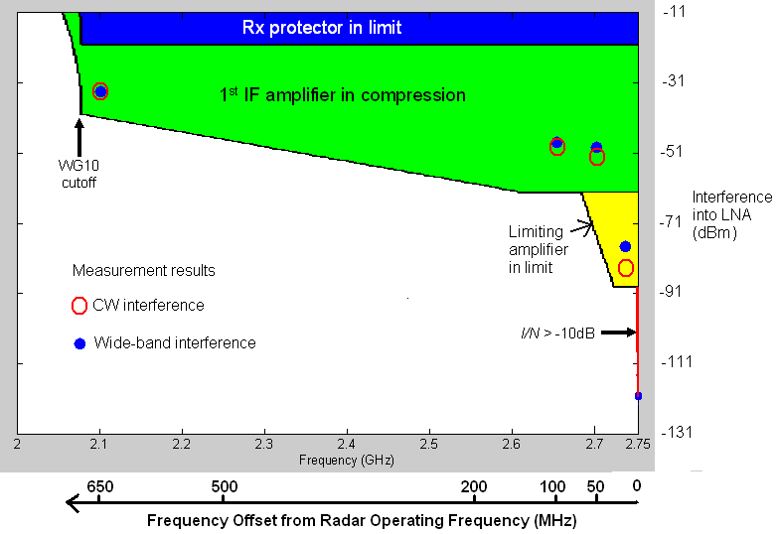

The results indicated that the proposed signal levels within the frequency band 2 500-2 690 MHz from wireless base station transmissions would impact on the performance of the radar type tested operating above 2 700 MHz. The opinions of the radar operators were sought. They confirmed that they regarded these results as significant and that they warranted further investigation. Unless action was taken to address the impact 2.6 GHz band signals would have on the performance of this radar type due to the inadequate adjacent band signal rejection of the radar receiver, future 2.6 GHz transmissions and/or radar operations would have to be restricted.

As a result of discussions between regulatory agencies and radar operators it was therefore agreed that further studies were required. Firstly the results of the injected testing needed to be validated through radiated trials. Secondly work would be needed to investigate, if necessary, how the radar receivers could be modified such that their adjacent band rejection is improved without impacting the operational performance of the radars. Finally work was needed to investigate whether these results were an indication of a generic issue relevant to all radar types or specific to the test radar type under consideration. Further work was therefore commissioned and the results obtained to date are summarised below.

**5.2 Site 1 Flight Trials, Phase 1**

The initial study focused on conducted tests and provided estimates of adjacent band transmission levels into the radar low noise amplifier that would cause a certain level of degradation to non‑fluctuating targets and therefore represented the worst case scenario. These flight trials used radiated measurements with the interference source being located in the main beam of the radar under test at a range of 350 metres. The target aircraft was a King Air B200 with a radar cross section (nose on) of 3.5 square metres.

A total of 18 runs were performed using various interference waveforms and at various signal levels. Each run was initiated at 54 NM and terminated at 28 NM with the aircraft maintaining a velocity of between 220-230 kts. The probability of detection was assessed from 50 nm to 30 nm to ensure that the aircraft was in stable flight along the predetermined flight path. Attenuation was applied in the radar receiver font end to emulate an aircraft with a cross sectional area of 1 square metre.

The test radar has three processing channels: Normal Radar (NR), Ground Clutter Filter (GCF) and Moving Clutter Filter (MCF).They will yield different results for signal and interference depending on the correlation of these signal inputs and Constant False Alarm Rate (CFAR). The output of these three channels are combined using an “OR” function, but they can be separately switched On/Off.  The NR channel has the lowest Signal to Noise Ratio (SNR) for a given Pd.  The effective detection thresholds for GCF and MCF are higher due to the processing required to remove clutter etc. During the testing, the Normal Radar and Ground Clutter Filter outputs were used and the results obtained are shown below.

Table 3

**Log of interference tests for each flight run and the average Pd for that run**

|  |  |  |  |  |  |
| --- | --- | --- | --- | --- | --- |
| **Run** | **Radar channel** | **Interference type** | **Interference frequency** | **Interference level, e.i.r.p. (dBm) at 350 m** | **Probability of detection  (Average over 50 nm to 30 nm)** |
| 1 | NR | CW | 2 690 MHz | OFF | 95% |
| 2 | NR | CW | 2 690 MHz | Level 1 = 50 dBm | 0% |
| 3 | NR | CW | 2 690 MHz | Level 2 = 35 dBm | 91% |
| 4 | NR | CW | 2 690 MHz | Level 3 = 20 dBm | 92% |
| 5 | GCF | CW | 2 690 MHz | OFF | 90% |
| 6 | GCF | CW | 2 690 MHz | Level 1 = 50 dBm | 19% |
| 7 | GCF | CW | 2 690 MHz | Level 2 = 35 dBm | 82% |
| 8 | GCF | CW | 2 690 MHz | Level 3 = 20 dBm | 76% |
| 9 | NR | AWGN 10 MHz | 2 690 MHz | Level 1 = 50 dBm | 0% |
| 10 | NR | AWGN 10 MHz | 2 690 MHz | Level 2 = 35 dBm | 69% |
| 11 | NR | AWGN 10 MHz | 2 690 MHz | Level 3 = 20 dBm | 92% |
| 12 | GCF | AWGN 10 MHz | 2 690 MHz | Level 2 = 50 dBm | 65% |
| 13 | NR | WiMAX 80% | 2 690 MHz | Level 1 = 35 dBm | 0% |
| 14 | NR | WiMAX 80% | 2 690 MHz | Level 2 = 50 dBm | 88% |
| 15 | NR | WiMAX 80% | 2 690 MHz | Level 3 = 35 dBm | 95.5% |
| 16 | NR | CW | 2 600 MHz | Level 1 = 50 dBm | 53% |
| 17 | NR | CW | 2 600 MHz | Level 2 = 35 dBm | 95.5% |
| 18 | NR | CW | 3 400 MHz | Level 2 = 35 dBm | 18% |

As would be expected, the probability of detection varied for each run with distance and the graph below illustrates the case for runs conducted when the Normal Radar channel was selected:

Figure 3

**Aircraft runs 1, 3, 17, 18, radar NR channel CW and AWGN interference – Test radar**



The results of these trials correlated within measurement accuracy with those obtained during the initial study.

**5.3 Design authority study**

A study was commissioned from the radar design authority, which was divided into two parts. The initial work was to develop a theoretical model of the test radar and use it to predict the impact that adjacent band signals would have on the radar. The subsequent work was to investigate the feasibility of modifying the radar receiver in a way that would be performance neutral with respect to its primary function but increase its ability to reject adjacent band signals.

The study contractor produced a mathematical model of the test radar receiver front end which took into account various gains, losses and filtering effects of the radar receiver stages. The results of this model were then compared to the measured results from the initial injected tests (see paragraph 4.1 above), both for modelled and measured performance, with the result as shown below with the yellow dots indicating the measured points.

Figure 4

**Modelled susceptibility of a test radar to adjacent use**

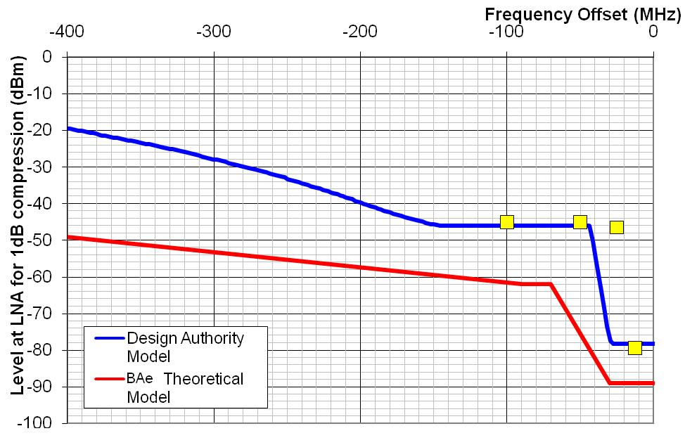

This revised modelling reduced the discrepancy that was present in the initial study between the theory and practical measurement with the exception of one point. However on further investigation it was found that the radar used for the initial testing had been modified to operate with a narrower IF bandwidth filter and, once this was taken into account, the one obvious marked difference was explained.

Having confirmed the results obtained in the initial testing the study contractor investigated how the radar adjacent band rejection could be improved. It was noted that, as was common design practice when the relevant test radar was designed, all of the filtering stages were after the amplification stages in order to minimise the noise figure. However since the low noise amplifier has a gain of around 34 dB, the impact on the noise figure of the radar of any filter fitted after this stage would be insignificant with the impact decreasing for filters installed further down the receiver chain. Therefore the order of the 1st IF Amplifier and filter could effectively be switched without degrading the noise figure of the receiver in order to improve the adjacent band rejection performance of the radar.

Running this configuration through the mathematical model indicated that, whilst the adjacent band performance of the radar was significantly improved as a result of the configuration change, it did not resolve the whole issue. The manufacturer estimated that additional mitigation would be required in the main radar beam, but not the auxiliary or high beam due to the additional antenna discrimination that was provided by this beam to the horizon. Replacing the current low noise amplifier with one that had a lower noise figure allowed an additional filter to be incorporated without theoretically affecting the operational performance.

The modification, combined with the switch in order of the 1st IF amplifier and filter and an upgrade to the main beam radar transmit-receive (TR) protection switch, provided a solution that theoretically met the adjacent band performance requirement without compromising the operational performance of the radar.

**5.4 Site 1 Flight Trials, Phase 2**

Phase 1 of the trials confirmed that the test radar would experience problems from signals below 2 690 MHz without suitable mitigation measures being put in place (see paragraph 5.2 above). Phase 2 of the trials took place in August 2009 with the intention of testing the effectiveness of the proposed mitigation modification designed by the study contractor (see paragraph 5.3 above). These trials consisted of 19 runs with both, the main beam and high beam as well as low and high radar frequencies being tested, and hence these trials were regarded as more comprehensive than the Phase 1 trials. A summary of the trial results is given below.

TABLE 4

**Probability of detection (MB averaged over 50-30 nm, AB averaged over 30-24 nm or to the O/H)**

|  |  |  |  |  |  |  |  |  |
| --- | --- | --- | --- | --- | --- | --- | --- | --- |
| **Run** | **Radar channel** | **Interference source** | | | **Radar frequency** | **Test range (nm)** | **Pd** | |
| **Modulation** | **Frequency (MHz)** | **e.i.r.p. (dBm)** | **Video%** | **Plot %** |
| 1 | NR attenuated | Reference | | | F2 | 50-24 | MB 92.9  AB 100 |  |
| 2 | NR attenuated | CW | 2 690 | 50 | F2 | 50-24 | MB 88.1  AB 100 |  |
| 3 | NR Attenuated | CW | 2 690 | 50 | F1 | 50-24 | MB 80.2  AB 100 |  |
| 4 | NR | CW | 2 690 | 53 | F2 | 50-OH | MB 56.6  AB 99.2 |  |
| 5 | NR | CW | 2 690 | 53 | F1 | 50-OH | MB 93.1  AB 99.3 |  |
| 6 | NR | Reference | | | F2 | 50-OH | MB 100  AB 100 |  |
| 7 | GCF | Reference | | | F2 | 50-24 | MB 85.9  AB 100 | MB 72.7  AB 90.0 |
| 8 | GCF attenuated | CW | 2 690 | 50 | F2 | 50-24 | MB 53.8  AB 100 | MB 40.0  AB 100 |
| 9 | GCF Attenuated | CW | 2 690 | 50 | F2 | 50-24 | MB 85.7  AB 100 | MB 70.9  AB 87.1 |
| 10 | GCF Attenuated | CW | 2 690 | 50 | F1 | 50-24 | MB 80.4  AB 100 | MB 65.3  AB 93.3 |
| 11 | NR | CW | 2 600 | 53 | F2 | 50-24 | MB 95.1  AB 96.6 | MB 85.0  AB 86.7 |
| 12 | NR | CW | 2 600 | 53 | F1 | 50-24 | MB 96.0  AB 100 | MB 86.9  AB 93.3 |
| 13 | NR | AWGN | 2 685 | 50 | F2 | 50-24 | MB 8.1  AB 92.9 | MB 1.0  AB 58.6 |
| 14 | NR | AWGN | 2 685 | 50 | F1 | 50-24 | MB 99.0  AB 100 | MB 83.0  AB 89.7 |
| 15 | NR | WiMAX  10 MHz | 2 685 | 50 | F1 | 50-24 | MB 36.6  AB 96.4 | MB 20.6  AB 83.3 |
| 16 | NR | WiMAX 10 MHz | 2 685 | 50 | F1 | 50-24 | MB 96.0  AB 100 | MB 84.7  AB 86.4 |
| 17 | NR Attenuated | Reference | | |  | 50-24 | MB 83.2  AB 100 | MB 77.8  AB 86.2 |

The results of this trial were not conclusive. Blocking was clearly evident in some of the runs in the January trials and the equivalent runs in the August trials show no signs of blocking, under the higher adjacent channel input powers to the radar receiver. Whilst the results for CW would suggest that the proposed modifications achieved their objective of improving the radar receiver capability to reject adjacent band signals, those for AWGN and WiMAX were less conclusive and would not be sufficient to provide evidence for a safety case. It is believed that the reason for the inconclusive results was the radar receiver in-band noise produced by the interference source; however other mechanisms were not ruled out. The reason for the inconclusive results is therefore still being investigated and may require further flight trials to identify whether it has been correctly identified and satisfactorily resolved.

**5.5 Site 2 Trial**

The purpose of the Site 2 trial was to confirm whether the tested modifications affected the performance of the radar, especially the Moving Target Indicator (MTI), in the absence of 2.6 GHz transmissions. Site 2 was selected for the trial as there is significant ground clutter along the coast near the site. The results of the trials were that the MTI performance was not affected as a result of the modification and that equipment parameters such as noise figure and the minimum discernible signal were either the same or slightly improved. It was therefore concluded that the tested modifications did not adversely affect the performance of the radar.

**5.6 Predicted impact on other aeronautical radars**

In parallel with the practical work described above, discussions have been held with the various radar manufacturers who are the design authorities for radars currently operated in some European countries. As a result of these discussions and the information supplied, it is possible to derive estimates for the potential separation distances between existing radar and transmissions within the frequency band 2 500-2 690 MHz from a mobile network base station. The estimates below are based on assumptions such as the estimated adjacent band radar receiver performance, various assumed margin and link allowances, and the application of free space path loss conditions. They should be regarded as indicative and subject to change as further information becomes available.

Table 5

**Initial estimates of minimum coupling loss separation distances (based on free-space path loss) to avoid the potential for blocking to different ATC radar operating above 2 700 MHz by transmissions  
in the frequency band 2 500-2 690 MHz**

|  |  |  |  |  |  |
| --- | --- | --- | --- | --- | --- |
|  |  | Test radar measured blocking performance | Radar Type 2 assumed blocking performance | Radar Type 3 assumed blocking performance | Radar Type 4 assumed blocking performance |
| Maximum receive power at radar receiver input | dBm | –41 | –41 | –27 | –27 |
| Feeder loss | dB | 2 | 2 | 4 | 2 |
| Pre LNA filter loss@2690MHz | dB | 0 | 0 | 1 | 0 |
| Antenna gain to horizon (wrt Omni) | dB | 28 | 28 | 30 | 28 |
| Antenna cross-polarisation factor (circular polarisation radars) | dB | 3 | 3 | 3 | 3 |
| Multiple interference allowance | dB | 3 | 3 | 3 | 3 |
| Antenna pattern and sitting variation | dB | 2 | 2 | 2 | 2 |
| Apportionment of interference  (e.g. 25% of Interference margin) | dB | 6 | 6 | 6 | 6 |
| Anomalous propagation allowance | dB | 8 | 8 | 8 | 8 |
| **Maximum power incident to equivalent omni antenna (T&D Applications)** | **dBm** | **–83** | **–83** | **–68** | **–69** |
|  |  |  |  |  |  |
| Assumed adjacent channel transmitter power | dBm | 61 | 61 | 61 | 61 |
| **Minimum coupling loss separation** | **km** | **141** | **141** | **25** | **28.1** |
| **(based on free space path loss)** | **NM** | **77.4** | **77.4** | **13.8** | **15.5** |

It should be noted the above estimated separation distances are assumed to be worst case separation distances (and in some cases will be beyond the radio horizon). Further work is expected to quantify the selectivity performance of other types of operational radars. It is anticipated that the protection requirements can be better quantified once testing of the various types of operational ATC radars has been undertaken.

**6 Conclusion**

The work carried out to date clearly indicates that a range of radar receivers are potentially susceptible to planned transmissions below 2 690 MHz (such as those from mobile network base-stations) even if substantially separated by frequency or geography. The effect on the operation of radars, without adjustment of the planned adjacent band transmissions and/or the performance of the radars, is predicted to be unacceptable.

Protecting radar reception from emissions in adjacent bands (and these emissions may have a significant frequency offset from that of the radars) could impose significant constraints on the extent to which adjacent bands may be exploited by non-radar services until radars are upgraded.

Given that similar types of radars are operated by other administrations, the information provided in this document may be used when planning services in the 2 500–2 690 MHz frequency band.

Information gathered so far indicates that the level of susceptibility varies according to the radar type. Generally, newer Solid State ATC radars have better adjacent band signal rejection and hence are thought to be less susceptible than some older types of Magnetron/TWT ATC radars.  Studies are planned to obtain the further data that is needed to assess the extent to which radar types, other than the radar tested, are susceptible to signals generated in adjacent bands.

It is important, in the interests of safety as well as those of prospective users of the frequency bands 2 500-2 690 MHz bands that this issue is addressed as a matter of urgency.

In the longer term, it may be necessary to take concerted international action to improve radar receiver selectivity in the interests of securing optimal use of the radio spectrum.

Annex 1 TO STUDY 1

**Interference measurements at NEXRAD field locations**

**1.1 NEXRAD configuration for measurement and characterization of interference signals**

In response to reported interference at NEXRAD field sites, technical personnel performed an initial set of interference-assessment measurements at the Grand Rapids, Michigan, NEXRAD site. The purpose of the measurements was to identify the characteristics of the interference and to identify, if possible, the interference source(s).

The interference signals were measured and documented by performing measurements of their frequency domain and time domain characteristics at various points within the NEXRAD receiver, as shown schematically in Figure 1. An abbreviated set of these measurements (at one IF point and one RF point) was subsequently performed at the Jacksonville, Florida, NEXRAD station[10].

Detailed procedures that were developed and followed during this study for interference assessments at NEXRAD stations are summarized briefly here. Interference-assessment measurements were performed with the NEXRAD transmitter turned off; the radar was operated in a passive, receive-only mode. The radar antenna was initially scanned 360 degrees around the horizon to catalog and record all possible interference signals with both peak and average detection. The azimuthal catalog was created from spectrum analyzer data, the spectrum analyzer being operated in a zero-hertz span mode with a sweep time equal to the time required to rotate the NEXRAD antenna 360 degrees around the horizon. The spectrum analyzer bandwidth was adjusted to 1 MHz to replicate the processing bandwidth of the NEXRAD receiver. Peak detection showed impulsive activity, including signals from other radars in the area. Average detection eliminated impulsive, radar-like signals and showed only high duty signals such as produced by communication transmitters.

The NEXRAD antenna was then slewed to each individual azimuth where high duty cycle interference signals had been observed. The antenna elevation-tilt angle was adjusted to maximize the level of the interference at each azimuth. Interference was usually maximized at a 0.5-degree elevation angle, the lowest angle of the radar’s regular conical scan[11].

Detailed time-domain measurements of interference characteristics were then performed on each of those azimuths. Time domain measurements of the detected envelope of the interference signal were performed with a spectrum analyzer that was operated in a zero-hertz span mode. Data were recorded via a laptop PC connected to the spectrum analyzer.

Figure 1-1

**Schematic block diagram for NEXRAD interference-documentation measurements at Grand Rapids; at Jacksonville the measurements were only performed at J3 and J15**

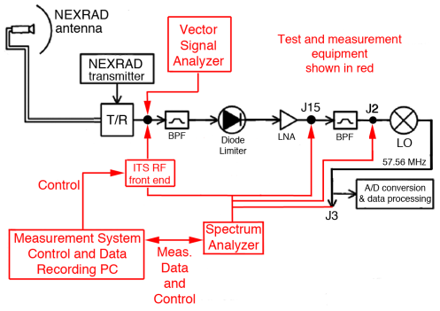

**1.2 Interference azimuth-scan results**

The results of the Grand Rapids 360° peak and average scanning are shown in Figure 1-2. Although some impulsive energy occurred on some azimuths (as evidenced by its appearance on the peak-detected scan but not on the average-detected scan), such emissions are unlikely to cause interference to the NEXRAD receiver due to their low duty cycle. Three azimuths (determined to be four after close examination) exhibited high levels on both the peak and average scans. These occurred on azimuths where interference strobes had been noted in the radar data. It is important to note that the noise floors in Figure 1-2 are those of the radar receiver, not the measurement system*.* Thus the interference-to-noise (*I/N*) ratios that are observed in this figure are the *I/N* ratios of the interference in the radar receiver.

A detailed azimuth-scan observation was performed on each of the interference azimuths that were identified in Figure 1-2. The result is shown in Figure 1-3. In this figure, the exact azimuths of two of the interference lobes are established as being at 289.4° and 304.8°. The central lobe, which showed some complexity in its structure, was examined more closely, with the result shown in Figure 1‑4. It was resolved into two separate azimuths at 294.6° and 296.0°. Similarly detailed sets of individual azimuth scans were performed at Jacksonville.

Figure 1-2

**360-degree interference scan through the Grand Rapids NEXRAD antenna.  
The same 360-degree scan procedure was performed at Jacksonville**

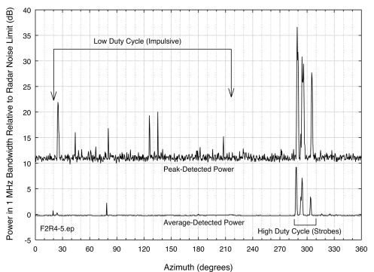

Figure 1-3

**Detailed azimuth scan on interference lobes. The noise floor is that of the radar, peak-detected.  
(The radar average noise floor limit is 10 dB lower.) The middle lobe between 289.4° and 304.8°  
has a complex structure described in Figure 4**

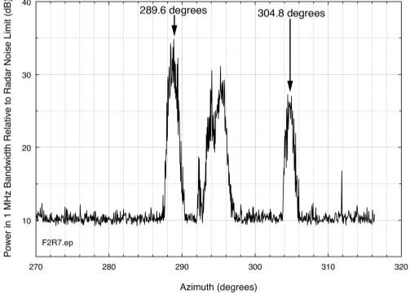

Figure 1-4

**Detailed azimuth scan on the central interference lobe of Figure 32. At this scale, the central lobe  
resolves into two interference azimuths, at 294.6° and 296.0°**

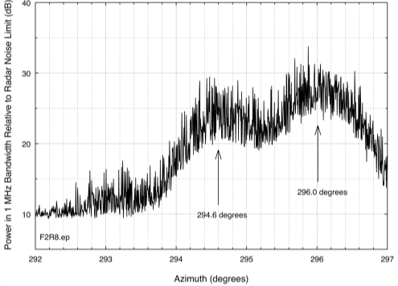

**1.3 Elevation-scan results for the interference signals**

On each of the interference azimuths at Grand Rapids, the NEXRAD antenna was scanned in elevation from 0° to +20°, to ascertain the range of elevations through which the interference is occurring. The results are shown in Figure 1-5 through Figure 1-8. At Jacksonville all measurements were performed at an elevation angle of +0.5°.

Figure 1-5

**Elevation scan at 289.4° azimuth. The interference is measurable up to +2°**

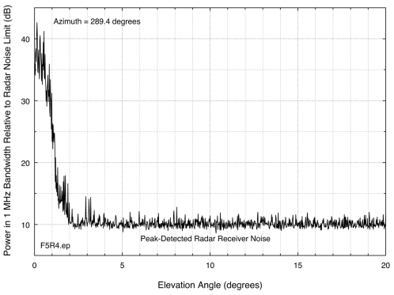

Figure 1-6

**Elevation scan at 294.6° azimuth. The interference is measurable up to +1.5°**

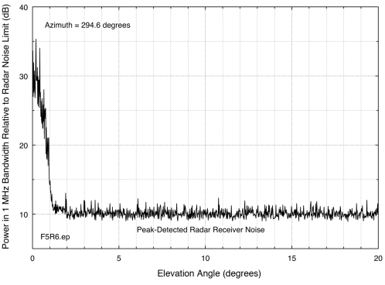

Figure 1-7

**Elevation scan at 296.0° azimuth. The interference is measurable up to +2°**

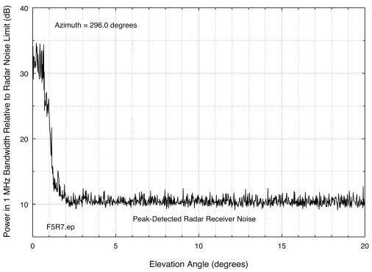

Figure 1-8

**Elevation scan at 304.8° azimuth. The interference is measurable up to +1.5°**

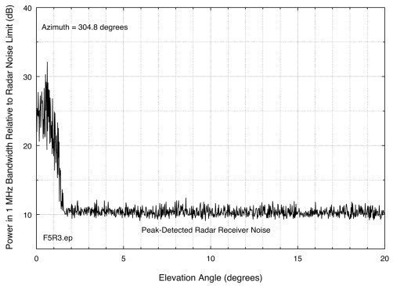

**1.4 Measurements of the interference time domain envelopes**

Time domain scans were performed on each of the four interference azimuths (289.4°, 294.6°, 296.0° and 304.8°) at Grand Rapids. The WiMAX signal modulation, as earlier base lined (Figures 1-2, 1-3 and 1-4), was observed on all four azimuths. Figure 1-9 shows an example of the observed interference modulation, on the strongest interference azimuth at 289.4°.

Comparing this to the baseline WiMAX measurement data Figure 1-5 and Figure 1-6, this modulation, with an overall 5 ms periodicity consisting of 3 ms on and 2 ms off, is consistent with WiMAX signal modulation. All interference azimuths at Grand Rapids and Jacksonville showed the same WiMAX-consistent signal structure. Figure 1-10 and Appendix B show time-domain interference envelopes for signals at Jacksonville. In all cases the interference characteristics were consistent with WiMAX signals.

The time-domain envelopes of Figure 1-9 and Figure 1-10 generally lack the well-defined preambles and well-formed frames seen in Figure 1-5 and Figure 1-6. This is because the interference signals were observed on NEXRAD frequencies, well above the center-tuned frequencies of the stations that were transmitting them. Due to an off-tuning effect called the rabbit ears phenomenon[12], pulses measured with systems that do not convolve the pulses’ fundamental-frequency energy will show a different envelope than they do when measured on their fundamental frequencies, while leaving the observed the pulse widths unchanged. The data of Figure 1-9 and Figure 1-10 are consistent with this off-tuning effect.

Figure 1-9

**Example of the interference time-domain envelope observed in the Grand Rapids NEXRAD receiver on all four interference azimuths. Note intentional time-dependent variation in frame power.  
Irregular envelopes are explained in Section 4.6.3**

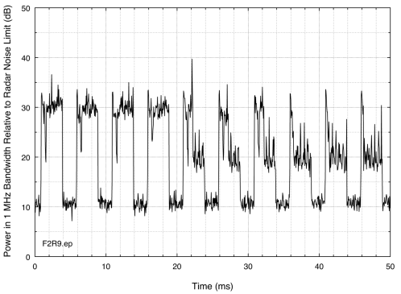

Figure 1-10

**Example of interference signal at Jacksonville at 84.5° azimuth**

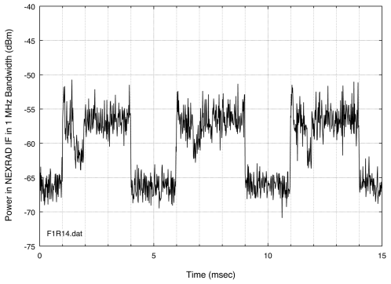

**1.5 Spectrum measurements of the interference through the NEXRAD antennas**

On each of the interference azimuths at Grand Rapids and Jacksonville, the spectra of the interference signals were measured through the NEXRAD antenna, ahead of its RF front-end bandpass filter. The results are shown in Figure 1-11 through Figure 1-16.

In these figures, the observed interference signals have the spectrum characteristics of WiMAX base stations (see the spectra of Section 3). Unwanted emissions from signals with WiMAX characteristics were observed on the frequencies of the Grand Rapids and Jacksonville NEXRADs (2 710 and 2 705 MHz, respectively). The spurious emission plateau that is characteristic of WiMAX base station signals (see Section 3) is observed on the low-frequency side of the WiMAX emissions in Figure 1-11–Figure 1-16, but on the high-frequency side of those emissions the spectra at Grand Rapids extend to lower power levels.

Eventually all of the interference azimuths identified at Grand Rapids and Jacksonville were exactly correlated with operational WiMAX base stations, confirming that the interference was caused by WiMAX station operations. However, the interference mechanism remained to be determined.

Figure 1-11

**WiMAX interference signal at Grand Rapids measured through the NEXRAD antenna on an azimuth of 289.4**

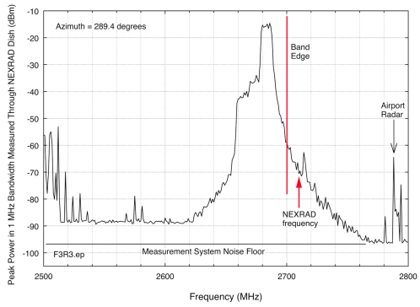

Figure 1-12

**WiMAX interference signal at Grand Rapids measured through the NEXRAD antenna on an azimuth of 294.6°**

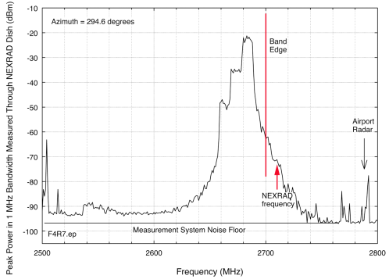

Figure 1-13

**WiMAX interference signal at Grand Rapids measured through the NEXRAD antenna on an azimuth of 296.0°**

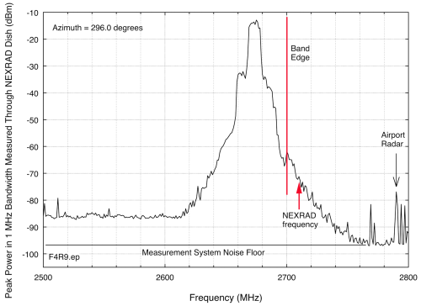

Figure 1-14

**WiMAX interference signal at Grand Rapids measured through the NEXRAD antenna on an azimuth of 289.4°**

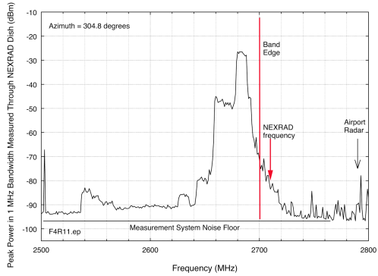

Figure 1-15

**WiMAX interference signals at Jacksonville measured through the NEXRAD antenna on an azimuth of 84.5°**

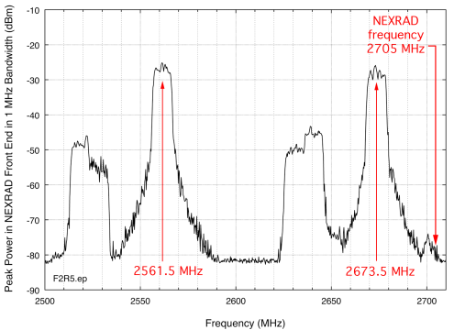

Figure 1-16

**Detail of the Unwanted emissions from a WiMAX base station transmitter at Jacksonville at 84.5°,   
going across the NEXRAD frequency of 2 705 MHz. This measurement was   
performed in 300 kHz to show additional spectrum details**

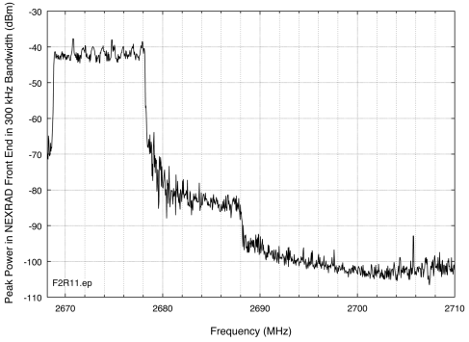

**1.6 Identification of the interference mechanism**

Two possibilities existed for the interference mechanism: front-end RF overload of the radar front-end low-noise amplifier or unwanted emissions from WiMAX that are co-channel with the radar frequency. These possibilities were not mutually exclusive; although typically only one or the other occurs for receivers in general, both can occur simultaneously. Therefore it was necessary to positively identify or exclude each of these interference mechanisms.

**1.6.1 Front-end overload condition**

Front-end overload occurs when the LNA in a receiver RF front end is not adequately protected (de‑coupled) from high-power out-of-band energy by a front-end bandpass filter between the receiver antenna and the LNA’s input. Conversely, the presence of a front-end bandpass filter in front of an LNA in a receiver will prevent the possibility of front-end overload of a receiver’s LNA[13] provided that the interfering signal is not within the passband of the filter.

**1.6.2 Appearance of front-end overload responses in the time domain**

It is possible to directly demonstrate from measurement data that front-end overload is or is not occurring, the approach being to carefully observe the characteristics of the victim receiver’s noise floor in the time domain when an interference signal is present. Because front-end overload causes a decrease in the gain of the LNA whenever the interference signal is present, and because there is a non-zero interval required for the gain of the LNA to recover to its normal level after the interference signal (a pulse, in the case of WiMAX emissions) ceases, front-end overload will manifest itself in the time domain as a dip in the victim receiver noise floor in the time interval immediately after the end of each interference pulse. This overload response artifact is shown for an actual LNA output, measured under controlled conditions, at the top of Figure 1-17. For the WiMAX pulses that have been observed in the NEXRAD receivers at Grand Rapids and Jacksonville, the corresponding deep, sharp dip that would be expected to occur after each WiMAX pulse has been sketched schematically in red on the data from Figure 1-10, as reproduced at the bottom of Figure 1-17. The *lack* of such dips after each WiMAX pulse in the actual NEXRAD time domain receiver data (as in the data of Figure 1-9 and Figure 1-10) provides a positive demonstration that the WiMAX interference mechanism in NEXRAD receivers is not front-end overload.

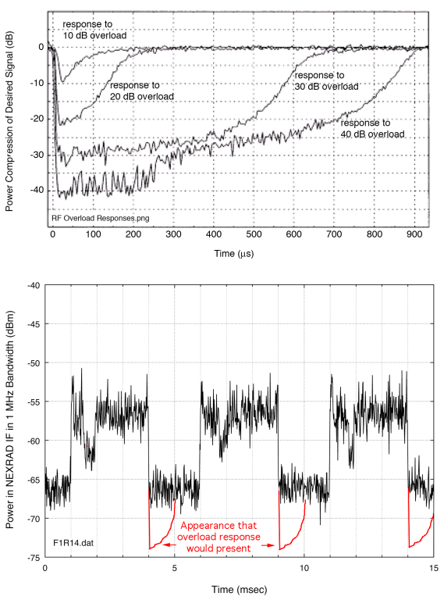

**1.6.3 Appearance of out of band emissions in the time domain (Rabbit Ears)**

As noted above, when pulsed energy is observed in the time domain on frequencies that do not include its fundamental frequency, the pulse shapes no longer look the same as at the fundamental [17]. Instead, on some unwanted emissions the centers of the pulses drop in amplitude relative to the pulse edges. The occurrence of this so-called rabbit ears effect (which sometimes only shows prominent rising edges) is therefore an indication that unwanted emissions energy is being observed. Many of the WiMAX measurements in Grand Rapids and Jacksonville show the rabbit ears effect, which is seen in Figure 1-9 and Figure 1-10. The occurrence of rabbit ears is another indication that the interference is due to unwanted emissions from WiMAX transmitters.

**1.6.4 Additional proposed tests for front-end overload**

Two additional tests for front-end overload might be performed between NEXRAD receivers and WiMAX base stations. One of these tests would be to observe the power level of interference in the NEXRAD receiver while the output power of the interfering WiMAX base station is reduced by some known amount of power. If the power reduction at the WiMAX base station is *X* dB, then a reduction of *X* dB in the observed interference level would indicate that front-end overload is *not* the cause, because front-end overload is a non-linear effect. Unfortunately, since the levels of unwanted emissions produced by a power amplifier do not necessarily change linearly with total amplifier power output, a non-linear response could also be consistent with unwanted emissions as the source of the interference. A power-reduction test of the base station transmitter would therefore tend to be inconclusive.

A different test for front-end overload, and one that would be conclusive, would be to install either a 2 500-2 690 MHz bandpass filter or a 2 690 MHz lowpass filter on the output of a WiMAX station that is causing interference. If the interference is eliminated by the filter installation, then front-end overload is eliminated as a causative mechanism, and unwanted emissions into the adjacent frequency band are confirmed as the cause. Filter installation at some WiMAX sites in the United States has now provided this confirmation.

**1.6.5 WiMAX Turn-Off test in Jacksonville**

FCC personnelfrom Tampa, Florida, coordinated a turn-off test of two WiMAX base station signals. The two frequencies, which were earlier observed in the interference data of Figure 1-15, originated from a single WiMAX base station and occurred on the single azimuth of 84.5° from the NEXRAD at frequencies of 2 673.5 MHz and 2 561.5 MHz. (The power of the signal at 2 673.5 MHz was much higher than that of the 2 561.5 MHz signal.) The test consisted of turning off first the stronger signal at 2 673.5 MHz, and then the weaker signal at 2 561.5 MHz, while the IF output of the NEXRAD was monitored at connector NEXRAD J3 (Figure 1). Then the weaker signal was turned back on, and finally the stronger signal was restored to operation. As with the earlier observations, the radar IF output was monitored with a spectrum analyzer that was tuned to the NEXRAD’s IF frequency and which was running in a zero-hertz span mode so as to show the time response of the radar receiver to the interference energy.

The results of this turn-off test are shown in Figure 1-17. When the first, and stronger, signal was turned off, the interference power level in the radar IF dropped significantly. (The signals were observed with average detection to make them distinctly and cleanly visible; the peak-power levels of Figure 1-17 were therefore 10 dB higher than the average levels seen in Figure 1-10.) This drop‑off is visible in Figure 1-17. When the second signal, tuned 143.5 MHz below the NEXRAD frequency, was turned off, Figure 1-17 shows a second drop-off of energy in the radar receiver.

Figure 1-17

**Turn-off test observation in the Jacksonville NEXRAD for two WiMAX signals at 2 673.5 and   
2 561.5 MHz transmitted from a single base station**

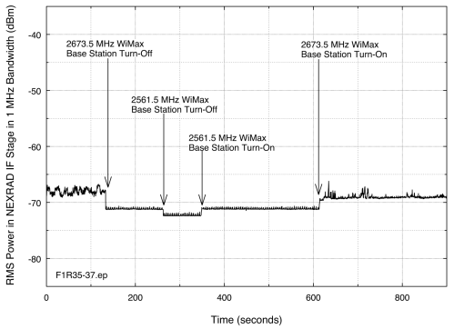

**1.6.6 Vector signal analyzer recordings of the interference signal**

The interference signal was recorded at Grand Rapids as a complex waveform with a vector signal analyzer (VSA) at the NEXRAD antenna feed, ahead of the first bandpass filter, as shown in Figure 1. The strongest interference signal, at 289.4°, was measured. The VSA has a bandwidth of 36 MHz. In order to record the interference across both its intentional emission region and its out‑of-band (OOB) and spurious emissions regions, the VSA was tuned initially to the intentional frequency of the interference source, the source’s emissions were recorded, and then the VSA was gradually tuned to successively higher frequencies, 36 MHz at a time, with recordings made across the OOB and spurious regions. These VSA recordings may be used for play-back into a variety of radar receivers in subsequent interference-effects tests and measurements of NEXRADs, ATC radars (ASRs and GPNs) and possibly even eventually maritime surface search radars.[14]

**1.7 Identification of the interference source locations**

The spectra and time-domain waveforms of the Grand Rapids and Jacksonville interference matched the baseline WiMAX spectra of Section 3. The spectrum measurements performed through the NEXRAD antennas at these two locations showed that WiMAX base station unwanted emissions on NEXRAD operational frequencies caused the interference. An on-line search of the Grand Rapids licensee’s WiMAX coverage resulted in the identification of four towers within 4-8 km of the NEXRAD that were thought to be strong candidates as source locations of the interference. The initial identifications were based on identical azimuths of the towers with the observed azimuths of the interference. Table 1-1 summarizes these tower locations.

Table 1-1

**Grand Rapids towers identified as origination points of WiMAX interference   
to the Grand Rapids NEXRAD**

|  |  |  |  |  |  |
| --- | --- | --- | --- | --- | --- |
| **Az from Nexrad** | **Latitude (decimal)** | **Longitude (decimal)** | **Dist. (km)** | **Approx. height AGL[15] (m)** | **Description** |
| 289.4° | 42.909803 | -85.606453 | 5.38 | 33 | Tower near RR tracks at Breton Rd SE and 29th St SE |
| 294.6° | 42.923983 | -85.634836 | 8.07 | 30 | Tower near RR tracks at Calvin Ave SE and Kalamazoo  Ave SE |
| 296.0° | 42.909275 | -85.588439 | 3.94 | 26 | Water tank near Shaffer SE and 29th St SE |
| 304.8° | 42.935686 | -85.626319 | 8.10 | 26 | Water tank near Boston SE and Plymouth SE |

**1.8 Verification of grand rapids BRS/EBS emissions on identified towers**

At each of the four preliminarily identified towers at Grand Rapids, spectrum measurements were performed in situ to verify that they were sources of BRS/EBS emissions, and that the emissions matched those observed at the NEXRAD on each of the four interference azimuths. A portable spectrum analyzer and microwave horn antenna were transported to the vicinity of each tower and were used to measure the emissions from each tower. The measurements were performed whenever possible from the same direction relative to the tower as the NEXRAD. Because WiMAX base stations use frequency diversity for sector coverage, matching of in situ measurement azimuths to the NEXRAD azimuth at each tower caused the in situ data to match, as nearly as possible, the spectrum emissions observed at the NEXRAD (Figures 1-11 to 1-14). The results of the in situ measurements are shown in Figures 1-18 through 1-21; images of the four towers are shown in Figure 1-22 . Individual BRS/EBS WiMAX towers were not visited at Jacksonville.

Figure 1-18

**In situ measurement of tower emissions at 289.4, Breton Rd. and 29th St. SE,   
Grand Rapids, Michigan**

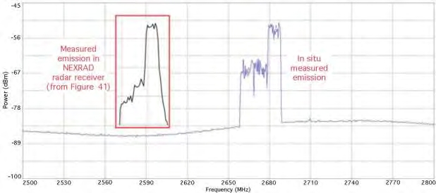

Figure 1-19

**In situ measurement of tower emissions at 294.6, Calvin Ave SE and Kalamazoo Ave SE,   
Grand Rapids, Michigan**

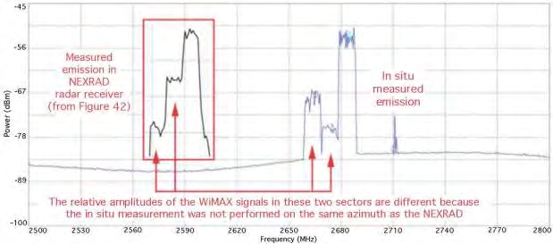

Figure 1-20

**In situ measurement of tower emissions at 296.0, water tank at   
Shaffer Ave. SE and 29th St. SE, Grand Rapids, Michigan**

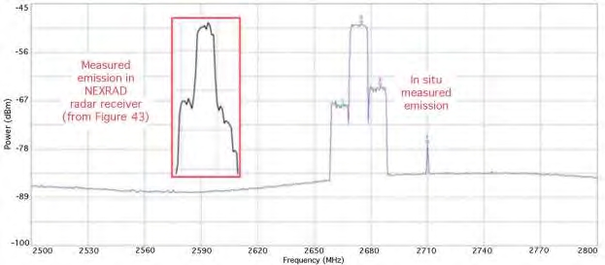

Figure 1-21

**In situ measurement of tower emissions at 304.8, Boston SE and  
 Plymouth SE, Grand Rapids, Michigan**

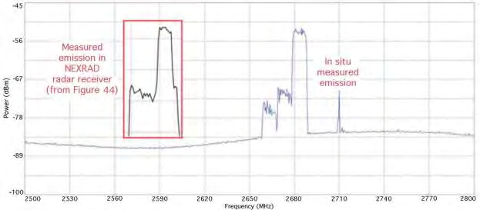

Figure 1-22

**Images of four Grand Rapids BRS/EBS towers where the signals shown in Figures 1-11 to Figure 1-14 were transmitted. Azimuths are as measured from the Grand Rapids NEXRAD station location**

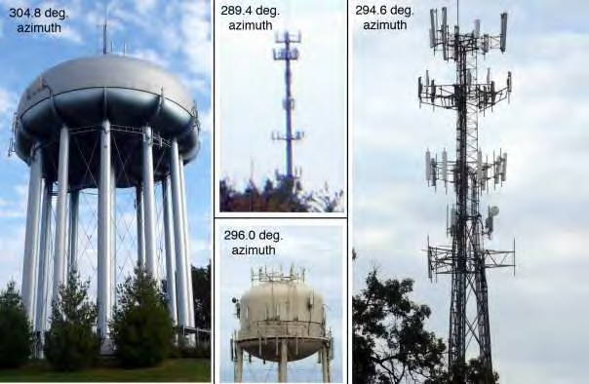

Annex 2 of Study 1

**NEXRAD technical characteristics**

**2.1 NEXRAD radars operating in the band 2 700-3 000 MHz**

NEXRAD weather radars (Figure 2-1) operate within the United States and Possessions at frequencies between 2 705–3 000 MHz. As summarized in Table 2-1, they use klystrons to generate high-power pulses approximately 1 μs long, transmitting and receiving with high gain parabolic antennas that generate pencil beams that are repetitively conically scanned through space around each radar station.

Figure 2-1

**A typical NEXRAD radar tower, here at Grand Rapids, Michigan. The antenna center is 24 m (80 ft) above ground level (AGL). Transmitter and receiver are located in small shelter at tower base with low-loss   
waveguide running the tower length**

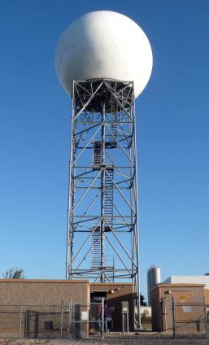

Table 2-1

**Summary of NEXRAD (WSR-88D) technical characteristics**

|  |  |  |
| --- | --- | --- |
| Parameter | Units | Description |
| Peak transmitter power | kW | 750 |
| Transmitter type |  | Klystron tube |
| Operational frequency range | MHz | 2 700-3 000 |
| Antenna type |  | 9 m (28 ft) diameter parabolic reflector with microwave feed horn at power center |
| Antenna gain | dBi | 45.5 |
| Antenna height above ground | m (ft) | 24 (80) |
| Antenna beam type |  | Pencil |
| Antenna beam width | degrees | 0.95 (3 dB width)  0.15 (boresight accuracy) |
| Antenna polarization |  | Linear horizontal |
| Antenna sidelobe levels | dB | At least 27 below main-beam gain |
| Antenna beam scanning protocol |  | Conical scan, +0.5° to +20° elevation |
| Antenna beam scanning rate | rpm | 6 (10 sec/scan revolution interval) |
| Transmitted pulse widths | μs | short pulse: 1.6  long Pulse: 4.5 |
| Transmitted pulse modulation |  | P0N (unmodulated CW pulses) |
| Transmitted pulse repetition rates | pps | Short pulse: 318 to 1304  long pulse: 318 to 452 |
| Receiver bandwidth | MHz | 0.795 |
| Receiver channels |  | Linear output, I/Q, and log output |
| Nominal receiver noise figure | dB | 1.5 |
| Receiver thermal noise level in 0.795 MHz bandwidth | dBm | –113.5 (computed) |
| Base moments (data products) |  | Reflectivity, velocity and spectrum width |
| Maximum operational distances | Km (nm) | reflectivity: 460 (248)  velocity: 230 (124) |

NEXRAD operations have safety-of-life status in the United States table of allocations. The technical and operational aspects of NEXRAD meteorological radars are described in International Telecommunications Union, Radiocommunication Sector (ITU-R), “Technical and operational aspects of ground-based meteorological radars,” Recommendation ITU-R M.1849, Jun. 2009. As summarized in Table 2-2, NEXRADs observe and track severe weather including precipitation, hail, tornado and wind shears. NEXRAD data generate watches and warnings for severe weather, including emergency broadcasts.

Table 2-2

**NEXRAD base data products and derivative processed outputs [16]**

|  |  |
| --- | --- |
| Base moment output | Processed outputs |
| Reflectivity | Precipitation monitoring and tracking, hail structures, echo tops, vertically integrated liquid, severe weather probability and forecasting |
| Velocity | Mesocyclone observations, tornado vortex signatures, velocity azimuth displays, shear-structure observations |
| Spectrum width | Turbulence observations |

**2.2 NEXRAD receiver design**

NEXRAD receivers incorporate the following stages, in the order that meteorological echo energy passes through them: the antenna (parabolic reflector and feed); an RF front-end channel bandpass filter; a PDL; an LNA; a length of low-loss RF cable running from the top of the tower to the receiver shelter; another RF bandpass channel filter; a frequency mixer-down converter which converts the RF energy to a frequency band centered at 57.56 MHz; and an analog-to-digital converter. Base data products of reflectivity, velocity, and spectrum width are derived from the digital data stream. Figure shows the receiver design in a simplified block diagram schematic.

Figure 2-2

**Simplified block diagram of the NEXRAD receiver system**

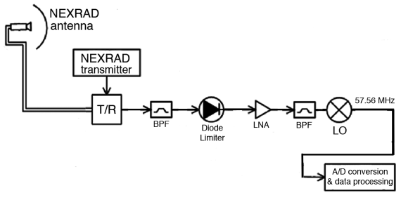

**2.3 Frequency-response measurements of NEXRAD receiver stages**

As shown in Figure 2-3, various combinations of NEXRAD receiver components were swept with a carrier wave from a vector signal generator (VSG) to characterize their frequency responses.

The results of the front-end component characterization measurements are shown in Figure 2-4 to Figure 2-8. Figure 2-4 shows the LNA frequency response; Figure 2-5 shows the insertion loss of the PDL, which is constant with frequency. Figure 2-6 shows the frequency response of the front‑end RF filter, the PDL and the LNA; this figure demonstrates the significant extent to which the front-end filter limits the coupling of the LNA to energy that is off-frequency from the radar receiver’s desired range of operation. Figure 2-7 shows a detailed view of the radar receiver’s front‑end bandpass filtering; it is centered on the radar’s frequency of 2 710 MHz and is 13 MHz wide at the 3 dB points. Figure 2-8 shows the bandpass response of the RF filter that follows the LNA, and which is intended to filter out unwanted LNA response products. Its response is essentially identical to that of the front-end filter.

Figure 2-3

**Schematic block diagram of NEXRAD receiver-component frequency-response   
characterization measurements. Measurement hardware is shown in red**

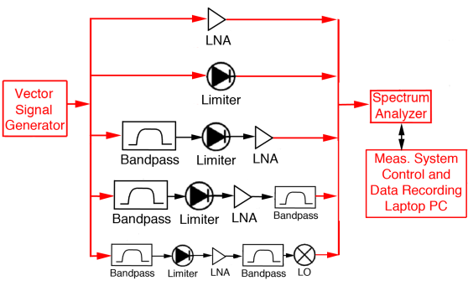

Figure 2-4

**Measured broadband frequency response of the NEXRAD front-end low noise amplifier**

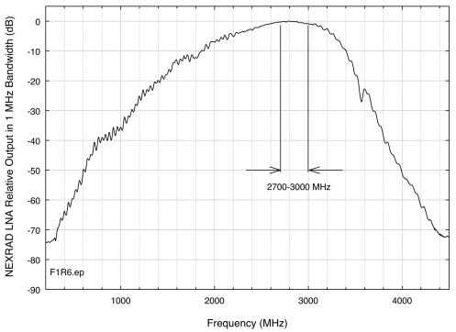

Figure 2-5

**Measured broadband passive diode limiter insertion loss. The loss was about 1.5 dB**

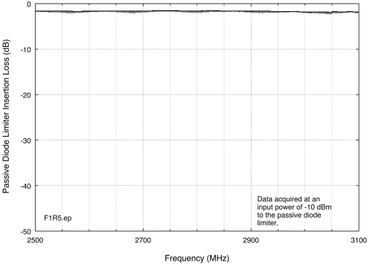

Figure 2-6

**Measured broadband frequency response of the combination of the RF bandpass filter, passive diode limiter and low noise amplifier in the NEXRAD RF front end. This is essentially the frequency response of the RF filter, as it is the limiting component in the series**

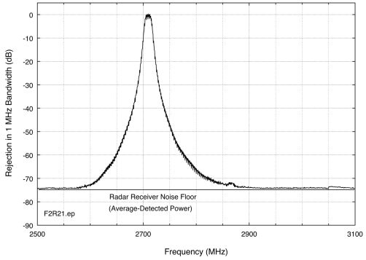

Figure 2-7

**Detail of the passband region of Figure 2-6**

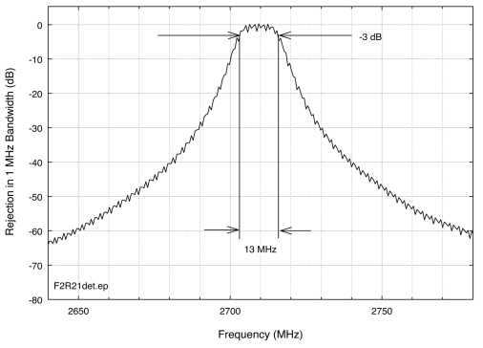

Figure 2-8

**Frequency response of the bandpass filter that follows the low noise amplifier. Its response is essentially identical to that of the front-end filter installed ahead of the low noise amplifier**

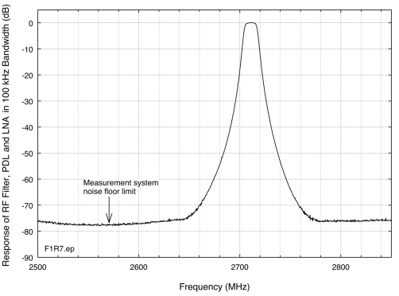

**2.4 NEXRAD RF gain compression measurement**

The VSG was also used to measure the power-compression behaviour of the NEXRAD LNA. For this measurement, the VSG was fixed-tuned to the radar’s operational frequency and its input power to the LNA was increased in 1 dB increments as the output power of the LNA was measured. The resulting data are shown in Figure 2-9. The 1 dB compression level occurs at an input power   
of –7.5 dBm to the LNA.

Figure 2-9

**Power-compression behaviour of the NEXRAD front-end low noise amplifier**

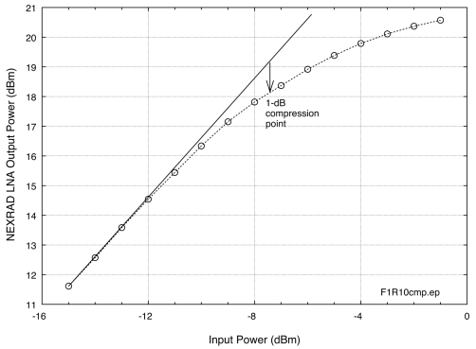

**2.5 Summary of NEXRAD receiver electromagnetic compatibility characteristics**

The data presented here show that the NEXRAD receiver design conforms to well-recognized practices for robust EMC performance in the presence of high-power out-of-band signals. The radar receiver’s wideband, highly sensitive front-end LNA input is protected from high-power out‑of‑band energy by a diode limiter to protect against catastrophically high input power that could damage electronic circuitry and a narrowband channel bandpass filter to eliminate overload effects. Another, identical filter is installed at its output to eliminate possible intermodulation products.

However, no receiver front-end design, including that of NEXRADs, can mitigate interference from co-channel interference energy. Furthermore, NEXRADs cannot be significantly re-tuned unless their front-end filter assemblies and klystrons are replaced.

**2.6 NEXRAD** **frequency dependent rejection**

**2.6.1 Calculation of frequency dependent rejection**

Frequency dependent rejection (FDR) is a key element in EMC link budget calculations. NTIA OSM calculated each receiver’s FDR response for each transmitter with and without the filter using the FDR program included in MSAM. The minimum frequency separation between the radars and the WiMAX transmitters is 21.5 MHz, with the WiMAX operating below the radar.

The emission spectrum data for the WiMAX transmitters was normalized in power and frequency for the FDR program. The radars’ IF selectivity were also normalized in power and frequency for the FDR program. For the filtered case, the roll-off on the transmitter emission spectra was 10 dB per decade once it reached the level where it intercepted the predicted level. For the unfiltered case, the roll-off was 10 dB per decade once it intercepted the level where the emissions met the predicted filtered level.

**2.6.2 Frequency dependent rejection for NEXRAD radar**

The IF response of the NEXRAD receiver had been previously measured and those data were used for these calculations. The IF response was measured to a level of –60 dB, and for these calculations the curve was extended to the –100 dB point and given a roll-off of 20 dB per decade (Figure 2-10).

Figure 2-10

**Measured NEXRAD IF frequency-response curve**



The FDR that were calculated for the NEXRAD receiver versus the filtered and unfiltered emissions for the WiMAX transmitters are shown in Figure 2-11. This figure shows that at 21.5 MHz of frequency separation the filtered FDR was 110 dB. At that delta frequency the unfiltered WiMAX Radio 1 FDR was 80 dB, the Radio 2 FDR was 76 dB, and the Radio 3 FDR was 72 dB. Clearly the filter did, at a minimum, increase the FDR by 30 dB. Figure D-2 also shows that the filtered FDR continued to increase as the frequency separation became larger, since both the transmitter and the receiver were rolling off.

Figure 2-11

**Frequency dependent rejection plot for NEXRAD receiver versus WiMAX transmitters**

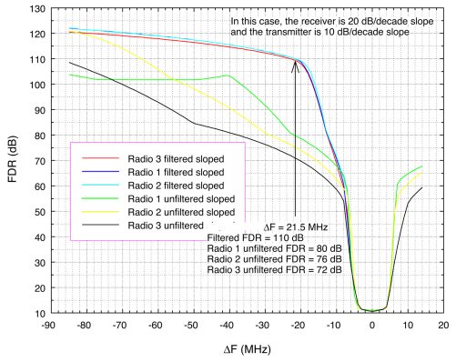

**2.7 Calculation of protection distances**

The minimum required separation distance to protect each radar receiver from a WiMAX base station transmitter is calculated using the Irregular Terrain Model (ITM) propagation model, after link budget analyses have determined the maximum interference power and corresponding path loss. The separation distances are calculated for the filtered and unfiltered emissions for each WiMAX transmitter, under the condition that the WiMAX antenna down-tilt angle is either 0 degrees or 5 degrees below the local horizon. The results are shown in Figures 2-12 through 2-15. The following link-budget equation is used:

*IMax*= *PT* + *GT* – *LP* – *FDR* + *GR* – *LS*, where:

*IMax*= Maximum interference level (dBm);

*PT* = Transmitted Power (dBm);

*GT* = Transmitter antenna gain (dBi);

*LP* = Atmospheric path loss (dB);

*FDR* = frequency-dependent rejection (dB);

*GR* = Antenna gain of the receiver (dBi)

*LS*= Insertion loss within the receiver front-end (dB).

Re-arranging terms: *LP*= *PT* + *GT* – *IMax* – *FDR* + *GR* – *LS*.

The ITM propagation model is run in reverse mode, to calculate the distance at which the path loss meets the required values. The ITM model settings are shown in Table 2-3 and the radar EMC characteristics are shown in Table 2-4.

Table 2-3

**Irregular terrain model settings for WiMAX-to-radar electromagnetic compatibility analysis**

|  |  |
| --- | --- |
| ITM Parameter | ITM Parameter Value |
| Mode of variability | Broadcast |
| Delta H | 90 |
| WiMAX transmitter height (m) | 33 |
| Receiver height (m) | NEXRAD = 33 |
| Transmitter site criteria | Very Careful |
| Receiver site criteria | Random |
| Dielectric | 15 |
| Conductivity | 0.005 |
| Surface refractivity | 301 |
| Radio climate | Continental Temperate |
| Percent time | 50 |
| Percent location | 50 |
| Percent confidence | 50 |
| Polarity | Horizontal |

Table 2-4

**Radar parameters for electromagnetic compatibility analysis**

|  |  |  |
| --- | --- | --- |
| Parameter | Unit | NEXRAD |
| 3 dB IF BW | MHz | 0.712 |
| Noise figure | dB | 2.5 |
| I/N Protection criteria | dB | –10 |
| Receiver noise Power | dBm/MHz | –113 |
| Maximum interference level | dBm/MHz | –123 |
| Antenna gain | dBi | 45 |
| System loss | dB | 2 |
| Antenna height | m | 33 |

WiMAX transmit power, *PT*, is set to 42 dBm, and WiMAX antenna gain, *GT*, is set to 14 dBi.

Figure 2-12 shows the results for WiMAX antenna down-tilt angles of 0 degrees. Figure 2-13 shows results for WiMAX antenna down-tilt angles of 5 degrees below the horizon. The down-tilt results were based on the antenna pattern of Figure 3-5, with corresponding decoupling values as a function of down-tilt angle as shown in Figure 4-1.

**2.8 Calculated separation distances for 0 degrees of WiMAX antenna down-tilt**

Figure 2-12

**Distance-frequency separation distance curves for NEXRAD and WiMAX,   
with WiMAX down-tilt angle = 0 degrees**

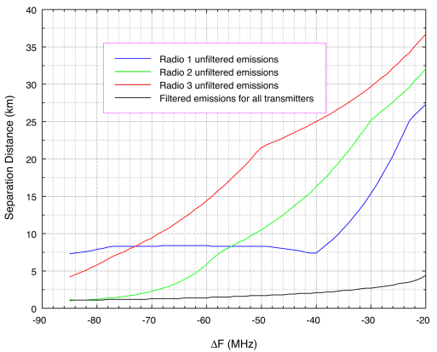

Figure 2-13

**Distance-frequency separation distance curves for NEXRAD and WiMAX,   
with WiMAX down-tilt angle = 5 degrees**

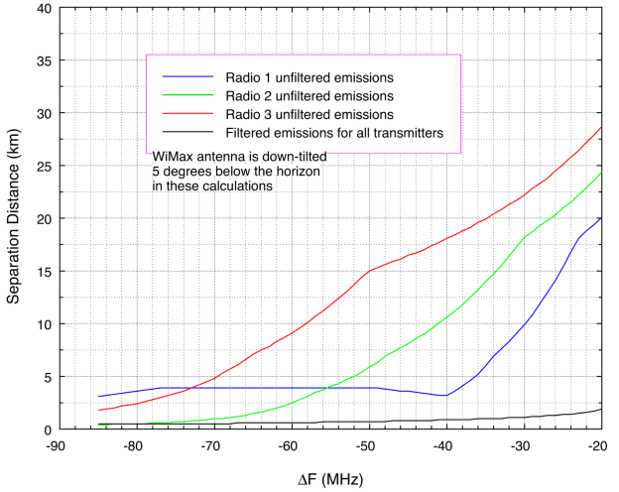

Table 2-5 shows a summary of the WiMAX antenna gain reduction as a function of down-tilt angle.

Table 2-5

**WiMAX antenna gain reduction as a function of down-tilt angle**

|  |  |
| --- | --- |
| Angle (degrees) | Gain reduction (dB) |
| 0 | 0 |
| 1.5 | 1.5 |
| 2.5 | 2.5 |
| 5.0 | 7.5 |
| 7.5 | 15 |
| >10 | 20 |

**2.9 Summary of electromagnetic compatibility frequency-separation distance curves**

A methodical approach to the problem of measuring interference levels in situ, determining the interference mechanism (co-channel energy on the victim receivers’ frequencies in this case), establishing the IF-response characteristics of the subject receivers, and measuring the emission spectra of the interfering transmitters with and without supplemental output RF filtering results in the frequency-distance separation curves shown in Figures 2-12 and 2-13 These curves may be used to establish compatible operations between WiMAX transmitters and meteorological radar stations if none of the other possible mitigation approaches (as described below) prove to be effective.

Table 2-6 summarizes the results of the various scenarios and compares the separation distances for filtered and unfiltered WiMAX emission, along with WiMAX antenna down-tilting. The required separation distances collected in Table 12 are for the case of the ΔF between the WiMAX transmitter and the radar receivers being 22 MHz. The actual closest ΔF is 21.5 MHz, but the models were run with 1 MHz increments starting at ΔF = 20 MHz.

Table 2-6

**Summary separation distances (km) for ΔF = 22 MHz**

|  |  |  |
| --- | --- | --- |
| WiMAX Transmitter | NEXRAD | |
| **No down-tilt** | **5 Deg. down-tilt** |
| Filtered | 3.7 | 1.9 |
| Radio 1 (unfiltered) | 25.9 | 20.1 |
| Radio 2 (unfiltered) | 30.5 | 24.4 |
| Radio 3 (unfiltered) | 35.1 | 28.7 |

The results in Table 2-6 show that the filter significantly reduces the separation distances that are required between the WiMAX transmitters and the meteorological radar receivers. The worst case is the Radio 3 transmitter with the NEXRAD receiver, requiring 35.1 km of separation distance when it is unfiltered and uses a 0 degree vertical tilt angle. When its emissions are filtered, the required separation distance for the Radio 3 transmitter and the NEXRAD and all other WiMAX transmitters is 3.7 km. When the WiMAX antenna is down-tilted to -5 degreeswiththe emissions being filtered, the distance reduces to 1.9 km. It is anticipated that these relatively small separation distances should be able to be coordinated between meteorological radar operators and communication service providers.

If the Radio 1 emissions are not filtered and the Radio 3 antenna is down-tilted by 5 degrees, the required separation distance is 20.1 km. For the unfiltered Radio 2 transmitter this down-tilt only distance is 24.4 km and for the unfiltered Radio 3 transmitter the down-tilt only distance is 28.7 km.

Annex 3 of Study 1

**2.6-2.7 GHz WIMAX technical characteristics**

**3.1 Technical characteristics of 2.6-2.7 GHz WiMAX base stations**

WiMAX[17] (IEEE 802.16)[18] is a relatively new technology that is used for high speed data transfer for fixed and mobile terminals with licensed applications in the radio band 2 500-2 690 MHz[19]. WiMAX has two formats: Time Division Duplex (TDD) and Frequency Division Duplex (FDD). WiMAX service began to be offered in selected United States cities in 2009. Sometimes called “4G,” WiMAX service competes with that of carriers that are using 3G, EDGE and LTE technology. EMC concerns are not exclusive to WiMAX; any technology can potentially cause adjacent-band EMC problems. Initial knowledge of EMC issues has simply happened to concern WiMAX base stations.

WiMAX system architecture is similar to that of cellular systems, comprising base stations (3-1) and tower-mounted antennas (Figure 3-2) and servicing fixed or mobile terminals. Typical transmitter power levels of 20 W and antenna gains of +16 dBi give these stations a typical e.i.r.p. of 790 W. The number and density of 2.6 GHz WiMAX transmitters is expected to increase as service coverage expands.

Figure 3-1

**Example of a WiMAX base station transmitter (photo by Groupe Aménagement Numérique des Territoires, licensed under** [**Creative Commons**](http://en.wikipedia.org/wiki/en:Creative_Commons)[**Attribution 2.0 Generic**](http://creativecommons.org/licenses/by/2.0/deed.en) **license)**

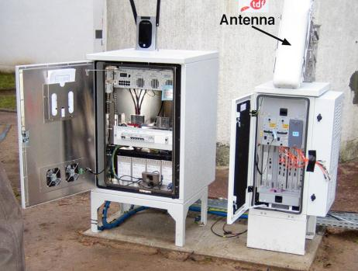

Figure 3-2

**An example of a tower on which are mounted antennas for a variety of communication systems,   
including WiMAX, at Broomfield, Colorado**

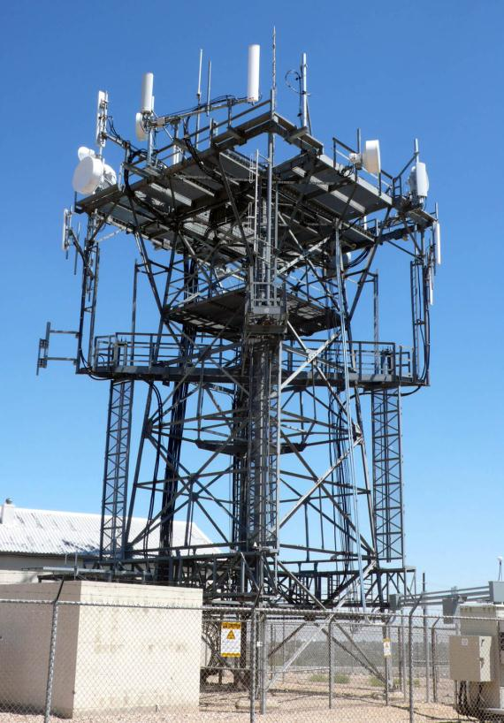

**3.2 WiMAX 2.6-2.7 GHz spectrum channel plan in the United States**

The Upper Band Segment (UBS) channels and frequencies of 2.6-2.7 GHz WiMAX base station transmitters are shown in Table 3-1. Preliminarily understood 2.6 GHz WiMAX transmitter and antenna characteristics are provided in Table 3-2. Additional WiMAX towers are expected to be deployed at locations across the United States. Domestic WiMAX licensees are authorized to merge contiguous channel authorizations into other channel bandwidths, with an emission bandwidth of 10 MHz being most commonly used.

Table 3-1

**Channel frequencies for 2.6-2.7 GHz WiMAX stations, from 47 CFR §27.5**

|  |  |
| --- | --- |
| Broadcast radio service (BRS) channel | Channel frequency range |
| BRS Channel 2 | 2 618–2 624 MHz |
| BRS Channel E1 | 2 624–2 629.5 MHz |
| BRS Channel E2 | 2 629.5–2 635 MHz |
| BRS Channel E3 | 2 635–2 640.5 MHz |
| EBS Channel F1 | 2 640.5–2 646 MHz |
| EBS Channel F2 | 2 646–2 651.5 MHz |
| EBS Channel F3 | 2 651.5–2 657 MHz |
| BRS Channel H1 | 2 657–2 662.5 MHz |
| BRS Channel H2 | 2 662.5–2 668 MHz |
| BRS Channel H3 | 2 668–2 673.5 MHz |
| BRS Channel G1 | 2 673.5–2 679 MHz |
| BRS Channel G2 | 2 679–2 684.5 MHz |
| BRS Channel G3 | 2 684.5–2 690 MHz |

Table 3-2

**Typical WiMAX base station transmitter characteristics**

|  |  |
| --- | --- |
| WiMAX base station parameter | Value |
| Emission bandwidth | 5 and 10 MHz |
| Modulation | Adaptable range from QPSK to 64 QAM |
| Typical channel transmission power | 20 watts = +43 dBm |
| Typical channel e.i.r.p. | 790 watts = +59 dBm |
| Digital-to-analog converter bits | 10 |
| Digital-to-analog converter noise | –60 dB below fundamental power |
| Computed unfiltered spurious emissions | –70 dB below fundamental power |

**3.3 WiMAX base station antenna characteristics and frequency response**

WiMAX base station antennas (Figure 3-3) are mounted on high towers, water tanks, and rooftops to provide sector coverage. Groups of sectors provide 360-degree coverage around each site. The antennas form fan-shaped beams with wide azimuth (sector) width but with a narrow elevation-angle dimension. Elevation beam angles are usually tilted slightly downward to maximize coverage for customers located at or near ground level.

Figure 3-3

**A WiMAX base station sector-coverage antenna with +16 dBi gain and 90-degree azimuth coverage**

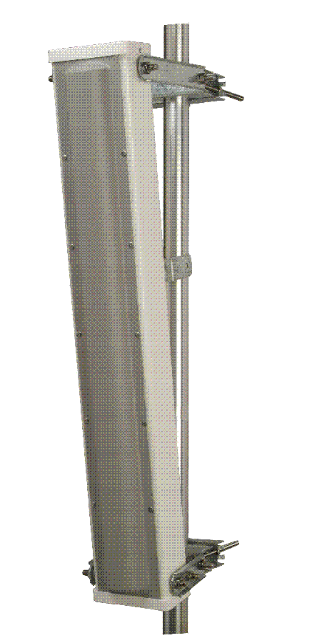

3-3 lists characteristics of typical WiMAX base station antennas. Most base stations employ sets of dual element, slant-polarized[20] 90° or 65° coverage antennas to illuminate a 120° sector for each 10 MHz channel; three such sectors provide 360° coverage at a typical base station tower, with three 10 MHz channels being concomitantly used per tower.

Table 3-3

**Typical 2.6 GHz WiMAX base station antenna characteristics**

|  |  |
| --- | --- |
| 2.6 GHz UBS WiMAX Parameter | Value |
| Typical sector antenna gain | +16 dBi |
| Typical sector antenna azimuth coverage | 120° (most common),  also sometimes 90° |
| Polarization | Slant (+/- 45 degrees, most common), also sometimes vertical or horizontal |
| Typical antenna height above ground | 30 m (100 ft) |

Antenna patterns for a model[21] commonly used by WiMAX and LTE service providers for their base stations are shown in Figure 3-4. The antenna’s beam can be down-tilted by as much as ‑10 degrees below horizontal by mechanically adjusting the mount. Vertical tilt angles are adjusted with either a manual crank mechanism or else a remotely-controlled electric motor, depending on the site.

Figure 3-4

**Antenna pattern of a typical WiMAX base station antenna, as measured by the manufacturer**

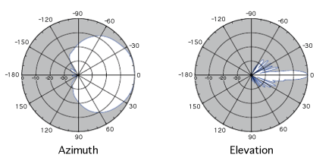

Engineers measured the antenna’s frequency response; the result is shown in Figure 3-5. The radiated-emission measurement was performed with the antenna’s main beam bore sighted on a suitcase measurement system.

Figure 3-5

**Measured frequency response of a typical WiMAX base station antenna**

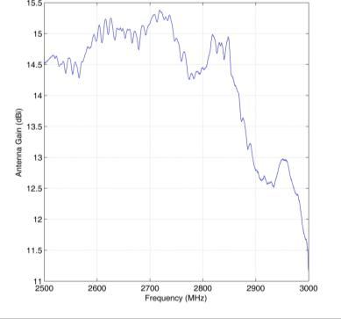

Figure 3-5 shows that across frequencies of 2 500–2 850 MHz the antenna’s response is essentially flat, with just 3 dB of reduction occurring between 2 850-3 000 MHz. Thus the antenna’s response across radar frequencies of 2 700-3 000 MHz will not significantly reduce the unwanted emission levels that would be coupled from WiMAX or LTE transmitters to radar receivers.

**3.4 Measured technical characteristics of radiated WiMAX signals**

Prior to traveling to Grand Rapids and Jacksonville, and in order to obtain baseline technical characteristics of WiMAX base station transmitters against which the characteristics of interference signals from unidentified locations could later be compared for the purpose of signal identification, Engineers performed detailed emission measurements on a WiMAX system.. The received signals were measured only for spectrum and time domain envelopes; they were not demodulated. The measured spectrum is shown in Figure 3-6; typical time domain envelopes are shown in Figure 3-7 and Figure 3-8.

Figure 3-6 shows three signals, each 10 MHz wide,[22] that correspond to different azimuthal coverage sectors. The sector within which the measurement system was located shows the highest power level; the power levels for the other sectors appear lower because the measurement system was not located within the main-beam coverage sectors of those other two base station antennas. The spectrum shape is characterized by a rapid drop of about 45 dBc (from the desired emissions’ power level to the beginning of the roll-off) to the beginning of the OOB roll-off. On the low‑frequency side, the OOB roll-off extends from about ‑45 dBc to about ‑67 dBc. Beyond that, the spurious emissions are suppressed to between approximately ‑67 dBc to ‑70 dBc. On the high‑frequency side of the fundamental-frequency emissions, the OOB roll-off of the emission in the coverage sector of the measurement system are masked by the in-band, desired emissions of the other two coverage sectors. The spurious emissions of the lowest- frequency transmitter emerge, however, from the desired emissions of the other two sectors at 2 655 MHz and, like those on the low-frequency side of the spectrum, remain at a plateau of about ‑68 dBc up to a frequency of 2 700 MHz. The spurious emissions roll off above 2 700 MHz but are still measurable above the measurement system noise floor at frequencies up to 2 720 MHz. This emission meets applicable spectrum regulations but may nevertheless still be high enough to potentially cause EMC problems with radar receivers above 2 700 MHz.

Figure 3-6

**A WiMAX base station emission spectrum measured in situ at a field location**

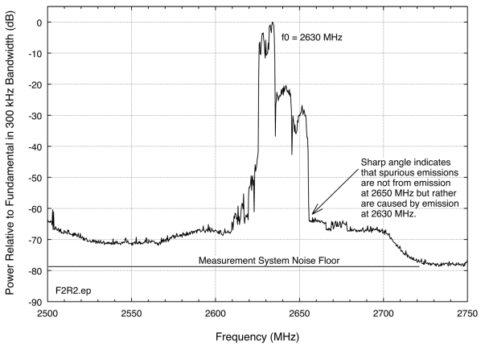

Figure 3-7

**Measured time-domain characteristics of an operational WiMAX base station signal. Preamble  
 power is fixed while frame power levels vary**

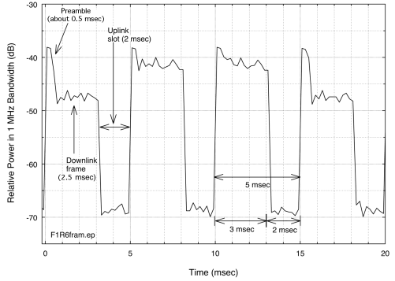

Figure 3-8

**Example of time variation in amplitudes of operational WiMAX base station frames.  
 Preamble power is fixed while frame power levels vary**

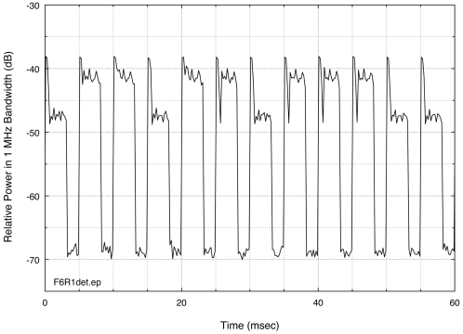

In summary, a preliminary baseline emission spectrum data taken in the field shows that a typical WiMAX emission spectrum consists of three fundamental-frequency emissions, each 10 MHz wide, directly adjacent to each other. These desired emissions will appear to vary in power from one to the next as result of the fact that a measurement system will always be located within the mainbeam coverage of one sector and will necessarily therefore be located within the sidelobe or backlobe coverage of the other sectors. The desired emissions drop rapidly to about –45 dBc at their edges, and then the spectrum roll-off will be more gradual from that point to a level where the emission levels plateau at about –68 dBc, the spectrum width from the –45 dBc point to the ‑68 dBc point being on the order of 15–20 MHz.

In the time domain, the envelope emission measurements of Figure 3-5 – Figure 3-8 show that the WiMAX base station (downlink) signal is characterized by a periodic on-and-off sequence. The overall repetition interval is 5 ms, with the first 3 ms being occupied by the transmitted downlink signal and the following 2 ms being quiet (Figure 3-5) for reception of uplink signals from subscriber units. Each 3-ms downlink transmission interval consists of a preamble lasting approximately 0.5 ms followed by a data frame lasting 2.5 ms.

As shown in Figure 3-7–Figure 3-8, the amplitudes of the preambles are constant. But as shown in the same figures the amplitudes of the data frames can vary from one to the next by at least 8 dB. This observation has implications for the selection of optimal detection modes in measurements of radiated WiMAX emissions. Positive peak detection will yield consistent and repeatable power measurements of WiMAX signals since the constant-amplitude preambles will always be detected at a constant amplitude in this mode. In comparison, root-mean-square (RMS) average detection results could vary somewhat depending on the extent to which the frame-data amplitudes might vary.

**3.5 Radiated WiMAX power as a function of measurement detection mode and bandwidth**

When assessing interference effects in radar receivers, the incident power level, *I*, of interference signals needs to be compared to the average[23] thermal noise level, *N*, of the receivers. The gated[24] average level of interference in the receivers is the relevant parameter for EMC studies for high duty cycle interference as found in WiMAX signals. Power received in WiMAX signals as a function of receiver bandwidth also needs to be known for such studies.

Since *N* is thermal noise with Gaussian characteristics, it has an approximately 10 dB difference between peak and average. Its power level varies in direct proportion to measurement bandwidth, resulting in a 10-log variation with bandwidth for decibel-unit measurements of *N*. The levels of *I* as a function of detection mode and bandwidth were ascertained empirically for the operational, radiated WiMAX signal at Broomfield, Colorado. The signal was measured with both peak and average detection in bandwidths of 100 kHz, 300 kHz, 1 MHz and 3 MHz; the results are shown in Figure 3-10–Figure 3-11.

The power levels measured for that signal at 2 650 MHz in each detection mode and measurement bandwidth in Figure 3-9–Figure 3-10 are plotted in Figure 3-11. As read from Figure 3-9, both the peak and average power levels of WiMAX signals vary in direct proportion to the measurement bandwidth, resulting in a 10-log rate of variation with bandwidth for decibel measurements.

This happens to be identical to the rate of variation of thermal noise power with bandwidth (as occurs in radar receivers). The offset between the peak and average power levels of the WiMAX signal is observed to be 17 dB; it is independent of the measurement (and therefore receiver) bandwidth.

Figure 3-9

**Peak-detected WiMAX emissions in four measurement bandwidths**

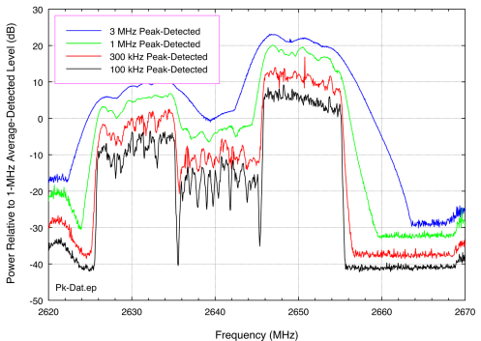

Figure 3-10

**Average-detected WiMAX emissions in four measurement bandwidths**

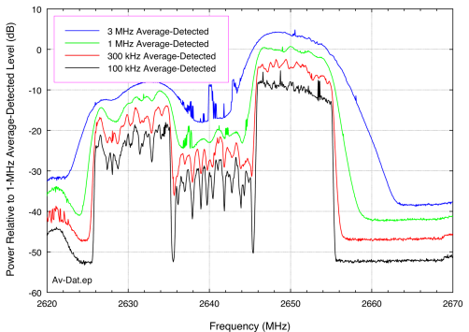

Figure 3-11

**Relative on-frequency measured WiMAX peak and average power levels, with variation   
in measurement bandwidth. Data points taken at 2 650 MHz from the curves   
in Figure 3-9–Figure 3-10**

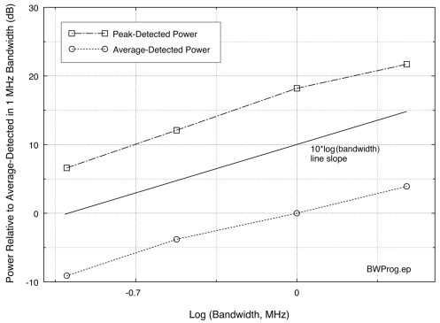

**3.6 Unfiltered hardline coupled measurements of WiMAX emission spectra**

WiMAX OOB and spurious emission levels needed to be measured. Emission measurements can be obtained at field locations but may be best measured under controlled conditions in laboratory environments when possible. For this purpose, test staff contacted a WiMAX service provider in mid-2011 and requested assistance with the problem of measuring such radio emissions. The provider responded by working with engineers on a second series of emission spectrum measurements that were performed at the provider’s test facilities in August and October 2011. At the service provider’s facility, NTIA engineers set up a portable emission spectrum measurement system on a workbench inside an underground, shielded enclosure as shown in Figure 3-14.

NTIA performed an initial scan with the WiMAX stations turned off, so as to observe and document the background spectrum environment inside the shielded room; no ambient signals were present in the band 2 700–2 900 MHz. Next, emission spectra were measured for three WiMAX base station transmitters, each manufactured by a different company.

Each WiMAX radio was operated by the service provider’s engineers in a typical field configuration at its normal output power level and with simulated communication traffic running on the highest-frequency channel in the band at 2 683.5 MHz. A high-power attenuator in the shielded room (Figure 3-12) kept the WiMAX input power to the measurement system below +10 dBm. Baseline measurements were performed with no supplemental filtering on the radio outputs as this unfiltered configuration is used by default by the service provider at field locations.

NTIA performed the spectrum measurements in 1 MHz and 100 kHz bandwidths with peak and average detection. NTIA engineers used a yttrium-iron-garnet (YIG) (Figure 3-12) off-tuning technique to minimize the effects of a dynamic range “coffin corner” effect that arises when the instantaneous dynamic range of a measurement system cannot overcome a rapid frequency‑dependent change in spectrum power.

**3.7 Hardline-coupled WiMAX measurement system set-up**

The measurement system consisted of an RF front end, a front-end controller, a spectrum analyzer, a vector signal analyzer (VSA), controller computers for the spectrum analyzer and the VSA, and associated miscellaneous RF cables and connectors (Figure 3-12). Although Figure 3-13 shows two possible WiMAX radios for schematic purposes, in fact any number of WiMAX radio types could be measured at the facility.

The RF front end was a custom-built portable box containing a calibration noise diode, a tunable YIG microwave bandpass filter, and preamplifiers. A second box controlled this RF front-end box. All the units were operated under computer control.

Figure 3-12

**Hardline-coupled WiMAX spectrum measurement block diagram**

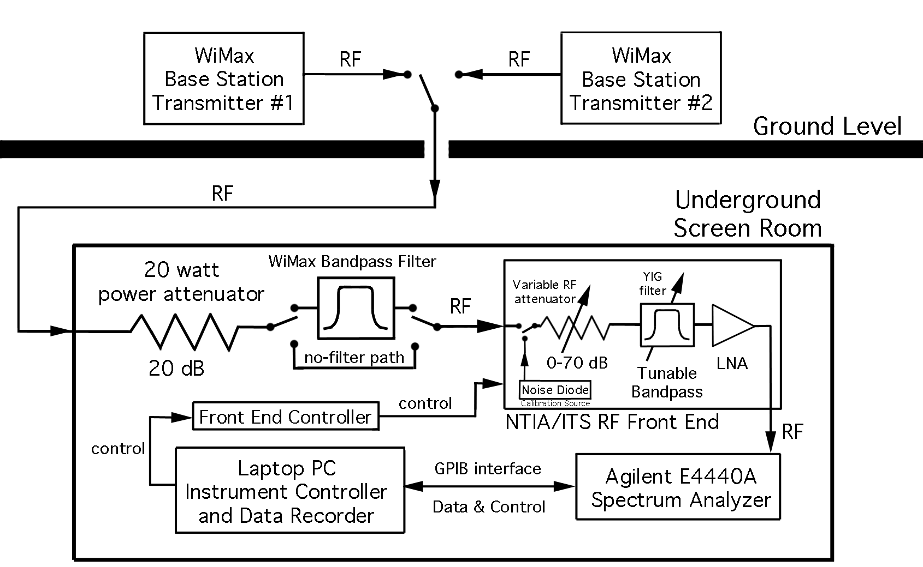

A goal of the spectrum measurements was to measure the unfiltered WiMAX base station spectra with as much dynamic range as possible, and hence over the widest frequency range possible. The measurements ultimately achieved dynamic ranges of 91 to 96 dB.

**3.8 WiMAX base station emission spectra without output filtering**

As already noted, the baseline emission spectra of the WiMAX base stations were measured without any output filtering installed, as the radios are normally deployed without supplemental filtering. Figure 3-13 to Figure 3-16 show measured spectra for three types of WiMAX radio base stations produced by three separate manufacturers. In this Report these are designated as WiMAX Radios 1, 2 and 3.

Each peak spectrum was measured in 1 MHz and 100 kHz bandwidths. This comparative measurement showed the extent to which the fundamental, OOB and spurious WiMAX emissions vary as 10-log or 20-log of bandwidth.[25] The data show that peak-detected WiMAX spectra vary as 10-log of bandwidth. Figure 3-17 shows the peak and average-detected spectra of Radio 2. The spectra of Radios 1 and 3 would look very similar. The offset between peak and average emissions is nearly constant across the fundamental, OOB and spurious regions, running between 15 to 20 dB at all frequencies. This result is consistent with the radiated peak vs. average WiMAX data in Figure 3-9–Figure 3-11.

Figure 3-13

**Peak-detected emission spectrum of WiMAX Radio 1**

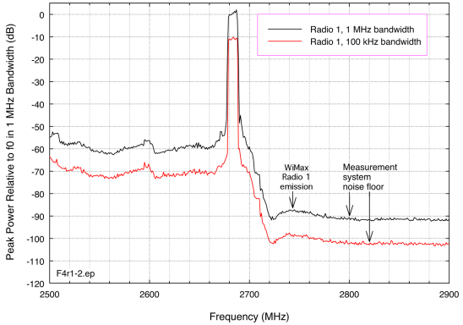

Figure 3-14

**Peak-detected emission spectrum of WiMAX Radio 2**

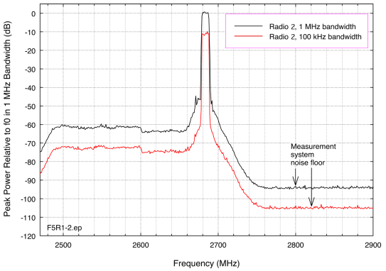

Figure 3-15

**Peak-detected emission spectrum of WiMAX Radio 3**

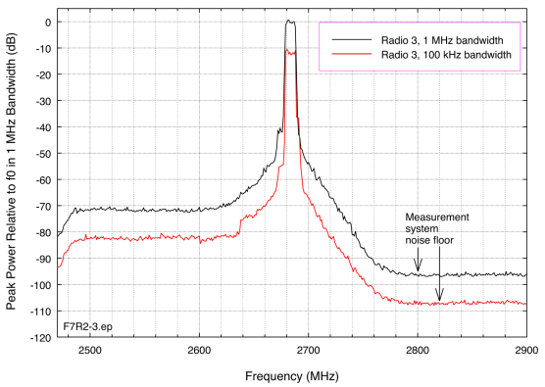

Figure 3-16

**Comparative peak and average emission spectra of WiMAX Radio 2**

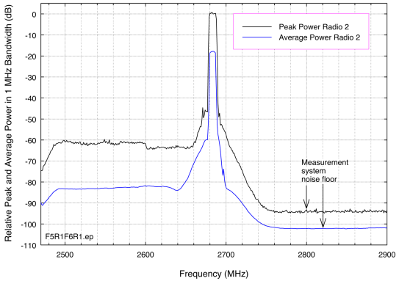

**3.9 Summary of WiMAX base station emission characteristics**

WiMAX base stations in the United States use multi-sector sets of antennas on high towers, rooftops, and water tanks (typically 30 m AGL) to provide services to subscribers. Channel bandwidths are 5 MHz but operationally each azimuth sector typically occupies 10 MHz, made up of pairs of 5 MHz channels. Intentional radiation is transmitted on frequencies between 2 618 and 2 690 MHz. Frequency diversity is used at each station on a sector-dependent basis. Three frequencies are typically used per tower, one for each 120-degree coverage sector.

WiMAX base station antennas have broad azimuthal patterns but narrow vertical patterns. Vertical antenna beam widths are on the order of 7 degrees and the vertical tilt angles of the antennas are adjustable; antenna tilt angles are usually set somewhat below horizontal to maximize coverage of subscribers. Antenna polarization is usually slanted at 45 degrees and antenna frequency response is nearly flat up to at least 3 000 MHz, well into the adjacent radar band edge at 2 700 MHz. Therefore antenna polarization and frequency response will probably not be useful for de-confliction of possible adjacent-band EMC problems, but antenna tilt angles might be adjusted for this purpose.

WiMAX base station downlink signals radiate with a 5 ms periodicity. In each 5 ms period the first 3 ms is used for a 0.5 ms preamble transmission followed immediately by a 2.5 ms data frame transmission. The last 2 ms is a quiet period for reception of subscriber uplink data. The preamble amplitude is fixed but the data frame amplitudes vary by at least 8 dB on a frame-to-frame basis.

WiMAX base station signal power varies as 10-log of measurement (or receiver) bandwidth across the fundamental, OOB and spurious regions of WiMAX emission spectra. Peak-detected spectrum measurements will yield consistent and repeatable results due to the fixed preamble amplitudes. Average-detected measurements of operational, radiated WiMAX signals may be more problematic due to the variation in frame amplitudes.

The offset between peak-detected and average-detected WiMAX emission spectra runs between 15 and 20 dB across the fundamental, OOB and spurious regions. On the whole, 17 dB may be used as a best-fit number for the WiMAX peak-to-average offset.

The gated (not frame-to-frame) average level of interference in NEXRAD receivers is the relevant parameter for EMC studies for high duty cycle interference, as occurs in WiMAX signals. NEXRAD receivers are designed to mitigate low duty cycle pulsed interference from other radars, not high duty cycle communication signals.

Unfiltered WiMAX emission spectra measured with up to 96 dB of dynamic range show measurable OOB and spurious emissions at frequencies as high as 2 760, 2 780 and 2 800 MHz for the radios of three respective manufacturers. Although these emissions meet applicable regulatory limits, they can potentially pose EMC problems for radar receivers operating at frequencies above 2 700 MHz.

Annex 4 of study 1

**Adjacent-band interference mitigation options**

Based on all of the technical work performed in this study, interference into NEXRADs from WiMAX (and possibly eventually other types of adjacent-band transmitters) can be mitigated using the following methods, or combinations of them. Both existing and planned base stations should be considered when determining the most appropriate course of action. In situations where minimal amounts of interference are occurring, the simpler and less costly methods may be attempted first to mitigate the interference. Mitigation options are listed here in the order of increasing levels of estimated cost, difficulty, and effort. Pros and cons are discussed for each option.

**4.1 Down-Tilting of WiMAX base station transmitter antennas**

As shown in Figure 4-1, some down-tilting of WiMAX base station antennas will produce additional decoupling of interference energy from adjacent-band NEXRAD receivers.

Figure 4-1

**Detail of Annex 3, Figure 3-4, showing amount of down-tilt needed to achieve 12 dB   
of decoupling in the antenna pattern**

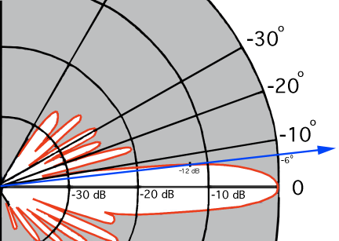

**Pro:** Down-tilting the vertical beams of WiMAX base stations can produce some decoupling between WiMAX transmitters and NEXRAD receivers. The vertical pattern of commonly used WiMAX base station antennas is very narrow . The effectiveness of such down-tilting in reducing interference power levels in NEXRAD receivers was demonstrated during a test at Grand Rapids, Michigan, in mid-2011, where the *I/N* level was reduced by 12 dB by down-tilting a WiMAX antenna by a few degrees. The down-tilt of some antennas in that provider’s network can be remotely controlled, while others need to be adjusted manually on-site.

**Con:** Down-tilt angles affect WiMAX service coverage. Modification of down-tilts could reduce service to some customers.

**4.2 Off-tuning WiMAX base station transmitters from upper WiMAX band edge**

**Pro:** Experience with local re-arrangement of the WiMAX frequency plan at Grand Rapids has shown that increased frequency off-tuning of unfiltered WiMAX emissions below the upper band edge of 2 700 MHz does at some point achieve the same level of interference mitigation as can be achieved by installing bandpass filtering. WiMAX networks are typically centrally managed and the base stations can be re-tuned with relative ease. Usually all of the WiMAX radios in a single market are procured from a single vendor, so network frequency plans are internally consistent and optimal across each market. This makes it easier to concentrate WiMAX frequencies near the bottom of the WiMAX frequency band in market areas near NEXRAD stations.

**Con:** Changing the frequency of even a single WiMAX base station has a ripple effect across the entire network in each market area, so thorough and careful planning is required before WiMAX frequencies are modified. Centralized frequency management causes single changes to cascade through the entire market, making retuning logistically challenging. Revised frequency plans are not trivial to develop and new ones can require a day or two to be established and verified on each network. This process may adversely affect the service to some customers during that time period, and thus may temporarily adversely affect operations and revenues. (Note: Not all BRS spectrum is readily available in all markets for such reassignment.)

**4.3 Installation of filters on WiMAX base station transmitters**

**Pro:** Installing bandpass filters on WiMAX transmitters will permit them to operate on their highest allocated frequency (2683.5 MHz) without causing interference at a separation distance of 5 km at an antenna height that is approximately the same as the height of NEXRAD receiver antennas. Filter installation is the most completely effective option among all possible approaches. The filters are relatively inexpensive to include during the installation of new WiMAX base stations. However, current WiMAX transmitters require four filters per station. At some locations, more than one station is operated per sector. There are also ancillary costs, and a cost to weatherproof the new connections.

**Con:** Retrofitting bandpass filters at *existing* WiMAX base stations has a cost roughly ten times the cost of installing them at new base stations. The main retrofit cost is for labor to access the stations, install the filters, and ensure that all connections are weatherproofed. Access to some locations, such as water towers, requires costly labor expenditures. (WiMAX service providers commonly contract this work on a market-by-market basis.) Given that other mitigation options are available which can be effective and less costly, blanket installation of bandpass filters at all WiMAX base station sites would be unnecessary and needlessly costly. It may be best to resort to filter installation only at WiMAX base stations where the need for interference mitigation has been established and where other, less costly mitigation approaches have been attempted but have been found to be ineffective.

**4.4 Establishing larger physical separation distances between WiMAX transmitters and NEXRAD receivers when frequency separations are small**

**Pro:** If the frequencies of a WiMAX and a NEXRAD station are so close as to potentially cause interference to the NEXRAD, then the interference can be mitigated by maintaining a sufficiently large physical separation distance between them. This distance would be at or beyond the radio LOS between their respective antennas. Establishment of separation distances beyond radio LOS between WiMAX transmitters and radar receivers requires minimal additional intervention within each of the systems.

**Con:** Many NEXRAD radars are located near population centers to provide effective alerts for severe weather and other phenomena. WiMAX networks routinely need to serve those same population centers. So it will generally not be practical (cost and time to relocate being substantial) to use geographical separation alone to mitigate existing interference between stations. However, careful pre-planning for the frequencies of new WiMAX stations can provide for larger separation distances from local NEXRADs when frequency separations need to be small.

**4.5 Reduction in the heights of WiMAX base station transmitter antennas**

**Pro:** NEXRADs utilize antenna gains of +45 dBi. While the WiMAX base station antenna gains are not so large, the antennas of these two systems are typically located at comparable heights of 24‑30 m (80–100 ft) AGL and both systems direct their antenna beams at vertical angles that are close to the horizon. NEXRAD antennas are located on 24 m (80 ft) towers to provide relatively clutter-free coverage toward and above the horizon, while WiMAX antennas are placed high to achieve maximal coverage for their base stations toward and below the horizon. So mainbeam coupling will sometimes occur, maximizing interference. Reducing the heights of some WiMAX base station antennas could reduce the maximum system-to-system coupling levels.

**Con:** WiMAX antenna heights and beam angles have been established to provide optimal network coverage versus base station costs. Reducing the heights of some WiMAX base station antennas would affect network coverage and could reduce service to some customers. High labor costs might also be incurred on a station-by-station basis and some new, costly gap-filling base stations might need to be established if WiMAX antenna heights were reduced.

**4.6 Retuning NEXRAD frequencies enough to mitigate interference**

Taking factors of gain and loss for WiMAX and NEXRAD into account, for a separation distance of 1.6 kilometers (one mile) or more, NEXRAD stations operating at a frequency of 2 723.5 MHz or higher should not experience impacts from WiMAX stations operating in the BRS band. This is supported by empirical observations; NEXRAD stations reporting strobes have all been tuned below 2 720 MHz.

**Pro:** Retuning the radar can reduce effects of unwanted emissions from transmitters in the BRS band enough to mitigate interference by positioning the radar frequency at a more aggressive point in the filter roll‑off of the WiMAX station. Stated another way, if a NEXRAD is experiencing WiMAX interference, re-tuning it to a sufficiently higher frequency can decouple its receiver enough from WiMAX unwanted emission energy as to eliminate the interference.

**Cons:** NEXRADs use custom-built RF front-end bandpass filters that would have to be replaced in the event of retuning. Other NEXRAD components (the RF diplexer, circulator, and transmitter klystron) would also need to be adjusted or replaced to accommodate that change; these modifications would be expensive and time-consuming. Some new parts may not be readily available since NEXRADs are now out of production. Retuned NEXRADs would need to be recertified. In addition, changing the frequency of a single NEXRAD can have a ripple effect on the frequency assignments of other NEXRAD, ASR, and GPN radars in a geographic area. This could cause multiple radars in an area to need to be retuned (with front-end filters needing to be replaced in ASR-9s and equivalent GPNs) and operationally recertified if a single NEXRAD is retuned.

REFERENCES

[1] Wang, Z., M. Ganley, Bal Randhawa and I. Parker, “Interference from radars into adjacent band UMTS and WiMAX systems,” ERA Report (Cobham Technical Services, CTS) Report for Ofcom, ERA Report number 2007-0554, Sep. 2007.

[http://stakeholders.ofcom.org.uk/binaries/research/technology-research/2007-0554.pdf.](http://stakeholders.ofcom.org.uk/binaries/research/technology-research/2007-0554.pdf)

[2] Ganley, M. and S. Munday, “Assessment of the potential for interference into an ‘S-band’ air traffic control radar from 2500 to 2690 MHz systems,” ERA Technology (Cobham Technical Services) Report for Ofcom, ERA Report number 2008-0456, Issue 4,   
Oct. 2008.

[http://stakeholders.ofcom.org.uk/binaries/spectrum/spectrum-awards/awards-in-](http://stakeholders.ofcom.org.uk/binaries/spectrum/spectrum-awards/awards-in-preparation/757738/588_Assessment_of_the_Poten1.pdf)  
[preparation/757738/588_Assessment_of_the_Poten1.pdf.](http://stakeholders.ofcom.org.uk/binaries/spectrum/spectrum-awards/awards-in-preparation/757738/588_Assessment_of_the_Poten1.pdf)

[3] Ganley, M. and Z. Wang, “Potential impact of out-of-band emissions from the 2.6 GHz auction on S-band maritime radar,” ERA Technology (Cobham Technical Services) report   
for the UK Maritime and Coast Guard Agency (MCA), Report number 2009-0258, Jun. 2009.

[http://www.dft.gov.uk/mca/2009-0258_final_-_mca-2.pdf.](http://www.dft.gov.uk/mca/2009-0258_final_-_mca-2.pdf)

[4] C. Blackler, “Watchman radar: Receiver selectivity improvements in the 2700-3100 MHz band,” SELEX Systems Integration, Report number SSI-PS0305-ENG-405, 1 Dec. 2009.

[http://stakeholders.ofcom.org.uk/binaries/spectrum/spectrum-awards/awards-in-](http://stakeholders.ofcom.org.uk/binaries/spectrum/spectrum-awards/awards-in-preparation/757738/592_Watchman_Radar_Receiver1.pdf)  
[preparation/757738/592_Watchman_Radar_Receiver1.pdf.](http://stakeholders.ofcom.org.uk/binaries/spectrum/spectrum-awards/awards-in-preparation/757738/592_Watchman_Radar_Receiver1.pdf)

[5] Helios Company report, “Review of radar receiver adjacent channel thresholds of  
UK S-band ATC radars: final Report,” summarizing work performed by Cobham Technical Services (CTS) and SELEX for Ofcom, 10 Dec. 2009.

[http://stakeholders.ofcom.org.uk/binaries/spectrum/spectrum-awards/awards-in-](http://stakeholders.ofcom.org.uk/binaries/spectrum/spectrum-awards/awards-in-preparation/757738/594_Review_of_Radar_Receive1.pdf)  
[preparation/757738/594_Review_of_Radar_Receive1.pdf.](http://stakeholders.ofcom.org.uk/binaries/spectrum/spectrum-awards/awards-in-preparation/757738/594_Review_of_Radar_Receive1.pdf)

[6] L. Ashton, “Phase 2 of 2.6 GHz trials at RAF Honington Aug 2009,” ERA Technology for Ofcom and UK Ministry of Defense (MoD), Issue 2, 4 Nov. 2009.

[http://stakeholders.ofcom.org.uk/binaries/spectrum/spectrum-awards/awards-in-](http://stakeholders.ofcom.org.uk/binaries/spectrum/spectrum-awards/awards-in-preparation/757738/590_Mepward_Report___Phase_1.pdf)  
[preparation/757738/590_Mepward_Report___Phase_1.pdf.](http://stakeholders.ofcom.org.uk/binaries/spectrum/spectrum-awards/awards-in-preparation/757738/590_Mepward_Report___Phase_1.pdf)

[7] L. Ashton, “Phase 2 of 2.6 GHz trials at Portland Aug 2009,” ERA Technology for Ofcomand UK MoD, Issue 2, 4 Nov. 2009.

[http://stakeholders.ofcom.org.uk/binaries/spectrum/spectrum-awards/awards-in-](http://stakeholders.ofcom.org.uk/binaries/spectrum/spectrum-awards/awards-in-preparation/757738/591_Mepward_Report___Phase_1.pdf)  
[preparation/757738/591_Mepward_Report___Phase_1.pdf.](http://stakeholders.ofcom.org.uk/binaries/spectrum/spectrum-awards/awards-in-preparation/757738/591_Mepward_Report___Phase_1.pdf)

[8] Ofcom Report, “Coexistence of S band radar systems and adjacent future systems,”  
11 Dec. 2009.

[http://stakeholders.ofcom.org.uk/binaries/spectrum/spectrum-awards/awards-in-preparation/infoupdate.pdf.](http://stakeholders.ofcom.org.uk/binaries/spectrum/spectrum-awards/awards-in-preparation/infoupdate.pdf)

[9] Louth, G. “Consultation on assessment of future mobile competition and proposals for combined award of 800 MHz and 2.6 GHz spectrum,” Ofcom Briefing for Stakeholders,   
22 Mar. 2011.

[http://stakeholders.ofcom.org.uk/binaries/consultations/combined-award/annexes/briefing.pdf.](http://stakeholders.ofcom.org.uk/binaries/consultations/combined-award/annexes/briefing.pdf)

[10] Real Wireless Ltd., “Airport deployment study: final Report,” Real Wireless for Ofcom, 19 Jul. 2011.

[http://www.ofcom.org.uk/static/spectrum/Airport_Deployment_Study.pdf.](http://www.ofcom.org.uk/static/spectrum/Airport_Deployment_Study.pdf)

[11] Ofcom report, “Communications signals in the 2.6 GHz band and maritime radar -technical assessment of interference,” 2 Aug. 2011.

[http://stakeholders.ofcom.org.uk/binaries/spectrum/spectrum-awards/awards-in-](http://stakeholders.ofcom.org.uk/binaries/spectrum/spectrum-awards/awards-in-preparation/2011/Maritime_technical_report.pdf)  
[preparation/2011/Maritime_technical_report.pdf.](http://stakeholders.ofcom.org.uk/binaries/spectrum/spectrum-awards/awards-in-preparation/2011/Maritime_technical_report.pdf)

[12] Electronic Communications Committee (ECC) of the European Conference of Postal and Telecommunications Administrations (CEPT), “Compatibility between the mobile service in the band 2 500-2 690 MHz and the radiodetermination service in the band 2 700-2 900 MHz,” ECC Report 174, Mar. 2012.

[http://www.erodocdb.dk/docs/doc98/official/pdf/ECCRep174.pdf.](http://www.erodocdb.dk/docs/doc98/official/pdf/ECCRep174.pdf)

[13] International Telecommunications Union, Radiocommunication Sector (ITU-R), “Technical and operational aspects of ground-based meteorological radars,” Recommendation ITU‑R M.1849-0.

[http://www.itu.int/dms_pubrec/itu-r/rec/m/R-REC-M.1849-0-200906-I!!PDF-E.pdf.](http://www.itu.int/dms_pubrec/itu-r/rec/m/R-REC-M.1849-0-200906-I!!PDF-E.pdf)

[14] Sanders, F. H., R. Sole, B. Bedford, D. Franc and T. Pawlowitz, “Effects of RF interference on radar receivers,” NTIA Technical Report TR-06-444, U.S. Dept. of Commerce, Sep. 2006.

[http://www.its.bldrdoc.gov/publications/2481.aspx.](http://www.its.bldrdoc.gov/publications/2481.aspx)

[15] U.S. Department of Commerce, Office of Spectrum Management, “Manual of Regulations and Procedures for Federal Radio Frequency Management,” Chapter 5, Jan. 2008 Edition, May 2011 Revisions.

[http://www.ntia.doc.gov/files/ntia/publications/manual_5_11.pdf.](http://www.ntia.doc.gov/files/ntia/publications/manual_5_11.pdf)

[16] Sanders, F. H., R. L. Hinkle, and B. J. Ramsey, “Measurement procedures for the Radar spectrum engineering criteria (RSEC),” NTIA Technical Report TR-05-420, U.S. Dept. of Commerce, Mar. 2005.

[http://www.its.bldrdoc.gov/publications/2450.aspx.](http://www.its.bldrdoc.gov/publications/2450.aspx)

[17] Sanders, F. H., “The rabbit ears pulse-envelope phenomenon in off-fundamental detection of pulsed signals,” NTIA Technical Memorandum TM-12-487, Jul. 2012,

[http://www.its.bldrdoc.gov/publications/2678.aspx.](http://www.its.bldrdoc.gov/publications/2678.aspx)

[18] Sanders, F. H., R. L. Hinkle and B. J. Ramsey, “Analysis of electromagnetic compatibility between radar stations and 4 GHz fixed-satellite earth stations,” NTIA Technical Report TR-94-313, U.S. Dept. of Commerce, Jul. 1994.

[http://www.its.bldrdoc.gov/publications/2340.aspx.](http://www.its.bldrdoc.gov/publications/2340.aspx)

ABBREVIATIONS/ACRONYMS

AGL Above ground level

ASR Airport surveillance radar

ATC Air traffic control

CTS Cobham Technical Services

CFR Code of Federal Regulations

CW Continuous wave

BRS Broadband Radio Service

DOD Department of Defense

EBS Educational Broadband Service

EIRP Effective isotropic radiated power

EMC Electromagnetic compatibility

FAA Federal Aviation Administration

FCC Federal Communications Commission

FDR Frequency-dependent rejection

GMF Government Master File

GPN Ground Radar Navigation (DOD ATC radar)

IF Intermediate frequency (of a heterodyne receiver)

I/N Interference-to-noise ratio

IEEE Institute of Electrical and Electronics Engineers

ITS Institute for Telecommunication Sciences (NTIA)

ITU-R International Telecommunications Union, Radiocommunication Sector

LBS Lower Band Segment of BRS/EBS

LNA Low noise amplifier

LOS Line-of-sight (distance) on a smooth round Earth

LTE Long Term Evolution

MBS Middle Band Segment of BRS/EBS

NAS National Airspace System

NEXRAD Next Generation Weather Radar also designated WSR-88D

NOAA National Oceanic and Atmospheric Administration

NTIA National Telecommunications and Information Administration

NWS National Weather Service

Ofcom Independent regulator and competition authority for the UK communications  
industries

OFDM Orthogonal frequency division multiplexing (modulation)

OOB Out of band (radio emissions)

PDL Passive diode limiter

PPI Plan position indicator (azimuth-range radar data display)

QAM Quadrature (four level states) amplitude modulation

QPSK Quadrature (four phase states) phase shift keyed modulation

RF Radio frequency

ROC Radar Operations Center (of NOAA/NWS)

RSEC United States Radar Spectrum Engineering Criteria

S Band United States band designation for frequencies between 2 700 and 3 700 MHz

TDWR Terminal Doppler Weather Radar

UBS Upper Band Segment of BRS/EBS

VSA Vector signal analyzer

VSG Vector signal generator

WFO Weather Forecasting Office of NOAA/NWS

WiMAX Worldwide Interoperability for Microwave Access (trademark of the WiMAX forum)

WSR-88D NEXRAD weather surveillance radar, type accepted 1988, Doppler-capable

______________

1. * If restricted access is selected the WMO Document will only be accessible to the WMO WIKI registered users.
2. Although the data in this Report are specifically related to interference from WiMAX base stations, it is believed that other types of broadband signals using other modulation schemes would generate similar interference effects in meteorological radar receivers. This interference commonality for all broadband signals interfering with radars has been documented in National Telecommunications and Information Agency [Report TR-06-444](http://www.its.bldrdoc.gov/publications/2481.aspx), September 2006.
3. Wang, Z., M. Ganley, Bal Randhawa and I. Parker, “Interference from radars into adjacent band UMTS and WiMax systems,” ERA Report (Cobham Technical Services, CTS) report for Ofcom, ERA Report number 2007-0554, Sep. 2007. <http://stakeholders.ofcom.org.uk/binaries/research/technology-research/2007-0554.pdf>
4. Electronic Communications Committee (ECC) of the European Conference of Postal and Telecommunications Administrations (CEPT), “Compatibility between the mobile service in the band 2 500-2 690 MHz and the Radiodetermination service in the band 2 700-2 900 MHz,” ECC Report 174, Mar. 2012. <http://www.erodocdb.dk/docs/doc98/official/pdf/ECCRep174.pdf>
5. Information on a common measurement Report of APWPT and the DKE WG 731.0.8 (DIN/VDE) “A study of LTE interference potential with regard to PMSE operation”
6. The NEXRAD radar is a meteorological radar operated in the United States. It has characteristics similar to other ground based meteorological radars operated in other parts of the world.
7. Strobes are interference artefacts; they are oriented along a radial and result in blanked-out coverage zones on meteorological radar displays. Weather data are suppressed within the geographic areas of coverage where strobes occur.
8. Additional details regarding the interference measurements that were taken on both meteorological and aeronautical surveillance radars can be found in NTIA Report 13-490. Also of note is the fact that this Report was used as the primary reference for this document.
9. 5.384AThe bands, or portions of the bands, 1 710-1 885 MHz and 2 500-2 690 MHz, are identified for use by administrations wishing to implement International Mobile Telecommunications-2000 (IMT-2000) in accordance with Resolution **223 (WRC-2000)**. This identification does not preclude the use of these bands by any application of the services to which they are allocated and does not establish priority in the Radio Regulations.
10. Characterization of the NEXRAD receiver at Jacksonville would have been redundant to the work done previously at Grand Rapids.
11. NEXRAD antennas can be down-tilted to zero degrees and even to angles below horizontal, but such tilt angles are not commonly used operationally.
12. Sanders, F. H., “The rabbit ears pulse-envelope phenomenon in off-fundamental detection of pulsed signals,” NTIA Technical Memorandum TM-12-487, Jul. 2012, <http://www.its.bldrdoc.gov/publications/2678.aspx>
13. Sanders, F. H., R. L. Hinkle and B. J. Ramsey, “Analysis of electromagnetic compatibility between radar stations and 4 GHz fixed-satellite earth stations,” NTIA Technical Report   
    TR-94-313, U.S. Dept. of Commerce, Jul. 1994. <http://www.its.bldrdoc.gov/publications/2340.aspx>
14. Sanders, F. H., R. Sole, B. Bedford, D. Franc and T. Pawlowitz, “Effects of RF interference on radar receivers,” NTIA Technical Report TR-06-444, U.S. Dept. of Commerce, Sep. 2006. <http://www.its.bldrdoc.gov/publications/2481.aspx>.
15. AGL is above-ground-level height; heights determined by shadow lengths of the WiMax towers observed in Google Earth imagery, as compared with the shadow length of the NEXRAD tower of known height.
16. International Telecommunications Union, Radiocommunication Sector (ITU-R), “Technical and operational aspects of ground-based meteorological radars,” Recommendation ITU-R M.1849, Jun. 2009. <http://www.itu.int/dms_pubrec/itu-r/rec/m/R-REC-M.1849-0-200906-I!!PDF-E.pdf>
17. See [http://www.WiMAXforum.org/](http://www.wimaxforum.org/) for more information about WiMAX systems.
18. See <http://www.ewh.ieee.org/r10/pune/WiMAX2010/Mobile-WiMAX-802.16e-PHY-02.pdf>
19. Federal Communication Commission (FCC) Broadband Radio (BR) service (47 CFR, Part 27).
20. Slant polarization supports the decorrelated multiple elements needed for Multiple Input Multiple Output (MIMO) operation.
21. Specified by the manufacturer as slant-polarized, +17 dBi gain, 65 degrees horizontal beamwidth, 7 degrees vertical beamwidth, front-to-back ratio in excess of 30 dB, rated for up to 250 watts input power.
22. Detailed examination of the nominal 10 MHz channel structure shows that each channel is actually composed of a pair of 5 MHz wide sub-channels. The orthogonal frequency division multiplexed (OFDM) WiMAX signal constellation consists of a large number of contiguous, narrow-band carriers, with a zero-amplitude carrier in the center; these render the appearance of two 5 MHz-wide sub-channels.
23. “Average” in this report always refers to linear, root mean square (RMS) average power. For thermal noise RMS average power is 2 dB lower than log average.
24. “Gated” means average power during WiMAX preambles and frames, not the average across complete frame-to-frame cycles that would include about 40 percent down time.
25. Sanders, F. H., R. Sole, B. Bedford, D. Franc and T. Pawlowitz, “Effects of RF interference on radar receivers,” NTIA Technical Report TR-06-444, U.S. Dept. of Commerce, Sep. 2006. <http://www.its.bldrdoc.gov/publications/2481.aspx>.