Possible architecture for cache synchronization and metadata exchange between GISCs

Table of content
The communication structure between the GISCs 1
The benefits of the current architecture 3
The drawbacks of the solution 3
So, what are the possible options? 4
A possible implementation of this architecture 6
Recommended Text 9

The communication structure between the GISCs
The role of a GISC is defined as:
- Receive observational data and products that are intended for global exchange from NCs and DCPCs within their area of responsibility, reformat as necessary and aggregate into products that cover their responsible area;
- Exchange information intended for global dissemination with other GISCs;
- Disseminate, within its area of responsibility, the entire set of data and products agreed by WMO for routine global exchange (this dissemination can be via any combination of the Internet, satellite, multicasting, etc. as appropriate to meet the needs of Members that require its products);
- Hold the entire set of data and products agreed by WMO for routine global exchange for at least 24 hours and make it available via WMO request/reply (”Pull”) mechanisms;
- Maintain, in accordance to the WMO standards, a catalogue of all data and products for global exchange and provide access to this catalogue to locate the relevant centre;
- Provide around-the-clock connectivity to the public and private networks at a bandwidth that is sufficient to meet its global and regional responsibilities;
- Co-ordinate with the Centres within its area of responsibility a WIS telecommunications infrastructure that can meet the WIS requirements for information exchange within the area and that can exchange agreed WIS time critical and operational critical information with other areas.
- Ensure that they have procedures and arrangements in place to provide swift recovery or backup of their essential services in the event of an outage (due to, for example, fire or a natural disaster);
- Participate in monitoring the performance of the system, including monitoring the collection and distribution of data and products intended for global exchange.

In term of data exchanges, these functions can grouped in:
- Exchanges between GISCs
- Exchanges between the GISC and the DCPCs and NCs in the area of responsibility
- Exchanges between the GISC and its users
This document concentrates on the first aspect, the exchanges between the GISCs.
In the most likely scenario, the WIS will operate with 15 GISCs. As discussed already many time, and in order to comply with the defined role above, the GISCs will have to maintain a metadata catalogue as well as a 24h cache.
Having the same catalogue and a complete and consistent 24h cache is a must to serve the clients of the WIS.
In order to do so, and following the agreed architecture (see TT-WISC 2013 report), each GISC must:
- Harvest the metadata catalogue from the other 14 GISCs. This is, in principle, done using OAI-PMH over the Internet
- Establish a bilateral link with the other 14 GISCs and exchange the data to be stored in the catalogue. This is, in principle, done using FTP over the RMDCN
The figure below represents the target architecture with the “links” over the WIS Core Network.
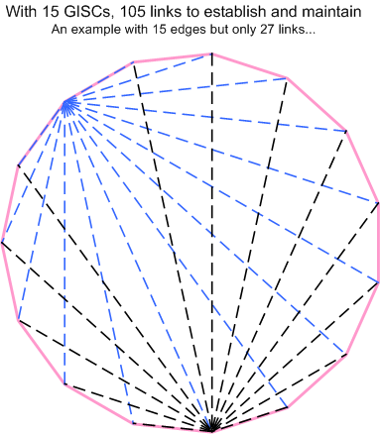

The benefits of the current architecture
- Reuse of a known solution
All 15 GISCs have a very long experience of running the GTS. The GTS is based on the creation of these bilateral links and has proved to work very well over the past. Reusing the same technical solution (bilateral links, FTP application) is therefore the most obvious choice and should allow a smooth co-existence (or transition) between the GTS and the WIS. It also avoids having to create new technical solution and “reinventing the wheel” when there is no need to.

- Shorter delays for tsunami warning and other urgent messages
With the current architecture of the GTS, a tsunami warning or any other urgent message may have to be routed via multiple RTH, IMTN centers and NMHSs before reaching everyone. Studies have taken place in order to reduce the delay in transferring these messages. The queuing mechanism was reviewed and various delay parameters were adjusted. However, the number of “hops” between the originator of the messages and all the recipients is still the same. Having direct communication between all GISCs will reduce dramatically the number of “hops”. In an ideal scenario this should be 3: NC – GISC – GISC – NC. This is a much better solution than today.

The drawbacks of the solution
- Technical and political complexity of establishing the bilateral links
It has been agreed to use the well-known GTS mechanism to exchange the data to be included in the 24h cache. With 15 GISCs, this requires 14 bilateral links per GISCs. It is therefore a total of 105 bilateral links to be agreed, configured, maintained and supervised.
At the moment, with 7 GISCs up and running, we should have 28 links. As an example, Météo-France out of the six required links has only two (the “historical” GTS links) and has has started discussion for another two. When more and more GISCs will be operational this will require a tremendous effort. It may also be politically challenging for certain GISCs to establish bilateral links.
If some links are missing it means that some GISCs will have to relay to other GISCs the data they are receiving from a 3rd one. By doing so, we may end up having to maintain the equivalent of a MSS routing table.

- Networking aspects
Thanks to the RMDCN, and the any to any capability of MPLS, the low level networking aspect supports the creation of the links without further difficulty. However, the RMDCN supports classes of service. Exchanging data between any other GISC is possible but if this traffic is of critical importance, then it should be classified in the “right” class of service. This would increase the complexity of the configuration of the routers used on the RMDCN.

The agreed application to exchange data between the GISCs for the cache is FTP. FTP is a very good protocol and widely used. Unfortunately, FTP is based on “unicast”. It means that in order to send the same data to 14 destinations, each GISC will have to establish 14 FTP sessions and send the same file 14 times. Considering the relatively high cost of managed network such as the RMDCN, this is not a cost effective option.

- 24h cache consistency
One of the challenges we are currently facing and the agenda of the 2014 TT-GISC meeting in Toulouse, is an example of this, there isn’t yet an agreed method to assess the 24h cache consistency. With the current solution, as there isn’t one reference, it is extremely difficult to make sure that a particular cache in complete and consistent. This is still a subject of study.

So, what are the possible options?
- Reduce drastically the number of GISCs
In the early days of the WIS, the number of anticipated GISCs was between 3 and 5. With such a number of GISCs, having a consistent 24h cache and the harvesting of the metadata would be much easier. However, the role “Co-ordinate with the Centres within its area of responsibility a WIS telecommunications infrastructure”, would be even more challenging than it is already with a smaller number of GISCs (de facto the area of responsibility would be larger). It would also be very politically difficult to accept by the Centres that would lose the status of GISC, considering the efforts already made. Over the lifetime of the WIS, it is likely that the number of GISCs will slowly be reduced but without any guaranteed time frame and target number.

- Use other protocol for data exchange
The harvesting aspect isn’t as challenging as the exchange of data for the 24h cache. The modification rate of the metadata is quite low and as harvesting is done over the Internet, the network bandwidth is not really a problem. Using a unicast based protocol for the harvesting is acceptable.

The main challenge is the 24h cache. As already explained, the protocol used is FTP over the WIS Core Network once bilateral links are established. Another interesting option would be to use multicast. In 2012 and again in 2014, the Expert Team on Telecommunication Infrastructure (ET-CTS) is considering this solution. Using multicast for the data exchange between GISCs is quite an attractive option as it would eliminate one of the most challenging aspects, the networking issue and would simplify the two others. However, in order to do so, we have to:
- Use a network that is multicast capable
- Agree on another application replacing FTP (unicast by nature)
The Next Generation RMDCN which is currently deployed is not yet multicast ready. From a networking point of view, having one site being the source and all the others being the recipient of the multicast traffic is fairly easy. Unfortunately, we have 15 sources and as many recipients. Therefore, having a multicast ready network with potentially 15 sources is a challenge for the MPLS network providers. It is still unknown if the RMDCN will support such an architecture.
The other problem is the availability of a multicast file transfer protocol. ET-CTS has identified to potential candidates:
- NewTec from Tellicast
- MFTP (opensource solution)
EUMETSAT is currently using the solution from Tellicast to disseminate the satellite products over satellite links and has conducted some tests (and is planning to use this operationally in the future) of the GEANT network. This is a commercial product. In order to use this solution, all GISCs would have to buy and operate that solution. Considering the diversity of IT environment between the GISCs and the financial aspect, this would probably be very difficult to agree.
In 2011 and 2012, The Bureau of Meteorology in Australia tested the MFTP software and has identified some technical difficulties (mainly related to performance) that would need to be addressed before recommending this solution. It must also be noted that MFTP as opensource project isn’t very popular, as the need for such a solution is not widely spread. Selecting opensource software when its expected lifetime and available support are doubtful isn’t a very attractive option.
Even if rather tempting, a multicast based solution is unlikely to become usable in the near future.
- Change the architecture
As already explained above, two of the roles of the GISCs are purely “internal” (limited between the GISCs), the proposed solution is to dedicate two sites (for redundancy purposes) to facilitate the data exchange between the GISCs. So, instead of sending the same data to the 14 other GISCs, a GISC would send the data to two “sites”, which would then resend the data to the 14 others GISCs.
As all the GISCs must be connected to the RMDCN, one site should be reachable on the RMDCN and in order to protect the WIS of a potential failure of the RMDCN the second site would be reachable on the Internet.
The figure below represents the proposed architecture.
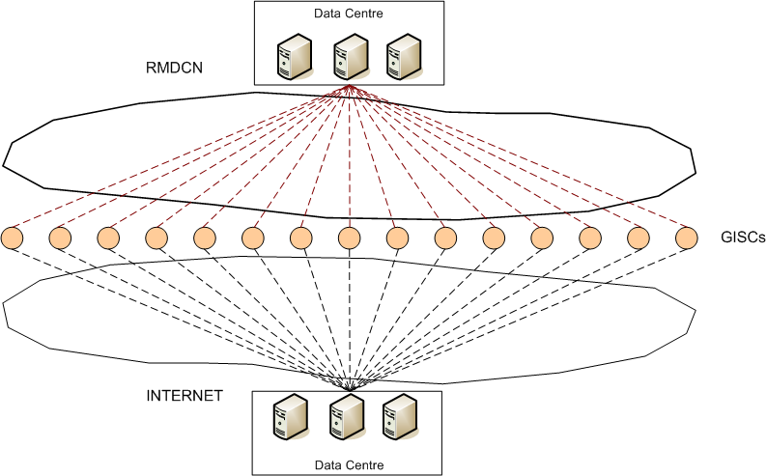

A possible implementation of this architecture
- The Cloud
“Cloud computing” refers to the logical computational resources (data, software) accessible via a network (through private network or Internet etc.), rather than from a local computer. The on-line service can be offered by a cloud provider or it could be a private organization’s own.
In the “cloud computing” market, the services are often described as either:
- SaaS: Software as a Service
- PaaS : Platform as a Service
- IaaS : Infrastructure as a Service

IaaS: Infrastructure as a Service
In an IaaS, the client can use resources in the cloud, such as virtual servers, Internet bandwidth and storage to create servers to provide extra computing/networking resources. This is rather similar to the traditional hosting environment with the addition of virtualisation, which gives an extra level of flexibility. Creating an extra virtual machine in a data centre is much easier and quicker than installing a physical device.

PaaS: Platform as a Service
Instead of giving access only to the infrastructure, the “cloud computing” provider can also give access to development and production resources in the cloud. The client is responsible for the development of his own software, based on a standard platform such as J2EE.

SaaS: Software as a Service
Finally, “cloud computing” providers give direct access to a software environment (e.g. GoogleDocs) for standard software. By thus pushing standardisation a step further, the client is able to outsource a lot of standard services into the cloud. Only the applications strictly related to the core business are run locally (or using an IaaS service). Standard applications such as email, word processing, HR management etc. are available with SaaS.

- The GaaS: Gisc as a Service
For the GISCs, as the applications are quite specific, the proposed solution is to use an IaaS from Cloud Computing provider and to add on the infrastructure the required software. This would create something that can be called GaaS, Gisc as a Service.

To run GAAS, we would need:
- A small sets of Virtual Machines split in two different Data Centres (for redundancy purposes)
- A downsized GISC software (or an MSS application) to run on these VMs
- One or preferably two teams to manage the VMs and the service
A possible option for the software and the management of the solution would be for volunteering GISCs to provide the software and run the service for a period of, for example, three years and then, after this period two new GISCs would be in charge of running the GaaS.

- The potential cloud providers
  - A “generic” cloud provider
The technical requirements for the GaaS solution are quite basic. Potentially, any provider (Amazon, Rackspace...) could potentially be used. In order to obtain the required level of service, the provider should:
- Offer an SLA on the VDCs
- Have at least on the two VDCs connected onto the RMDCN
In such a scenario, the GISCs would need to agree on a provider and find a contractual arrangement to procure and pay for the service. Though possible, the contractual arrangements and the paying mechanism would require some effort.
  - Potential use of the RMDCN network provider as a service extension
Interoute, the provider of the Next Generation RMDCN is offering a “Virtual Data Centre” (VDC) service.
From their brochure on VDC:
Virtual Data Centre (VDC) is Interoute’s scalable, fully automated Infrastructure as a Service (IaaS) solution. VDC provides on demand computing, storage & applications integrated into the heart of your IT infrastructure.
Interoute VDC is the first cloud computing solution that can be deployed with the simplicity and convenience of the public cloud, combined with the security and confidence that a private cloud brings.
The ability to offer fully automated public and private cloud on the same platform makes VDC unique.
The VDC Data Centres are not isolated but built intoInteroute’s pan-European network which spans more than 60,000 km of lit fibre, making VDC Europe’s largest cloud services platform. The network advantage means we don’t charge you for any data transfers in and out of your VDC or between VDC zones.
The public cost (see http://www.interoute.com/vdctrial2013) for 8 VMs each with 8 vCPU (cores) and 16GB of RAM and a total storage of 1TB is just above €2500 a month.
Interoute doesn’t charge for the bandwidth usage on the RMDCN or on the Internet for the traffic to and from VDC.
The additional monthly cost for each GISC would therefore be approximately 170€
At the moment, the RMDCN service is managed by ECMWF. In the late 90’s a MoU to manage the GTS on behalf of the countries in RA VI was signed between WMO and ECMWF. Recently, and this was accepted by ECMWF Council, the service has been extended to the WIS Core Network and all GISCs should be connected to the RMDCN.
The option of having a cloud service as part of the provision of the RMDCN Next Generation was considered.
It would be fairly straightforward to include the “Virtual Data Centre” service as an extension to the RMDCN.
Contractually this would require:
- WMO to request ECMWF to extend the RMDCN service to VDC
- ECMWF and Interoute to agree new terms of services and sign an amendment to the RMDCN contract
- Each GISC would then have to sign an amendment to his order to include a share of the GaaS option.

Recommended Text
The basic requirement is that all WMO members have the information from the global community necessary to provide their critical operational meteorological and related services.
Corollary: members have to make available agreed information they collect/produce to other members (basis of Res 40) within the agreed time frames.
This is reflected in the roles identified for the GISCs which are a core hub in communications between GISC AMDCN’s. From a telecommunications perspective, the two basic requirements are for the GISC to:
- Collect information intended for global dissemination from their area of responsibility via their AMDCN and send to other GISCs;
- Receive information intended for global dissemination or distribution to their AMDCN from other GISCs and disseminate to centres within their area of responsibility via their AMDCN.

Required data exchange only between the GISCs.
The present architecture requires GISCs to send information to all other GISCs via a fully meshed network. Instead of creating a fully meshed traffic flow between all the GISCs, it is proposed to consider the use of a cloud service to simplify the communication structure between the GISCs.
Further analysis is required to make sure that the service level offered by such an architecture is consistent with the level of SLA required to the GISCs. Considering that the RMDCN is the operational network between the GISCs, connecting the cloud provider on the RMDCN is therefore required in order to guarantee the timeliness of the data exchange. Among the various cloud providers, Interoute, the provider of the RMDCN Next Generation, is potentially an attractive solution. They propose the “Virtual Data Centre” service. Their data centers are connected on their MPLS backbone, thus allowing the connectivity between the VDC and the RMDCN (and the Internet) at no additional cost.
Other providers could be considered as well, noting that the contractual arrangement could be more difficult to put in place.
The meeting agreed that this is potentially an interesting solution to facilitate the communication between the GISCs. The next step would be to start a pilot using Interoute VDC to assess whether this approach is a viable option. Such pilot would last a year or so, and volunteer GISCs would be invited to join.
The pilot would require:
- two VMs in two different data centres (one for the RMDCN, one for the Internet)
- one or two GISC to install and maintain the required software
and as many GISCs as possible to use these facilities to exchange metadata and data.
It is suggested to present this option of having a pilot to the next session of ICT-ISS and if agreed, seek approval from ECMWF to support the pilot, find interested GISCs to maintain the VMs. The pilot could start in Q4-2014 for a year and the report would be presented at the next ET-CTS session early 2016.

