|  |  |  |
| --- | --- | --- |
| **WORLD WEATHER WATCH COMMISSION FOR BASIC SYSTEMS** |  | |
|  | |  |
| **Expert Team on Telecommunications Infrastructure (ET-CTS) Brasilia, Brazil 18-21 March 2014**  **Submitted by:** Jose L. Gianni (RTH Buenos Aires) | | **ET-CTS/2014-Doc[23]  Agenda Item [2.]** |
|  | | 21 March 2014 |

# Review of the current status of implementation of TCP/IP at RTH BA.

* **WIS**
* **MSS**
* **GTS**
* **NATIONAL NETWORK**
* **INTERNET ACCESS**
* **IPV6**
* **RECOMMENDED TEXT**

**WMO INFORMATION SYSTEM Background**

* **According to WIS DCPC nomination our Center has chosen the Commercial acquisition of the application, especially due to government policies in terms of support and maintenance.**
* **After a long and difficult previous process, a tender was launched a year ago becoming IBLSOFT’s Discover Weather application the benefitted one.**

**Present**

* **DCPC DW Buenos Aires has been installed, is up and running very recently (a few days ago):** [**http://dcpc.smn.gov.ar**](http://dcpc.smn.gov.ar)



**MESSAGE SWITCHING SYSTEM**

* **Moving Weather v. 1.6.7 (recently upgraded).**
* **CentOS Linux SO, HW: two HP ProLiant 5G servers connected in cluster configuration (to be migrated this year).**
* **IPV6 full compatible.**
* **Operational since Dec. 2009.**
* **Messir COMM, former MSS still available for secondary circuits**.
* **AFD is widely used**

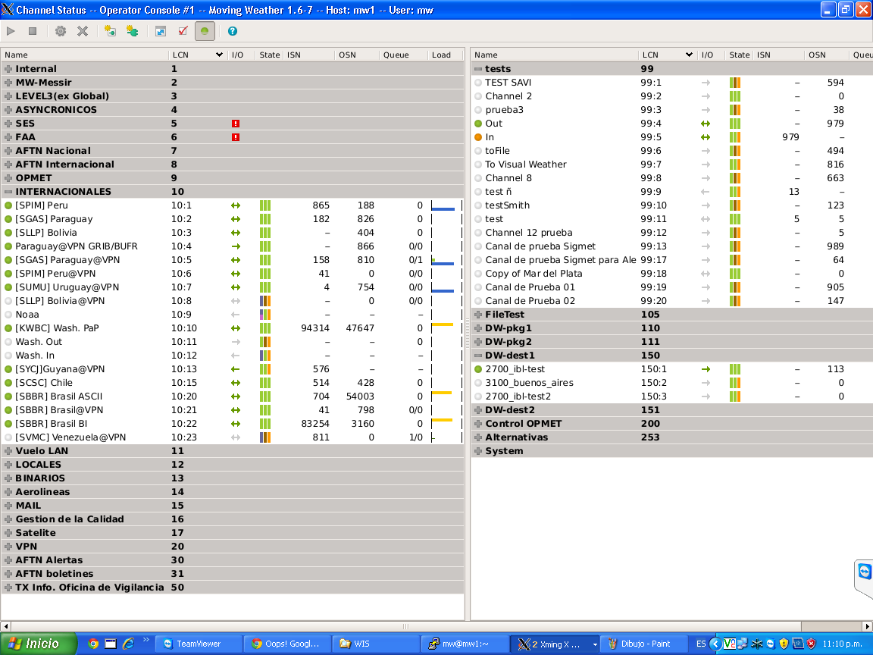

**GLOBAL TELECOM. SYSTEM**

**Regional VPN network**

* **Operational since 2009**
* **Tools usage: OpenSource Linux Fedora, OpenVpn and AFD (Automatic File Distribution).**
* **Present status:**
* **RTH Brasilia took care of RTH Venezuela duties.**
* **Thought the WMO VCP Framework, English Guyana joined the network last year.**

**CURRENT GTS LINKS**

|  |  |  |  |  |  |
| --- | --- | --- | --- | --- | --- |
| **COUNTRY** | **CITY** | **CIRCUIT TIPE** | **SPEED** | **TRANSFER**  **PROTOCOL** | **REMARKS** |
| **USA** | **Washington**  **(GISC)** | **Leased Line** | **64K** | **TCP/IP**  **SOCKETS** | **Backup via Internet (TCP/IP SOCKETS)** |
| **BRASIL** | **Brasilia**  **(GISC)** | **Internet (VPN)** | **-** | **FTP-TCP/IP**  **SOCKETS** | **Backup via Internet** |
| **CHILE** | **Santiago**  **(NC)** | **Internet**  **VPN** | **-** | **TCP/IP SOCKETS** | **Email and AFTN/AMHS as a backup** |
| **BOLIVIA** | **La Paz**  **(NC)** | **AMHS,**  **Internet VPN** | **-** | **X400/X500**  **FTP** | **Simultaneous operation** |
| **PARAGUAY** | **Asunción**  **(NC)** | **AMHS**  **Internet VPN** | **-** | **X400/X500**  **FTP** | **Simultaneous operation** |
| **PERU** | **Lima**  **(NC)** | **AMHS**  **Internet VPN** |  | **X400/X500**  **FTP** | **Simultaneous operation** |
| **URUGUAY** | **Montevideo**  **(NC)** | **Internet VPN** | **-** | **FTP** | **Email as backup** |
| **VENEZUELA** | **Maracay**  **(NC)** | **Internet VPN** | **-** | **FTP** | **AFTN/AMHS as backup** |
| **GUYANA** | **Georgetown**  **(NC)** | **Internet**  **VPN** |  | **FTP** | **RTH BA as backup** |

**-Original RAIII Telecommunications Network-**

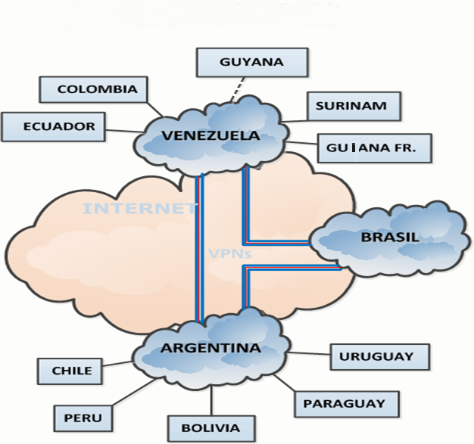

**-Present RAIII Telecommunications Network-**

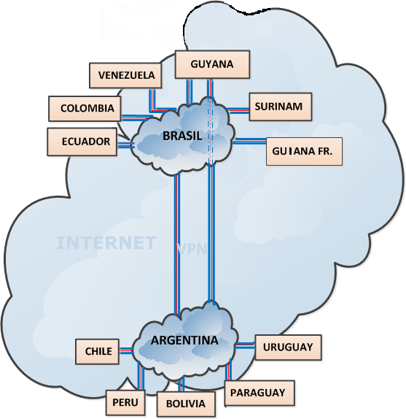

**NATIONAL NETWORK**

* **Thanks to the domestic manufacture of satellite technology, Argentina will have its own satellite and will not depend upon international operators to offer services within the country’s territory.**
* **The ARSAT 1 satellite will be launched by mid-2014 and will offer a wide array of telecommunications services such as television, telephony and Internet access, among others, with full coverage in Argentina, Chile, Uruguay and Paraguay. In the future, the entire continent will be covered by upcoming ARSAT 2 and 3 (2016/2017)**

**Technical data:  
  
 -Orbital Position: 72º W**

**-Coverage Area: Southern Cone**

**-Capacity: 24 channels broadcast on Ku-band**

**-Total Mass: approx. 2.9 tons**

**-Useful Load: 350 Kg (771.617 lb) 3.5 KW**

**-Useful Life: 15 years**

**Ku Band EIRP**

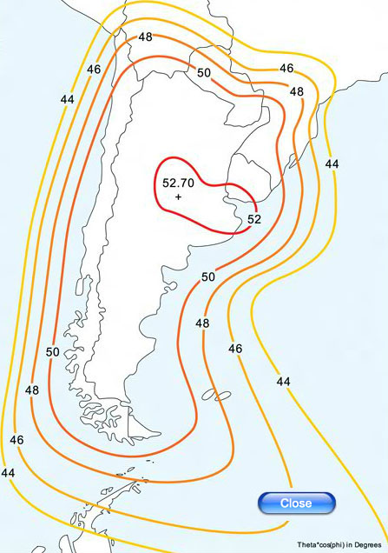

**INTERNET ACCESS**

* **Main Internet -ISP Level3 (ex. Global Crossing)**

**-Bandwidth 80 Mbps.(To be upgraded this year).**

**-Autonomous system 2765.**

**-SLA: plan to be subscribed this year**

* **Internet 2 via Innovared (Educational and Research**

**Argentina National Network).**

**-Bandwith 20Mbps, possibly to be upgraded this**

**Year.**

**-Pending SLA**

**IPV6**

* **Assigned a /48 block from Innovared, Educational Network (2001:1318:1021::/48) last year.**
* **Level3 our mean ISP, was the first-and remains the only-global communications provider with IPv6 natively deployed in both its private and public backbone networks; the company is uniquely qualified to enable a transition to IPv6.**
* **Our Center has intended to participate in IPV6 initiative this year.**
* **We do not have plan to deploy IPv6 for internal use yet, even if our network infrastructure are ready**

**RECOMMENDED TEXT**

* **Cooperate with Brasil in order to establish an appropriated spaghetti diagram for the Region.**
* **Human resources to meet all the future challenges should be a MUST.**

**THANK YOU!!**