Review of the current status of implementation of TCP/IP procedures and applications at WIS centers

GTS Links
Current status of GTS links connected:
OBS RMDCN link 2Mbps
Primary and secondary data centre connections at 2Mbps. These are being migrated to Interoute RMDCN NG. Implementation of links has been delayed at the local carrier end and is scheduled in time for cutoff of RMDC. DMVPN will be used as a backup if delays continue – this is being testing over the coming weeks.
Internet Link 250 Mbps
Primary and secondary data centre connections
Noumea 1mbps???? OPT
Jakarta & Singapore 64kbps Singtel VPLS
Fiji 64kbps

Internet.
Current 250 Mbps internet links and primary and secondary data centres will be migrated to a new Australian Federal Government Consolidated Gateway during 2014.

Current utilisation of RMDCN circuit.
OBS RMDCN link
Currently running at 3g per day in, and 1 gig per day out.
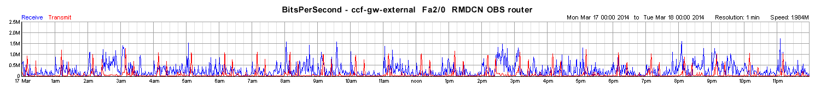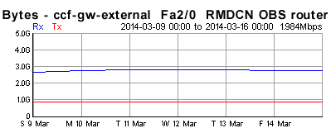
Internet
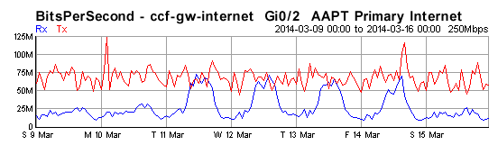

Noumea
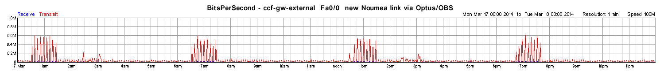
Singtel
This link is highly utilized at 64kbbs
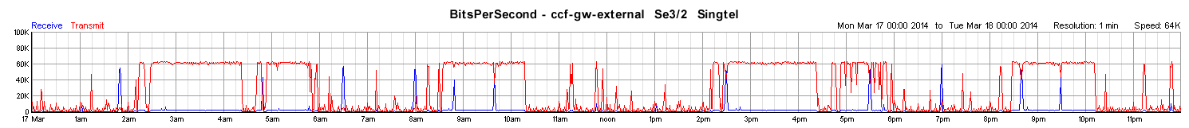
Fiji
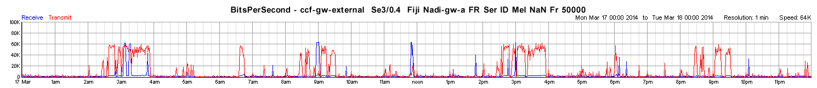

Recommended Text
Bureau of Meteorology will be moving to RMDCN-NG in April/May 2014, and will use DMVPN as part of the transition. Internet access will be migrated to consolidated Government gateway during 2014 and should keep the same functionality.
--------------------

