Review of the current status of implementation of TCP/IP at Meteo-France

GISC status
The Toulouse GISC status was presented at the TT-GISC meeting in Toulouse, on February 2014 (see [3]).
The highlights are:
- vGISC offers an OpenWis web portal and tools for metadata manipulation.
- Odyssey Radar DCPC operational (under OpenWIS).
- Agreement on Cooperation for backup with GISC Moscow.
The current duties are:
- Finalization of the backup implementation between GISCs Toulouse and Moscow.
- Finalization of the vGISC implementation between GISCs Toulouse and Exeter.
- Continuation of the deployment of links with others GISCs (Tokyo, Washington).
- Metadata improvement.
- Involvement in the evolution of OpenWIS and migration to opensource.

Internet access

Main Internet Access
The main Internet access is provided by IMS Networks, with a 300 Mbps bandwidth which should be upgraded in 2014.
There are 2 different physical circuits, one for the main link and one for the backup.
The SLA provides:
- 99.98% availability
- 7x24x365 monitoring
- 4 hours of mean time to recover
All WIS traffic using the Internet use this access.

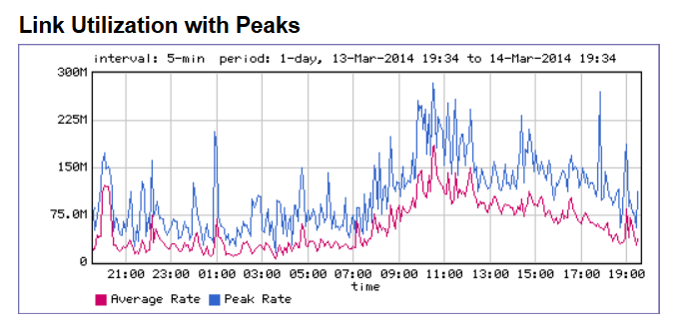
Figure 1 : Main Internet link occupancy on a business day - Inbound - UTC+1
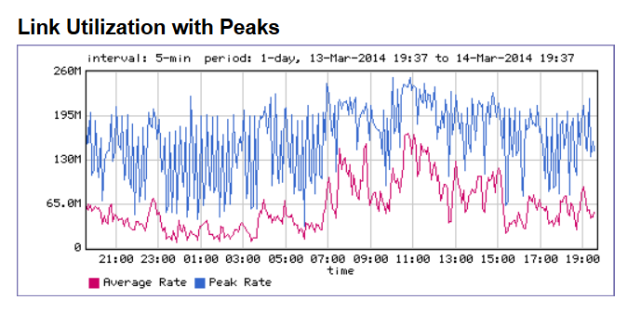
Figure 2 : Main Internet link occupancy on a business day - Outbound - UTC+1

Renater Internet accesses
Renater (see [1]) is the French research and academic network; it is connected to its European counterpart, Geant.
Meteo-France is connected to Internet by Renater at Toulouse and Lannion, with a 1 Gbps bandwidth on each site.
Lannion is directly connected to Renater.
Toulouse is connected to Renater through the Toulousan metropolitan academic network, called Remip (see [2]).
Those two links do not have any SLA.
According to the terms of use of Renater, those accesses are only used for research and academic activities.
Lannion and Toulouse are connected for operational services by an internal IP-VPN network, operated by Orange Business Services, respectively with 30 Mbps and 160 Mbps bandwidth and 99.98% availability.
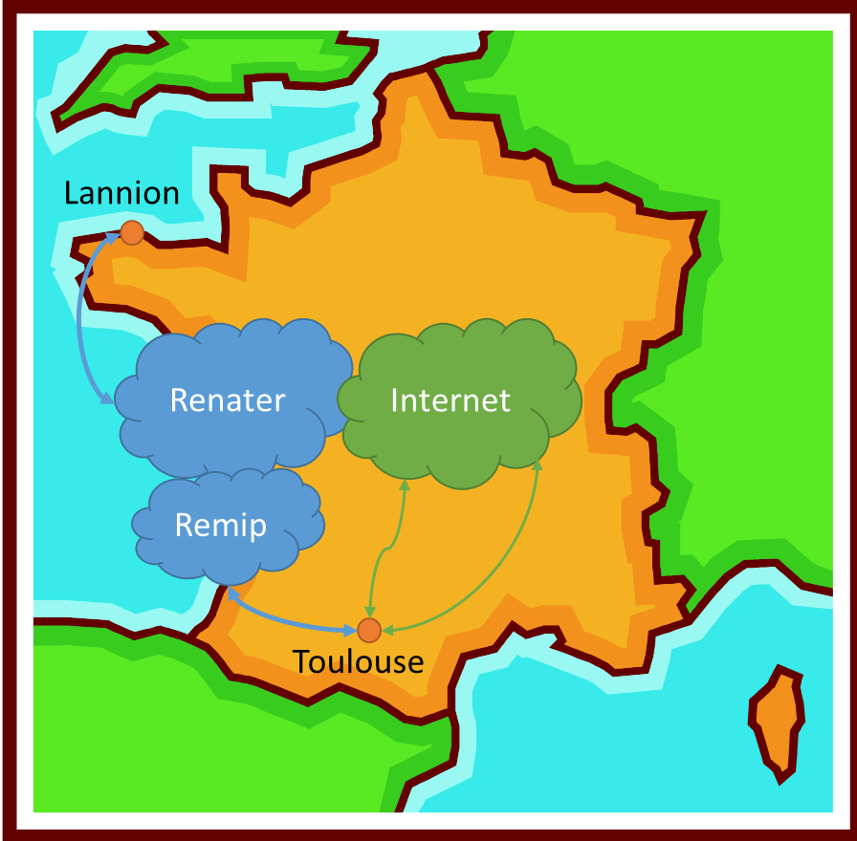
Figure 3 : Internet accesses at Meteo-France

RMDCN-NG access
Meteo-France is connected to RMDCN-NG with a 50 Mbps bandwidth with a platinium service level.

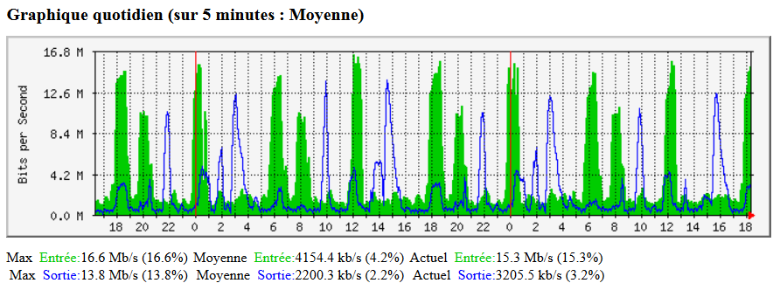
Figure 4 : RMDCN-NG link occupancy from March, 12th to March, 14th - UTC

IPv6 status
Meteo-France is part of the WMO IPv6 pilot project.
A /48 network is routed by our ISP, IMS, on our main Internet access.
A test PC with the ECMWF ISO image is reachable from the Internet since September 2013.
We do not have plan to deploy IPv6 for internal use yet, even if our network infrastructure (both equipment and internal IP-VPN network) are IPv6 ready.

Multicast status
Meteo-France took part in the 2012 Eumetsat experiment using the Toulouse Renater/Remip access but could not achieve Multicast connectivity.
We suppose that it was due to a Remip issue.
We should take part of the next Eumetsat experiment, keeping in mind that the use of our Renater links is not compatible with high operational requirements.
We do not have any internal use of multicast.

References
[1] Renater : http://www.renater.fr/?lang=en
[2] Remip : http://www.remip.prd.fr/
[2] Toulouse GISC status – Doc 29 : http://wis.wmo.int/doc=2957

Recommended Text
Meteo-France has a high availability level on both its RMDCN-NG and Internet accesses. The recent increase in the RMDCN-NG bandwidth, from 10 Mbps to 50 Mbps, is sufficient for our current needs. The Internet access bandwidth should increase shortly.
Meteo-France is part of IPv6 and multicast experiments but does not have any plan for upcoming internal use.
As for the Toulouse GISC, DCPC Odyssey radar is under implementation and vGISC proposes through internet a web portal for metadata management. This service is offered for NC’s and DCPC of vGISC area of responsibility.

--------------------

