Review of the current status of implementation of TCP/IP procedures and applications at WIS centers at GISC Beijing

CMA’s international network connection migrated to RMDCN-NG
CMA migrated to RMDCN-NG on Jan 14, 2014. All transition implementation was completed in 2 hours. The linkspeed as well as the bandwidth of CMA’s RMDCN-NG connection upgraded from 4Mbps (RMDCN) to currently 8Mbps.
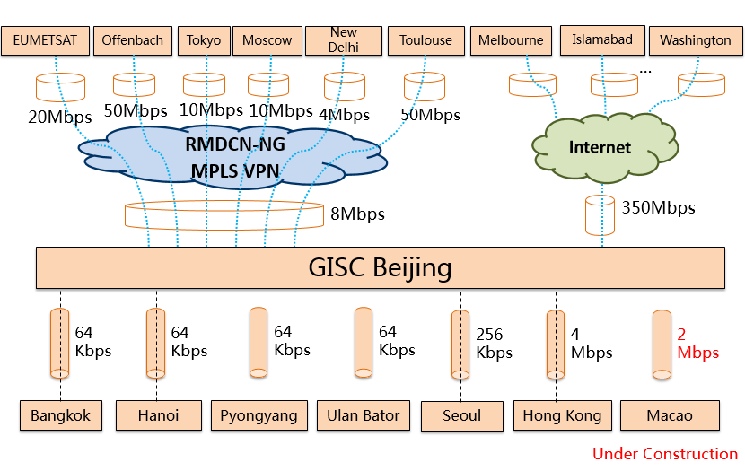
Figure 1. International Telecommunication Network of CMA

GISC Beijing data dissemination Service
GISC Beijing provide two data dissemination channel, CMACast unidirectional and Internet bidirectional.
About 20GB data daily broadcast via CMACast system to CMACast members, include:
- Australia, Bangladesh, DPRK, Indonesia, Iran, Kazakhstan, Kyrgyzstan, Laos, Malaysia, Maldives, Mongolia, Myanmar, Nepal, Pakistan, Philippines, Sri Lanka, Thailand, Uzbekistan, Viet Nam, Hong Kong and Macau, China.
Internet data dissemination from GISC Beijing include:
- Russia: 7MB daily, by Push
- Nepal: 20MB daily, by Pull
- Mongolia: 200MB daily, by Pull

IPv6 and Multicast
CMA connected to IPv6 network in 2006 via China National Education and Research Network. The access speed of the IPv6 connection is 100Mbps with /48 mask IPv6 address block. In 2008, CMA participated in IPv6 performance test leading by ECMWF. And CMA also participated the recent IPv6 pilot project. Up to now, CMA didn’t make a clear IPv6 transplant strategy and all the operation is based on IPv4.
Last year, a research project be supported to test the data dissemination based on multicast in provincial level inside CMA. There’s no final result of the project now and we will keep up to date on the progress.

Internal communication facility of CMA
1. Compass (Beidou) Navigation Satellite System for Emergency Communication
The emergency communication system is for the country-level station emergency communication while all the public communication facility are in failure, support the observation data transmission and SMS. This system is based on compass navigation satellite system, which support communication in “Message” format, and the satellite system could cover all china. Capability of communication depend on the SIM card: speed of the third-level SIM card is 73Bytes/min, and the fourth-level SIM card is 106Bytes/min. In the test environment, transmission of single AWS observation report file could be implemented in 5 mins, sounding observation report file transmission could be completed in 50 mins. The actual test results show that compass navigation satellite system could fulfill the requirement of emergency communication in country-level station. In first stage of the system, 80 country-level stations in Sichuan province will be deployed before June, 2014.
2. CMA’s National Communication City Backup System
CMA’s national communication backup system started construction in Sep, 2013. The backup site is about 20km west of CMA, in Beijing. The main backup functions include:
- CMA’s internal network and communication system
- CMA’s international network system and GISC Beijing
- Master station of CMACast system

