Review of the current status of implementation of TCP/IP procedures and applications at WIS centers

Current status of implementation of the GTS circuits
Current status of GTS circuits connected with the RTH Tokyo is shown in Table 1 and configuration on connectivity is shown in Figure 1.
- Topics:
  - Establishment of a new link with Offenbach; Oct 2012
  - Entire replacement of the MSS; Oct 2013
  - Migration of the WIS core network from the previous RMDCN (Orange Business Services) to RMDCN Next Generation (Interoute); Feb 2014
  - Météo-France and JMA will establish the direct link in a short time.
- Details are shown here;
  - http://www.jma.go.jp/jma/jma-eng/jma-center/rth/GTS_upgrades.html
Table 1 Implementation status of GTS circuits connected to RTH Tokyo
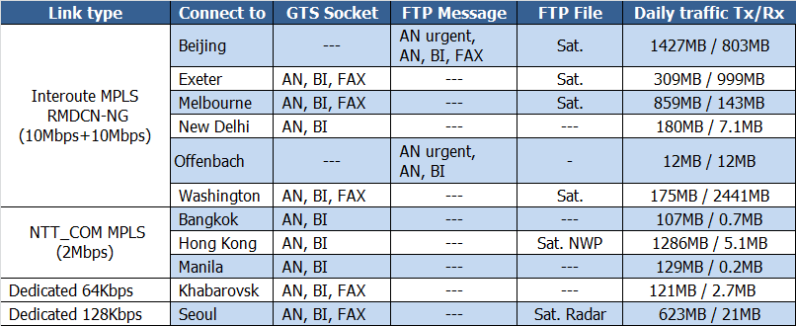

Implementation status of TCP/IP protocol and applications
TCP/IP protocol is running on all the GTS circuits connected to the RTH Tokyo. Simple FTP is used to exchange satellite data with Washington, Melbourne, Beijing, Seoul and Hong Kong. Products of JMA's one week ensemble forecast model are also distributed to Hong Kong by simple FTP. Currently, data and products are exchanged in the following manner.
From
Washington: GET by Tokyo
Melbourne: PUT by Melbourne with file renaming
Exeter: PUT by Exeter with file renaming
Offenbach: PUT by Offenbach with file renaming
Beijing: PUT by Beijing with file renaming
Seoul: PUT by Seoul with file renaming
Hong Kong: PUT by Hong Kong with file renaming
To
Washington: PUT by Tokyo with file renaming
Melbourne: PUT by Tokyo with file renaming
Exeter: PUT by Tokyo with file renaming
Offenbach: PUT by Tokyo with file renaming
Beijing: GET by Beijing
Hong Kong: PUT by Tokyo with file renaming
Seoul: PUT by Tokyo with file renaming

Note) GTS file naming convention is used in these file exchange

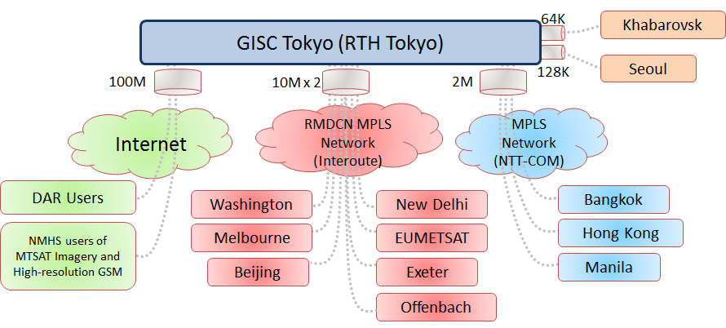
Figure 1: Configuration of the GTS circuits connected to the RTH Tokyo

WIS
3.1 Status of JMA
- Global Information System Centre (GISC)
- 8 Data Collection or Production Centres (DCPCs)
- RTH
  - RSMC-Typhoon
  - RSMC-Geographical
  - RSMC-ATM
  - Satellite Centre
  - GPC-LRF (Forecast)
  - RCC (Tokyo Climate Centre)
  - WDC-GG (Greenhouse Gases)

3.2 GISC Tokyo
Services:
- Part A - Global Telecommunication System (GTS)
- Part B - Data Discovery, Access and Retrieval (DAR) Services [Internet]
  - Metadata management
    - Metadata search
    - Web interface for metadata creation and modification
  - GISC cache
    - Warnings, WMO format data
    - Facilitate data subscription
  - Help desk
  - Gateway to data services by DCPC
    - SATAID service - MTSAT imagery & more
    - Global Spectral Model products in 0.5 deg and 0.25 deg
- GISC Backup

Establishment of the Disaster Recovery Site (DRS)
JMA has a plan to establish the Disaster Recovery Site (DRS) on west side of Japan (Osaka city, 500km far from Tokyo) in 2015. The DRS will prepare the same as current MSS and access lines of MPLS networks. The MSS on DRS will be synchronized the data from current MSS passing through the internal backbone.
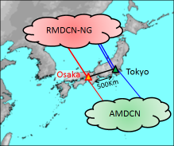

Traffic analysis
5.1 Increasing trend of traffic volume.
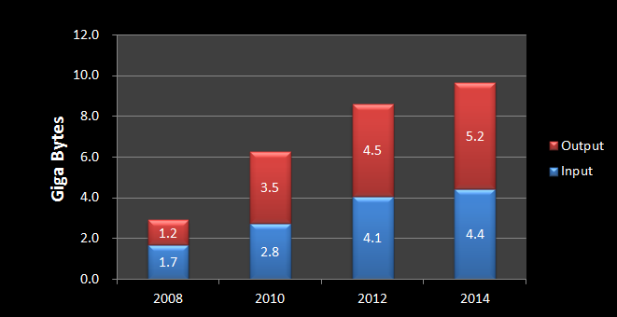
Figure 2 Statistics of traffic volume
5.2 Traffic volume in each channel
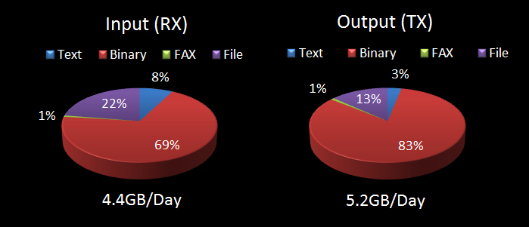
Figure 3 Statistics of traffic volume in each channel (data type)
5.3 Traffic status of each circuit
5.3.1 Washington - Tokyo
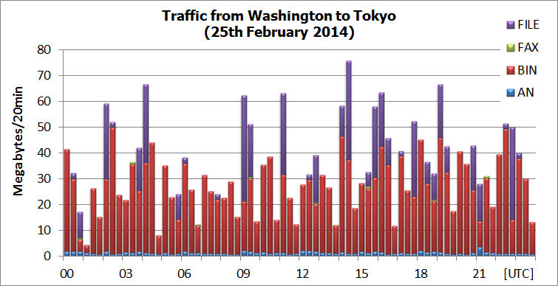
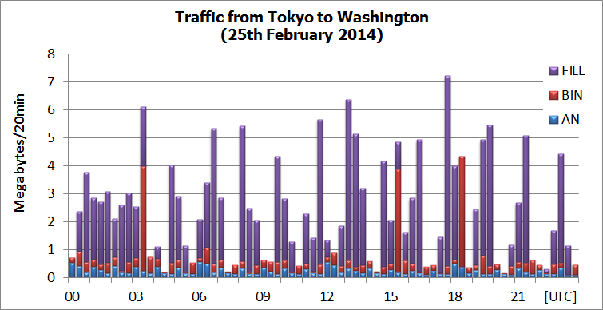

5.3.2 Melbourne - Tokyo
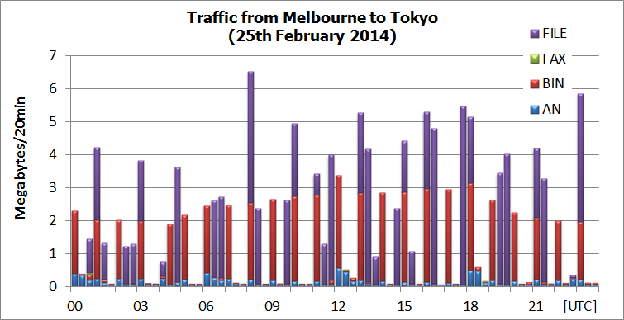
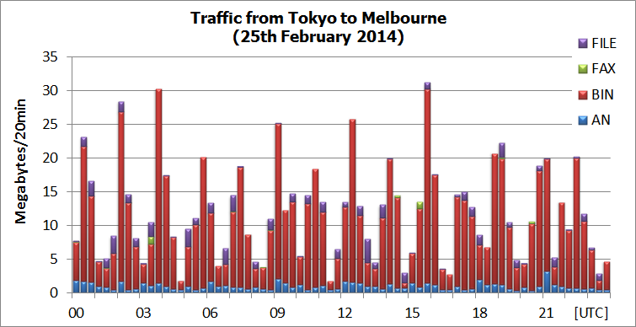

5.3.3 Beijing - Tokyo
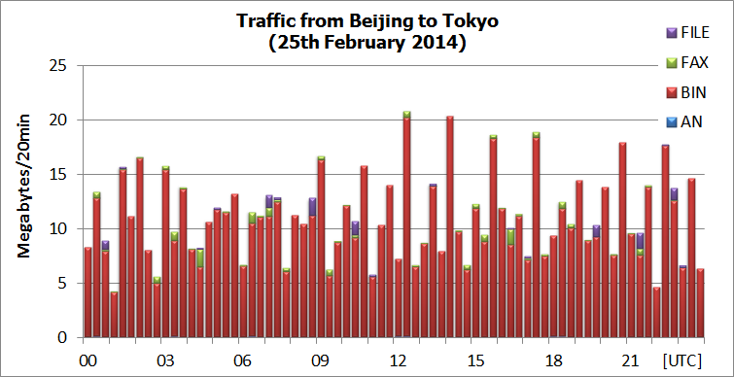
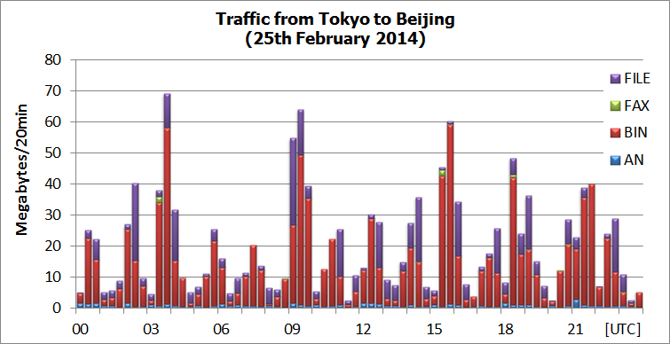

5.3.4 Exeter - Tokyo
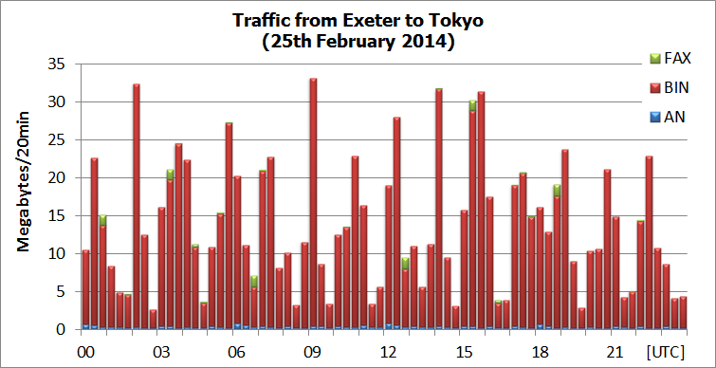
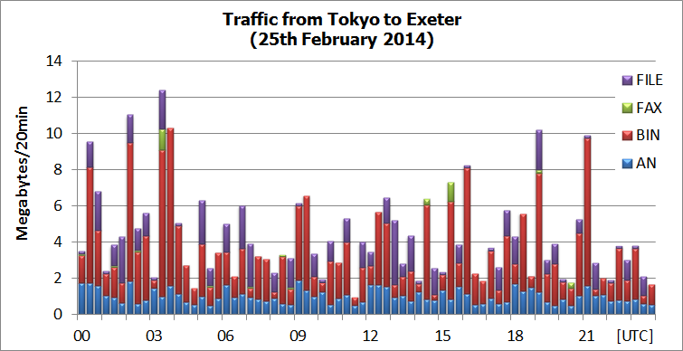

5.3.5 Offenbach – Tokyo
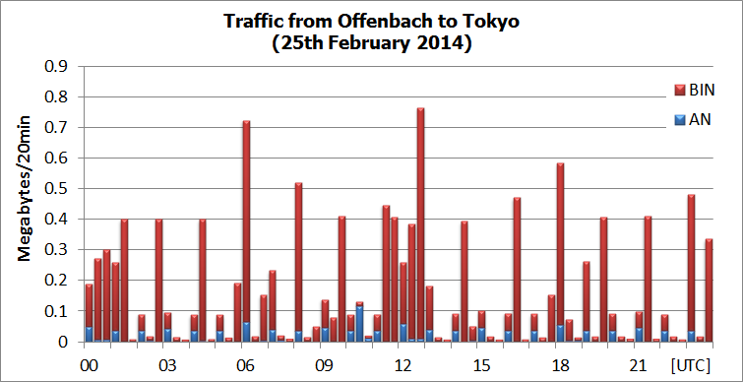
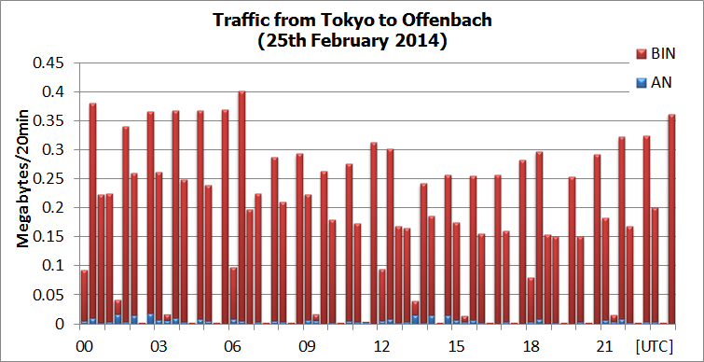

5.3.6 New Delhi - Tokyo
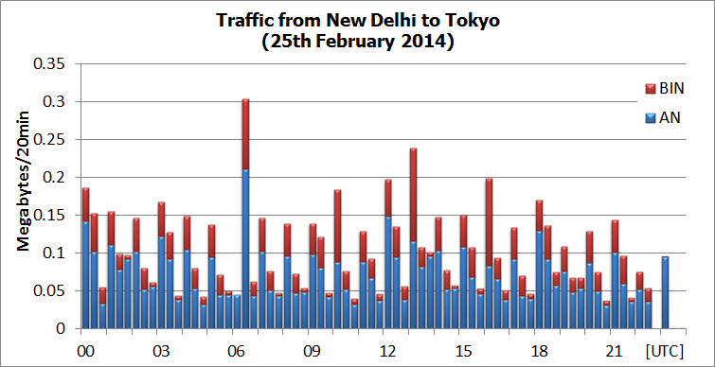
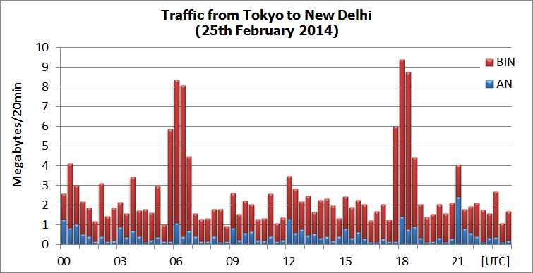

5.3.7 Bangkok - Tokyo
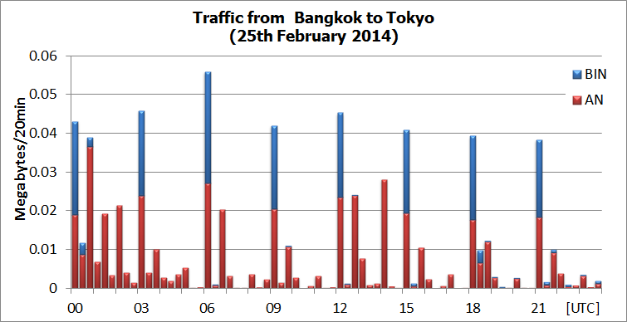
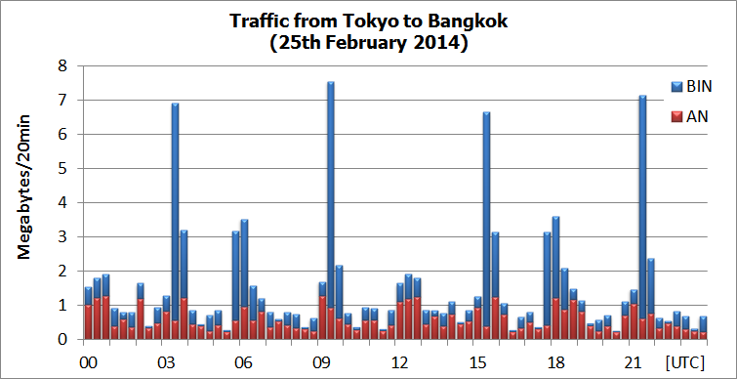

5.3.8 Khabarovsk Tokyo
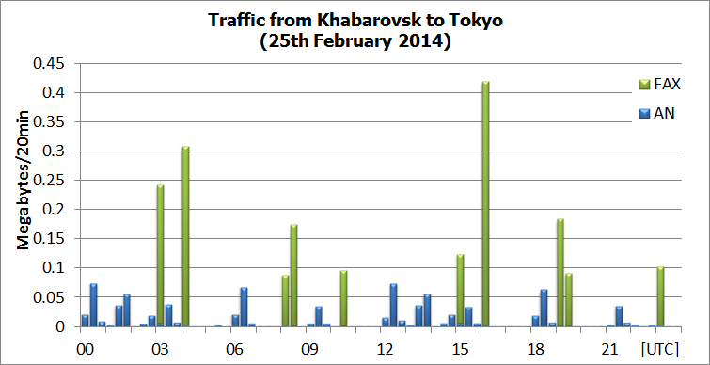
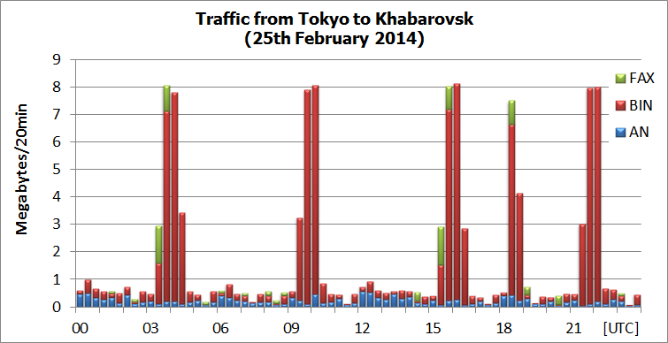

5.3.9 Hong Kong - Tokyo
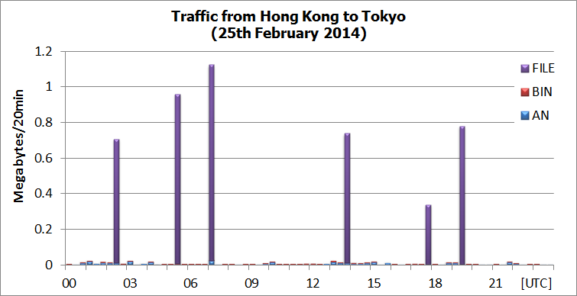
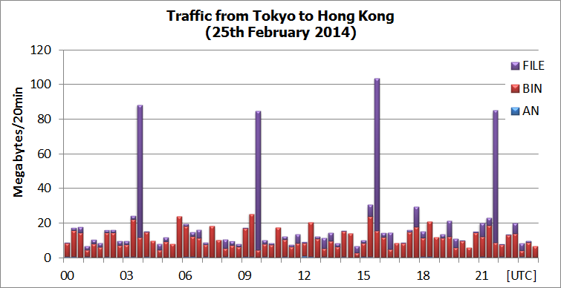

5.3.10 Seoul - Tokyo
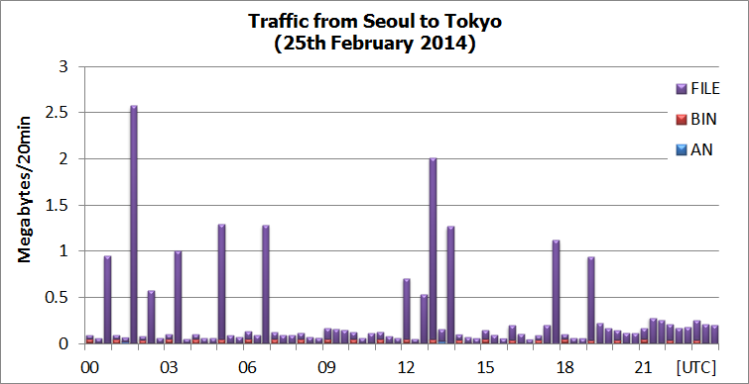
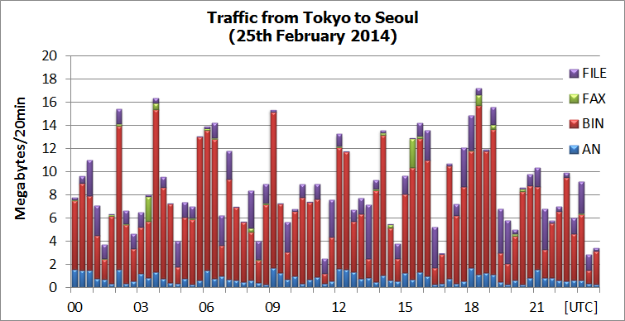

5.3.11 Manila - Tokyo
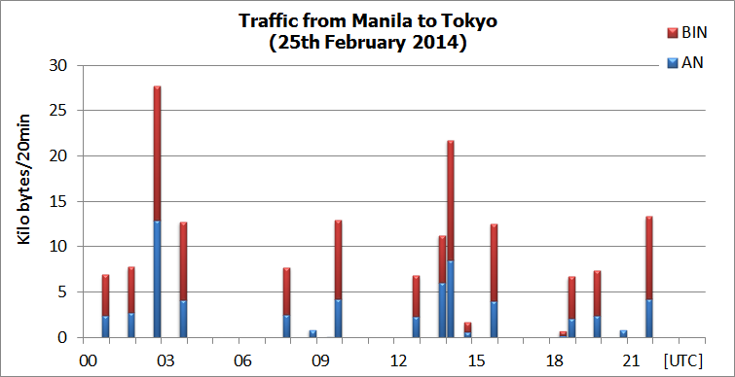
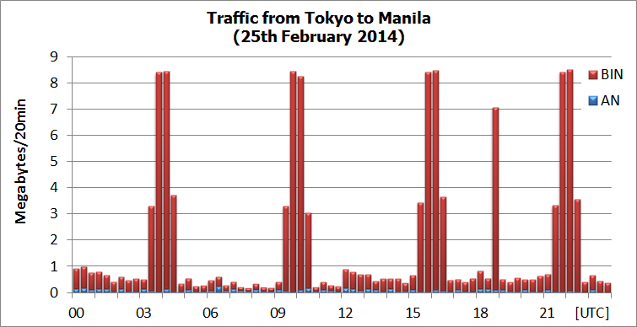

5.4 Traffic status of the Internet for WIS part-B (DAR).



