Review of the current status of implementation of TCP/IP at ECMWF

Internet Access
ECMWF is been connected to the Internet using two diverse 10Gbps circuits provided by Janet, the UK Research and Academic network. Until recently Janet used a pricing model based on the cost of IP bandwidth, which was biased towards low-speed connections used for schools and colleges (100Mbps or 1Gbps), making 10Gbps services very expensive. Therefore ECMWF would only purchase sufficient IP bandwidth for its operational needs and periodically review and increase the facility. In 2013 Janet introduced a new pricing model based on the actual cost of delivery, and this has allowed ECMWF to obtain full 10Gbps IP bandwidth for equivalent cost of 1.3Gbps under the old scheme. Under a further cost-saving agreement with Janet the two 10Gbps circuits are configured using BGP in active/backup mode, meaning operational traffic will normally run over one circuit only.
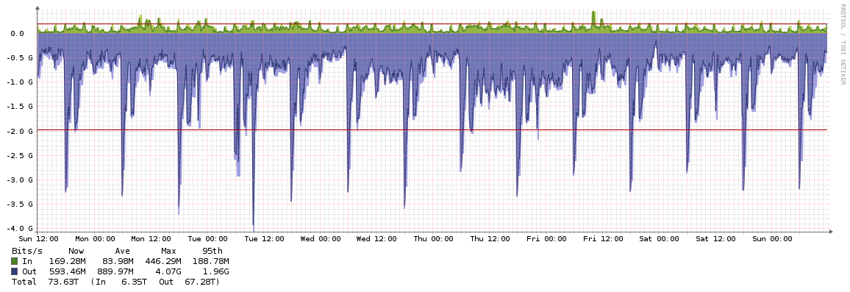
Figure 1 - ECMWF Data Transfer on Internet 3-9 March 2014
There are currently eight “data mover” servers disseminating products on the Internet at ECMWF, and in 2014 it is planned to increase this to 12, to accommodate anticipated increase in data volume.

RMDCN Access
ECMWF has 200Mbps on the RMDCN-NG (Interoute service), and is in the process of upgrading to 500Gbps. Since we have only recently completed migration to the Interoute service, other sites are not yet taking full advantage of the additional available bandwidth, but we expect over the next year to see this change. There is a separate report (3.7.1) on the status of the RMDCN Next Generation.
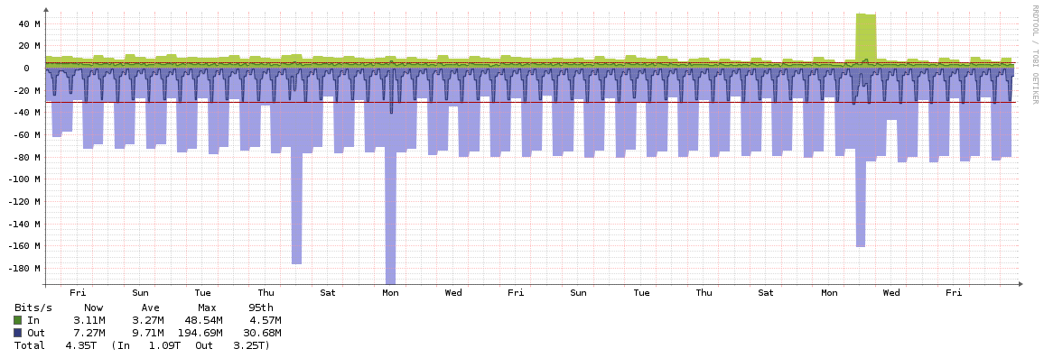
Figure 2 - ECMWF Data Transfer on RMDCN 7 February - 10 March 2014

IPv6
Since 2010 ECMWF has deployed IPv6 on its Internet connection. ET-CTS Doc 3.2.1(1) presented at the 2012 Geneva meeting[1] contains a good summary of the experience so far (“relatively effortless with zero impact on the operational IPv4 network”).
Since then we have continued to operate IPv6 in production and offered the facility for dissemination partners. However there has not been any expansion into other network domains such as the LAN or mobile devices.
On several occasions since 2012 when there have been performance problems with IPv4 on the Internet, tests have shown that IPv6 was unaffected. We can take advantage of this situation to work around short-term problems on the Internet, but it is likely that in time the phenomenon will disappear as more traffic and services are moved onto the IPv6 Internet.
Below is a figure showing the daily IPv6 dissemination traffic volume from ECMWF:
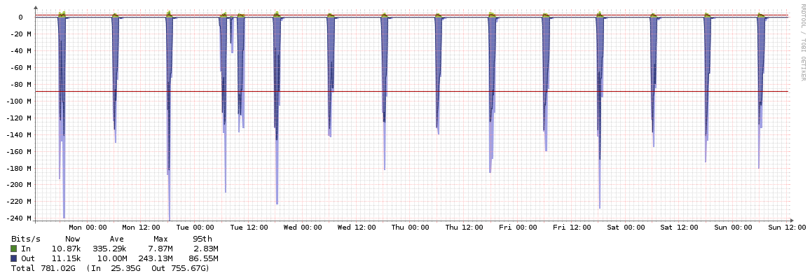
Figure 3 - ECMWF IPv6 Data Transfer on Internet 3-9 March 2014

Terrestrial Multicast
ECMWF participated in a joint evaluation of multicast on the RMDCN in 2012 together with EUMETSAT. The purpose of the trial was to investigate end-to-end multicast use over a terrestrial, managed, wide area network. The scenario tested was based on data exchange between GISC sites.
The RMDCN trial was a success for ECMWF with all outcomes achieved (see report [2]). However experiences with multicast in general highlight limitations in the technology which require further analysts or consideration of alternatives (for example the proposal in Item 3.3.1 of this meeting).
The Internet trial, run by EUMETSAT, was also a success, but highlighted that the Internet routers in operation at ECMWF (Vyatta) were not suitable for operational multicast. As part of a normal lifecycle replacement of these devices in 2014 their replacements (Brocade CES) will provide full operational support for Multiprotocol BGP including IPv4/IPv6 multicast.

References
[1] Adoption of IPv6 at ECMWF
http://www.wmo.int/pages/prog/www/WIS/wiswiki/tiki-download_wiki_attachment.php?attId=1131 (accessed 10th March 2014)
[2] Report on the RMDCN Multicast Trial 2012 – ECMWF Participation
http://rmdcn.ecmwf.int/Documentation/Multicast/RMDCN-Multicast-Trial-2012-ECMWF-Report.pdf (accessed 10th March 2014)

Recommended Text
ECMWF continues to upgrade its TCP/IP environment in line with the requirements of operational services. In 2013 the Internet connection IP bandwidth was increased to 10Gbps. In 2014 the RMDCN connection IP bandwidth will be upgraded to 500Mbps. Internet routers will also be replaced in 2014 to provide IPv4/IPv6 unicast and multicast, and additional ECPDS Internet Data Mover servers deployed.

