Review of the current status of implementation of TCP/IP procedures and applications at WIS centers

GISC circuits:
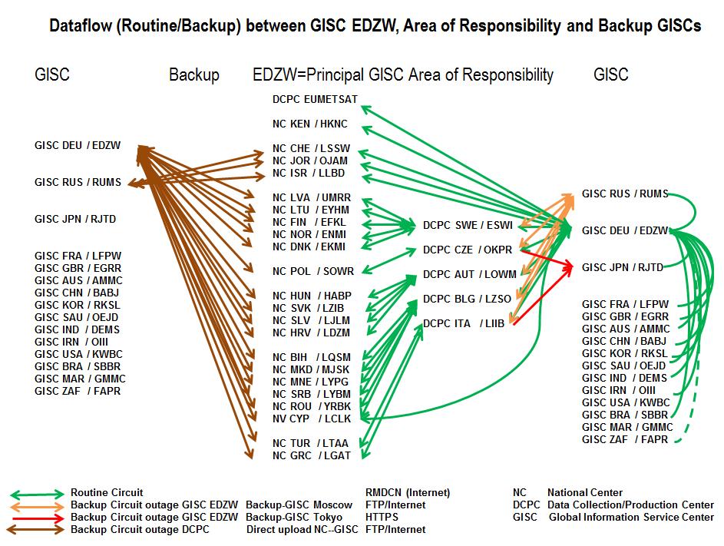

The current connection of GISC Offenbach to the RMDCN is a 50Mbit/s line, and is a Platinum site type.

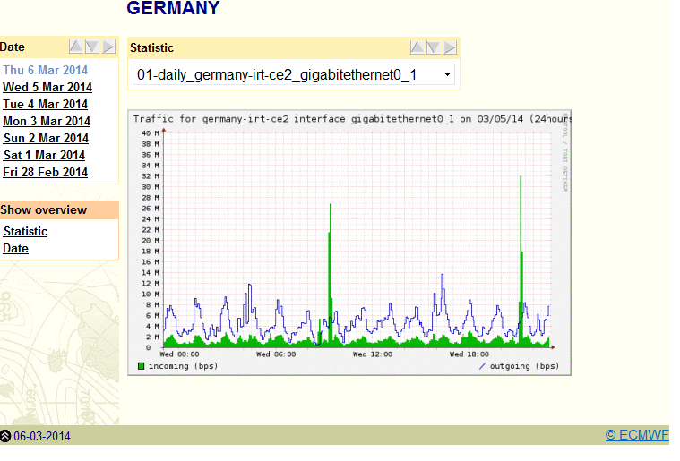

GISC backup:
GISC Offenbach has Backup agreements with GISC Moscow and GISC Tokyo. All data intended for global exchange of GISC Offenbach’s AoR are uploaded to GISC Moscow, the setup of uploading those data also to GISC Tokyo is in progress. Also in progress is the setup of uploading the data of GISC Moscow’s and GISC Tokyo’s AoR to GISC Offenbach (2014/15).
Offenbach offers backup via the Internet for all connected WIS partners (ftp). The capacity of the Internet connections in total is 10 Gbit/s, 6,5 Gbit/s in Offenbach (2 ISPs, peering at DE-CIX), and 3,5 Gbit/s at the backup data center.

Experiences with terrestrial Multicast and IPv6
- Pilot project to implement terrestrial Multicast for internal data dissemination; tested commercial software called Tellicast; was not put into operation because of high configuration overhead and sufficient available bandwidth
- Participation in ECMWF’s IPv6 pilot project
- Some small lab setup to help define the steps for implementing IPv6
- Tunneling protocols are blocked (Teredo, Isatap, 6to4)
- IPv6 stack on Microsoft clients disabled per group policy
- IPv6 address range assigned (PI), ULA only for internal management networks, not for clients/servers, not planned to use NAT, will use dual stack
- Client/server subnets will be /64 (SLAAC), P2P links will be /127 (RFC 6164)
- Native IPv6 connection established at backup computing site (BGP)
- Implementation will start with external services (Web-, ftp-servers)
- next steps will be finishing the addressing plan, discussions with ISPs if smaller ranges than the assigned /48 will be routed, setting up of DNSv6, NMS tools for IPv6, implementing first-hop security (RA guard, SeND, ND cache limits, …)
- possible use cases:
  - transfer of model output from ECMWF (disaster backup NWP of DWD at ECMWF)
  - DMVPN router at backup computing site

Recommended Text
WIS center Offenbach has established all circuits in its Area of Responsibility, most of them via the RMDCN. A few of the connections are established using the Internet. The standard data transfer method is now FTP/HTTPs. GISC Offenbach has also established circuits to all operational GISCs, and has invited GISC USA and GISC Morocco to establish the circuits as well.
GISC backup procedures have been set up for both GISC Moscow and GISC Tokyo. All data intended for global exchange are available via a closed user group on an Internet FTP server (EC 65 request).

--------------------

