Metadata Management Service(MDMS)

- Basic concept and the scope of the MDMS
Based on WIS technical requirements, MDMS means the 'services' of uploading/downloading and maintaining metadata. It also includes the developing guideline for implementing management system to support the services of adding, editing, deleting metadata and WIMMS.Functional and technical requirements for the MDMS system are defined at the WMO technical documents, and the system should be modified properly to cope with the standardized metadata and its core profile.

- Current status on MDMS
  - MD management system
GISCs have their own SW tools for the MD management with the properly implemented functionalities, but their operations are slightly different.(online editor, uploading for xml file or via ftp put)

  - Considering parts
It will be asked to modify&upgrade the SW version to cope with the variation on metadata core profile. It is also recommended to show the reference guide for the metadata management for non GTS data.

- MD harvesting from the outside of WIS (GEOSS)
As an example system of outside of WIS, here’s the ‘clearing house’, which is GEO web portal for providing GEOSS data to the authorized user and providing 3 types of metadata formats including ISO19115 standards. All metadata from the clearing house can be harvested at the system of GEONET, however, as for WIS, only the metadata with ISO19115 can be harvested from the clearing house whereas the data could be searchable via remote search function like SRU. For the harvesting all MD from the GEOSS, the one of the following activities should be provided at least one GISC.
- Providing SW tool for transferring MD format from GEOSS to WIS
- Modifying WIS MD SW to accept the MD format of GEOSS

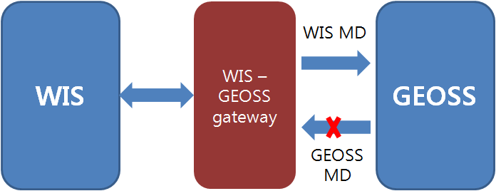
Fig. 1. WIS-GEOSS gate way.

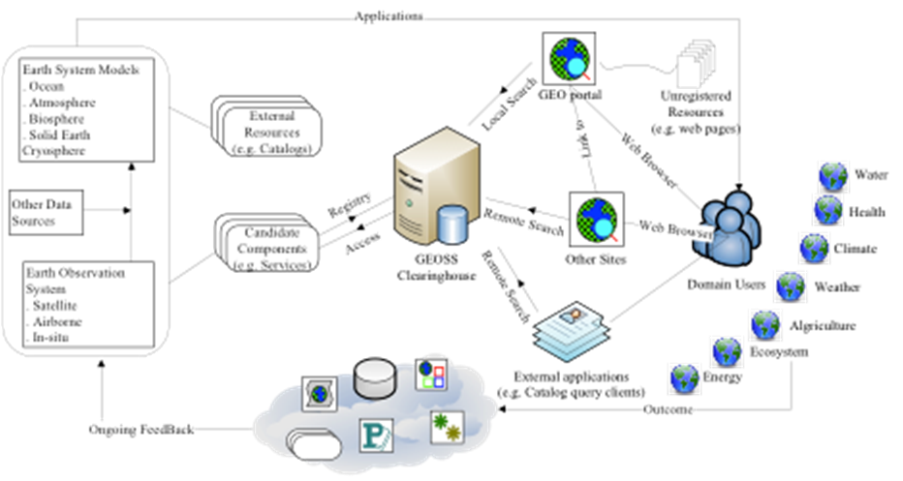
Fig. 2. Overview on GEO information flow

Recommended Text
Mr. Sunghoi HUH presented the metadata management service discussing the possible approaches to synchronize the metadata between WIS and GEOSS discovery metadata catalogues. (GISC and GEOSS Portal) It is suggested that GISC Seoul can take on a role of WIS-GEOSS gateway as a possible way to ensure GEOSS Data is available in WIS if current remote search method is interrupted. In addition to mirroring the catalogue, GISC Seoul could also be a mirror SRU service for SRU users presently relying on the GEOSS portal SRU server.

