# GTS AMDCN Toulouse current status

## GTS AMDCN current status

### Presentation plan:

* GTS links with Toulouse
* RMDCN Traffic
* Internet
* Plan for next years

### GTS links



### GTS MSS daily traffic



### Toulouse AMDCN links

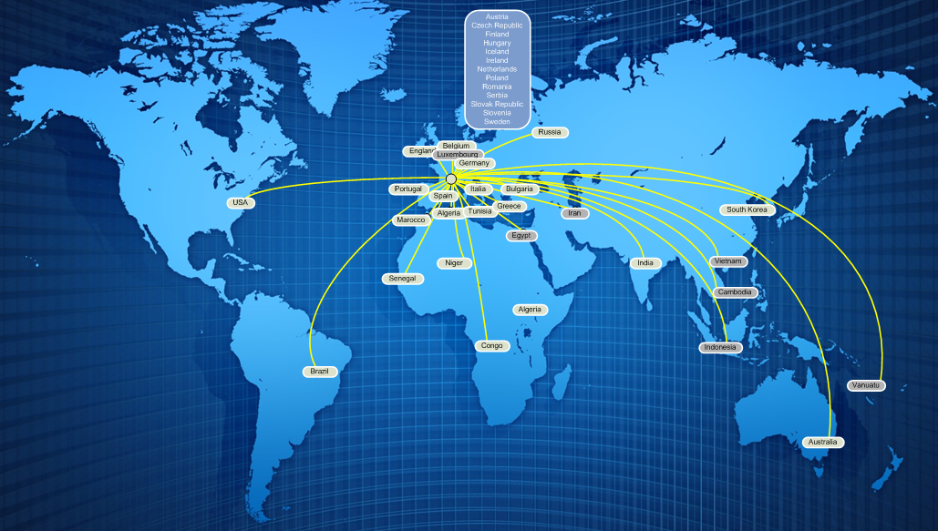

### WMO and AMSS recommendations

* Alpha bulletins files with .a .b > 15K
* All bulletins “Alpha” .a and .b >15K are disseminated with .f or .b
* Other no limits

### BUFR migration

* TAC to BUFR migration done (TEMP, CLIMAT and SYNOP)

### File naming convention

* WMO file name convention has been integrated
* With PFlag T A W Z in input
* With Pflag T A W in output

### Network curent status and evolution

* Internet
  + Speed: 300 Mbps
  + Used by ALADIN community for products delivery
  + Backup for RMDCN in pull mode
* Research link
  + RENATER / GEANT : 1Gbps Research traffic
* RMDCN
  + 10Mbps, will be upgraded to 50Mbps with the next generation of RMDCN

### RMDCN daly traffic example July the 08th of 2013

1. Input

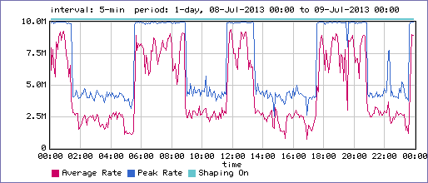

1. Output



