5.4 Search (internal and SRU)

The Difference of file format of data files from GISC cache
A closer look at the downloaded data files shows that the GISC caches contain different data formats. The following paper analyses the differences on the example SMJP01 RJTD - during the tests we could not download the bulletin from GISC Exeter due to an error in the login service.
The topic “difference of file format” is mentioned in ET WISC final report 2012. 4.11.4 of the final report says that the GISCs should harmonize the format. The Task Team Leader of WISC/TT-GISC received prior to the meeting the topic for discussion.
- GISCs Beijing, Melbourne, Offenbach, Seoul, Tokyo, Toulouse (alphabetical order)
- Target GTS bulletin SMJP01 RJTD
- Date Time 2013/07/01 00Z

Both authors suggest that ET-WISC encourages the GISCs to use the “Meteorological bulletin” as the default file format for the 24h cache.

Investigation results

Beijing
The file format of Beijing includes…
- Message Length, Format Identifier
- Starting Line
- Abbreviated heading
- Text part
- End of message signals
File Name | A_SMJP01RJTD010000_C_RJTD_20130701001911.txt
Head | 0000183100[SOH]  44454  SMJP01 RJTD 010000  AAXX 01004  47401 12/70 72116 10196 20157 30091 40105 58006 60002 81142  333 20165 70000=
(Hex View) | 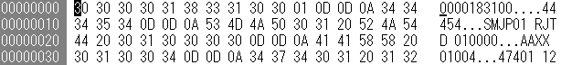
Foot | 47991 16/// /2112 10305 20232 30124 40134 50001 69902  333 20266=  [ETX]
(Hex View)

Melbourne
The file format of Melbourne includes…
- Text part
File Name | A_SMJP01RJTD010000_C_RJTD_20130701000000_3dcc5099fe18724fd1ab090d8e355a0c.txt
Head | AAXX 01004  47401 12/70 72116 10196 20157 30091 40105 58006 60002 81142  333 20165 70000=
(Hex View) | 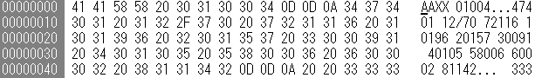
Foot | 47991 16/// /2112 10305 20232 30124 40134 50001 69902  333 20266=
(Hex View)

Offenbach
The file format of Offenbach includes…
- Starting Line
- Abbreviated heading
- Text part
- End of message signals
File Name | A_SMJP01RJTD010000_C_RJTD_20130701002030.txt
Head | [SOH]  SMJP01 RJTD 010000  AAXX 01004  47401 12/70 72116 10196 20157 30091 40105 58006 60002 81142  333 20165 70000=
(Hex View) | 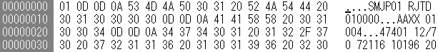
Foot | 47991 16/// /2112 10305 20232 30124 40134 50001 69902  333 20266=  [ETX]
(Hex View)

Seoul
The file format of Seoul includes…
- Abbreviated heading
- Text part
File Name | A_SMJP01RJTD010000_C_RJTD_20130701001932_68_9240fdae9593a4e0e91827ece88be25a.txt
Head | SMJP01 RJTD 010000  AAXX 01004  47401 12/70 72116 10196 20157 30091 40105 58006 60002 81142  333 20165 70000=
(Hex View)
Foot | 47991 16/// /2112 10305 20232 30124 40134 50001 69902  333 20266=
(Hex View)

Tokyo
The file format of Tokyo includes…
- Abbreviated heading
- Text part
File Name | A_SMJP01RJTD010000_C_RJTD_20130701001932_68.txt
Head | SMJP01 RJTD 010000  AAXX 01004  47401 12/70 72116 10196 20157 30091 40105 58006 60002 81142  333 20165 70000=
(Hex View)
Foot | 47991 16/// /2112 10305 20232 30124 40134 50001 69902  333 20266=
(Hex View)

Toulouse
The file format of Toulouse includes…
- Text part
File Name | A_SMJP01RJTD010000_C_RJTD_20130701000000_3dcc5099fe18724fd1ab090d8e355a0c.txt
Head | AAXX 01004  47401 12/70 72116 10196 20157 30091 40105 58006 60002 81142  333 20165 70000=
(Hex View)
Foot | 47991 16/// /2112 10305 20232 30124 40134 50001 69902  333 20266=
(Hex View)

The following picture visualizes the different file formats in a compact way.
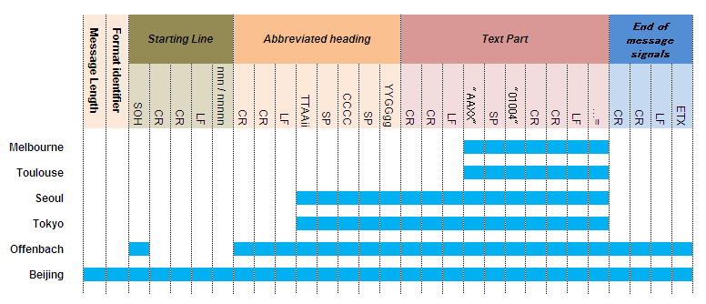
Also, we can categorize the difference as follows;
Melbourne | text part
Toulouse | text part
Seoul | Meteorological bulletin
Tokyo | Meteorological bulletin
Offenbach | Meteorological message
Beijing | TCP/IP FTP + Meteorological message
The outline of the difference of file format of GISC cache
There is no definitive difference in file format, but a small difference can be seen in the format of each GISC. Normally it is not a problem, but when users change the data provider, it can be inconvenient to them.
Note:
One primary usage of the 24h cache is that a NMHS downloads data files and directly – without further processing - injects it into its MSS. Both authors note that the file format “text part” option is not compatible for all MSSs.

Recommended Text
Mr. Shigeharu Nishikawa (JMA) reported the result of investigation for differences of the file format of each GISC Cache. He mentioned that there is only a minor difference, but this can result in any inconvenience to the user, especially in case of active GISC backup procedures. In addition the usage of “text part” as file format is not considered as compatible for all MSS for injection without further processing.
Both authors of the paper suggest that ET-WISC encourages the GISCs to use the “Meteorological bulletin” as the default file format for the 24h cache.

References
ET-WISC Final Report 2012 Melbourne http://www.wmo.int/pages/prog/www/ISS/Meetings/ET-WISC_Melbourne2012/FReport-ET-WISC2012.doc

