# Status Report of GISC Beijing

## GTS Communication and Networking

1. RTH Beijing joins into RMDCN upgraded to 4 Mbps
2. Dedicated lines of RTH Beijing connected with Bangkok, Hanoi, Pyongyang, Ulan Bator and Seoul
3. Internet connection with other GTS centres

The diagram below shows the current GTS circuits connected with RTH Beijing.

## CMACast-Meteorological Broadcast system which operated by CMA

CMACast is the next generation satellite data broadcast system of CMA based on DVB-S2 technology with both file and multimedia transmission capability. It is a major component of CMA national and international data dissemination network. CMACast is also a major component of IGDDS and GEONETCast. CMACast rent a whole 36MHz C-band transponder using AsiaSat-4 C band frequency to cover Asia and part of south-western Pacific area. More than 400GB daily data could be transmitted. In 2008, GEONETCast formed near global coverage by three regional infrastructures (see the picture below), EUMETCast, FENGYUNCast and GEONETCast Americas. Now CMACast has replaced FENGYUNCast as GEONETCast Nerwork Centre (GNC) in Asia. With the coordination and cooperation of GNCs, users in Asia Pacific region, who have CMACast reception system in operation,will be able to receive all GEONETCast broadcasting data and products in all societal benefit areas.

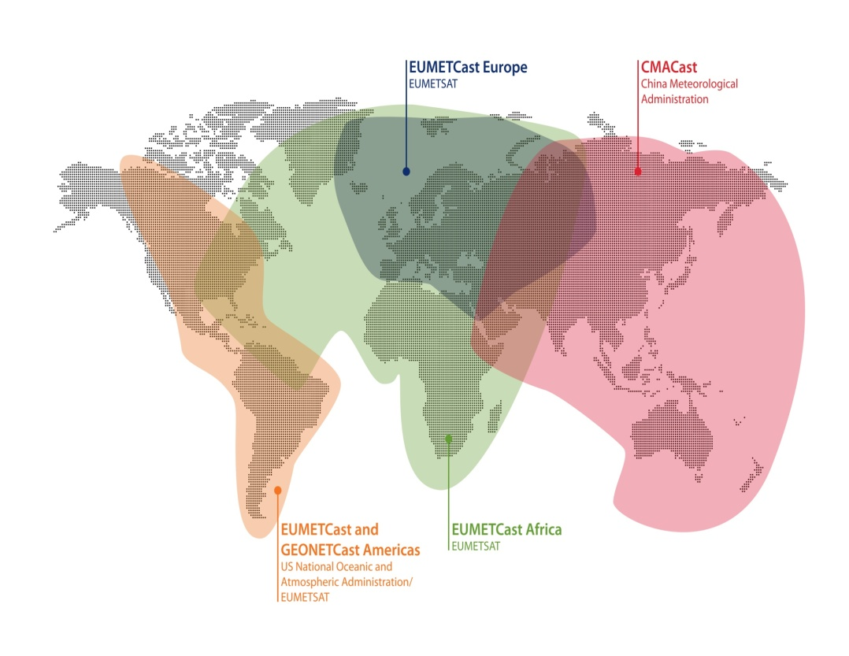

## Milestones of GISC Beijing

1. 2007.5 Establish CMA Pilot WIS portal
2. 2009 Initiated to develop WIS services in CMA
3. 2010.8 GISC Beijing candidate endorsed by ET-GDDP
4. 2011.8 GISC Beijing start formal operation
5. 2012.6 CMA Internal DCPCs start their trial operation

### Initiated to develop WIS services in CMA in 2009

1. It adopts J2EE framework and layered modular design (see the figure below), yields simple structure and easily scalable components, and owns user-friendly web interface for accessing metadata and data services

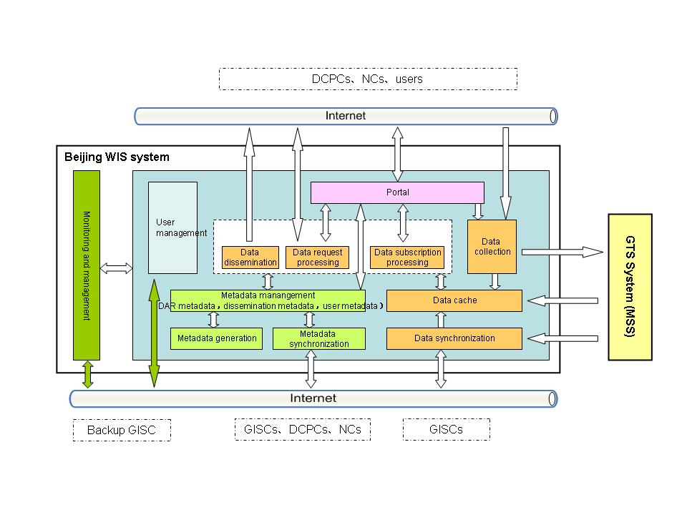

1. It is fully compliant with WIS technical specifications and standards.
   1. DAR metadata: WMO Core Profile 1.2
   2. Metadata synchronization: OAI-PMH, FTP
   3. Data: TAC, BUFR, CREX, GRIB, NetCDF, ….
2. Data collection and dissemination: TCP sockets, FTP, HTTP, SMTP, multicast, …

## Current status of GISC Beijing

### Exchanging metadata with DWD, JMA, Meteo France, UKMO, BoM, KMA and HKO

### Testing harvesting with INMET, NOAA, PME, …

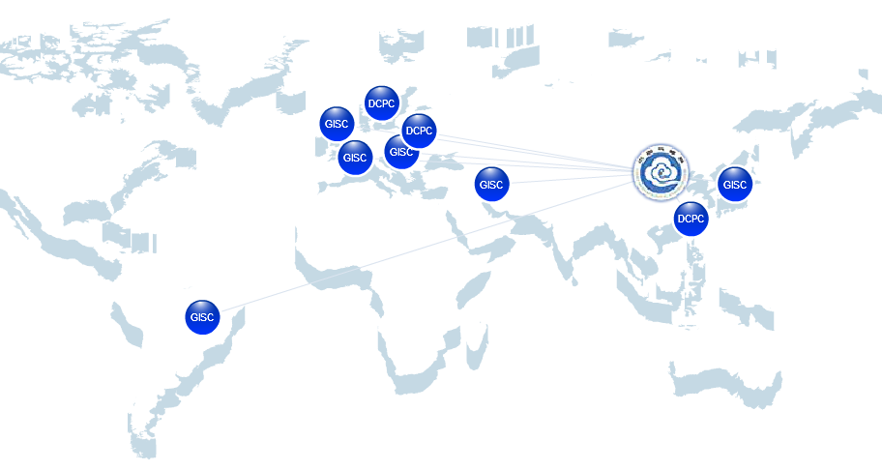

### Available services: metadata search, data subscription, data request/reply, web data ingest, metadata ingest

1. Offering WIMMS

Since Feb. 2012 - Provide 4 approaches to maintain metadata and to support WIMMS service

* 1. metadata online editor
  2. metadata upload via web form
  3. metadata harvesting via OAI protocol
  4. metadata harvesting via FTP protocol

1. Data dissemination Integrated with the data services of CMACast
   1. GTS – to other WIS/GTS centers via FTP, TCP sockets
   2. Internet – to other centers, end-users via FTP, HTTP, SMTP
   3. CMACast – to other centers, end-users

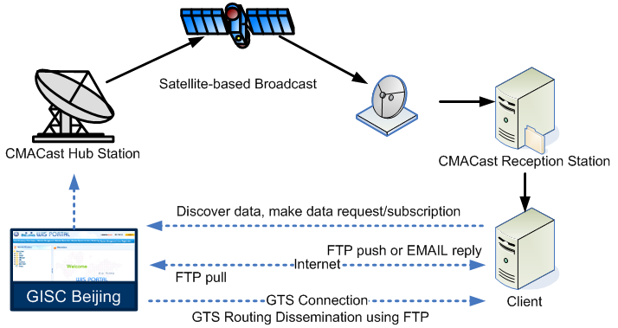

1. Metadata Services
   1. Provide Metadata generation, Metadata upload, Metadata online editor and Metadata synchronization to create metadata in Metadata Catalogue
   2. Provide Remote Search based on SRU, Metadata Directory and Metadata Search.

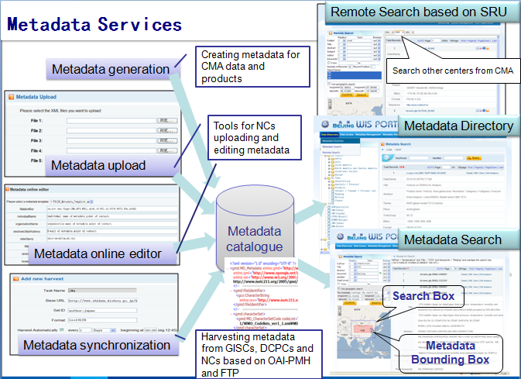

1. Available Data

|  |  |  |
| --- | --- | --- |
| Data Type | | CMA WIS |
| GTS global exchange data | **Surface observations** | **Yes** |
| **Upper air observations** | **Yes** |
| **Other observations** | **Yes** |
| **NWP products** | **Yes** |
| TIGGE products (from 10 centers) | | **Yes** |
| Satellite data  (DCPC NSMC) | **FengYun -2E cloud  motion vectors products** | **Yes** |
| **FengYun -2D/E products** | **Partly** |
| **FengYun -3B data** | **Partly** |
| CMA climate data (DCPC BCC) | **Climate monitor products** | **Yes** |
| CMA NWP data (DCPC NMC) | **Marine weather  information broadcast** | **Yes** |
| **Tropical cyclone warning** | **Yes** |
| **Tropical cyclone FAX** | **Yes** |
| **T639L60 global medium- range model products** | **Yes** |
| EUMETSAT data |  | **TBD** |

1. Ready for providing EUMETSAT data by CMACast
   1. The user who has installed CMACast Reception could access those data by CMACast.
   2. The data (list below) access should be authorized by EUMETSAT.

|  |  |
| --- | --- |
| **Meteosat 0° Service** | **0° SEVIRI Level 1.5 Image Data** |
| **0° Meteosat Meteorological Products** |
| **Meteosat 57.5° Service** | **IODC High Resolution Image Data** |
| **IODC Meteosat Meteorological Products** |
| **Third-party GEO Services** | **GOES-W/GOES-E** |
| **METOP** | **Level 1** |
| **Level 2** |
| **NOAA-19** | **Level 2** |
| **JASON** | **OSDR/OGDR** |

### User Registration Until 1st, July 2013

1. There are 72 users from 33 WMO Members registered in GISC Beijing, including 24 WIMMS users.
2. Totally the visit count is beyond 80000 times.

### CMA Internal DCPCs

1. Develop internal DCPCs, and provide their products via GISC Beijing portal
2. Be assessed by ET-GDDP around June of 2012



## Progress and Plan in 2013

1. Provide more data
   1. Internal DCPC’s products
   2. EUMETSAT data for CMACast
2. Promote NCs metadata generation in the area of responsibility
3. Collaboration with JMA (GISC Tokyo)
   1. Dissemination metadata exchanging
4. Collaboration with PME (GISC Jeddah candidate)
   1. Metadata Synchronization