Plugin feature of WIS discovery catalogue search interface

Motivation
- WIS discovery catalogue is one of the main pillars of the System, and making it accessible to as many users as possible has the particular importance.
- WIS catalogue is synchronized among and provided by GISCs as one of their essential services. Users generally access the catalogue on websites owned by GISCs, which means staff members of NCs and general public need to visit a GISC website to look up NC’s metadata records and access to the whole catalogue.
- The motivation of developing a plugin feature is to support NC’s implementation of WIS catalogue search interface on their websites and to make the catalogue more relevant to all users and staff members of NCs who are responsible for maintaining the catalogue.

Description of plugin feature under development
- GISC Tokyo’s plugin feature of catalogue search interface is now being developed jointly by GISC Tokyo and the WMO Secretariat.
- The plugin resides in GISC Tokyo server and is accessed by adding scripts in HTML pages.
- The plugin feature enables any WIS centre to have WIS catalogue search interface on their own websites very easily, by embedding a few lines to access javascripts.

Examples of websites with WIS catalogue search interface
- Below are two examples of the plugin feature applied to the website of Philippine Atmospheric Geophysical and Astronomical Services Administration (PAGASA) and GISC Tokyo as demonstration. Search results are actually a response of GISC Tokyo’s search function and are displayed dynamically on the websites.
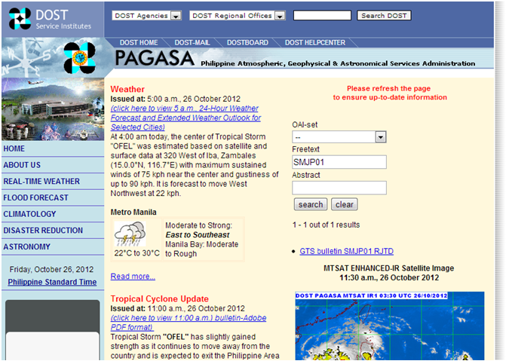
(A demonstration page with the applied plugin feature)
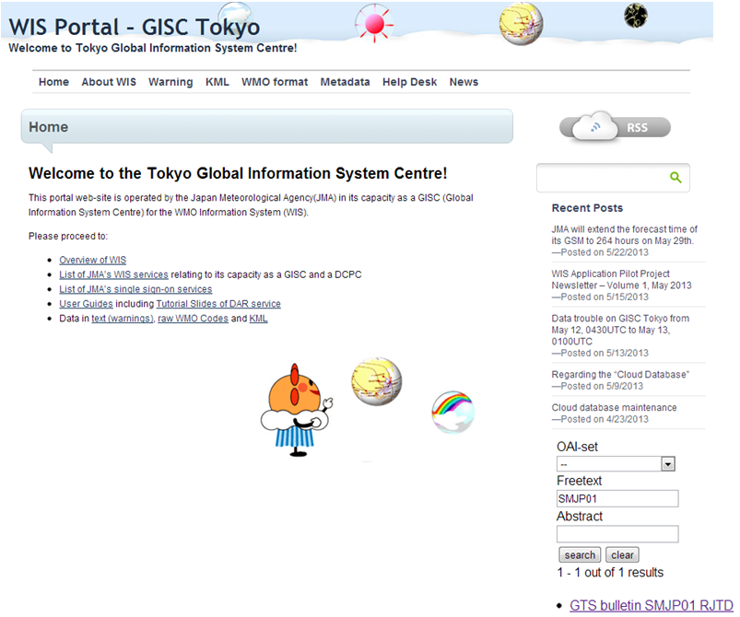

Recommended Text
The meeting noted the work developed jointly by GISC Tokyo the Secretariat in creating a plugin feature of WIS discovery catalogue search interface. It agreed that this kind of feature nurtures NCs’ sense of participating in WIS activities, which may encourage users to more access to and the use of the catalogue and efficient updates of metadata records for their data/products.

--------------------

