3.1 Status reports of WIS Centres

Status Report of GISC Washington (WMO Region IV)

Introduction
The following document lines out the activities from GISC Washington during the time from March 2011 to June 2013. During this time US National Weather Service (NWS) successfully passed WMO WIS Audit in April 2013, began incorporating of DCPCs, and coordination efforts with its GISC backup partner – Brazil.
Development of both a WIS overview initiative for DCPC/NC Candidates and WIS Training Plan are being established in order to assist DCPCs/NCs in their preparations for incorporation into GISC Washington and develop awareness within Region IV for support WIS functions as the next phase. This assistance will include providing guidance in metadata creation and area of responsibility as DCPC/NC. GISC Washington will also be planning capacity building for neighboring countries, and participate in coordinating WIS workshops for Region IV.

Status of GISC Washington
As designated in Sixteenth WMO Congress in June 2011, NWS has completed the following in establishing of GISC Washington:
- Completed update of C1which was accepted by WMO 28 February 2013
- Completed WMO GISC audit 16 April 2013
- Incorporated DCPC National Atmospheric Research Center (NCAR) into GISC/DAR catalog
- Planning for incorporation of DCPC RSMC-Canada into GISC/DAR catalog
- Initiated outreach to WMO designated RA-IV DCPC candidates
- Conducted test data exchange with back up GISC Brazil July 10 2013
- Providing WIS overview to GISC-Washington participants and RA-IV Member States (on as needed basis)
- Initiating metadata training program for GISC-Washington staff and other RA-IV participants

GISC Washington's services
GISC Washington’s NWSTG is the primary data communications switching system of the NWS, and is the communications part of WMC Washington. It functions as the gateway to all other national and international meteorological, hydrological, and aviation communication centers, and functions as central monitoring facility for RTH Washington. It is an essential node of the GTS relaying selectively on the circuits of the MTN, as agreed, the bulletins received from these circuits and /or from RTHs not situated on the MTN. It also maintains Catalog of Meteorological Bulletins for WMO Region IV. In addition GISC Washington has been operating traditional GTS as WIS Part-A and services of WIS Part-B.
Part-A
- Global Telecommunication System (GTS)
Part-B
- Metadata maintenance for area of responsibility
- Discovery, Access and Retrieval (DAR)
- GISC Cache

GISC Washington’s Current Capabilities
What we can do now:
- DAR catalog search and retrieval
- Exchange DAR catalogs with other GISCs and designated Backup GISC (Brazil)
- Provide a 24 hour data cache interface
- Provide the complete GISC Washington metadata set.
- Preliminary Metadata catalog harvesting from WMO Region IV designated DCPCs (NCAR)

GISC Washington Network
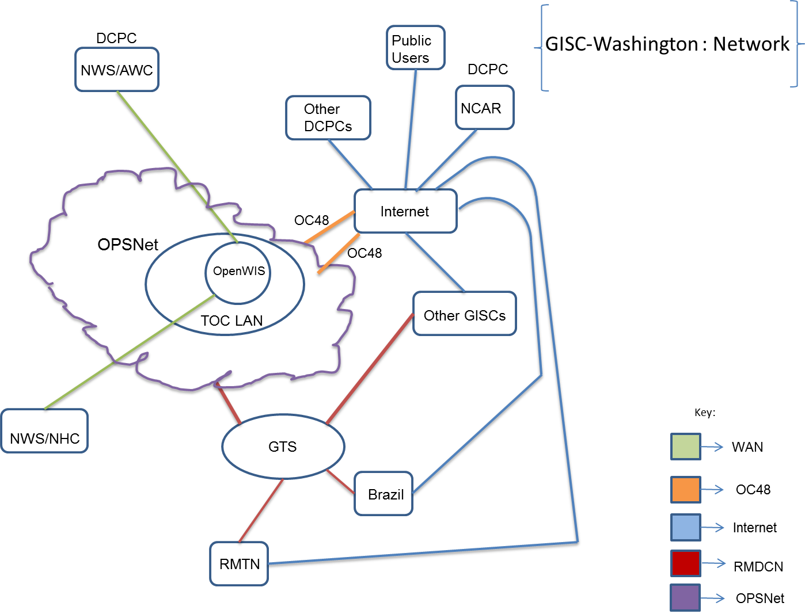

GISC Washington's Continuing Plan
Expected next steps:
- Coordination with remaining candidate DCPCs, Regional NCs, and other GISCs
- GISC fully operational by end 2013

