Specialist User Interfaces

Expert Emulator for GTS Abbreviated Headers and File Names
- The purpose of this paper is to introduce the that there is a need for a GTS Expert Emulator to be developed and operated at all GISCs to enable users to make fast and accurate searches on GTS information. Such an emulator would also be useful in the creation of appropriate file identifier fields in WIS Metadata.
- The Manual on GTS (WMO No 386) defines how to construct abbreviated headings (AHL). See reference 1 summarizing Attachment II-5 “Data designators T1T2A1A2ii in abbreviated headings” of the Manual on GTS reproduced at http://www.wmo.int/pages/prog/www/ois/Operational_Information/Publications/WMO_386/AHLsymbols/07_Vol1Part2_AttII05.pdf . The same skill set used by GTS experts to create AHL is used to create and maintain GTS Filenames for use in FTP and in e-mail.
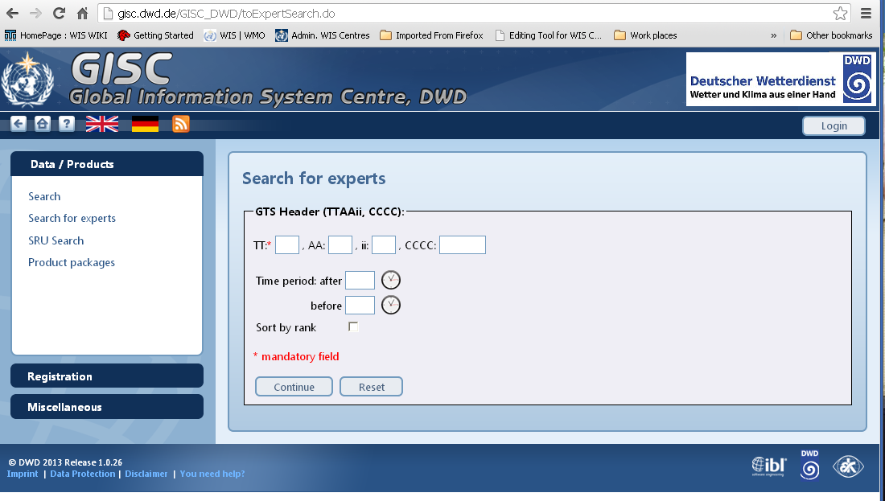
Figure 1 Advanced user interface at GISC Offenbach (http://gisc.dwd.de/GISC_DWD/toExpertSearch.do)
- A user equipped with the full knowledge of AHLs and their use in the GTS can take full advantage of Advanced Search User Interfaces such as the one shown in Figure 1 from GISC Offenbach.

What would a GTS AHL / filename emulator look like?
- The secretariat experimented with a simple AHL generator in which a user can build the product or data information (eg Tide observation from Oman in CREX format as shown in Figure 2. The interface would also allow a user to put in an AHL and decode the AHL into its relevant fields (not shown here)
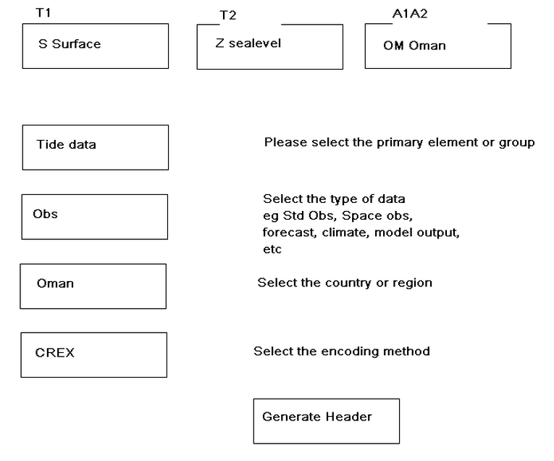
Figure 2 Concept model for multi entry input that will generate an AHL or reverse (ie Decode an AHL)
- The difficult part of this process is the encoding of the AHL using the tables defined in Attachment II-5 of the Manual on GTS. The algorithm developed by the Secretariat can be seen working at http://www.wmo.int/pages/prog/www/WIS/test/chained_select/ttaaii.php. It produces the options for each selection. Unfortunately, this algorithm is not sufficiently mature enough to justify completing the development of the generator shown in figure 2 within available resources and other priorities. An example of how the algorithm works is in figures 3, 4 and 5.

Why develop an AHL/GTS File-naming Emulator?
- The secretariat has noted that with the retirement of many experts over recent years, there has been a steady decrease in the number of people with well-developed skills in working with AHL and GTS filenames. Also, if WIS is to benefit the Members who do not have staff with these GTS skills, it should be considered a priority to address this issue and to facilitate the use of advanced search features by non-experts wishing to find and subscribe to GTS products.
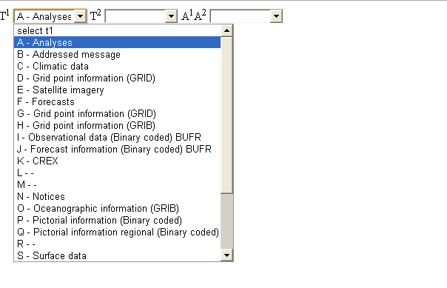
Figure 3 Selecting T1
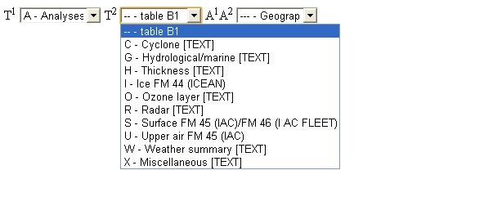
Figure 4 Selecting T2

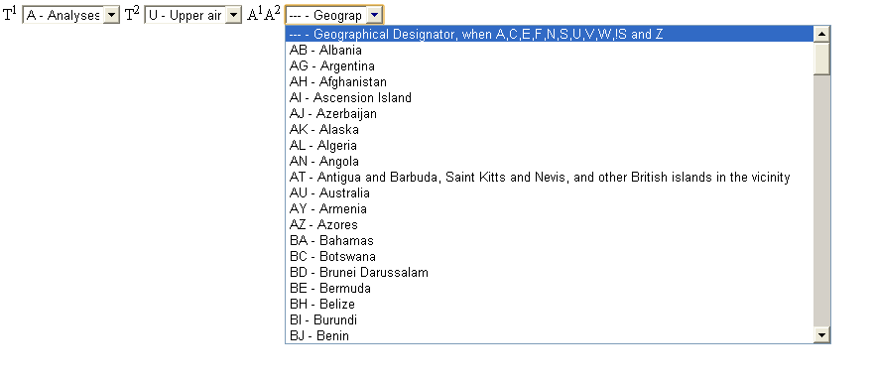
Figure 5 Selecting A1A2
- It is recognized that WIS search needs to be made usable by non-experts, however, this paper proposes that non-experts could benefit from the use of an advanced search feature based on an AHL/GTS File-naming emulator. ET-WISC is invited to review this minor project and to make appropriate recommendations.

References
- http://gisc.dwd.de
- Manual on the GTS (WMO No 386)
- Extract of Manual on GTS Vol I part II-5 http://www.wmo.int/pages/prog/www/ois/Operational_Information/Publications/WMO_386/AHLsymbols/07_Vol1Part2_AttII05.pdf
- Test AHL Generator http://www.wmo.int/pages/prog/www/WIS/test/chained_select/ttaaii.php

Recommended Text
The meeting noted the pilot work undertaken by the secretariat in creating a GTS Abbreviated Header generator. It agreed that in addition to improving search for general users, there is a need for GISCs to develop and implement an AHL emulator driven advanced search feature for GTS users. Such an emulator would also be useful in the creation of appropriate file identifier fields in WIS Metadata

--------------------

Manual on GTS Attachment II-15
Manual on GTS Attachment II-16

