# 3.5 Report on GTS and AMDCN

## GTS

In October 2012, GISC Tokyo established circuit from Tokyo to Offenbach on RMDCN. Current protocol is TCP/IP(FTP) and disseminate data of AN, AN urgent, BIN, File. Current status is as following tables…

|  |  |  |  |  |  |
| --- | --- | --- | --- | --- | --- |
| **Circuit connected with** | **Type of circuit** | **Circuit speed (bps)** | | **Protocol** | **Data types** |
| **Tokyo side** | **NMHS side** |
| WMC Melbourne | MPLS | 10M | 2M | TCP/IP  (Socket, FTP) | AN, BIN, FAX, File |
| WMC Washington | MPLS | 10M | 1M | TCP/IP  (Socket, FTP) | AN, BIN, FAX, File |
| RTH Beijing | MPLS | 10M | 4M | TCP/IP  (FTP) | AN, AN urgent, BIN,  FAX, File |
| RTH Offenbach | MPLS | 10M | 8M | TCP/IP  (FTP) | AN, AN urgent, BIN,  File |
| RTH Exeter | MPLS | 10M | 2M | TCP/IP  (Socket, FTP) | AN, BIN, FAX,  File |
| RTH New Delhi | MPLS | 10M | 1M | TCP/IP  (Socket) | AN, BIN |
| RTH Khabarovsk | Dedicated (digital) | 64k | 64k | TCP/IP  (Socket) | AN, BIN, FAX |
| RTH Bangkok | MPLS | 2M | 128k | TCP/IP  (Socket) | AN, BIN |
| NMC Hong Kong | MPLS | 2M | 1M | TCP/IP  (Socket, FTP) | AN, BIN, File |
| NMC Manila | MPLS | 2M | 64k | TCP/IP  (Socket) | AN, BIN |
| NMC Seoul | Dedicated (digital) | 128k | 128k | TCP/IP  (Socket, FTP) | AN, BIN, FAX,  File |

Current Status of GTS Circuits Connected with RTH Tokyo

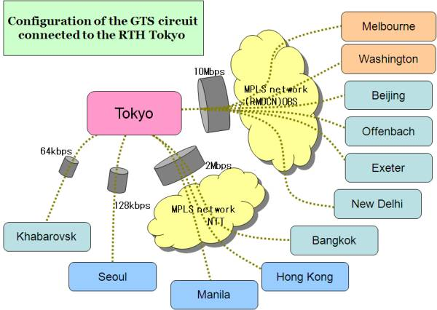

## GTS traffic volume

Daily traffic volume on the GTS at Tokyo is increasing year by year.

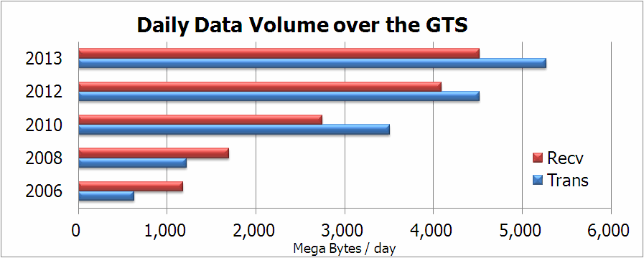

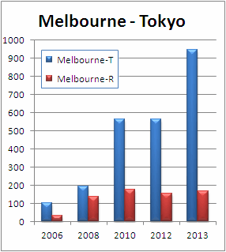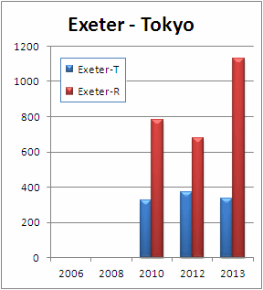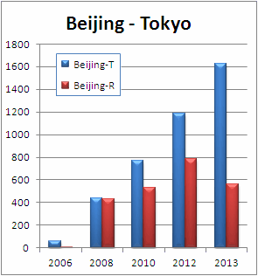Daily traffic volume on each GTS link (Mega Bytes/day).

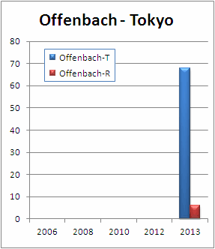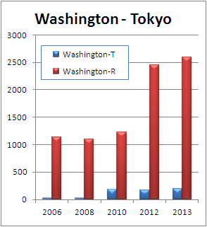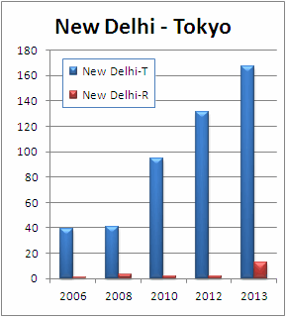

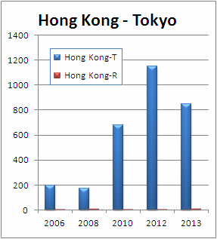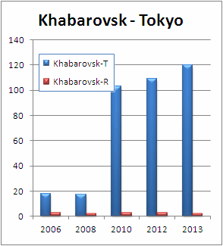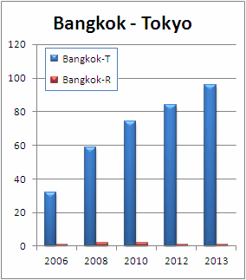

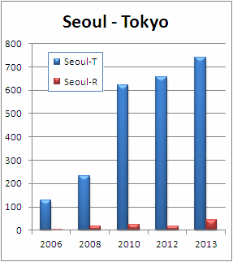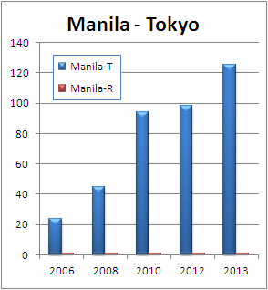

## Migration to new MSS

GISC Tokyo will migrate our MSS in October 2013, and GISC Tokyo has been arranging with neighboring GTS centers and EUMETSAT for this migration of MSS. In this migration, there is no need to change IP address and protocols at any centers.

## Next Generation of RMDCN

In February 2013, JMA signed Accession Agreement and Order form. JMA had completed contract for procurement. Installation work started in March and finished at middle of April. Currently, JMA is now in Implementation of the circuit line.

## AMDCN

According to the Manual on WIS, WIS Core network is based on the Main Telecommunication Network (MTN). Follow the philosophy of WIS core network, AMDCN can be based on an RMTN (Regional Meteorological Telecommunication Network). All six Regional Associations have an RMTN to exchange meteorological data and products stably and reliably and each RMTN has been constructed from various types of telecommunication infrastructures, for example dedicated leased line, MPLS network, Internet, satellite communication and so on.

To establish AMDCN, each GISC should consider the conditions of telecommunication infrastructure in its area/zone/region of coverage of responsibility and cost effectiveness.

According to the survey in 2012, in RA-II, 81 GTS circuits are in operation. The number of operational circuits of each type is as follows;

* Dedicated leased line (35)
* Internet (23)
* MPLS (20)
* Other (3)

Taking into account the current structure of the RMTN, all the GISCs in RA-II should support at least top three communication infrastructures, “dedicated leased line”, “Internet” and “MPLS”. This will be a fast way to establish an AMDCN and accelerate WIS implementation.

AMDCN of GISC Tokyo consists of above major three network infrastructures, direct connects to Bangkok and Manila through the MPLS network, and dedicated leased line and internet via RTH Bangkok. The data and metadata expected for regional exchange between NMHSs are exchanged/managed by RHT Bangkok and data and metadata expected for Global exchange are exchanged/managed by GISC Tokyo.

|  |  |  |  |
| --- | --- | --- | --- |
| **NMHS** | **Connection** | **Bandwidth** | **Type** |
| Cambodia | Via Bangkok(128Kbps) | Best effort | Internet |
| Lao PDR | Via Bangkok(128Kbps) | 64Kbps | Dedicated |
| Myanmar | Via Bangkok(128Kbps) | Best effort | Internet |
| Philippines | Direct | 64Kbps | MPLS |
| Thailand | Direct | 128Kbps | MPLS |
| Vietnam | Via Bangkok(128Kbps) | 64Kbps | Dedicated |

Current Status of AMDCN of GISC Tokyo

As a fastest/easiest/cost-effectiveness backup way, GISC Tokyo has been providing users with subscription manager (application) based on the DAR service. Users can get their preferable set of data automatically and near-real time (every 30 second) with a few times mouse click and without any configuration at GISC side. Users can change target data anytime without any arrangement at GISC side.