3.1 Status reports of WIS Centres

Status Report of JMA

Introduction
Since official operation in August 2011, JMA has been striving for performing stable operation of GISC Tokyo and 8 DCPCs. GISC Tokyo added some system and performance monitoring for this matter with thinking what “WIS Monitoring” is. Also GISC Tokyo keep developing WIS/GISC software to enhance our operation and for RA-II/V WIS Application Pilot Project.
The RA-II/V WIS Application Pilot Project was established in order to develop software applications for support WIS functions as the next phase of the VPN Pilot Project in Regions II and V. And this Project focuses on internet-based applications designed to run on PC for every member’s WIS operations.
Upon request from NCs, GISC Tokyo has been helping metadata creation and maintain for NCs in area of responsibility and as WIMMS. GISC Tokyo has been exchanging collected metadata with 6 operational GISCs.
For capacity building for neighboring countries, GISC Tokyo held the 2nd WIS workshop, “JMA workshop on WIS Implementation” in Tokyo October 2012. Also GISC Tokyo joined 3 WIS workshop in Seoul, Doha and Melbourne.

Status of JMA
As designated in Sixteenth WMO Congress in June 2011, JMA has started service of GISC Tokyo and following services of WIS Centres on 1st August 2011.
 | DCPC | Purpose
1 | RMDC Tokyo - Typhoon Centre | Provide information on tropical cyclones in the western North Pacific and South China Sea.
2 | RMDC Tokyo - Geographical | Produce regional analysis and short-term forecast.
3 | RMDC Tokyo - ATM/EER Centre | Produce transport simulation of hazardous substances in the atmosphere.
4 | The Meteorological Satellite Center | Operate geostationary satellites and disseminate its imagery.
5 | The Regional Climate Centre (Tokyo Climate Center) | Provide climate products to support climate services of NMHSs in the Asia-Pacific region.
6 | The Global Producing Centre for Long-range Forecasts | Provide long-range forecast.
7 | The World Data Centre for Greenhouse Gases | Collect, archive and provide data on greenhouse gases and related gases.
8 | The Regional Telecommunication Hub | Collect, distribute, and exchange data and products on GTS.

GISC Tokyo's services
GISC Tokyo has been operating traditional GTS as WIS Part-A and services of WIS Part-B.
Part-A
- Global Telecommunication System (GTS)
Part-B
- Metadata maintenance for area of responsibility
- WMO interim metadata management service
- Discovery, Access and Retrieval (DAR)
- GISC Cache
- Subscription
Also GISC Tokyo has been disseminating following data files…
- SATAID Service (MTSAT Imagery and NWP products for SATAID software)
- High-Resolution GSM data

Status of user registration and usage
Currently, GISC Tokyo provide 76 user accounts from 41 members of WMO.

User Accounts by Regional Area (except International organization)

GISC Tokyo disseminate data files about 100 GB a day from GISC Cache. Especially, Amount and number of High Resolution GSM product is increasing.

Average Daily Download Volume from GISC Cache

Networks
In October 2012, GISC Tokyo established circuit from Tokyo to Offenbach on RMDCN. Current protocol is TCP/IP(FTP) and disseminate data of AN, AN urgent, BIN, File.
GISC Tokyo will migrate our MSS in October 2013, and GISC Tokyo has been arranging with GTS centers and EUMETSAT for migration of MSS. In this migration, there is no need to change IP address and protocols at any centers.

System monitoring including access log analysis
Since official operation, GISC Tokyo has been analyzing http access log files and investigating user activities. GISC Tokyo added some system monitoring (e.g. log files, server resource, metadata exchange, subscription) to keep stable operation and to keep GISC’s service levels.
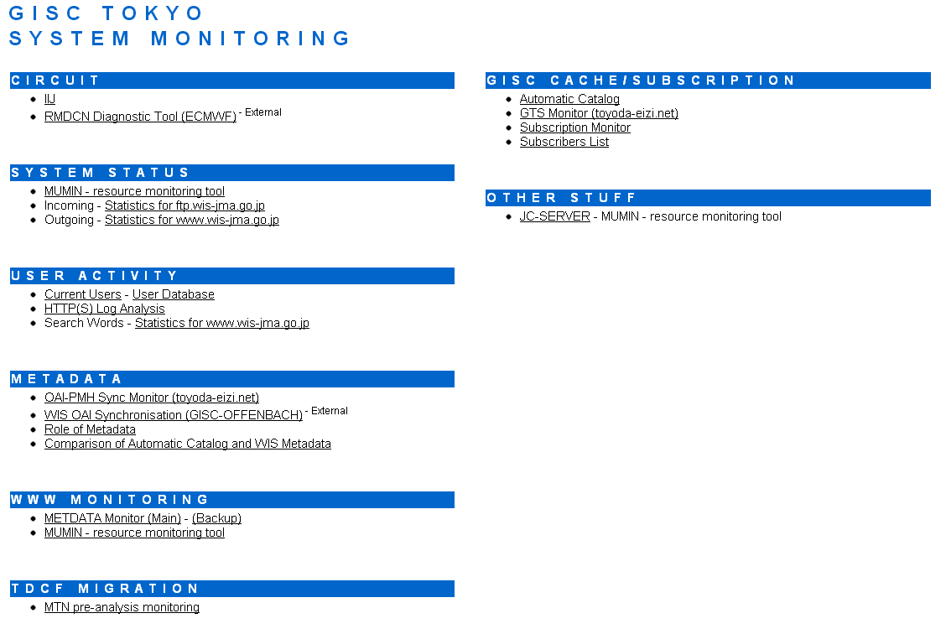
GISC Tokyo’s System Monitoring portal page

Collaboration
JMA has been keeping a stable operation with cooperation of center concerned. Towards the GISC back-up, JMA has been discussing with BOM, CMA and DWD. Also, JMA is collaborating with CMA on the WIS application pilot project.

Recommended Text
Mr. Shigeharu Nishikawa reported current status of JMA. He mentioned that JMA will migrate their MSS in this October, In this migration, there will be no need to change about network configuration.

