5.3 DAR

GISC Tokyo Subscription Manager for Microsoft Windows
As one of theme of RA-II/V WIS Application Pilot project, GISC Tokyo has been developing “GISC Tokyo Subscription Manager”. This is automatic data acquisition software for GISC cache of GISC Tokyo running on Microsoft Windows. This software is developed for ordinary PC users and features are …
- Easy setup.
- Easy download setting with simple GUI.
- No additional program.
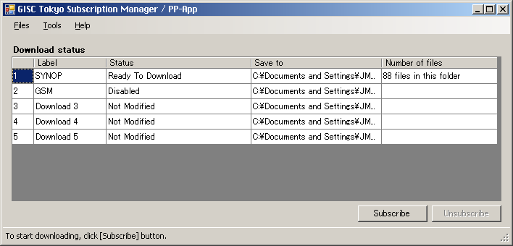
Screen shot of Subscription Manager : “Main Window”

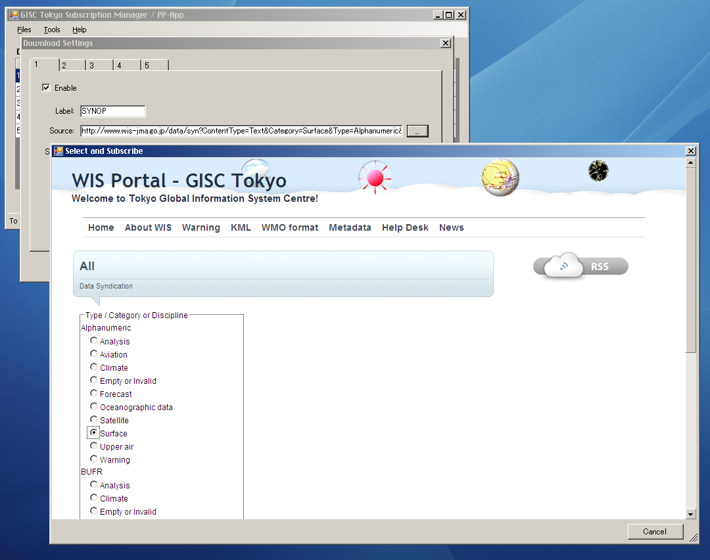
Screen shot of Subscription Manager : “Download Setting wizard”

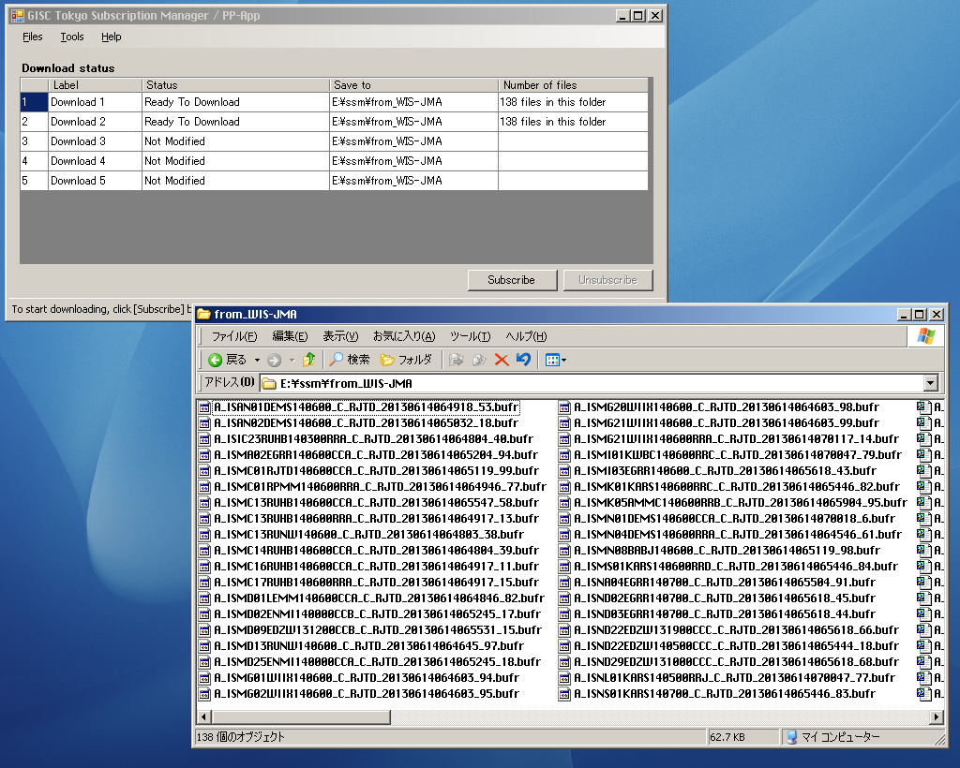
and get data files!
Click “Subscribe”
Screen shot of Subscription Manager : “Download”
This software is developed with Microsoft Visual Basic. If the operating system is Microsoft Windows 7 or higher, users dose not need to install any other program like wget (If the OS is Microsoft Windows XP, Microsoft .net framework must be installed). Setup to download is very easy with using wizard and dialogue. Users can download data files from GISC Cache of GISC Tokyo only with this program.

Recommended Text
Mr. Shigeharu Nishikawa demonstrated (reported?) GISC Tokyo’s subscription software and he mentioned that operation of this software is very easy and useful for ordinary PC users and for users who can not prepare the servers and it is important point to expand the usage of data files of GISC cache.

