Final Report of the expert team on GTS-WIS Operations and Implementation
(Moscow, 29-31 May 2012)

Original document online at http://wis.wmo.int/doc=1739

-----------------

WORLD METEOROLOGICAL ORGANIZATION

COMMISSION FOR BASIC SYSTEMS

MEETING OF THE EXPERT TEAM ON GTS-WIS
OPERATIONS AND IMPLEMENTATION

FINAL REPORT

Moscow, 29-31 May 2012
DISCLAIMER

Regulation 42
Recommendations of working groups shall have no status within the Organization until they have been approved by the responsible constituent body. In the case of joint working groups the recommendations must be concurred with by the presidents of the constituent bodies concerned before being submitted to the designated constituent body.

Regulation 43
In the case of a recommendation made by a working group between sessions of the responsible constituent body, either in a session of a working group or by correspondence, the president of the body may, as an exceptional measure, approve the recommendation on behalf of the constituent body when the matter is, in his opinion, urgent, and does not appear to imply new obligations for Members. He may then submit this recommendation for adoption by the Executive Council or to the President of the Organization for action in accordance with Regulation 9(5).

CONTENT
i. EXECUTIVE SUMMARY
1. ORGANIZATION OF THE MEETING
1.1 Opening of the meeting
1.2 Adoption of the agenda
1.3 Working arrangements
2. WIS IMPLEMENTATION AND SYSTEM MONITORING OF WIS CORE NETWORK
3. WIS DATA MONITORING
4. PROCEDURES FOR THE COLLECTION, ROUTEING AND DISTRIBUTION OF DATA AND PRODUCTS
5. OPERATIONAL INFORMATION SERVICE (OIS) RELATED TO ISS
6. REVIEW OF THE MONITORING RESULTS OF THE OPERATION OF THE WWW
7. OTHER BUSINESS
8. CLOSURE OF THE MEETING

EXECUTIVE SUMMARY

The meeting of the CBS Expert Team on GTS-WIS Operations and Implementation (ET-OI) was held in Moscow from 29 to 31 May 2012 under the chairmanship of Mr Kelvin Wong (Australia).
As WIS has been announced operational as of 31 January 2012 WIS centres were requested to move forward with the terminology whenever appropriate in preparing their documents and use the terms WIS Core Network, WIS Routeing Plan, Core Network Subscription Catalogue, AMDCN Subscription Catalogue and WIS Monitoring for all WMO Programmes instead of MTN, RMTN, GTS, Volume A, Volume C1, Routeing Catalogue and Quantitative Monitoring of the WWW. Furthermore, November 2014 will be a milestone for migration to TDCF with nearly all categories of TAC (except aviation) cease to be distributed in parallel with TDCF so WIS monitoring will need to focus on capturing any irregularities in the distribution of TDCF data and products in the WIS Core Network.
The subject of WIS Monitoring attracted rigorous discussions in the meeting. WMO Secretariat requested that an agreed document on the plan for the monitoring of the operation of the WIS will need to be in place before CBS in September 2012 for updates to be made to the Manual on WIS and Guide to the WIS. It has become more urgent for ICT-ISS and CBS to update the Manual and the Guide as the two other WE-VGISC Exeter and Toulouse in RA-VI will join GISC Tokyo, Beijing and Offenbach to become operational in June 2012. However, the group was unable to reach a consensus on some aspects of the document. Some members felt comfortable with the additional cost required for their DCPCs/NCs to conduct WIS Monitoring as this is impossible to assess at this early stage of WIS operation. It is also difficult to assess all other programmes other than the WWW Programme.
A valid comment by the chair and the Secretariat should be noted. Members tend to assume that WWW Monitoring (AGM, IWM, SAM, SMM) will be applying to all WIS centres and all WMO Programmes and the associated cost to their organisation would be very expensive. The message that this group and ICT-ISS needed to convey to Members is to think beyond what they have been doing for the last 20 years with all the WWW monitoring procedures and come up with more innovative methods of monitoring in WIS focusing on customer and user direct feedbacks which can now be obtained or can be made available under WIS more cost effectively.
The objective of WIS Monitoring should also enable functions of WIS centres to minimise the cost of operating WIS. It is also essential to be able to plan and scale WIS components in order to meet changing user needs. This will address the question of effectiveness of WIS from a user’s subjective assessment, in particular, whether users are satisfied with the services and performance of WIS. The group was in favour of a task team to be established to draw up an effective plan for WIS Monitoring by October 2013 and invite operational and designated GISC/DCPC centres to participate in pre-operational implementation to test its effectiveness and report the progress to CBS-Ext.(2014).

Other major issues identified by the group included the findings of the TDCF validation report that outlined extensive errors in TDCF messages compiled by third party commercial vendors. The report also revealed that although the international components of BUFR messages were usually coded correctly, regional and national components were frequently poor or incorrect. Furthermore progress reports prepared for each region by various groups have were in different formats making it difficult to create overall summaries.
The outcomes of the meeting will be submitted to the meeting of the Implementation Coordination Team of the Information Systems and Services (ICT-ISS) of the CBS OPAG-ISS, to be held on 13-15 June 2012 in preparation for the CBS-XV in September 2012
- ORGANIZATION OF THE MEETING

1.1 Opening of the meeting
1.1.1 The CBS Expert Team on GTS-WIS Operations and Implementation (ET-OI) was held at the Aviamettelecom of the Russian Federal Service for Hydrometeorology and Environmental Monitoring (Roshydromet) in Moscow from 29-31 May 2012. The meeting was opened at 10.00 am by the ET-OI Chair Mr Kelvin Wong (Australia). Six Core Members and seven GISC centre representatives from nine countries participated in the meeting. The Secretariat was represented by Mr David Thomas. A list of the participants is included in the Annex to this paragraph. The meeting made use of teleconferencing via WebEx extensively during the meeting to allow participation by Chief DRMM Dr Steve Foreman and Core Member Mr Chris Little to attend part sessions of the meeting.

1.1.2 Dr Alexander V. Frolov, Permanent Representative of the Russian Federation with WMO attended the opening session and welcomed the participants to Moscow. In his opening remarks Dr Frolov stressed the importance of development of communications system which underpins the components of the Global Observing System (GOS), Global Telecommunication System (GTS) and Global Data Processing and Forecasting System (GDPFS) of the World Weather Watch Programme of WMO. Dr Frolov noted the important role of the work of the Expert Team to recommend best practices and to implement the new technologies under the visionary plan that WIS has undertaken. He underlined the complexity of information collection and distribution systems in Roshydromet and other WIS centres and the importance for the Expert Team to address issues of the new technologies for a smooth transition to implement the new concepts and operate the new systems. He also highlighted the plan being activated in Russia to operate a GISC centre in Moscow in cooperation with France, and also other DCPC prototypes with Obninsk as a pilot followed by centres in the Arctic/Antarctic and the solar radiation centre in St Petersburg. Dr Frolov wished the participants a successful meeting and a pleasant stay in Moscow.

1.1.3 The chair thanked Roshydromet and the co-chair Mr Leonid Bezruk for hosting the meeting and all the pre-meeting arrangements and congratulated them on the excellent facilities they had organised. The chair also expressed deep appreciation to Dr Frolov for addressing the meeting personally and highlighted the objective for this meeting to continue improving the technology in telecommunication and information delivery under WIS to support all WMO Programmes as what WWW has achieved beginning from the sixties in its core mission in operational meteorology. The Main Telecommunication Network (MTN) has evolved from multiple dedicated links on GTS to the WIS Core Network and Area Meteorological Data Communication Network (AMDCN) connecting each GISC to DCPCs and NCs in the GISC area of responsibility similar to the Regional MTN network. It is important that this group helps Members understand the concept as CBS expert team members may sometimes get confused

1.2 Adoption of the agenda
1.2.1 The meeting adopted the agenda as reproduced in the Annex to this paragraph. The chair led a round table introduction of the 13 participants. Alexander Kats, member of IPET-DRC attended part sessions of the meeting on Day 2 and Day 3.

1.2.2 The outcomes of the meeting will be submitted to the meeting of the Implementation Coordination Team of the Information Systems and Services (ICT-ISS) of the CBS OPAG-ISS, to take place in Geneva, 13-15 June 2012.

1.3 Working arrangements
1.3.1 The meeting agreed on the working arrangements and working hours including a visit of Moscow GISC on Day 1 and a visit of Moscow sites on Day 2. WebEx conferencing will be arranged with Core Member Mr Chris Little from U.K. Met. Office and Dr Steve Foreman, Chief, Data Representation, Metadata and Monitoring (DRMM) from WMO Secretariat at a suitable time during the day taking into consideration the time difference between Moscow and Exeter/Geneva.

2. WIS IMPLEMENTATION AND SYSTEM MONITORING OF WIS CORE NETWORK
2.1 Current status of implementation of WIS
2.1.1 WIS implementation represents the ongoing support of the GTS and associated data management functions. ET-OI Core and Associate Members from 17 Member countries were requested to provide a status report of WIS implementation for their GISC/DCPC or NC. As WIS has been announced operational as of 31 January 2012 WIS centres were requested to move forward with the terminology whenever appropriate in preparing their documents and use the terms WIS Core Network, WIS Routeing Plan, Core Network Subscription Catalogue, AMDCN Subscription Catalogue and WIS Monitoring for all WMO Programmes instead of MTN, RMTN, GTS, Volume A, Volume C1, Routeing Catalogue and Quantitative Monitoring of the WWW. Furthermore, November 2014 will be a milestone for migration to TDCF with nearly all categories of TAC (except aviation) cease to be distributed in parallel with TDCF so WIS monitoring will need to focus on capturing any irregularities in the distribution of TDCF data and products in the WIS Core Network.

2.1.2 Ten reports from GISC/DCPC centres were received from ET-OI members whose countries operate an operational GISC/DCPC or engaged in its implementation at various stages. A summary of the status of operation of the GISC/DCPC reports is given in Table 1. Full reports of the GISC/DCPC and presentations are available from the WMO WIS wiki.

Table 1. Summary of the status of operation of the GISC/DCPC centres based on reports submitted to ET-OI

WMO Member | GISC/DCPC | Operational / Plan of Operation
Japan | GISC Tokyo | Operational wef 1 August 2011
China | GISC Beijing | Operational wef 15 August 2011
Germany | GISC Offenbach | Operational wef September 2011
France | WE-VGISC Toulouse | Operational wef June 2012
United Kingdom of Great Britain and Northern Ireland | WE-VGISC Exeter | Operational service planned for June 2012.
Australia | GISC Melbourne | GISC audit conducted 31 May-1 June,  operation planned for 2013 Q1.
Russian Federation | GISC Moscow | Software upgraded, equipment expected to be delivered in summer. Testing to be conducted in November 2012 and planned for GISC afterwards.
Iran, Islamic Republic of | GISC Tehran | GISC audit submission planned for July/August 2012.
Argentina | DCPC Buenos Aires | Tendering of necessary software in progress. No confirmed dates of DCPC audit.
Kenya | DCPC Nairobi | No specific details of WIS implementation for DCPC Nairobi. No planned dates for DCPC audit.

2.2 System performance monitoring
2.2.1 Performance monitoring of WIS centres are outlined in paragraph 3.5.10, 3.6.10 and 3.7.5 in the Manual on WIS Part III for GISC, DCPC and NC respectively. The system monitoring for GISC centres, in particular, shall report routinely to other GISC centres and the WMO Secretariat. This includes the status and performance of connectivity to WIS centres in its area of responsibility and the collection and dissemination of WIS information (data and products) such as the IWM and other programme-related monitoring.
2.2.2 The meeting reviewed a document prepared by Mr Kenji Tsunoda. The document illustrated three types of system monitoring as follows:
- System and network performance
- Metadata synchronisation monitoring
- Bulletin level monitoring

It noted that many centres have already monitored their system usage of CPU, memory, disk, network usage and other aspects of system performance by various tools. The RMDCN web site has also provided some useful real-time analysis of traffic statistics averaged every five minutes for each GISC centre since 2010. The real-time analysis is good for trouble shooting and the statistical analysis is excellent for considering upgrade bandwidth and so on. Mr Tsunoda commented that these types of system monitors are useful for system administrators to maintain the system and network and for their sustainable operations but they might not be useful for other GISC centres and WMO secretariat.
2.2.3 Some useful examples of network monitoring were presented to the meeting including network transmission delays between WIS centres averaged over 10-minute periods and the monitoring of switching delays for GTS traffic in the WIS Core Network with the MTN centres connected to Tokyo using various connection procedures such as socket protocol, WMO batched ftp protocol and ftp urgent channel. Figures 1, 2 and 3 illustrate the typical delays expected in each of the connection procedures.
Figure 1. Switching delay for circuits using GTS socket protocol

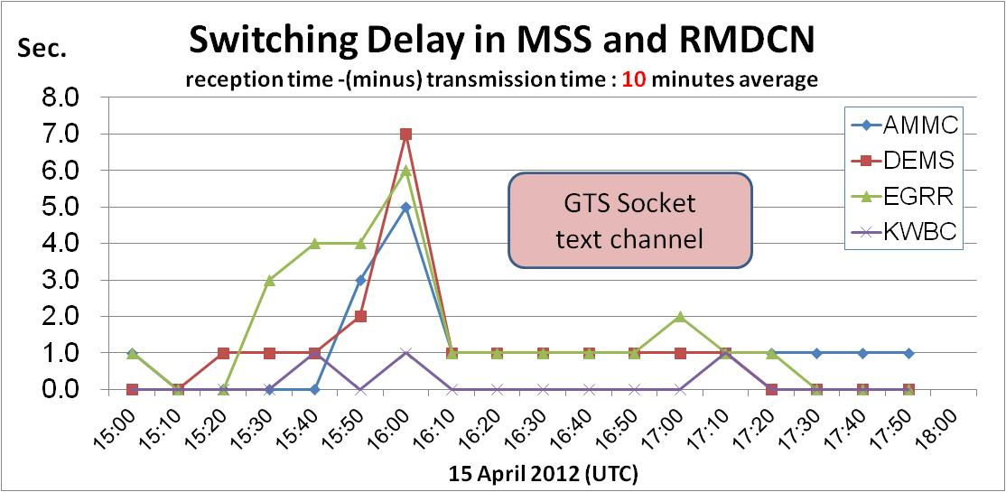

The traffic delays indicated in Figure 1 using GTS socket protocol are typically coincided with the delivery of NWP products for its 12 UTC model run.
Figure 2. Switching delay for circuits using WMO ftp batched protocol

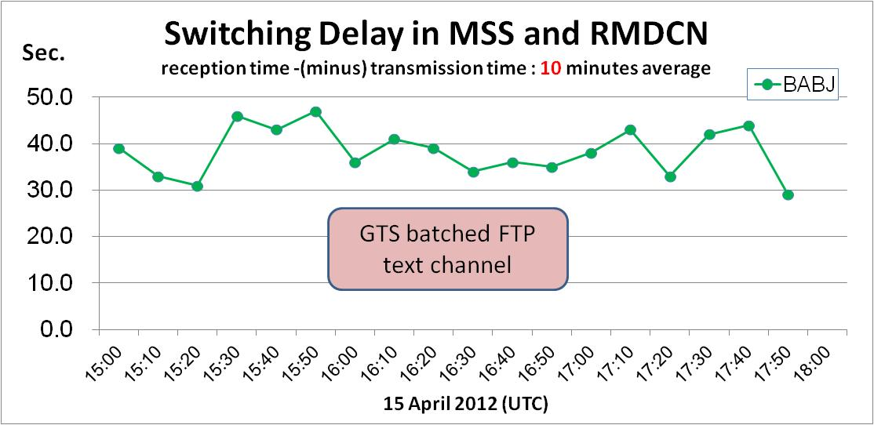

The traffic delays indicated in Figure 2 are typical average delays for circuits using WMO batched ftp protocol as the messages are transmitted every 60 seconds or in batches of 100 messages per file whichever comes first. Therefore each message is expected to have an average delay of about 30 seconds as a minimum.

Figure 3. Switching delays for circuits using ftp urgent channel

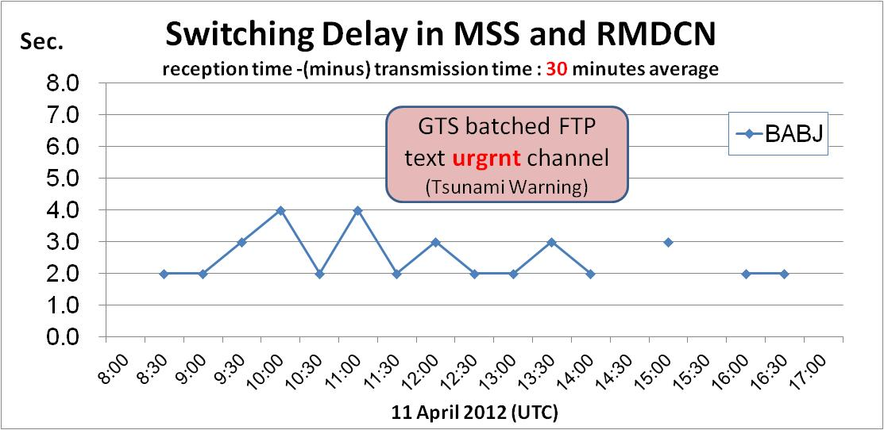

The ftp urgent channel does not accumulate messages and is therefore no waiting time before transmission. It transmits one message at a time in one file. Time critical messages such as Tsunami Warnings are transmitted on this channel to avoid the typical average delay of 30 seconds or more as in ftp batched protocol.
2.2.4 Metadata synchronization monitoring was presented to the meeting as a recommended practice of WIS monitoring at GISC centres as it is one of the most important key functions of WIS. GISC centres are required to synchronize its WIS comprehensive metadata catalogue with other GISCs according to Part III of the Manual on WIS paragraph 3.5.6. This is also related to WIS Technical Specification-9 such that distributed instances of of DAR metadata do not diverge in content by more than one day, paragraph 4.10.2 of the Manual on WIS refers.
2.2.5 Sample monitors for the status of metadata synchronization (snap shot), the discrepancies (at least once a day) and the history of changes (every four hours) as they are being produced at GISC Tokyo are presented to the meeting. The monitors are available at:
http://toyoda-eizi.net/2011/syncmon/curr/DIAG.html
http://toyoda-eizi.net/2011/syncmon/curr/DIFF.html
http://toyoda-eizi.net/2011/syncmon/curr/SMRY.html
Users can also obtain the results by Atom feed (RSS) at:
http://toyoda-eizi.net/2011/syncmon/news.atom
2.2.6 Regular bulletin monitoring to identify irregularities in data reception in order to take more immediate remedial actions at GISC centres was presented to the meeting. The method is to compare the list of abbreviated headings identified as received today against those received yesterday or any time period in the past, e.g. a week ago or a month ago. This is a significant improvement to the current quantitative monitoring of the WWW in AGM, IWM, SMM and SAM which requires a long time before any results can be analysed and made available to RTH and NMC centres to take action. Sample results of comparisons are available at the GISC Tokyo test site http://toyoda-eizi.net/2012/gtsmon/mon.html providing records of non-receipts of bulletins such as:
- Not received yesterday;
  - but received the day before yesterday (one-day missing and still missing)
  - but received a week ago (one-week missing and still missing)
  - but received a month ago (one-month missing and still missing)
  - but received in last month (for CLIMAT)
- Received yesterday;
  - but not received since yyyy-mm-dd (missing ? days, but resumed yesterday)

  - DAR metadata and data synchronization
2.3.1 The meeting reviewed two documents presented by Mr Kenji Tsunoda and Mr Jacques Anquetil related to DAR metadata and data synchronization at GISC Tokyo and GISC Toulouse both centres commenced operation with effect from August 2011 and June 2012 respectively. The three operational GISC centres in Tokyo, Beijing and Offenbach started synchronization of DAR metadata periodically with each other using OAI-PMH since 2011. GISC Toulouse joined the synchronization in April 2012. The four operational GISC centres are now harvesting metadata from each other producing an identical metadata set and providing DAR service via their WIS portal.
2.3.2 Details of the GISC Tokyo metadata synchronization monitor are described in para. 2.2.4 and 2.2.5. The meeting noted the metadata harvesting and synchronization facilitated through OpenWIS as operated at GISC Toulouse. The interface configured for harvesting can use OAI-PMH, Catalogue Service for the Web (CSW), GeoNetwork, File System and WEBDAV. Similar Monitor Catalogue Content page offers an administrative view of all catalogue metadata and its extracted attributes. OpenWIS also provided a statistics page for the catalogue including the catalogue size, total number of metadata and a table showing the volume of metadata harvested, synchronized or locally created per day and per source.
    - With reference to data synchronization or replication the meeting was presented two scenarios for exchange of global data under OpenWIS:
- Exchange of global data via MSS/FSS harness whereby the replication process aims to replicate a GISC’s Cache around the world in ‘real-time’. This process runs in parallel with the GTS circulation and is limited to products inserted in the Cache during the last 24 hours
- Using the P2P-framework JXTA to implement the Cache Replication mechanism. For the ‘normal’ mode of operation every OpenWIS node (GISC, DCPC, NC) will join one or more so-called JXTA peer groups which limit the scope of data exchange. Within a peer group the peers are able to synchronise their repositories via a PUSH-based mechanism, basically consisting of the following three steps:
  - Publish/Discovery of new files (arriving from GTS Collection)
  - Select/Request relevant files
  - Retrieval/Transfer of files

  - Management and operational aspects of DCPC and NC in areas of GISC
2.4.1 The meeting reviewed the document submitted by Mr Kenji Tsunoda in his proposed actions for GISC centres to take up the responsibilities of MTN/RTH centres in respect of the functions and responsibilities of Meteorological Telecommunication Centres as described in Manual on the GTS, Part I, paragraph 2.1(h).
“2.1 The WMCs (as regards telecommunications) and the RTHs shall be responsible for:
...
(h) For WMCs/RTHs on the MTN, maintaining the Catalogue of Meteorological Bulletins as regards bulletins issued from the zone for which they are responsible ...”
According to the Technical Regulations, Volume I, [A.3.1] 2.1.3 “Members making meteorological transmissions shall provide the Secretariat with details of the contents and schedules of their transmission programmes.” In practice NMCs do not create Advanced Notifications and notify WMO directly. The current maintenance procedures of Volume C1, Catalogue of Meteorological Bulletins are all done by MTN/RTH centres on behalf of the NMCs.

2.4.2 Apart from the key role of timely updates of Volume C1 for centres in its area of responsibility, other proposed actions for the GISC centres also include the following:
- Evaluate the metadata in its area of responsibility including syntax and contents
- Compare the metadata in its area of responsibility against actual data received and conduct bi-annual updates of Volume C1 irrespective of whether discrepancies are detected.
- Decode all data received from its area of responsibility

GISC Tokyo also designed and implemented a simple and easy-to-use metadata editing tool following the data structure of Volume C1 using MS-Excel. This is prepared to help small WIS centres in their beginning stage of WIS operation. The output produces a file in xml which they can send it to their Principal GISC for update of the DAR metadata. The meeting congratulated the efforts of GISC Tokyo and cautioned that the metadata created from the MS-Excel editing tool may lose some details intended to be captured in the full metadata record if no attempts are made by the GISC centre to supplement it with other relevant supporting metadata of the centre.
3. WIS DATA MONITORING
3.1 WWW monitoring, past, present and future
3.1.1 This session of the meeting was conducted via WebEx conferencing with Dr Steve Foreman at WMO Secretariat. A first attempt to analyse the participation of MTN/RTH/NMC centres in AGM/IWM and SAM was conducted by RTH Melbourne early this year. The results were presented to the meeting by the chair. The purpose of the analysis was an attempt to answer some commonly asked questions such as:
- Which centres stopped participating AGM/IWM/SAM and why
- How successful is IWM as it was introduced in 2007
- What lessons can we learn if a new monitoring scheme is to be introduced

Table 2 provided a summary of the analysis of participation of the 97 centres that took part in the AGM and the September IWM from 2006 to 2011. The analysis was based on the AGM and IWM results submitted by the centres to WMO Secretariat with data files or scanned copies of paper submissions archived on the WMO ftp server. AGM/IWM participation appears to peak in 2008 with 67 centres participated and then dropped to 57 in 2011.
3.1.2 As NMC centres participated in IWM and exchanged results with their responsible RTH centres are no longer required to submit AGM/IWM results to WMO Secretariat this is likely to be the main reason for the decrease in number of centres submitting AGM/IWM results to WMO. Other possible reason for the decrease in number may be attributed to some results submitted in disk, on paper or via email, and they are not being archived in the ftp server in recent years. The meeting reviewed the results and indicated that further analysis is required to assess how many centres participated in IWM and stopped sending IWM results to WMO in order to ascertain the actual participation rate of IWM. According to RTH Offenbach more than 70 centres have registered for using the IWM software which was a contribution by Germany to the quantity monitoring activities coordinated by WMO. The trial of IWM commenced in 2007 after CBS-Ext.(06) officially launched its operation.
3.1.3 Table 3 provided a summary analysis of 36 centres as having submitted IWM results to WMO in September (2007-2011). In 2011 a total of 29 centres submitted results to WMO, of which 17 of them are MTN/RTH centres and 12 are NMC centres. However, there may be some centres sending IWM results directly to their responsible RTH/MTN centres so the figures in Table 3 may not reflect the actual number of centres implementing IWM. MTN and RTH centres were requested to comment on the extent of how IWM have been implemented in the NMC and RTH centres in their area of responsibility. Toulouse and Tokyo responded that they have been collecting IWM results from NMC centres in their area of responsibility since 2007 and 2008.
3.1.4 Table 4 presented a summary analysis of the centres participated in SAM based on the SAM results they submitted to WMO in January (2006-2011). A maximum of 17 centres participated in SAM in 2010 and the minimum was 12 in 2008. A total of 18 centres participated in SAM between 2005 and 2011, 14 of them are MTN or RTH centres and 4 are NMC centres.
Table 2. MTN/RTH/NMC centres submitted AGM/IWM results to WMO in September (2006 – 2011)

No. | Country | Centre | MTN/RTH  NMC | 2006 | 2007 | 2008 | 2009 | 2010 | 2011
1 | Solomon Is | Honiara | NMC |  |  |  | AGGG
2 | Australia | Melbourne | MTN | AMMC | AMMC | AMMC | AMMC | AMMC | AMMC
3 | China | Beijing | MTN | BABJ | BABJ | BABJ | BABJ
4 | Iceland | Reykjavik | NMC | BIRK | BIRK | BIRK | BIRK | BIRK | BIRK
5 | Canada | Montreal | NMC | CWAO | CWAO
6 | Algeria | Algers | MTN | DAMM | DAMM | DAMM | DAMM | DAMM | DAMM
7 | Benin | Cotonou | NMC |  |  | DBBB
8 | India | New Delhi | MTN | DEMS | DEMS | DEMS | DEMS | DEMS | DEMS
9 | Tunisia | Tunis | NMC |  |  | DTTA |  | DTTA | DTTA
10 | Germany | Offenbach | MTN | EDZW | EDZW | EDZW | EDZW | EDZW | EDZW
11 | Finland | Helsinki | NMC | EFKL | EFKL | EFKL | EFKL
12 | UK | Exeter | MTN | EGRR | EGRR | EGRR | EGRR | EGRR | EGRR
13 | Netherlands | De Bilt | NMC |  |  | EHDB |  | EHDB
14 | Ireland | Dublin | NMC | EIDB | EIDB | EIDB | EIDB | EIDB | EIDB
15 | Denmark  and Faroe Is | Copenhagen | NMC | EKMI | EKMI | EKMI | EKMI
16 | Norway | Oslo | NMC |  |  | ENMI | ENMI
17 | Sweden | Norrkoping | RTH | ESWI | ESWI | ESWI | ESWI
18 | Lithuania | Vilnius | NMC | EYHM | EYHM | EYHM | EYHM | EYHM | EYHM
19 | South Africa | Pretoria | RTH |  | FAPR |  | FAPR
20 | Central African  Republic | Bangui | NMC | FEFF | FEFF | FEFF
21 | Congo | Brazzaville | RTH |  |  | FCBB |  | FCBB
22 | Mauritius | Vacoas | NMC | FIMP | FIMP | FIMP | FIMP | FIMP | FIMP
23 | Seychelles | Seychelles  Intl Airport | NMC | FSIA | FSIA
24 | Zimbabwe | Harare | NMC |  |  |  | FVHA
25 | Canary Is | Las Palmas/  Santa Cruz De Tenerife | NMC | GCLP
26 | Morocco | Casablanca | NMC |  | GMMC | GMMC
27 | Senegal | Dakar | MTN |  |  | GOOY | GOOY | GOOY | GOOY
28 | Hungary | Budapest | NMC | HABP | HABP | HABP | HABP | HABP | HABP
29 | Egypt | Cairo | MTN | HECA | HECA | HECA |  | HECA | HECA
30 | Kenya | Nairobi | MTN |  | HKNC | HKNC | HKNC | HKNC
31 | Rwanda | Kigali | NMC |  |  |  |  |  | HRYR
32 | Tanzania  United Republic | Dar Es Salaam | NMC |  |  |  | HTDA |  | HTDA
33 | USA | Washington | MTN | KWBC | KWBC | KWBC | KWBC | KWBC | KWBC
34 | Cyprus | Larnaca | NMC |  |  | LCLK | LCLK
35 | Spain | Madrid | NMC | LEMM
36 | France | Toulouse | MTN | LFPW | LFPW | LFPW | LFPW | LFPW | LFPW
37 | Greece | Athens | NMC | LGAT
38 | Italy | Rome | RTH | LIIB | LIIB | LIIB | LIIB | LIIB | LIIB
39 | Slovenia | Ljubjana | NMC | LJLM | LJLM
40 | Israel | Bet Dagan | NMC | LLBD | LLBD | LLBD |  | LLBD
41 | Austria | Vienna | RTH |  |  |  | LOWM
42 | Portugal | Lisbon | NMC | LPMG |  | LPMG | LPMG | LPMG
43 | Bosnia and  Herzegovina | Sarajevo | NMC |  |  | LQSM |  | LQSM | LQSM
44 | Switzerland | Zurich | NMC | LSSW | LSSW |  | LSSW
45 | Turkey | Ankara | NMC |  | LTAA
46 | Serbia | Beograd | NMC |  |  | LYBM | LYBM |  | LYBM
47 | Slovakia | Bratislava | NMC | LZIB | LZIB | LZIB |  | LZIB | LZIB
48 | Bulgaria | Sofia | MTN | LZSO | LZSO | LZSO | LZSO | LZSO | LZSO
49 | Jamaica | Kingston/  Norman Manley | NMC |  |  |  | MKJP | MKJP
50 | Costa Rica | Juan Santamaria | NMC | MROC |  | MROC | MROC
51 | El Salvador | Comalapa/  El Salvador  Intl Airport | NMC |  |  | MSLP | MSLP

No. | Country | Centre | MTN/RTH  NMC | 2006 | 2007 | 2008 | 2009 | 2010 | 2011
52 | Cuba | Habana | NMC |  |  |  | MULH
53 | Cayman Is | Owen Roberts Intl | NMC | MWCR |  | MWCR | MWCR | MWCR
54 | Mexico |  | NMC |  | MXBA | MXBA | MXBA | MXBA | MXBA
55 | Fiji | Nadi | NMC | NFFN | NFFN
56 | New Caledonia | Noumea | NMC | NWBB | NWWB | NWBB | NWBB | NWBB | NWBB
57 | New Zealand | Wellington | RTH | NZKL |  | NZKL | NZKL | NZKL
58 | Saudi Arabia | Jeddah | MTN | OEJD | OEJD | OEJD | OEJD | OEJD | OEJD
58 | Iran | Tehran | RTH |  |  |  |  | OIII
60 | Jordan | Amman | NMC |  |  | OJAM | OJAM | OJAM
61 | Kuwait | Kuwait | NMC |  |  |  | OKBK
62 | Czech Republic | Prague | MTN | OKPR | OKPR | OKPR | OKPR | OKPR | OKPR
63 | UAE | Abu Dhabi | NMC |  |  |  |  | OMAA | OMAA
64 | Oman | Muscat | NMC | OOMS | OOMS | OOMS | OOMS | OOMS | OOMS
65 | Bulgaria | Sofia | RTH | LBSM
66 | Japan | Tokyo | MTN | RJTD | RJTD | RJTD |  |  | RJTD
67 | Korea | Seoul | NMC | RKSL | RKSL | RKSL
68 | Philippines | Manila | NMC |  |  |  |  |  | RPMM
69 | Russian  Federation | Moscow | MTN | RUMS | RUMS | RUMS | RUMS | RUMS | RUMS
70 | Russian  Federation | Novosibirsk | NMC | RUNW | RUNW | RUNW | RUNW | RUNW | RUNW
71 | Argentina | Buenos Aires | MTN | SABM | SABM | SABM
72 | Brazil | Brasilia | MTN |  | SBBR | SBBR | SBBR | SBBR | SBBR
73 | Ecuador | Quito | NMC |  |  | SEQU |  | SEQU | SEQU
74 | Poland | Warszawa | NMC | SOWR | SOWR |  |  |  | SOWR
75 | Venezuela | Maracay | RTH |  |  |  | SVBS
76 | Guyana | Timehri/  Cheddi Jagan Intl | NMC |  |  |  |  | SYCJ
77 | Antigua and  Barbuda | St Johns/  V.C. Bird Intl | NMC |  | TAPA |  | TAPA
78 | Barbados | Christ Church | NMC | TBPB | TBPB | TBPB | TBPB
79 | Dominica | Melville Hall | NMC |  | TDPD | TDPD | TDPD | TDPD
80 | St Lucia | Vigie/  Hewanorra Intl | NMC |  |  |  | TLPL
81 | Trinidad  and Tobago | Port-of-Spain/  Piarco | NMC | TTPP | TTPP |  | TTPP | TTPP | TTPP
82 | Kazakhstan | Almaty | NMC |  |  | UAAA
83 | Azerbaijan | Baku | NMC |  |  | UBBB
84 | Georgia | Tbilisi | NMC | UGGG
85 | Belarus | Minsk | NMC | UMMN | UMMN | UMMN | UMMN | UMMN | UMMN
86 | Latvia | Riga | NMC | UMRR | UMRR
87 | Uzbekistan | Tashkent | RTH |  | UTTW | UTTW | UTTW | UTTW | UTTW
88 | Sri Lanka | Colombo | NMC |  |  | VCCC | VCCC |  | VCCC
89 | Hong Kong,  China | Hong Kong | NMC | VHHH | VHHH | VHHH | VHHH | VHHH
90 | Macao, China | Macao | NMC | VMMC | VMMC
91 | Vietnam | Hanoi | NMC |  | VNNN
92 | Maldives | Male | NMC | VRMM | VRMM
93 | Thailand | Bangkok | RTH | VTBB | VTBB | VTBB | VTBB | VTBB | VTBB
94 | Indonesia | Jakarta | NMC |  |  |  | WIIX | WIIX | WIIX
95 | Malaysia | Kuala Lumpur | NMC | WMKK | WMKK | WMKK | WMKK | WMKK | WMKK
96 | Singapore | Singapore | NMC | WSSS |  | WSSS | WSSS | WSSS | WSSS
97 | Romania | Bucarest | NMC | YRBK | YRBK | YRBK | YRBK | YRBK | YRBK
 | MTN/RTH | 29 | AGM | 58 | 57 | 63 | 61 | 50 | 44
 | NMC | 68 | AGM/IWM | 56 | 57 | 67 | 66 | 56 | 57
 |  |  | IWM | 0 | 4 | 16 | 16 | 19 | 29

 | No AGM/IWM submitted
CCCC | AGM and IWM are both submitted
 | Submitted IWM and terminated AGM

Table 3. MTN/RTH/NMC centres submitted IWM results to WMO in September (2007 – 2011)

No. | Country | Centre | MTN/RTH  NMC | 2007 | 2008 | 2009 | 2010 | 2011
1 | Australia | Melbourne | MTN |  | AMMC | AMMC | AMMC | AMMC
2 | China | Beijing | MTN |  | BABJ | BABJ | BABJ | BABJ
3 | Canada | Montreal | NMC |  | CWAO |  | CWAO | CWAO
4 | Algeria | Algers | MTN |  |  | DAMM | DAMM | DAMM
5 | India | New Delhi | MTN |  |  |  | DEMS
6 | Germany | Offenbach | MTN |  |  |  | EDZW | EDZW
7 | Netherlands | De Bilt | NMC |  |  |  |  | EHDB
8 | Ireland | Dublin | NMC |  |  |  | EIDB
9 | Norway | Oslo | NMC |  | ENMI | ENMI
10 | Sweden | Norrkoping | RTH |  |  | ESWI | ESWI | ESWI
11 | Lithuania | Vilnius | NMC |  |  |  |  | EYHM
12 | South Africa | Pretoria | RTH |  | FAPR | FAPR | FAPR | FAPR
13 | Congo | Brazzaville | RTH |  |  |  |  | FCBB
14 | Mauritius | Vacoas | NMC |  |  |  |  | FIMP
15 | Senegal | Dakar | MTN |  | GOOY |  |  | GOOY
16 | Egypt | Cairo | MTN |  | HECA | HECA | HECA | HECA
17 | USA | Washington | MTN | KWBC | KWBC
18 | France | Toulouse | MTN | LFPW | LFPW | LFPW | LFPW | LFPW
19 | Italy | Rome | RTH | LIIB | LIIB | LIIB | LIIB | LIIB
20 | Israel | Bet Dagan | NMC |  | LLBD | LLBD | LLBD | LLBD
21 | Bosnia and  Herzegovina | Sarajevo | NMC |  |  | LQSM
22 | Switzerland | Zurich | NMC |  | LSSW |  | LSSW | LSSW
23 | Turkey | Ankara | NMC | LTAA
24 | Slovakia | Bratislava | NMC |  |  | LZIB
25 | El Salvador | Comalapa/  El Salvador  Intl Airport | NMC |  |  |  |  | MSLP
26 | New Caledonia | Noumea | NMC |  |  | NWBB | NWBB | NWBB
27 | New Zealand | Wellington | RTH |  |  | NZKL |  | NZKL
28 | Jordan | Amman | NMC |  |  |  |  | OJAM
29 | Czech Republic | Prague | MTN |  | OKPR | OKPR | OKPR | OKPR
30 | Oman | Muscat | NMC |  |  |  |  | OOMS
31 | Japan | Tokyo | MTN |  | RJTD |  | RJTD | RJTD
32 | Russian  Federation | Moscow | MTN |  |  |  | RUMS | RUMS
33 | Argentina | Buenos Aires | MTN |  | SABM |  |  | SABM
34 | Uzbekistan | Tashkent | RTH |  |  |  |  | UTTW
35 | Macao, China | Macao | NMC |  | VMMC |  | VMMC | VMMC
36 | Romania | Bucarest | NMC |  |  |  |  | YRBK
 | MTN/RTH |  | 19 | 3 | 11 | 10 | 13 | 17
 | NMC |  | 17 | 1 | 5 | 5 | 6 | 12
 | Total |  | 36 | 4 | 16 | 15 | 19 | 29

Table 4. MTN/RTH/NMC centres submitted SAM results to WMO in January (2005 – 2011)

No. | Country | Centre | 2005 | 2006 | 2007 | 2008 | 2009 | 2010 | 2011
1 | Australia | Melbourne | AMMC |  | AMMC |  | AMMC | AMMC | AMMC
2 | China | Beijing | BABJ | BABJ | BABJ | BABJ | BABJ | BABJ | BABJ
3 | Canada | Montreal |  |  |  |  |  | CWAO
4 | India | New Delhi | DEMS | DEMS | DEMS | DEMS | DEMS | DEMS | DEMS
5 | Germany | Offenbach | EDZW | EDZW | EDZW | EDZW | EDZW | EDZW | EDZW
6 | UK | Exeter | EGRR | EGRR | EGRR | EGRR | EGRR | EGRR | EGRR
7 | Sweden | Norrkoping | ESWI | ESWI | ESWI |  |  | ESWI | ESWI
8 | USA | Washington | KWBC | KWBC | KWBC | KWBC | KWBC | KWBC | KWBC
9 | Spain | Madrid |  |  |  |  | LEMM
10 | France | Toulouse |  | LFPW | LFPW | LFPW | LFPW | LFPW | LFPW
11 | Italy | Rome | LIIB | LIIB | LIIB | LIIB | LIIB | LIIB | LIIB
12 | New Zealand | Wellington | NZKL | NZKL | NZKL | NZKL | NZKL | NZKL | NZKL
13 | Japen | Tokyo | RJTD | RJTD | RJTD |  | RJTD | RJTD | RJTD
14 | Korea | Seoul | RKSL | RKSL |  | RKSL | RKSL | RKSL | RKSL
15 | Russian  Federation | Moscow | RUMS | RUMS | RUMS | RUMS | RUMS | RUMS | RUMS
16 | Argentina | Buenos Aires | SABM | SABM | SABM | SABM | SABM | SABM
17 | Brazil | Brasilia | SBBR | SBBR | SBBR | SBBR | SBBR | SBBR
18 |  |  |  |  |  |  |  | SCEM
 | MTN/RTH | 14 | 13 | 13 | 14 | 11 | 13 | 14 | 12
 | NMC | 4 | 1 | 1 | 0 | 1 | 2 | 3 | 1
 | Total | 18 | 14 | 14 | 14 | 12 | 15 | 17 | 13

WIS system monitoring
3.1.5 Mr Chris Little presented a high level conceptual document on WIS monitoring to the meeting via WebEx. The reasons he put forward for conducting WIS monitoring were well received:
- To ensure it meets its agreed requirements, such as functionality and performance;
- To ensure Members have sustainable, efficient and cost effective systems, processes and staffing;
- To monitor performance and capacity changes so that upgrades can be planned or bottlenecks and imbalances addressed;
- To monitor the uptake and rollout of the WIS, so that planning can be refined and legacy systems removed.
- Several WMO Members have undertaken ISO 9001 certification to demonstrate the appropriate quality of their services. Any agreed WIS monitoring activities coordinated through WMO towards such external recognition of quality would be helpful.

Mr Little also identified three target levels of applicability to WIS that covered (i) customers, (ii) services and products and (iii) system monitoring. The meeting agreed that the reasons for WIS monitoring and the target levels are good pointers and they are all relevant.
3.1.6 Other expressed comments by members of ET-OI indicated that more practical and solid guidelines are required in terms of technical and user related aspects at this important stage of getting WIS operational. Suggested approaches included steps taken to automate the procedures with minimum resource required on systems and to address how much monitoring will cost. In order to achieve the objective of WIS monitoring technology-wise, user-wise and information-wise a total cost of no more than ten percent would be acceptable. Any attempts to achieve more comprehensive WIS monitoring should not be too expensive. An alternative approach is to identify goals and tasks or define what we want to monitor with suggested options to address the issues. A single repository with standard formats and interfaces are possible solutions.
3.2 WIS monitoring for all WMO Programmes
    - The subject of WIS Monitoring attracted rigorous discussions in the meeting under this agenda item. The group was requested to review a document drafted by the Secretariat aimed to provide recommendations for the amendments to the Manual on WIS and Guide to WIS on the subject of WIS Monitoring. It has become more urgent for ICT-ISS and CBS to update the Manual and the Guide as the two other WE-VGISC Exeter and Toulouse in RA-VI will join GISC Tokyo, Beijing and Offenbach to become operational in June 2012. The current descriptions in the Manual on WIS under paragraph 3.5.10.2 are insufficient for WIS Monitoring. Furthermore there are no guidelines presented in the Guide to WIS covering different aspects of WIS Monitoring the group discussed in the meeting.

    - Dr Steve Foreman presented the document on “Quantitative Monitoring Procedures for data exchanged through the WIS” to the meeting via WebEx conferencing. The intention was to seek endorsement for replacement of IWM and other programme-related monitoring in paragraph 3.5.10.2 with WIS Monitoring and monitoring related to WMO Programmes. A new paragraph 7 will also be added in the Guide to WIS to provide guidelines on the following three types of monitoring (i) Network WIS Monitoring, (ii) Quantitative WIS Monitoring and (iii) Qualitative WIS Monitoring in order to address the following three commonly asked questions in the management of the WIS:
- how do we exchange information
- how much information do we exchange
- how well do we meet the expected standards for information exchange

    - A number of comments were raised in the meeting expressing concerns about the WIS Monitoring document. Some main concerns and counter proposals from members of the group are as follows:

  - Members have to install additional software for their DCPCs/NCs and this is impossible to assess at this stage;
  - It is also difficult to assess all other programmes which are in addition to the WWW Programme;
  - Cost unaffordable to their organisation if it requires more than 10% of their operating/staff cost;
  - No practical steps of implementation and automated tasks aimed to reduce the cost of operation;
  - No guidelines on options in procedures, repository, formats, interface, etc.;
  - Different terms used in the manual, performance monitoring against "collection and dissemination of WIS information (data and products)" in 3.5.10.2 which may imply only Quantitative Monitoring;
  - Follow too much to WWW Monitoring which is incomplete and too complicated and past its 'Sell By' date;
  - Not able to meet new requirements and the new comprehensive framework;
  - Need a working group to conduct a review and propose a simpler monitoring;
  - Paragraph 5.3 in Attachment X to the Guide on WIS under Plan for Monitoring the Operation of the WMO WIS is taken out of Attachment I-5, Manual on the GTS and has been re-worded replacing NMC/RTH/RSMC/WMC with NC/DCPC/GISC, and WWW with WIS. Although the frequency of reports to be prepared and exchanged is a recommended procedure (should) and not mandatory (shall), concerns were expressed as to how many Members would be ready to implement this new WIS monitoring noting that less than 50% of Members are taking part in the current WWW Monitoring (AGM/IWM) which is supposed to be mandatory for all Members, see meeting document Doc. 3.1(1).

    - The chair noted that Members tend to assume that WWW Monitoring (AGM, IWM, SAM, SMM) will be applying to all WIS centres and all WMO Programmes and the associated cost to their organisation would be very expensive. The message that this group and ICT-ISS needed to convey to Members is to think beyond what they have been doing for the last 20 years with all the WWW monitoring procedures and come up with more innovative methods of monitoring in WIS focusing on customer and user direct feedbacks which can now be obtained or can be made available under WIS more cost effectively.

    - The objective of WIS Monitoring should also enable functions of WIS centres to minimise the cost of operating WIS. It is also essential to be able to plan and scale WIS components in order to meet changing user needs. This will address another question about the effectiveness of WIS from a user’s subjective assessment, in particular, whether users are satisfied with the services and performance of WIS. The group was in favour of a task team to be established to draw up an effective plan for WIS Monitoring by October 2013 and invite operational and designated GISC/DCPC centres to participate in pre-operational implementation to test its effectiveness and report the progress to CBS-Ext.(2014).

3.3 Subscription metadata catalogues
Status of update by WIS centres to be added.
3.4 Status of cache download
The chair noted that maintaining a 24-hour cache intended for global exchange at GISC centres is a key function for GISC centres (para. 3.5.5 of Manual on WIS refers) and requested operational GISC centres to provide some statistics on cache download recorded at their GISC centres for this meeting. Mr Yoritsugi Ohno of GISC Tokyo and Mr Markus Heene of GISC Offenbach were able to provide some figures in short notice and presented to the meeting in Doc 2.1(8) and Doc 3.1(4). The meeting was confident that operational GISC centres are clearly capable of conducting regular monitoring of the cache down activities as part of their normal WIS monitoring tasks for purposes of exercising access control management at their centres and also for future planning.

4. PROCEDURES FOR THE COLLECTION, ROUTEING AND DISTRIBUTION OF DATA AND PRODUCTS

4.1 Observational data / WIS data and products
    - Plan for routeing observational data on the MTN (Attachment I-3, Manual on the GTS)

4.1.1.1 In response to the queries from GCOS Secretariat for some routeing problems of bulletins on GTS the chair and Mr Kenji Tsunoda identified a number of problems in the "Plan for routeing observational data on the MTN" given in the Manual on the GTS, Attachment I-3. GCOS Secretariat contacted RTH Melbourne seeking assistance for the distribution of the TEMP reports on the GTS from the recently restored upper air station at Khartoum (62721), Sudan. A summary report was provided to GCOS Secretariat outlining various problems of the Routeing Plan for the Khartoum (CCCC=HSSS) bulletins on the MTN following Attachment I-3 which is very much out of date. It was evident that many RTH centres are not aware of such routeing plan existed in the GTS Manual. The survey conducted with the 17 RTH centres indicated most RTH centres are not following the routeing plan. A revised routeing plan for observational data on the MTN is illustrated in Figure 4.

4.1.1.2 As indicated in the Terms of Reference of ET-OI: “(h) Review the standard and recommended procedures and practices of the Manual on the GTS related to the operation of the GTS, and propose amendments as required“, this is within the roles and responsibility of ET-OI. The chair considered that providing an updated default routeing plan would still be necessary. However, the status of operation of the MTN and RMTN networks in all the regions have moved

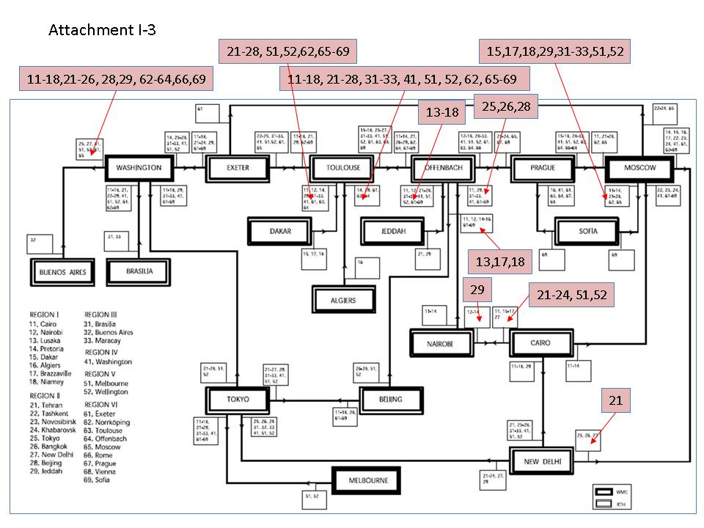

Figure 4. Revised routeing plan for observational data on the MTN (Attachment I-3)

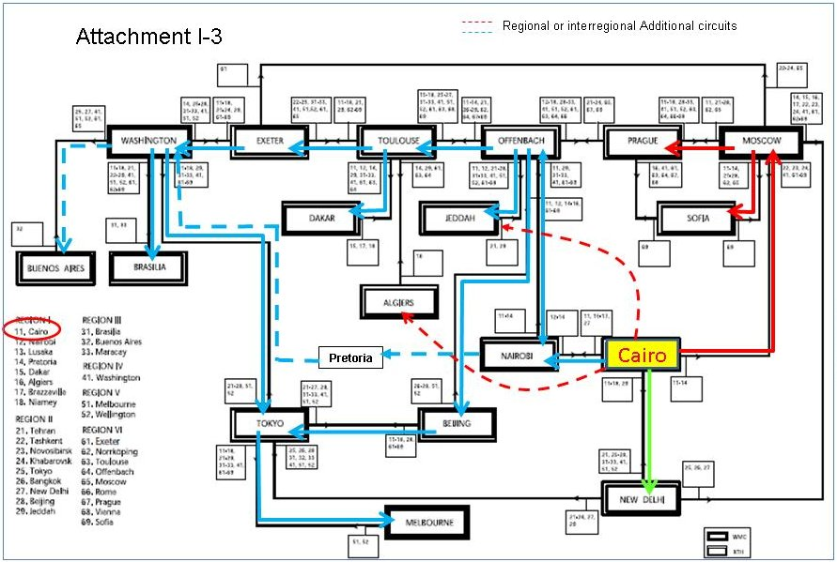

Figure 5. Recommended routeing plan for observational data originated from RTH Cairo

beyond what is described in the GTS Manual. ET-OI can verify the routeing plan and provide updates. The current plan is limited to 18 RTH centres on the MTN and use MTN routes only. It does not reflect the reality of the practical use of other RTH centres not on the MTN and the additional regional and interregional circuits. The chair recommended that for a full coverage of delivery to all destinations, the RTH centres not on the MTN and the additional circuits should also be included in the routeing plan. Figure 5 illustrated the recommended routeing plan for observational data originated from RTH Cairo.

4.1.1.3 A WIS routeing plan was presented by Mr Kenji Tsunoda to the meeting. According to the Manual on WIS, Part I, paragraph 1.3, “Global Information System Centres shall connect to other GISCs through the WIS Core Network, which is based on the Main Telecommunication Network (MTN). Data, products and metadata shall flow to a GISC from the DCPCs and NCs that are within its area of responsibility. ...”. A WIS routeing plan would have to follow a full mesh connection of all 15 GISCs and each GISC transmits its responsible data to all other GISCs 14 times. This was not considered to be possible or in fact necessary at this stage. It was recommended the WIS routeing plan can only be constructed on the existing connections on the WIS Core Network which includes all the RMDCN links and the Improved MTN (IMTN). Each GISC will transmit its responsible data to all other GISCs if possible.

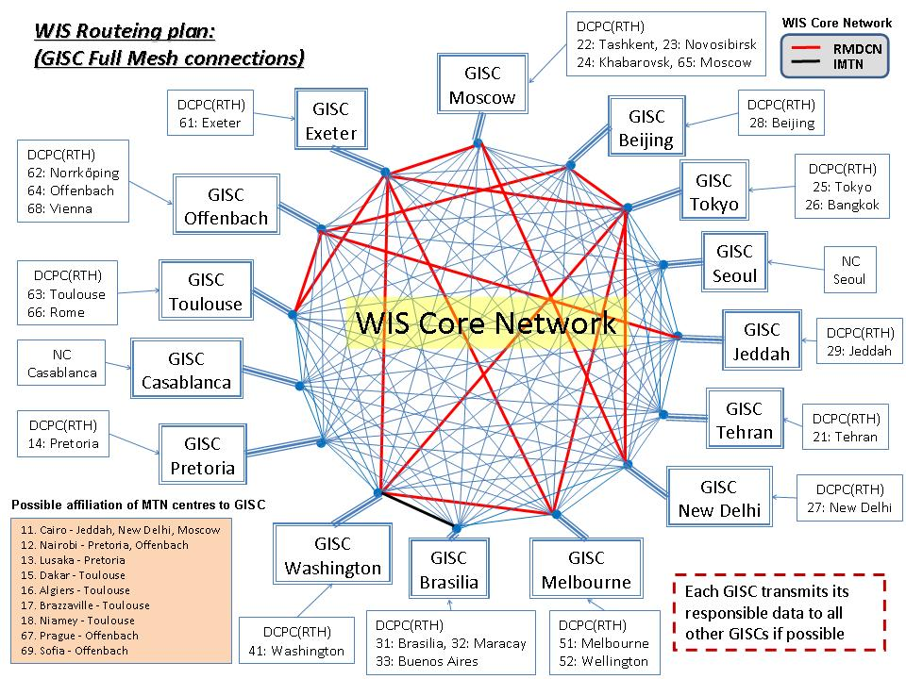

Figure 6. WIS Routeing Plan based on operating connections in the WIS Core Network

4.2 Abbreviated headings and WIS metadata

4.2.1 Incorrect use of abbreviated headings

To be supplied by members after meeting if any irregular use of headings are identified.

4.2.2 Allocation of abbreviated headers

To be supplied by members after meeting if requirements are identified.

4.3 Migration to Table Driven Code Form (TDCF)

4.3.1 Monitoring of the migration to TDCF for RBSN stations

The report was submitted to the IPET-DRC meeting by the Secretariat (Doc. 6.1.1(1), IPET-DRC) and was briefly discussed in the ET-OI meeting. The chair indicated that the discrepancies between the TAC and TDCF with the percentage of reports received for TDCF higher than TAC are highly unlikely. This is possibly due to an incorrect encoding of NIL reports in TDCF reports resulting NIL reports being counted as not NIL. The meeting recommended IPET-DRC to investigate into the matter as it is a very common error in TDCF reports. Furthermore, it is evident that NIL reports may or may not be included in bulletins depending on the practice at individual RTH centres.
4.3.2 Status of the national plans for the migration to TDCF
Reference is made to the documents presented to the IPET-DRC meeting, Exeter, 21-25 May 2012. A summary of the reports is presented in Doc. 4.3(5) prepared by the chair for this meeting.
4.3.3 Outcomes of the fourth meeting of the IPET-DRC related to the migration to TDCF
Reference is made to Doc. 7.1 prepared by the chair for this meeting. The document was also presented to the IPET-DRC meeting to seek the views of IPET-DRC members.
    - Status of the national plan for the migration of TDCF in Russian Federation and zone of responsibility of RTH Moscow
4.3.4.1 Mr Alexander Kats, Roshydromet on behalf of Mr Bezruk presented the activities on TDCF migration in Russian Federation and the zone of responsibility of RTH Moscow. Doc. 4.3(4) prepared by Mr Bezruk and the summary presentation by Mr Kats provided details of the status. In 2010 Roshydromet adopted the Programme "The priority measures for provision of the migration to TDCF", covering: a) development of the technologies of decoding TDCF data; b) development of the technologies of producing, collecting and disseminating data in TDCF and c) development of technologies of TAC ↔ TDCF data conversion. The outcome of the Programme has been successful as the central and regional centres are now able to process incoming BUFR surface, upper-air and CLIMAT reports. So far the usage of BUFR data in normal applications is limited due to the lack of global data coverage in TDCF data both in surface and upper-air reports.

4.3.4.2 Since December 2011 three upper-air stations of Roshydromet started producing upper-air BUFR reports with direct output of native data and metadata for delivery and exchange on the GTS. In 2012 this technology is being scaled to all regional administrations of Roshydromet. Direct output of native BUFR surface reports is under study. Meanwhile, RTH Moscow has implemented the FM-12→FM-94 BUFR conversion technology and real-time operation commenced since April 2012. The converted BUFR bulletins have been in exchange on GTS with bulletins now being delivered to all centres directly connected to RTH Moscow.
4.3.4.3 There has been some progress in the migration to TDCF for NMCs in the area of responsibility of RTH Moscow:
- NMC Belarus implemented the conversion of TAC surface meteorological observations to BUFR for stations from their national network and commenced delivering BUFR data for exchange on GTS. The conversion software is developed by a Russian company.

- NMC Georgia implemented the conversion of TAC surface meteorological observations to BUFR using the French Transmet software.

- NMC Armenia implemented the conversion of CLIMAT to TDCF in CREX.

- NMC Ukraine works on its own encoding/transcoding software.

Roshydromet plans to organize a workshop in 2012 with the support of WMO on the migration to TDCF for Members in its area of responsibility. A survey will be conducted to identify problems encountered when national meteorological services implement TDCF migrating. Roshydromet has prepared a detailed questionnaire which will help Roshydromet and NMHSs to schedule their activities on TDCF migration, to set tasks and requirements and to determine what support services are required. In order to enable capacity building in TDCF migration and to assist Members in the area of responsibility of RTH Moscow, Roshydromet offers the following assistance:
- Implementation of FM-94 BUFR→FM-12 conversion;
- Providing technologies for FM-94 BUFR→FM-12 conversion;
- Encoding and delivery of upper-air data in BUFR and/or CREX.

4.3.4.4 A detailed list of the abbreviated headers for the corresponding TAC and BUFR upper-air and surface bulletins transmitted from Khabarovsk (CCCC=RUHB), Novosibirsk (CCCC=RUNW), and Moscow (CCCC=RUMS) are given in Annex I and Annex II in Doc 4.3(4).
    - Status of migration of TDCF in RA-V
4.3.5.1 The chair provided the following summary of various reports submitted by members of IPET-DRC and ET-OI for their meetings in 2012. Four reports on migration to TDCF were presented in the IPET-DRC meeting in Exeter, 21-25 May 2012 including contributions from Czech Republic, Japan, China and Canada under agenda item 6 – Migration to Table Driven Code Form (TDCF). Russia and Australia also provided their reports under agenda item 4.3.4 and 4.3.5 in the ET-OI meeting. Table 5 listed links to all the documents in both meetings and outlined contents of the documents.
4.3.5.2 The meeting noted that there have been no standard formats and layouts in the presentation of the status of migration of TDCF in various regions. The meeting was requested to consider a suitable format for the purpose of monitoring the progress of MTDCF. A common practice was recommended by the chair in order to systematically monitor the progress of MTDCF in all the regions.
Table 5. Reports on the migration of TDCF presented in IPET-DRC (2012) and ET-OI (2012)

ET | Title | Submitted by
IPET-DRC | Report on Migration to TDCF in RA VI – ADD1  ADD1 provided summary of status of migration for 51 RA VI Member countries for CAT 1 data (SYNOP, TEMP, CLIMAT) | Eva Cervená
IPET-DRC | Status of the migration to TDCF in RA II - Annex  Annex provided a comparison of report counts for each RBSN station for CAT1 data (SYNOP,TEMP, PILOT) based the pre-analysis of the raw data provided by Melbourne and Tokyo for the SMM in 1-15 April 2012 | Jitsuko Hasegawa
IPET-DRC | BUFR messages received in CMA  1. Document provided report counts for a single day in May 2012 for groups of BUFR bulletins whose abbreviated header TTAAii belong to data types of certain groups, e.g. SYNOP, TEMP (A,B), TEMP (A,B,C,D), etc.  2. Various BUFR Table B and Table D descriptors reported for each group are provided.  3. Distinct time period values (0 04 024) for period data reported in SYNOP, e.g. extreme temperature, wind data, evaporation, radiation, etc.  4. Distinct values of vertical sounding significance (0 08 042) for TEMP and PILOT data.  Note: 3 and 4 are intended to isolate errors reported in BUFR as the descriptors isolated in this analysis are very common to have invalid values reported in the BUFR message | Fang Zhao
IPET-DRC | Status of the Migration to TDCF in Canada - Letter for PR  There is no comparison of what BUFR bulletins are being compiled and distributed for the corresponding TAC bulletins in Canada or in RA IV.  Note: In a separate announcement from NWS TOC Data Management on 19 April 2012 RTH Washington has notified other centres that experimental exchange of BUFR reports converted from TAC data types will commence with effect from 24 April 2012. The experimental exchange will continue until April 2014 starting with TAC data type SYNOP and followed by TEMP, .., PILOT, SHIP and TEMP DROP. | Yves Pelletier
ET-OI | Status of Migration to TDCF in Russian Federation and zone of responsibility of RTH Moscow – Annex I, Annex II  Annex I provided a list of TAC TEMP bulletins and the corresponding BUFR bulletins with all the station numbers being distributed from RUHB, RUNW and RUMS.  Annex II provided a list of TAC SYNOP bulletins and the corresponding BUFR bulletins with all the station numbers being distributed from RUHB, RUNW and RUMS. | Leonid BEZRUK
ET-OI | Status of migration of TDCF in RA-V  Provided the status of migration for RA V which included Australia (new BUFR bulletins implemented since 2010), Fiji, New Caledonia, French Polynesia, New Zealand, Philippines, Indonesia and Singapore.  Note: RTH Melbourne also compiled and distributed BUFR bulletins converted from TAC SYNOP, TEMP, PILOT and CLIMAT bulletins on behalf of PNG and Solomon Islands. | Kelvin WONG

5. OPERATIONAL INFORMATION SERVICE (OIS) RELATED TO ISS

5.1 Operational information Services (OIS) related to ISS – Existing components (WWW) and future plans (WIS)

5.1.1 The objective of the WWW Operational Information Service (OIS) is to collect from, and distribute to, WMO Members and WWW centres detailed and up-to-date information on facilities, services and products made available in the day-to-day operation of the WWW. For a smooth transition of WWW OIS to WIS operation ET-OI is tasked to coordinate and develop recommended practices and guidance on the management of, and access to, OIS related to WMO Programmes’ information exchange. Issues identified by ET-OI members and the Secretariat in the current operational procedures for update of OIS are discussed in agenda items 5.2 and 5.3 respectively.

5.2 Update of additional data and products, WMO Volume C1 and WIS DAR metadata
    - The meeting reviewed the update procedures of WMO Volume C1 and the list of Additional Data and Products identified by ET-OI members as causing serious problems in the maintenance of the datasets in OIS resulting in errors and inconsistencies being propagated into the WIS DAR metadata. A summary presentation was prepared by GISC Offenbach and presented by Mr Markus Heene to the meeting.

    - Data and products described in WMO Volume C1 are identified with a status flag indicating the product as ‘Essential (E), ‘Additional’ (A) or ‘Other’ (O) when Advanced Notifications are provided to WMO Secretariat by the RTH centres. However, irrespective of whether the flags are provided by the originating centre or the RTH centre on behalf of the NMC in the lack of instructions from the NMCs in their area of responsibility the flags are being ignored by the Secretariat when the information is updated in Volume C1. This has been an ongoing issue in Volume C1 as declaring Resolution 40 Additional Data is only acknowledged by WMO Secretariat through a formal letter from the PR to the Secretary General. The different requirements in update procedures for Volume C1 and the list of Additional Data have caused an un-acceptable risk of products indicated as ‘Additional’ (A) being handled as ‘Essential’ (E).

    - The WIS DAR metadata maintained at GISC centres has introduced an opportunity to rectify this problem as it combines the products under Volume C1 and the Resolution 40 Additional Data into a single source of metadata information. Furthermore WIS metadata for products owned by a Member can only be created and edited by that Member. The meeting supported any initiatives that will improve the efficiency and effectiveness in the maintenance of operational information service at WIS centres.

    - With the introduction of the WIS metadata catalogue that will contain information about whether the data are ‘Essential’ or ‘Additional’, the meeting considered that GISC centres with the support of the Secretariat will need to oversee the management aspects over the designation of information as ‘Essential’ or ‘Additional’ under Resolution 40. The following two scenarios at GISC centres were considered:

- Operational GISC centres will need to ensure the consistency of WIS metadata and the integrity of existing products which are marked as ‘Additional’ in the WIS metadata. The Additional Data in the startup metadata migrated from Volume C1 and the list of Additional Data at the operational GISC centre should be verified with the RTH/NMC in its area of responsibility or where the DCPC/NC centres have chosen the GISC centre as their Principal GISC. Any discrepancies identified in the migration process should also be verified with the cooperating WIS centres.

- New products created by the DCPC/NC centres at the operational GISC centre or via WIMMS by other data centres where the products are indicated as Additional Data should also trigger a series of operational procedures at the GISC centre to confirm the official status of the statement in the metadata. The GISC centre will also need to ensure appropriate procedures are followed for the management of Additional Data at their centre according to Resolution 40.

(Note by chair: Some discussions between the chair and ET-OI members took place after the meeting)

5.3 Efficiency and effectiveness of maintaining OIS for WIS
    - Dr Steve Foreman presented the document Doc. 5.3 submitted for this agenda item to the meeting via WebEx conferencing. The document describes issues with maintaining the Operational Information Service and suggested areas in which changes might be made. In particular, the meeting was requested to consider implementing procedures to ensure adequate governance of information as Essential or Additional under Resolution 40. This is in line with the discussions raised by GISC Offenbach with the introduction of the WIS metadata catalogue and the solutions recommended by the chair and ET-OI members in paragraph 5.2.4.

    - The meeting was also requested to consider whether it is possible and desirable to replace some aspects of the Operational Newsletter with automated information distribution of information where the changes are implemented using tools that could trigger such automated notifications (such as RSS feeds triggered by changes to metadata records). The meeting did not draw any immediate recommendation but would prefer a questionnaire be delivered to RTH centres to seek the view of majority users at their centres.

    - The update of WMO No. 9, Volume A, Observing Stations, Catalogue of radiosonde and upper-air wind systems in use by Members, Regional Basic Synoptic Network (RBSN) and Regional Basic Climatological Network (RBCN) are not maintained by OPAG-ISS. However, the catalogues are closely related to those items such as Volume C1, Routeing Catalogue, etc. which are maintained by OPAG-ISS. The meeting was requested to ensure the consistency between Volume A and Volume C1, and similarly the catalogues of various station networks with Volume A.

    - The update of Routeing Catalogue of bulletins is the responsibility of RTH centres but the update frequency remains an issue.

6. REVIEW OF THE MONITORING RESULTS OF THE OPERATION OF THE MTN

6.1 New Integrated Quantity Monitoring Application
6.1.1 The meeting reviewed the progress of the Integrated Quantity WWW Monitoring Application (IQWMA). Doc. 6.1 and the summary presentation prepared by Ms LI Xiang and Mr WANG Fudi and submitted for this agenda item were presented to the group. The meeting noted that China Meteorological Administration (CMA) has kindly offered the assistance for the development of the IQWMA since 2010. The functions being developed are based on the monitoring tasks outlined in the document. The tasks cover preparation of the reference datasets, analysis of the monitoring results and provide various reports for the AGM, IWM, SAM and SMM. CMA released the first version of IQWMA in May 2010 followed by a second version in October 2011. IQWMA is currently undergoing the testing phase. Dr Steve Foreman joined the meeting via WebEx conferencing and reported that the remaining IQWMA tasks to be tested are T7.7 and T7.9 (see Table 2 of the document). The chair thanked the efforts of CMA and requested the Secretariat to formally acknowledge the contribution of CMA in CBS.

6.2 Monitoring results of AGM, SMM and IWM
6.2.1 The meeting reviewed the results of the AGM in October 2011 and the associated analyses of the percentage of SYNOP, TEMP and CLIMAT reports available at MTN centres in comparison with the reports required from the RBSN stations and the number of silent stations for SYNOP, TEMP and CLIMAT during the October 2011 AGM grouped by regions. Detailed information on the availability of SYNOP, TEMP and CLIMAT reports from RBSN stations during the July 2010 to April 2011 AGM/IWM/SMM exercises are available on the WMO FTP server as follows:

Availability of reports by countries
ftp://ftp.wmo.int//GTS_monitoring/AGM-IWM-SMM/From_WMO/201007_201104/STAT1YEAR_synop_countries.rtf
Availability of reports by Regions and countries
ftp://ftp.wmo.int//GTS_monitoring/AGM-IWM-SMM/From_WMO/201107_201104/STAT1YEAR_synop_countries_regions.rtf
Availability of reports by Regions, countries and stations
ftp://ftp.wmo.int//GTS_monitoring/AGM-IWM-SMM/From_WMO/201007_201104/STAT1YEAR_synop_stations_countries_regions.rtf
Silent stations by Regions and countries
ftp://ftp.wmo.int//GTS_monitoring/AGM-IWM-SMM/From_WMO/201007_201104/STAT1YEAR_synop_silent_countries_regions.rtf
Silent stations by Regions, countries and stations
ftp://ftp.wmo.int//GTS_monitoring/AGM-IWM-SMM/From_WMO/201007_201104/STAT1YEAR_synop_silent_stations_countries_regions.rtf

Availability of reports by countries
ftp://ftp.wmo.int//GTS_monitoring/AGM-IWM-SMM/From_WMO/201007_201104/STAT1YEAR_temp_countries.rtf
Availability of reports by Regions and countries
ftp://ftp.wmo.int//GTS_monitoring/AGM-IWM-SMM/From_WMO/201007_201104/STAT1YEAR_temp_countries_regions.rtf
Availability of reports by Regions, countries and stations
ftp://ftp.wmo.int//GTS_monitoring/AGM-IWM-SMM/From_WMO/201007_201104/STAT1YEAR_temp_stations_countries_regions.rtf
Silent stations by Regions and countries
ftp://ftp.wmo.int//GTS_monitoring/AGM-IWM-SMM/From_WMO/201007_201104/STAT1YEAR_temp_silent_countries_regions.rtf
Silent stations by Regions, countries and stations
ftp://ftp.wmo.int//GTS_monitoring/AGM-IWM-SMM/From_WMO/201007_201104/STAT1YEAR_temp_silent_stations_countries_regions.rtf

Availability of reports by countries
ftp://ftp.wmo.int//GTS_monitoring/AGM-IWM-SMM/From_WMO/201007_201104/STAT1YEAR_climat_countries.rtf
Availability of reports by Regions and countries
ftp://ftp.wmo.int//GTS_monitoring/AGM-IWM-SMM/From_WMO/201007_201104/STAT1YEAR_climat_countries_regions.rtf
Availability of reports by Regions, countries and stations
ftp://ftp.wmo.int//GTS_monitoring/AGM-IWM-SMM/From_WMO/201007_201104/STAT1YEAR_climat_stations_countries_regions.rtf
Silent stations by Regions and countries
ftp://ftp.wmo.int//GTS_monitoring/AGM-IWM-SMM/From_WMO/201007_201104/STAT1YEAR_climat_silent_countries_regions.rtf
Silent stations by Regions, countries and stations
ftp://ftp.wmo.int//GTS_monitoring/AGM-IWM-SMM/From_WMO/201007_201104/STAT1YEAR_climat_silent_stations_countries_regions.rtf

The chair thanked the Secretariat for the detailed analyses provided for the meeting and urged members of ET-OI and RTH Focal Points to take note of the deficiencies revealed in the findings of the monitoring results. In particular, MTN centres are encouraged to contact the RTH and NMC centres in their area of responsibilities to verify the silent stations identified in their region and rectify the problems. The chair noted that in some cases the silent stations listed in the reports are due to a lack of update of stations in the RBSN/RBCN and discrepancies between components of the operational information, e.g. WMO Volume A and Volume C1, WMO Volume A and RBSN / RBCN station lists.
  - Review of procedures and formats of presentation
6.3.1 The Special Antarctic Monitoring (SAM) conducted in January 2012 collected for the first time results of the data receipts of SYNOP MOBIL reports at some participating MTN/RTH centres. METDATA IWM results were provided to WMO Secretariat by some RTH centres. Some RTH centres reported that the documents and data formats of presentation provided by the Secretariat were out of date and inconsistent with the new data type requested for SYNOP MOBIL. The chair agreed to review the procedures and the formats of presentation before commencement of the next SAM in January 2013.

- OTHER BUSINESS

  - TDCF validation

7.1.1 The chair presented a document on TDCF validation to the meeting outlining the extensive errors he identified in the TDCF messages compiled by third party commercial vendors. The validations also uncovered a lot of the regional and national practices of the TAC code forms of the NMHS are either not fully described in the Manual on Codes Volume II (Regional Codes and National Coding Practices) or non-existent. Results of the testing and validation indicated that while some parts of the BUFR message corresponding to the sections for international exchange in the TAC code form may well be encoded correctly in the BUFR report the parts related to sections for regional and national exchange are mostly not very well presented or in some cases completely against the normal practice of the NMHS.
7.1.2 The formal distribution of the BUFR/CREX message on GTS for international or regional exchange represents the approval of the data by the Member countries of WMO. However, there is currently no requirement for Members to conduct any formal validation on their BUFR/CREX message products if they use approved operational BUFR/CREX code forms and templates published in the Manual on Codes. Furthermore, there are no recommended guidelines for Members as to how the BUFR/CREX messages provided by their suppliers can be presented to any form of validation.
7.1.3 The meeting agreed that TDCF validation whether it is for implementation of a new or modified code form or an existing BUFR/CREX template shall include the following:
- To ensure that the TDCF messages conform to WMO BUFR/CREX code regulations and standards.
- To report if any of the regional reporting practice and national observing practice of the national meteorological service are to be preserved in BUFR
- To document the implementation of new improvements in reporting practice (regional or national) not previously recorded in the Manual on Codes Volume II for the TAC codes.
- To document any deviations in observing and reporting practices of the BUFR reports as against the existing TAC reports.
- Any observing and reporting practices relevant to the TDCF shall be presented to the Regional Associations and CBS for formal publication in a suitably administered repository that facilitated as a source of reference to Members similar to the Manual on Codes Volume II (Regional Codes and National Coding Practices) as for the TAC codes.

7.1.4 Problems were also identified in the BUFR converted TAC messages for which BUFR is the primary source of data and TAC is the generated product of the BUFR report. There are clear guidelines restricting the distribution of BUFR converted TAC messages on GTS. The chair reminded members to take note of this restriction and refrain from sending those BUFR converted TAC messages to other centres unless there are expressed requirement for such messages.

  - Issues from IPET-MDI
    - A summary of issues identified at the IPET-MDI meeting, Exeter, 21-24 May 2012 were presented to ET-OI for discussion seeking views on some proposed changes to the metadata standard:

- Support for multiple releases of metadata standard
- Creating information currently held in Volume C1 to be contained within the metadata record
- Multiple language metadata

7.2.2 Two types of changes to the metadata standard are expected; (i) the first and more frequent will be addition of functionality and enforcing additional practices, e.g. the introduction of metadata standards to operate the GISC caches, similar to the change in BUFR tables; (ii) the second type of change will occur less frequently, expected to be about five to ten years apart, will change the structure of the metadata, similar to the change in BUFR edition.
IPET-MDI is seeking a recommendation for the number of old versions of the metadata standard to be supported at GISCs based on the time and frequency Members are likely or need to update their metadata entries. According to the operational procedures in the Manual on the GTS the Members should notify the responsible RTH of any amendments in Volume C1 in respect of their bulletins and RTH centres should provide the valid catalogue and the advanced notification to the Secretariat in the common formats. The responsible RTH should also update the catalogue periodically, at least twice a year by 1 March and 1 September in accordance with the advanced notification, which has already become effective. ET-OI considered that there is no bearing between the frequency of updates and the number of versions that need to be supported by WIS. The number of versions to be retained should be determined by the acceptable number of versions most GISC centres prepared to support. It will not be practical for GISC centres to hold older versions than other centres can support.
    - An ongoing issue with the Volume C1 records is the lack of consistency in the presentation of texts in the columns of ‘Time Group’, ‘Content’ and ‘Remarks’ by different RTH centres. Furthermore the columns can refer to different terms of use depending on the specific bulletins. This caused some problems when the information was converted to the start-up metadata in late 2011, e.g. the area of coverage and grid spacing for GRIB bulletins are normally given in the ‘Content’ column and if the contents of the GRIB bulletin differs from those derived from the abbreviated heading, such information can be inserted in the ‘Remarks’ column. ET-OI did not recommend any changes to the format of Volume C1 to facilitate the conversion to metadata catalogue as it will be difficult to enforce the presentation of free form texts even with the best guidance. Efforts should be made to correct the metadata catalogue as Volume C1 will be superseded by the DAR metadata eventually. ET-OI supports the efforts to establish procedures to streamline the maintenance of metadata catalogue in the same way as the governance controls that apply to Volume C1.

7.2.3 The group agreed with IPET-MDI that although the metadata standard allows multi-lingual entries, the procedures for maintaining this would be enormous and it is unlikely any data owner would be in a position to provide all the language versions themselves. In summary National Centres may add local language translations to the original records for internal use, but the multi-lingual version of the metadata catalogue should not be published or synchronised with other GISC centres.

(Note by chair: Some discussions between the chair and ET-OI members took place after the meeting)
7.3 Country designators using ISO locations
7.3.1 The meeting was presented with an additional document describing the intention of WMO to use ISO 3166 country code instead of the WMO maintained list of geographical designators A₁A₂ given in Attachment II-5, Table C1. The geographical designators A₁A₂ for use in abbreviated headers T₁T₂A₁A₂ii CCCC YYGGgg covers either the Country or Territory designators in Table C1 Part I or the Area designators in Table C1 Part II. The meeting considered that routeing issues caused by the migration to use ISO 3166 country code are just technical problems which can be resolved by parallel routeing for both ISO 3166 and WMO country/area encoded headers. However, there may be many hidden down-stream applications at some centres configured to be triggered by such bulletins encoded with the WMO country/area headers. Typical examples are inundation map applications or emergency alerts triggered by certain tsunami bulletins in certain ocean areas. Such applications and alert systems can reside in organisations outside the control of NMHSs. While RTH centres may be sending the new bulletins to the user there is a risk for such applications to fail despite all efforts by RTH centres to distribute the old and new bulletins by parallel switching arrangements. The suggestion of a set migration date is also not appropriate. It should be a transition period as not all bulletins are compiled and distributed every day.
8. CLOSURE OF THE MEETING

8.1 The meeting closed on Thursday 31 May 2012 at 16h30.

Annex to paragraph 1.1.1
LIST OF PARTICIPANTS

Mr Kelvin WONG (Chair) | Bureau of Meteorology  G.P.O. Box 1289  MELBOURNE, VIC 3001  Australia  Tel: +61 3 9669 4227  Fax: +61 3 9669 4128  Email: k.wong@bom.gov.au
Mr Leonid BEZRUK (Co-chair) | Aviamettelecom of Roshydromet  2/12 Prokudinsky Lane  123242 MOSCOW  Russian federation  Tel: +7 (499) 795 22 60 ; +7 (499) 255 14 77  Fax: +7 (499) 252 55 04  Email: bezrouk@mecom.ru
Mr Jacques ANQUETIL (Core Member) | Météo-France  42, avenue Gaspard Coriolis  31057 TOULOUSE Cédex  France  Tel: +33 5 6107 8572  Fax: +33 5 6107 8109  Email: jacques.anquetil@meteo.fr
Mr José Luis GIANNI (Core Member) | Servicio Meteorológico Nacional  25 de Mayo 658  1002 BUENOS AIRES  Argentina  Tel: +54 11 5167 6767  Fax: +54 11 5167 6711  Email: gianni@smn.gov.ar
Mr Henry N. KARANJA (Core Member) | Kenya Meteorological Department  P.O. Box 30259  00100 NAIROBI  Kenya  Tel: +254 20 386 7880 ext. 2063  Fax: +254 20 387 6955  Mobile: +254 72 236 4465  Email: hkaranja@meteo.go.ke hkaranja2001@yahoo.com
Mr Kenji TSUNODA (Core Member) | Japan Meteorological Agency  Otemachi, 1-3-4  Chiyoda-ku  TOKYO 100-8122  Japan  Tel: +81 3 3218 3825  Fax: +81 3 3211 8404  Email: tsunoda@met.kishou.go.jp
Mr Chris LITTLE (Core Member) – Attended part sessions via WebEx | Met Office  FitzRoy Road  EXETER  United Kingdom of Great Britain and  Northern Ireland  Tel: +(44 1392) 88 62 78  Fax: +(44 1392) 88 56 81  chris.little@metoffice.gov.uk
Mr Fudi WANG (GISC Beijing) | China Meteorological Administration  46 Zhongguancun Nandajie  Haidian District  BEIJING 100081  China  Tel: +(86 10) 6840 6275  Fax: +(86 10) 6217 3225  Email: wangfd@cma.gov.cn
Mr Markus HEENE (GISC Offenbach) | Deutscher Wetterdienst  Frankfurter Strasse 135  D-63067 OFFENBACH AM MAIN  Germany  Tel: +49 69 8062 2648  Email: Markus.Heene@dwd.de
Mr Abbas NIAZALIZADEH MOGHADAM (GISC Tehran) | IRIMO  Iran Meteorological Organization  IRIMO, Meraj St  TEHRAN  Iran  Tel: +98 21 660 70 131  Fax: +98 21 660 70 013  Email: abas.n.alizadeh@gmail.com
Ms Elena Averyanova (GISC Moscow) | Aviamettelecom of Roshydromet  2/12 Prokudinsky Lane  123243 MOSCOW  Russian Federation  Tel: +7 (499) 795 2013  Fax: +7 (499) 252 5504  Email: Averyanova.Elena@mecom.ru
Mr Vladimir Tsukanov (GISC Moscow) | Aviamettelecom of Roshydromet  2/12 Prokudinsky Lane  123243 MOSCOW  Russian Federation  Tel: +7 (499) 795 2460  Fax: +7 (499) 252 5504  Email: cuk@itc.mecom.ru
Mr Pavel Tsukanov (GISC Moscow) | Aviamettelecom of Roshydromet  2/12 Prokudinsky Lane  123243 MOSCOW  Russian Federation  Tel: +7 (499) 795 2460  Fax: +7 (499) 252 5504  Email: tzu@itc.mecom.ru
Mr Alexander Kats (GISC Moscow) | Central Aerological Observatory of Roshydromet  Dolgoprudny,  Moscow region  Pervomayskaya St., 3  Tel: +7 (495) 408 6148  Fax: +7 (495) 576 3327(495) 408-61-48  Email: alexander.kats@cao-rhms.ru
Mr David THOMAS (Secretariat) | Chief, Information and Telecommunication System Division  Observing and Information Systems Department  World Meteorological Organization  7 bis Avenue de la Paix  Case Postale 2300  CH 1212 2 GENEVA  Switzerland  Tel: +41 22 730 8241  Fax: +41 22 730 8021  Email: dthomas@wmo.int
Dr Steve FOREMAN (Secretariat) – Attended part sessions via WebEx | Chief, Data Representation, Metadata and Monitoring  World Meteorological Organization  7 bis, avenue de la Paix  Case postale No. 2300  CH-1211 2 GENEVA  Switzerland  Tel: +41 22 730 8171  Fax: +41 22 730 8021  Email: sforeman@wmo.int

Annex to paragraph 1.2.1
Agenda Item | Title | Document No.  Presentation | Submitted by
1. | ORGANIZATION OF THE MEETING
1.1 | Opening of the meeting
1.2 | Adoption of the agenda | Doc.1.2 | Secretariat
1.3 | Working arrangement
2. | WIS IMPLEMENTATION AND SYSTEM MONITORING OF WIS CORE NETWORK
2.1 | Current status of implementation of WIS
2.1.1 | Status of implementation for GISC/DCPC Beijing | Doc.2.1(1)  Annex I | Xiang LI
2.1.2 | Status of implementation for GISC/DCPC Brasilia | Doc.2.1(2) | Jose Mauro REZENDE
2.1.3 | Status of implementation for DCPC Buenos Aires | Doc.2.1(3) | Jose Luis GIANNI
2.1.4 | Status of implementation for GISC/DCPC Exeter | Doc.2.1(4) | Chris LITTLE
2.1.5 | Status of implementation for GISC/DCPC Melbourne | Doc.2.1(5) | Kelvin WONG
2.1.6 | Status of implementation for GISC/DCPC Moscow | Doc.2.1(6)  Annex I, II | Leonid BEZRUK
2.1.7 | Status of implementation for DCPC Nairobi | Doc.2.1(7) | Henry KARANJA
2.1.8 | Status of implementation for GISC/DCPC Offenbach | Doc.2.1(8) | Bernd RICHTER
2.1.9 | Status of implementation for GISC/DCPC Tokyo | Doc.2.1(9) | Kenji TSUNODA
2.1.10 | Status of implementation for GISC/DCPC Toulouse | Doc.2.1(10) | Jacques ANQUETIL
2.1.11 | Status of implementation for GISC/DCPC Washington | Doc.2.1(11) | Walter SMITH
2.1.12 | Status of implementation for GISC/DCPC Iran | Doc.2.1(12)  Annex I, II | Abbas NIAZALIZADEH MOGHACAM
2.1.13 | Status report of other centres (GISC/DCPC/NC) - Casablanca, Jeddah, New Delhi, Pretoria, Seoul, Prague, Rome, Ankara, ASECNA | Doc.2.1(13) | Associate Members  RTH Focal Points
2.2.1 | System monitoring of WIS core network  (Capacities, Performance and Quality of Service) | Doc.2.2(1) | Kenji TSUNODA
2.3.1 | DAR metadata and data synchronisation at operational GISC centres | Doc.2.3(1) | Kenji TSUNODA
2.3.2 | DAR metadata and data synchronisation through OpenWIS | Doc.2.3(2) | Jacques ANQUETIL
2.4 | Management and operational aspects of DCPC and NC in areas of GISC | Doc.2.4(1) | Kenji TSUNODA
3. | WIS DATA MONITORING
3.1.1 | Quantity and Quality Monitoring of WIS operation, Past, Present and Future | Doc.3.1(1) | Kelvin WONG
3.1.2 | WIS Monitoring | Doc.3.1(2) | Chris LITTLE
3.2 | WIS Monitoring for all WMO Programmes | Doc.3.2  Summary | Secretariat
3.3 | Maintenance of Subscription Metadata Catalogue (Routeing Catalogue) and Discovery Metadata Catalogue (Volume A and C1) for WIS Monitoring of data and products for WMO Programmes | Doc.3.3 | Kelvin WONG
3.4.1 | Status of cache download at GISC Tokyo | Doc 3.4(1) | Yoritsugi OHNO
4. | PROCEDURES FOR THE COLLECTION, ROUTEING AND DISTRIBUTION OF DATA AND PRODUCTS
4.1 | Observational data / WIS data and products
4.1.1 | Plan for routeing observational data on the MTN  (Attachment I-3, Manual on the GTS) | Doc.4.1(1)  Table A I-3 | Kenji TSUNODA  Kelvin WONG
4.1.2 | WIS routeing plan – Core Network Subscription catalogue and AMDCN Subscription catalogue | Doc.4.1(2) | Kenji TSUNODA  Kelvin WONG
4.2 | Abbreviated Headings (GTS) and WIS Metadata
4.2.1 | Incorrect use of abbreviated headings and allocation of new abbreviated headers | Doc.4.2(1) | Kelvin WONG
4.2.2 | Maintaining abbreviated headings and WIS metadata in parallel | Doc.4.2(2) | Kelvin WONG

4.3 | Migration to Table Driven Code Form (TDCF)
4.3.1 | Monitoring of the Migration to TDCF for RBSN stations (WWW) and its equivalents for other WMO Programmes (WIS) | Doc.4.3(1) | Secretariat
4.3.2 | Status of the national plans for the migration to TDCF | Doc.4.3(2) | Secretariat  IPET-DRC chair
4.3.3 | Outcomes of the fourth meeting of the IPET-DRC related to the Migration to TDCF | Doc.4.3(3) | Secretariat  IPET-DRC chair
4.3.4 | Status of the national plan for the migration of TDCF in Russian Federation and zone of responsibility of RTH Moscow | Doc.4.3(4)  Annex I, II  Summary | Leonid BEZRUK  Alexander KATS
4.3.5 | Status of migration of TDCF in RA-V | Doc.4.3(5) | Kelvin WONG
5. | OPERATIONAL INFORMATION SERVICE (OIS) RELATED TO ISS
5.1 | Operational information services (OIS) related to ISS – existing components (WWW) and future plans (WIS) | Doc.5.1 | Secretariat
5.2 | Update of Additional Data and Products | Doc.5.2 | Bernd RICHTER
5.3 | Efficiency and effectiveness of maintaining OIS for WIS | Doc.5.3 | Secretariat
6. | REVIEW OF THE MONITORING RESULTS OF THE OPERATION OF THE MTN
6.1 | New Integrated Quantity monitoring application | Doc.6.1  Summary | Secretariat  Xiang LI, Fudi WANG
6.2 | Monitoring results of AGM, SMM and IWM | Doc.6.2 | Secretariat
6.3 | Review of procedures and formats of presentation | Doc.6.3 | Kelvin WONG
7. | OTHER BUSINESS
7.1 | Collaboration with IPET-DRC, TDCF Validation | Doc.7.1 | Kelvin WONG
7.2 | Collaboration with IPET-MDI, Issues from IPET-MDI | Doc.7.2 | IPET-MDI chair
7.3 | Country designators using ISO locations (link to ET-CTS Doc) |  | Timo Pröscholdt
8. | CLOSURE OF THE MEETING

http://www.wmo.int/pages/prog/www/WIS/wiswiki/tiki-index.php?page=et-oi-meeting-2012

