GISC Beijing - Tokyo Backup service

Background
GISC Beijing and GISC Tokyo have discussed GISC backup service in accordance with the Manual on the WMO Information System (WMO-No.1060). CBS-ext. (2014) adopted updates of the Guide to the WMO Information System (WMO-No. 1061) including a new part VI related to GISC backup procedures. This document reports a backup concept and current status of GISC Beijing and Tokyo.

Backup procedures between GISC Beijing and Tokyo

Backup by GTS
Some DCPCs have GTS connections to GISC Beijing and GISC Tokyo (i.e. DCPC Hong Kong, DCPC Bangkok). If a backup GISC sends the same data set as a principal GISC to DCPCs in advance, DCPCs keep receiving data from a backup GISC as usual without specific handling when a principal GISC is in failure. NCs connected to DCPCs also get data through DCPCs without interruption. It means duplicate transmission from both GISCs which will be implemented without additional cost but need arrangements for scope of backup data. Data collection from DCPCs and NCs is also implemented without special management by providing the same data set to a principal GISC and a backup GISC.
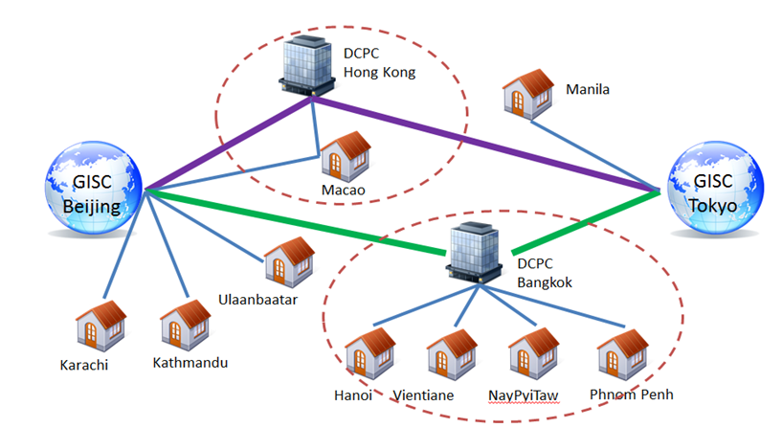
Figure 1: GTS connections

Backup data and products
Backup data and products should be determined considering data volume because GTS connections between DCPCs and GISCs have different bandwidth.
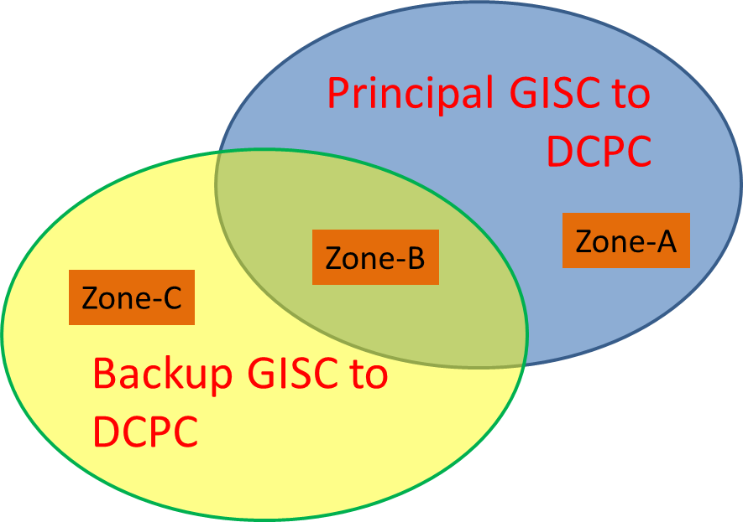
Figure 2: Classification of data/products
Figure 2 shows classification of data dissemination from GISCs to a DCPC:
・Zone-A: Need to backup
・Zone-B: Already done
・Zone-C: Out of scope
Data intended for global exchange in Zone-A should be backed up. It is decided to compare data lists (i.e. routing catalog) of GISCs. In the case of DCPC Bangkok the result of comparing routing catalogs from GISCs is as follows:
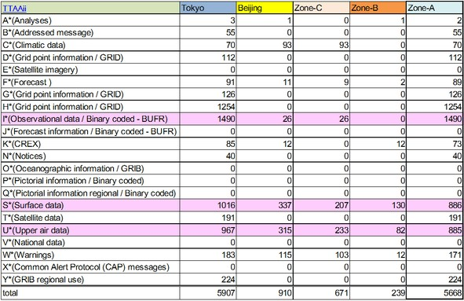
Table 1: Data dissemination to DCPC Bangkok
Considering a circuits bandwidth both GISCs will add I*(Observational data in BUFR), S*(Surface data), U*(Upper air data) to their MSS routing configuration firstly. Backup data will increase step by step according to the circuit condition. The same process applies to DCPC Hong Kong. The lists of backup data and products should be maintained and exchanged by GISCs and DCPCs at fixed periods.

Backup by Internet
NCs without a GTS connection to a backup GISC get data and products from DAR service when a principal GISC is in failure. Regarding a data collection of a backup GISC from NCs will be discussed.

Current status
GISC Beijing and Tokyo exchanged their routing catalogs and analyzed all data in the lists. Observational data in BUFR, Surface data and Upper air data in Zone-A will be disseminated to DCPC Bangkok and DCPC Hong Kong from their backup GISC during this year.

In Area of Responsibility of GISC Beijing:
Hong Kong, Macao, Mongolia (Ulaanbaatar), Pakistan (Karachi), Nepal (Kathmandu)

In Area of Responsibility of GISC Tokyo:
Thailand (Bangkok), Viet Nam (Hanoi), Laos (Vientiane), Myanmar (Nay Pyi Taw), Cambodia (Phnom Penh), Philippines (Manila)
DCPCs which plan of backup procedure is now in progress are in boldface. NCs covered by DCPCs are in italics.

Operational activities
・GISC Beijing and Tokyo exchange their routing catalogues at fixed periods (i.e. 3 or 4 months to be determined).
・Check the gap in the routing catalogues and modify the configuration of their MSS.
・Check the routing tables of DCPCs and keep the same data set provided to both GISCs.
・Hold the face-to-face meeting in Beijing or Tokyo annually .
Face-to-face meetings have been held every year since 2007.

Recommended Text
Ms. Zhu Ting and Mr. Kentaro Tsuboi reported the concept and status of GISC backup between GISC Beijing and GISC Tokyo. Ms. Zhu and Mr. Tsuboi also introduced an effective way of the backup procedure using GTS which needs arrangements for backup data but will be implemented without specific handling and additional cost.
--------------------

