GISCs Offenbach-Tokyo Backup Service

Introduction
DWD and JMA have been working on a mutual GISC backup using the Internet based on their prior feasibility study of each AMDCN. Signed letters on mutual backup services for GISCs were officially exchanged in January 2014. This document shows the study, current status, the reason why using the Internet and further efforts in order to enhance their backup completeness.

Feasibility Study
DWD and JMA agreed on the scope of essential services in their backup and investigated current situation and requirement of backup between DWD and JMA. DWD and JMA compiled our discussion in a document, “Feasibility Study on Backup Services for GISCs between JMA and DWD”. The study investigates the feasibility of interregional their GISC backup services in accordance to the Manual on WMO Information System (WIS) (Manual on WIS, WMO-No. 1060).
There are two phases for the implementation of the backup services; one is “Data Collection” phase where all centres of one GISCs AMDCN disseminate their data and products to the backup GISC, the other is “Data Dissemination of data/products intended for global exchange” which targets the dissemination of data and products in case of an outage of one GISC through the backup GISC. With the realization of both phase all necessary steps of a mutual backup service between DWD and JMA according to the Manual on WIS are fulfilled.

Data Collection
For the realization of the “Data Collection” phase, two different scenarios were analyzed; the first one is that a centre is directly connected to the principle GISC, and the second one is that a centre is indirectly connected to the principal GISC.

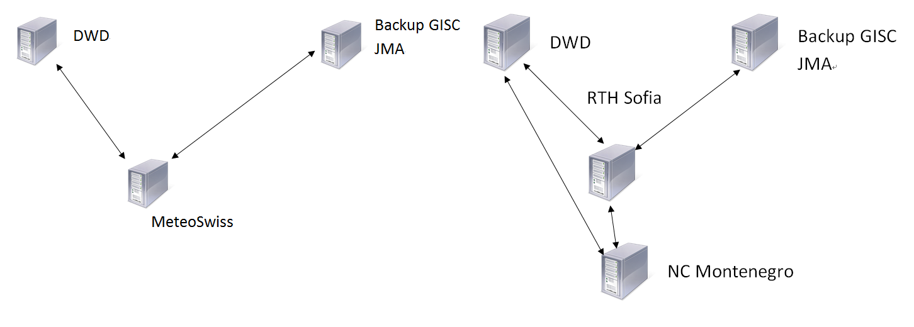
Figure 1 : Scenario 1
Direct connected Centre

Figure 2 : Scenario 2
Indirect connected Centre

Based on the analysis of both scenarios the following requirements for establishing a circuit is deducted:
• If a centre is directly connected to a GISC the backup GISC needs to establish a circuit.
• If a centre is indirectly connected to a GISC it is sufficient that the backup GISC establish a circuit to the corresponding RTH.
• The case where a GISC and a RTH (GISC ≠ RTH) are simultaneous offline is not considered cause of the negligible probability.
Taken this into consideration, DWD and JMA analyzed their AMDCN and identified the following necessary circuits in order that all centres in the area of responsibility are covered.
• DWD: Philippines, Thailand
• JMA: Austria, Bulgaria, Czech Republic, Israel, Italy, Jordan, Sweden, Switzerland, Kenya
Both sides implement the “Data Collection” via Internet because of some advantages. (see the paragraph “Advantages of using Internet”) DWD uses FTP server while JMA uses HTTPS server due to its security policy. Centres are informed of the way of file uploading, server address, user account by both sides.

Data Dissemination
Both sides use the already implemented subscription services (i.e. DAR). Thus DWD will provide 6 accounts for centres in AoR of GISC Tokyo while JMA will provide 26 accounts for centres in AoR of GISC Offenbach for their DAR service.

Current status
DWD and JMA have been increasing centres covered by backup step by step.

Data Collection
As of October 2015, the following centres are covered. The boldface is a centre uploading to backup GISC.
In AoR of GISC Offenbach:
Austria, Croatia, Czech Republic, Denmark and Faroe Islands, Finland, Greece, Hungary, Israel, Italy, Latvia, Lithuania, Norway, Poland, Slovenia, Sweden, Switzerland, Turkey
In AoR of GISC Tokyo:
Cambodia, Lao People’s Democratic Republic, Myanmar, Thailand, Viet Nam

Data Dissemination
In AoR of GISC Offenbach:
Test of download from GISC Tokyo is planned in Q4 2015. The manual of the test was prepared.
In AoR of GISC Tokyo:
Thailand has an account for downloading from Offenbach, and has a plan of download test.

Advantages of using the Internet
DWD and JMA noted that a circuit for backup purpose via the Internet provides the following advantages:
• Not all centres of the AMDCN have got a RMDCN connection while an Internet connection is available
• Not all centres may have sufficient RMDCN bandwidth disseminating data and products in parallel
• If a partially outage of RMDCN is the reason for the outage of a GISC, a backup through the Internet avoid a single point of failure
• Internet connection requires less configuration effort compared to the RMDCN connection

Operation and Further efforts
In order to enhance backup completeness, the followings are being worked on currently or planned to work on:
• Monitor backed-up data (Pic 1, 2), and take action after 24h silence
• Invite centres in both AoR to download test in order to enhance the completeness of the “Data Dissemination” phase
• Analyze routing catalogues to ensure that each NC receives all bulletins in the backup case
• Compare the lists of data which a centre disseminates to principal GISC and backup GISC in order to enhance the completeness of backed-up data
• Compare the size of each backup data for making sure the integrity
• Share and discuss any other operational issues in monthly telephone conference
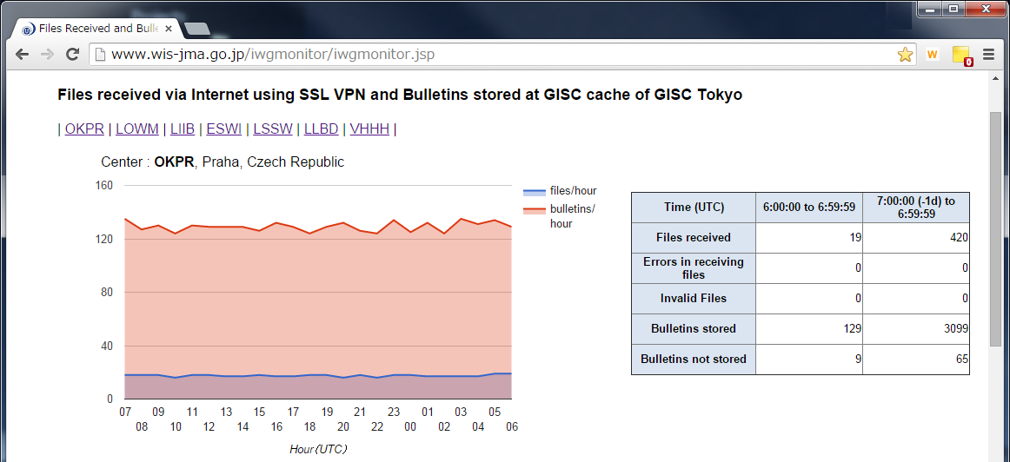
Pic 1: GISC Tokyo backup data collection monitor http://www.wis-jma.go.jp/iwgmonitor/iwgmonitor.jsp

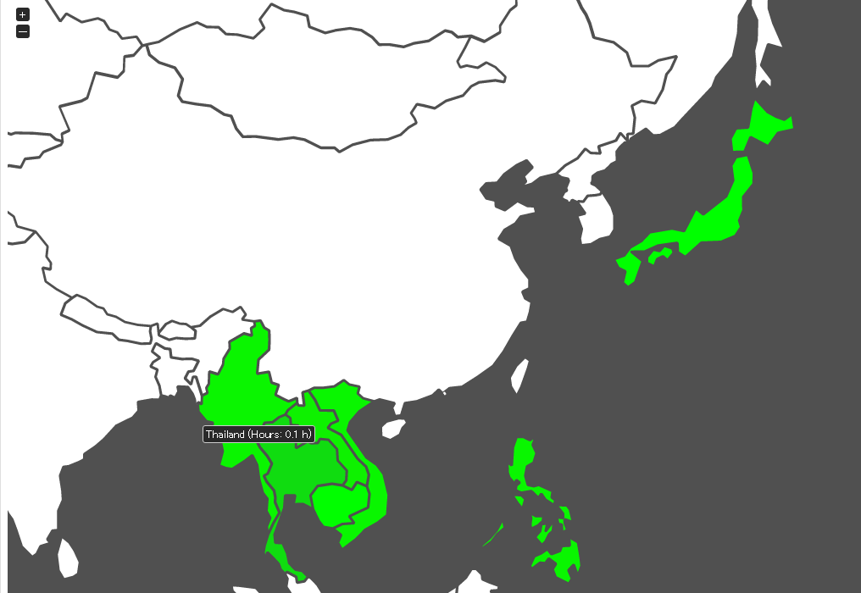
Pic 2: GISC Offenbach data collection monitor
https://gisc-test.dwd.de/monitor/gisc_tokyo_map.html

Actual backup case
When GISC Offenbach was in outage for about an hour in August 2015, GISC Tokyo received backup data from centres in AoR of GISC Offenbach via Internet continuously with neither interruption nor actions at the centres because of warm backup. In the result, the backed-up data were available on GISC Tokyo web server.
On the other hand, when an RTH in AoR of GISC Tokyo was in outage in March 2015, GISC Offenbach and GISC Beijing routed to GISC Tokyo GTS bulletins received from the RTH via Internet. In the result, GISC Tokyo was able to route the backed-up data as usual. This was an unexpected successful case.

References
Feasibility Study on Backup Services for GISCs between JMA and DWD

Recommended Text for Report
Mr Bernd Richter and Mr Yasutaka Hokase reported current status of mutual backup between GISC Offenbach and GISC Tokyo based on a concept of maximizing the use of current resources such as GTS, DAR and minimizing cost for GISC backup. Mr Richter and Mr Hokase also introduced advantages of using the Internet for backup and further efforts in order to enhance backup completeness.

--------------------

