# Data Policies

## Abstract

The following paper highlights two different possibilities to encode the “WMO data policy for globally exchanged data” (“WMOEssential”, “WMOAdditional” and “WMOOther”) following WMO Core Profile 1.3 in metadata and it analyses the impact on the users and GISCs.

### WMO data policy for globally exchanged data – WMO Core Profile 1.3

Part 2 of the WMO Core Metadata Profile version 1.3 [1] describes on page 61 2 possibilities to encode the WMO data policy.

Test method:

Inspect the instance document under test to assess whether one and only one instance of a term from the WMO_DataLicenseCode code list is specified using the following XPath: /gmd:MD_Metadata/gmd:identificationInfo//gmd:resourceConstraints/ ➘gmd:MD_LegalConstaints/gmd:otherConstraints// A normative version of the WMO_DataLicenseCode code list is published by WMO at: <http://wis.wmo.int/2012/codelists/WMOCodeLists.xml>.

A gmx:Anchor element may be used to specify the location of the code list, e.g. /gmd:MD_Metadata/gmd:identificationInfo//gmd:resourceConstraints/ ➘gmd:MD_LegalConstaints/gmd:otherConstraints/gmx:Anchor/@xlink:href = <http://wis.wmo.int/2012/codelists/WMOCodeLists.xml#WMO_DataLicenseCode>

The WMO Baseline Metadata published 2012 and most of the metadata for globally exchange data follow example number 1.

Example – WMO Core Metadata Profile version 1.3 Part 1 page 53

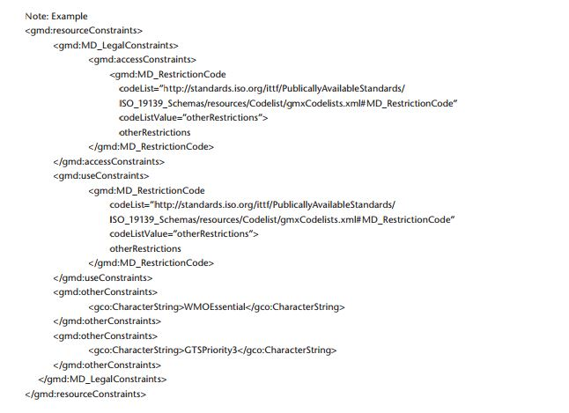

DCPC RTH Rome published recently metadata following example 2 which in my opinion is completely in line with the WMO Core Profile 1.3

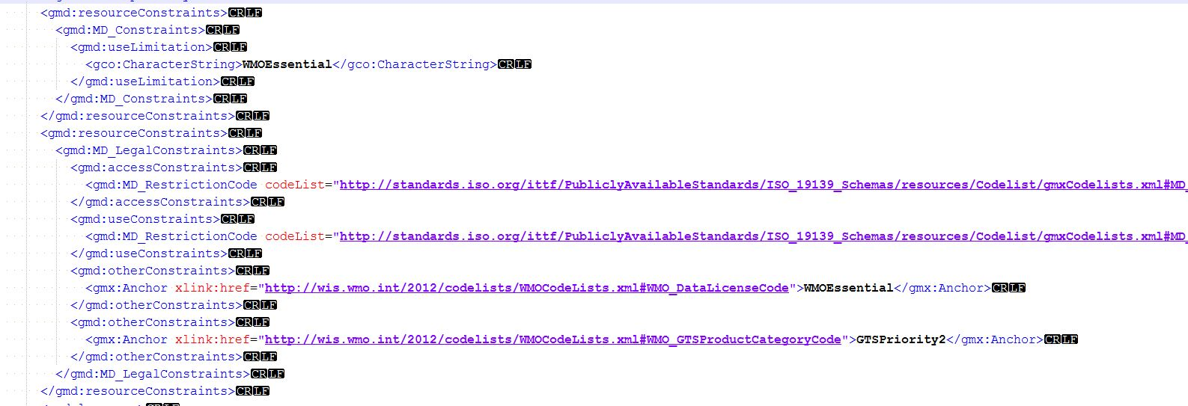

This record uses a <gmx:Anchor> element and a CodeList.

In a next step I searched all operational GISCs for the bulletin SMIY02 LIIB which metadata uses the encoding style of example 2.

I was able to download the bulletin from 2 portals while in all other case I wasn’t successfully for various reasons (network connection problem, search function at the time of the test not available, no metadata, and no account).



### Notes

Since WMO Core Profile 1.3 is endorsed I would like to suggest that each GISC checks its implementation if it can handle metadata following encoding style 2. Furthermore I would like to suggest that the meeting encourages IPET-MDRD to consider this example in the next version of the WMO Core Profile and to allow only one encoding style for crucial information to minimize the implementation work for the GISCs.

## References

[1] WMO Core Metadata Profile Version 1.3 Part 2 <http://wis.wmo.int/2013/metadata/version_1-3-0/WMO_Core_Metadata_Profile_v1.3_Part_2.pdf>

[2] WMO Core Metadata Profile Version 1.3 Part 1 <http://wis.wmo.int/2012/metadata/WMO_Core_Metadata_Profile_v1.3_Part_1.pdf>

## Recommended text for report

The meeting noted the presented report from Germany.

[Depending on the further decision of the meeting:

The meeting urges the GISCs to check if their implementation can cope with both possible encodings of the WMO data policy. Furthermore TT-GISC asks IPET-MDRD to consider this example and to avoid in the next version of WMO Core Profile multiple encoding styles for crucial information to minimize the implementation work for the GISCs.

]

--------------------