24h cache completeness

Abstract
The following paper describes an algorithm which GISC Offenbach uses to achieve 24h cache completeness.

24h Cache completeness
Since 2012 GISC Offenbach uses a small database application to identify missing data and products in its 24h cache. The algorithm was already presented at ET-WISC 2012 in Melbourne [1].
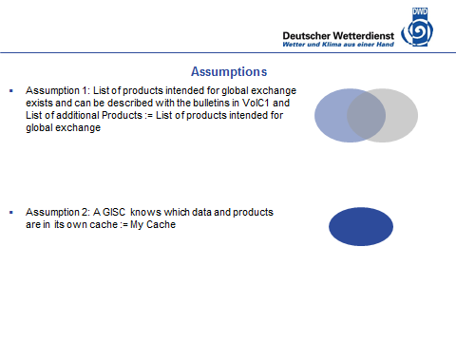
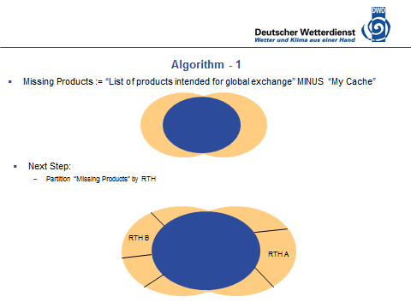

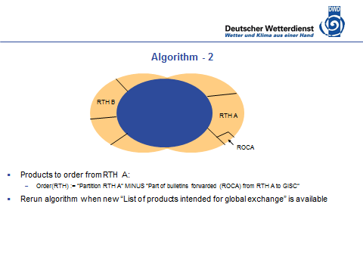
For practical reasons we exclude requests for CLIMAT TEMP and GRIB files.

Results
Since 2012 we identified approximately 3000 missing data and products. Almost 1000 data and products we received after sending a request while approximately 500 were deleted in the available publications. For approximately 1500 the requested status is still open.
We noticed a positive impact on our data assimilation because of more available station observations and for the quality of other global products.

Notes
In the process of fulfilling the 24h Cache requirement we contacted all GISCs. I like to note that in most cases we successfully established a circuit with the partnering GISC while in one case our request for a circuit is unanswered for more than 2 years.
Furthermore I would welcome an initiative which describes a process for interacting with the 2014 installed Inter-Program team for recommending which data and products belongs to the 24h cache.
Currently we are extending our algorithm to non-bulletin data and products. I would like to encourage IPET-MDRD to consider the case of non-bulletin data and products and the associated file pattern in the next version of the WMO core profile. For example some metadata authors are already following the recommendation of the IPET-MDI 2010 report (which were skipped in the WMO core profile 1.2) and are encoding the associated file pattern in the <gmd:describes> element.

References
[1] GISC Offenbach Report PPT 7.5b (Cache) http://www.wmo.int/pages/prog/www/WIS/wiswiki/tiki-download_wiki_attachment.php?attId=979

Recommended text for report
The meeting noted the presented report from Germany and recognizes the need for an agreed standard for associating non-bulletin data and products with a file pattern. The meeting will forward the request to IPET-MDRD.
[Depending on further decision of the meeting regarding the topic intended for global exchange I suggest that someone will liaise with OPAG-ISS chair to establish a procedure to interact the Inter-Program team for recommending which data and products belong to the 24h cache.]

--------------------

