Report of WIS Monitoring Demonstration

Introduction
WIS Monitoring work package 1 (WP1), which was organized by the WIS Monitoring project team in order to prepare and conduct the Demonstration to Congress 17, had worked on developing the monitoring dashboard prototypes. Participants of WP1 were the four GISCs, Brazil, China, Germany and Japan, supported by contributing centres and the project managers and members.
This document is the report of the Demo at Congress 17. I, WP1 lead, really appreciate everything all contributors have done for this demonstration.

Demonstration details
Date: 1-3 June 2015
Time: 8:30-17:30 | Europe Time (Geneva, GMT+02:00)
Venue: CICG (Centre International de Conférences Genève)
The demonstration booth was outside of main conference room for 17th Congress, and it was shared by WIGOS display on OSCAR, which included a large poster on Country Profile Database.

Staff
Name/Organization | Role or Representing
Rabia Merrouchi (NMSM) | GISC Casablanca
Yasutaka Hokase (JMA) | GISC Tokyo & WP1 Lead
David Thomas (WMO) | Secretariat
Steve Foreman (WMO) | Secretariat

Visitors
As Meteohydex – the Exhibition of Meteorological and Hydrological Instruments and Equipment – took place at the same time and place, visitors who came to our booth were not only Congress participants, including Director-Generals, but also Meteohydex participants.
Some of the visitors were familiar with WIS, but the majority of them were not. Hence, we explained what the WIS is, mainly by showing GISC portal web site.
Visitors were looking to find out more about WIS, and were a little confused about WIGOS and WIS. WMO Secretariats were also very interested in the demonstration, including finding out about WIS.

What we did
WMO Secretariat prepared for the demonstration by printing posters and pamphlets, making a video, setting up PCs as well as by introducing the demo to Congress participants during the presentation of the WIS document at Congress.
Usually, we talked to people who were looking at the posters and handed them the pamphlets and sometimes showed dashboards on a PC to explain the information provided by the monitoring.
Approximately 200 WIS Monitoring Pamphlets were handed to visitors.
The INMET dashboard (Pic 1) was very helpful as a visual tool to explain connections for data exchange through WIS. CMA/JMA dashboards (Pic 2, Pic 3, Pic 4) were used to show that WIS is operational, and to show time-series graphs that were helpful to explain what is going on in data exchange and management. The Calendar page of CMA dashboard was also used in showing maintenance schedule of WIS centres.

Comments from visitors
We got some comments from visitors as below;
- “It would be better to use information from WMO Country Profile Database (CPDB) in the dashboards.”
It is not clear what information from CPDB would be useful, because the person did not provide more detail. Some static information could be used for dashboard (e.g. WIS focal point, GTS links), if the CPDB is frequently maintained and it always shows latest information. This could be one of the options in future work.
- “We don’t know which value is right or wrong. It would be necessary to show if the value on dashboards is good or bad.”
Time-series graph can imply something happened if the graph drastically increase or decrease. However, users have no means of knowing if the value is within the expected range or is showing an abnormal situation. Some of the monitoring items may need to be displayed against reference criteria, which require more information to be provided by the centres. This would be further challenges which should be implemented after decision about what to monitor, though it is difficult.
Also, we were able to talk to delegations of India and Iran about this pilot project so that GISC New Delhi and GISC Tehran will soon work on providing JSON files.
The big issue was the question about going deeper in the dashboards, not just country but being able to look at Centres’ up time, telecommunications, metadata and data volumes etc.

Dashboards screenshots
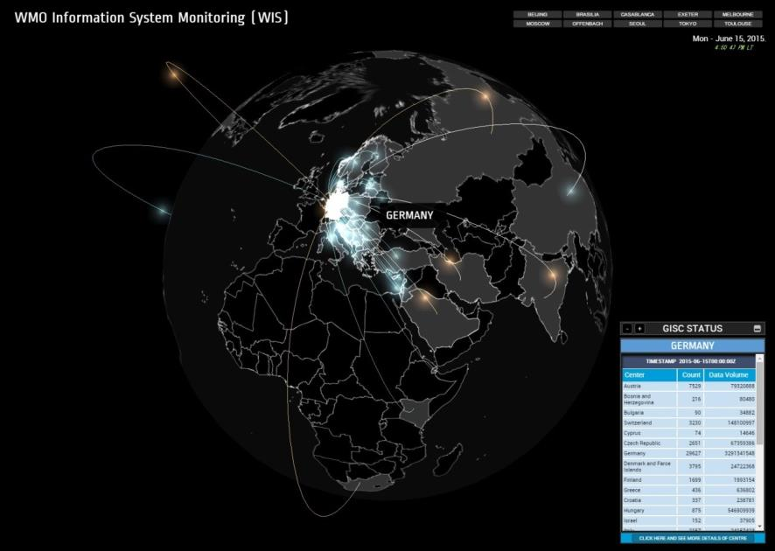
Pic 1. Screenshot of GISC Brasilia dashboard
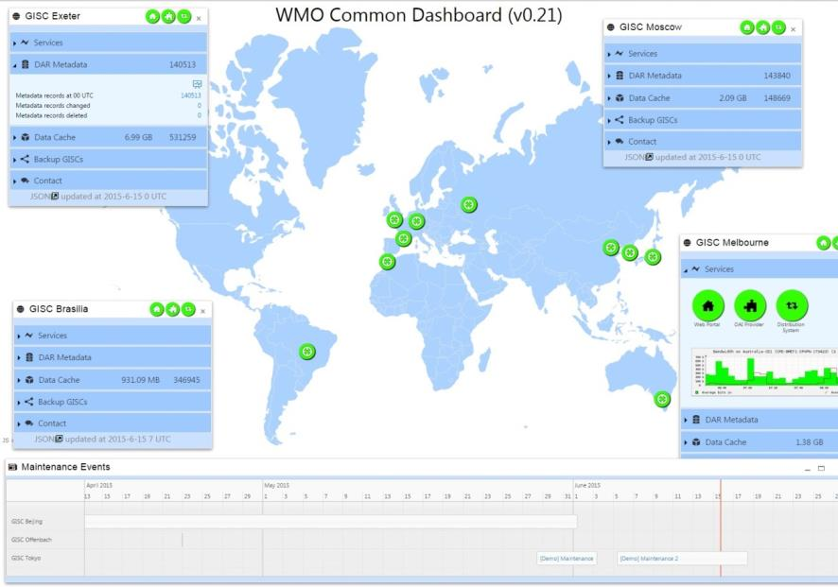
Pic 2. Screenshot of GISC Beijing dashboard
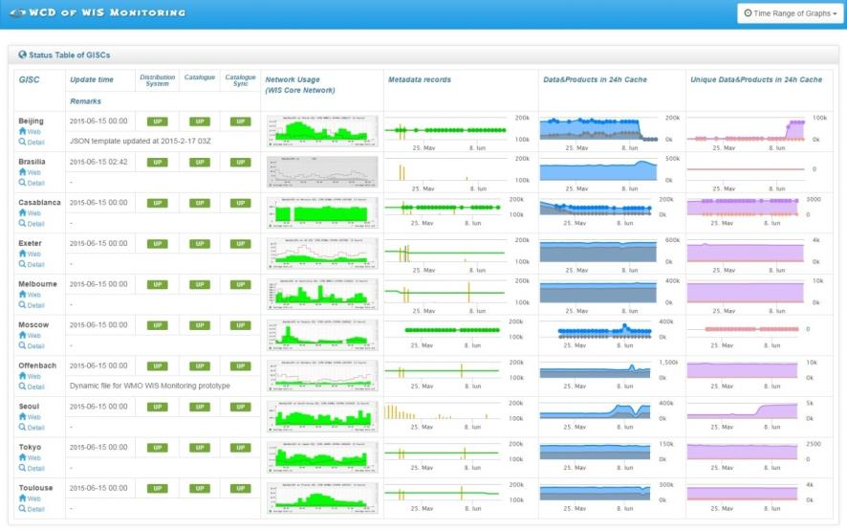
Pic 3. Screenshot of GISC Tokyo monitoring dashboard (main window for all GISCs)

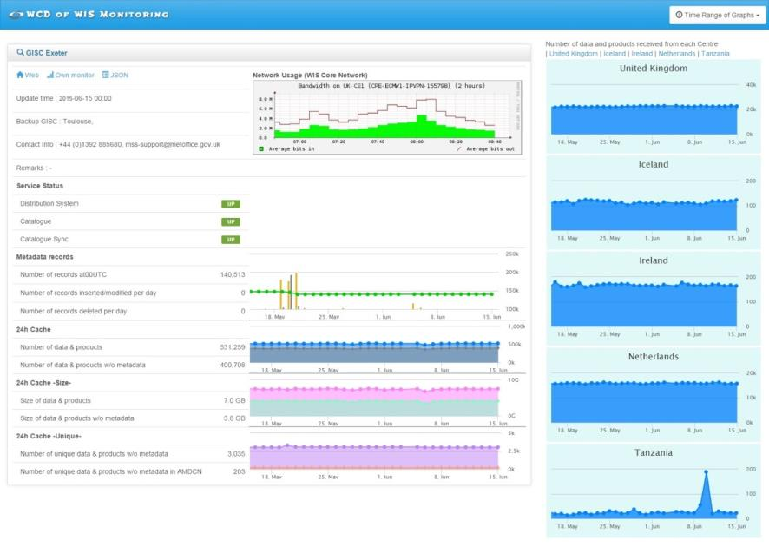
Pic 4. Screenshot of GISC Tokyo monitoring dashboard (detail window for one GISC)
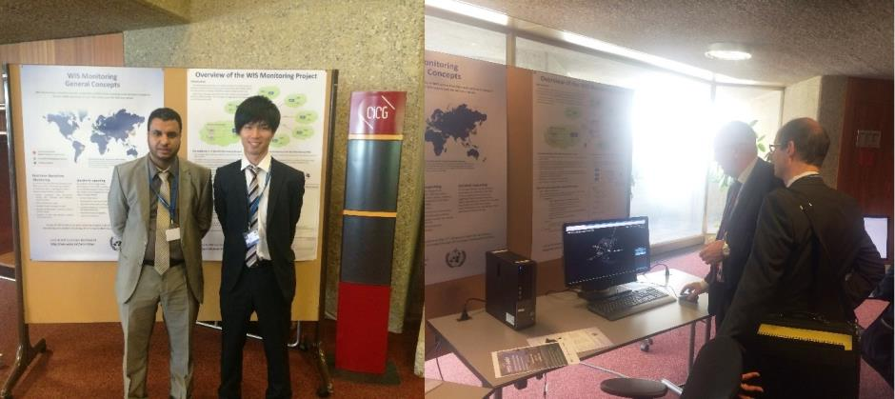
Pic 5. Demonstration booth

References
WIS Monitoring Project Telco - 1-Report.docx (http://wis.wmo.int/file=1429)

Recommended Text for Report
Mr Yasutaka Hokase, lead of work package for WIS Monitoring Demonstration, reported on the Demo at Congress 17. He also reported that the INMET dashboard was very helpful as a visual tool to explain connections for data exchange through WIS and that CMA/JMA dashboards were used to show that WIS is operational, and to show time-series graphs that were helpful to explain what is going on in data exchange and management. The meeting noted the usefulness of these showing. Mr Hokase informed that approximately 200 WIS Monitoring Pamphlets were handed to visitor at the Demo and that comments from visitors could be one of future options and further challenges. Mr Hokase thanks all contributors, the 10 GISCs -Beijing, Brasilia, Casablanca, Exeter, Melbourne, Moscow, Offenbach, Seoul, Tokyo, Toulouse- and the project members and managers, Mr Remy Giraud and Dr Weiqing Qu.
--------------------

